Internship Ready Software Development - Justification
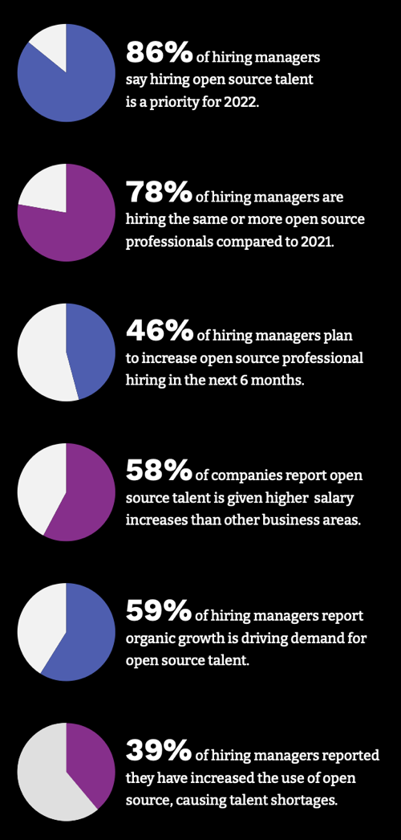
This course will provide effective skill training for students to have a successful Software Engineering Internship. It will allow the student to gain experience and confidence using version control, agile project development, and developing open-source software in an active learning environment within nine weeks. The need for this comes from conversations with industry partners and a commitment from KFSCIS to provide tech career awareness, readiness, upskilling, and other wraparound services tailored to improve tech students' employment success and alumni & company engagement in career development activities. Feedback will be given to students in a managerial style, e.g., through code reviews and sprint retrospectives.
The course prepares students for their first internship and post-graduation employment by bridging knowledge gaps, building software development portfolios, strengthening soft skills, and increasing confidence. Specifically, the instructor and learning assistant will guide computing students in building open-source software portfolios, which are critical to impress recruiters and hiring managers and are considered an industry best practice for acquiring a software development job.
According to the Linux Foundation’s 2022 Open Source Jobs Report, 93 percent of employers have difficulty hiring open-source talent. Growth in this area is projected to accelerate to at least 18.2 percent through 2026. Fig. 1 shows the growing importance of open source for employment in computer science.
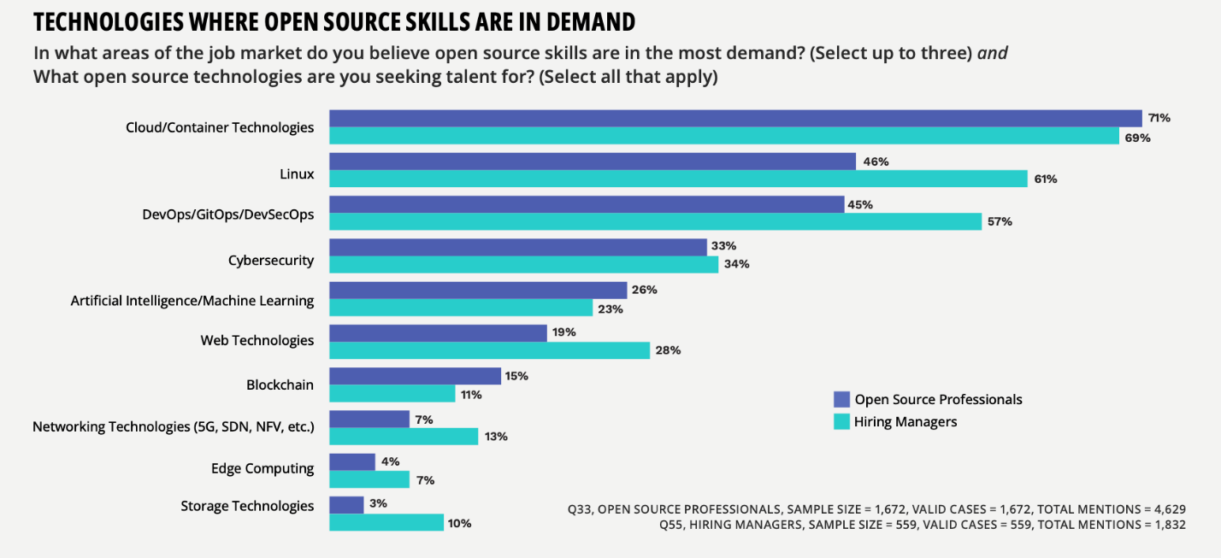
Students will start and/or contribute to an Open Source software project as a team by (1) using Git and Github, (2) applying Scrum software project management techniques, (3) learning a core framework or platform such as artificial intelligence application programming interfaces as part of their project. Learning will be self-paced, peer group organized, learning assistant guided, and appropriate for their skill level —building a career development community support system so students can support each other. In Fig. 2, from the above-mentioned report, the hiring demand and perceived need for tech talent with open-source skills are highlighted. The survey conducted in March 2022 among 1,672 open-source professionals and 559 respondents responsible for hiring open-source professionals shows the significance of open-source skills in the tech industry.
Fig.1 Open Source Jobs Report
Fig.2 Open Source Jobs Report

