The use of computational models in an AI course significantly enhances problem-solving in several ways:

1. Abstracting Complex Problems
- Computational models simplify real-world problems by representing them with mathematical structures, algorithms, and data.
- This abstraction helps students understand how to break down a complex task (e.g., navigation, image recognition) into solvable parts.

2. Enabling Experimentation and Simulation
- Students can build and test models like decision trees, neural networks, or reinforcement learning agents in simulated environments.
- This hands-on practice helps them see how AI techniques behave under different conditions and learn from trial and error.

3. Improving Algorithmic Thinking
- Designing models encourages a systematic approach to defining inputs, processing logic, and outputs.
- It sharpens skills in selecting appropriate algorithms (e.g., A* search, backpropagation) and tuning parameters for better performance.

4. Facilitating Interdisciplinary Learning
- Many AI models involve concepts from statistics, linear algebra, optimization, and logic.
- Students learn to apply these mathematical tools in practical problem-solving scenarios.

5. Visualizing and Interpreting Solutions
- Models often produce interpretable outputs (e.g., weights, classifications, probabilities), which help in understanding why a solution works.
- This fosters analytical skills and helps debug or improve models.

6. Encouraging Creativity and Innovation
- Computational models can be adapted and extended creatively to solve novel problems.
- This opens the door to innovation, as students are not limited to textbook examples.

In essence, computational models serve as learning tools and problem-solving frameworks that bridge theoretical AI concepts with practical application, empowering students to tackle real-world challenges confidently and clearly.
Let’s walk through how a decision tree helps in problem-solving within an AI course — with a concrete example and explanation.

Problem: Classifying whether a person is likely to buy a concert ticket
Input features:
- Age
- Income level
- Likes music (Yes/No)
Goal: Predict “Buy Ticket” (Yes/No)

🌳 Decision Tree Model
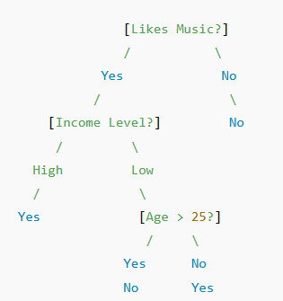

How This Helps in Problem-Solving

1. Abstraction of Real-World Scenario
- The model translates vague real-life intuition (e.g., "music fans are more likely to buy tickets") into a clear, testable structure.

2. Step-by-Step Decision Making
- Students learn how each node in the tree makes a decision based on data, e.g., checking if "Likes Music = Yes".
- This teaches logical flow and how to build conditional structures.

3. Interpretability
- The tree is easy to explain and interpret — great for beginners to see why a model makes a certain prediction.

4. Data-Driven Modeling
- Students use data to train the tree — learning how models evolve based on actual inputs, not assumptions.

5. Adaptability
- If a new feature (e.g., "Attended Past Concerts") is introduced, the tree can be modified and re-trained, showing flexibility of computational models.

✅ Conclusion
A decision tree model helps students:
- Represent problems logically
- Derive rules from data
- Test hypotheses
- Gain intuition about learning from data

Let’s now walk through how a neural network helps with problem-solving in an AI course, using the same problem as before — predicting whether a person will buy a concert ticket — and show how it differs from a decision tree.

🔍 Problem Recap: Predict if a person will buy a concert ticket
Input features:
- Age (numeric)
- Income level (numeric or categorized)
- Likes music (Yes=1 / No=0)
Output:
- Buy Ticket? (Yes=1 / No=0)

🧠 Neural Network Model Structure
A basic feedforward neural network (also called a multilayer perceptron) might look like:
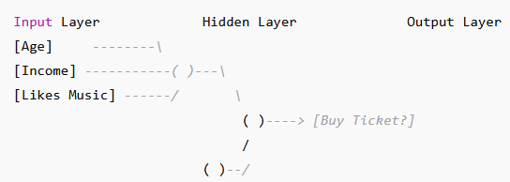
- Input layer: Takes numerical inputs (e.g., Age = 30, Income = $60K, Likes Music = 1)
- Hidden layer(s): Applies weighted combinations and activation functions (e.g., ReLU, Sigmoid)
- Output layer: Produces a probability (e.g., 0.87 → likely to buy ticket)

How This Aids in Problem-Solving

1. Generalization from Data
- Unlike decision trees (which follow rigid paths), neural networks learn patterns and can handle more subtle relationships.
- E.g., They can learn: “People under 30 with moderate income but who love music are still likely to buy tickets.”

2. Nonlinear Relationships
- Hidden layers with activation functions allow the network to model nonlinear combinations of features — helpful when relationships aren’t straightforward.

3. End-to-End Learning
- The entire network is trained using backpropagation, minimizing prediction error — a hands-on way for students to understand gradient descent and optimization.

4. Scalability
- Neural networks scale well with more features (e.g., social media activity, past concert attendance).
- Students see how models grow more powerful with data and structure.

5. Black-box vs Interpretability Tradeoff
- The model is less transparent than a decision tree, prompting students to explore techniques like feature importance or SHAP values.

Sample Input → Prediction
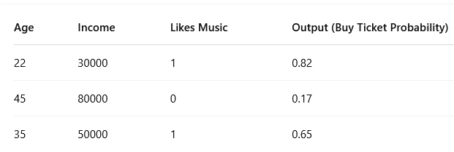

Conclusion
A neural network helps students:
- Solve more complex, nonlinear problems
- Practice optimization and backpropagation
- Understand abstraction and generalization in AI
- Build scalable models from raw data

