List of 2025-B5 courses from other units that may overlap with CS curriculum:
Course | Title | Remark
ISM4420 | Machine Learning for Business | Edit course
HFT4XXX | AI-Driven Transformation in Modern  Distribution & the Future of Food Supply Chains | New Course
ISM4XXX | Cloud Computing for Business Analytics & AI | New Course (pending author revision)
ISM4XXX | Advanced Machine Learning Capstone | New Course (pending author revision)
ISM4XXX | Generative AI Applications in Business | New Course (pending author revision)
DIG2XXX | Intro to Game Design and Development | New Course

https://users.cs.fiu.edu/~prabakar/upc/2024-2025_CurriculumCalendar_Bulletin.pdf
Faculty senate approval for B5: Apr 8th

ISM4420 (Author: Hemang Subramanian) -- Machine Learning for Business
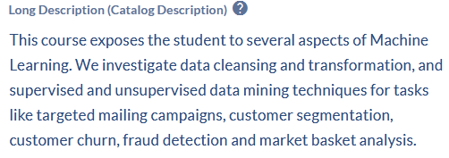

HFT4XXX (Author: Joseph Cilli) -- AI-Driven Transformation … Food Supply Chains
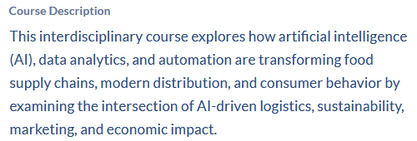

ISM4XXX (Author: Hemang Subramanian) -- Cloud Computing for Business Analytics & AI
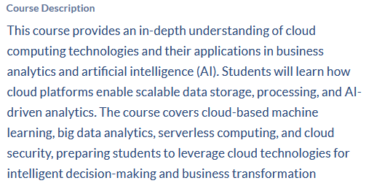

ISM4XXX (Author: Hemang Subramanian) -- Advanced Machine Learning Capstone
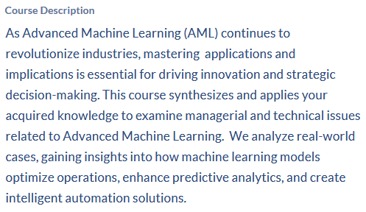

ISM4XXX (Author: Hemang Subramanian) -- Generative AI Applications in Business
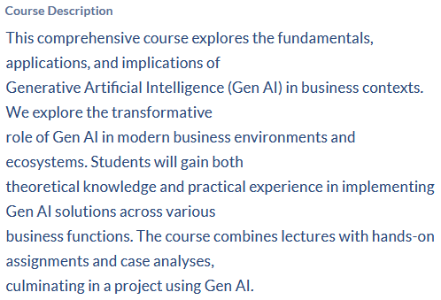

DIG2XXX (Author: Susan Jacobson ) -- Intro to Game Design and Development
