

COP 4534
Algorithm Techniques

Course Description
Basic algorithm design, including greedy algorithms, divide-and-conquer, dynamic programming, randomization, and backtracking. Graph, string, numerical, geometric, and optimization algorithms. Prerequisite: COP3530 or COP3538

Student Learning Outcomes/Objectives

1. Analyze algorithms using basic techniques. [Analyze]
2. Write recursive methods [Create].
3. Implement linked data structures such as linked lists and binary trees. [Create]
4. Analyze advanced data structures such as balanced search trees, hash tables, priority queues, and the disjoint set union/find data structure. [Analyze]
5. Examine several sub-quadratic sorting algorithms including quicksort, mergesort and heapsort. [Analyze]
6. Examine some graph algorithms such as shortest path and minimum spanning tree [Analyze]
7. Build solutions using the standard data structure library of a major programming language [Create]

Course Prerequisites
Course prerequisites, if any, are listed below. Prerequisite: COP3530 or COP3538

Textbook and Course Materials

ALGORITHM DESIGN MANUAL
Required/Recommended: Required

Authors: SKIENA Publisher: SPRINGER Publication Date: 2020

Copyright Date: 2020
ISBN 10: N/A
ISBN 13: 9783030542559
Chapters/Pages: See the section Schedule of Topics

Panther Book Pack

Get all required course materials for $20.50 per undergrad credit hour through Panther Book Pack. Youʼll be charged automatically unless you opt out within 3 days after the add/drop deadline.
For more details, to compare costs, and to learn how to access your course materials, visit the Panther Book Pack information page on FIU OneStop.

Expectations of the Course

Learning Management System

This course will use Canvas; all assignments are turned in via Canvas.

Language and Platform

The programming language is Java; students can use the integrated development environment (IDE) of their choice. At this level, students are expected to be fluent in the creation, building, running, and debugging of multifile projects in Java.

Instructional Method

The class is based on the concept of active learning. Active learning is an instructional method where students engage in the learning process, participating in discussions, problem solving, experimenting and other active activities, rather than passively listening to long lectures. Students are expected to use their laptops in class, hence IDEs,

compilers, etc. are to be installed to be able to develop programs and engage in the activities assigned in class.

Attendance

There is a positive correlation between attendance and academic success. Our class is face-to-face and meets twice a week; attendance to every class is strongly recommended. If you must miss a class due to an emergency, please do the best you can to keep up to date by using the materials posted in Canvas: class slides, assignments, and other classwork.

Assignments & Assessments

Projects: Projects will contain programming exercises.

Midterm Exam: students will have approximately one hour to complete it. It will be taken in the classroom, on the designated day.
Final Exam: the Final Exam will be comprehensive (i.e. cumulative) and students will have approximately two hours to complete it. It will be taken in the classroom, on the designated day.
LockDown Browser: all our tests will require the Respondus LockDown Browser.

Late Projects: Projects submitted after the due date will receive a 10% grade deduction per day up to 3 days (i.e. 10%, 20%, and 30%, respectively). After the third day project assignments will not be accepted. At the instructor discretion, point deduction might be waived under extenuating circumstances. In case of an emergency, contact the instructor before the due date (or as soon as the emergency allows it) to obtain approval and discuss a plan if late submittal or make-up work is approved.
Incorrect Submissions: Projects incorrectly submitted (for example, blank projects, another course content, etc.) will be considered as not submitted. After submission, make sure you check to verify correct deliverables were uploaded in Canvas.
Source Code Submission: For all projects that require the submission of source code, the .java files will be submitted, not the .class files. Project submission containing .class files instead of .java files will be considered unsubmitted and will be given a grade of 0.

Project Requirements: All aspects listed in projects are considered mandatory requirements. Do not make assumptions on what to do, what not to do, or what could be done in ways different than the ones listed. Failing to follow requirements will result in point deduction. Read carefully each project description and don't hesitate to ask if you have questions.
Missed In-class Tests: All tests are completed during class time, in the classroom. Students who have missed an in-class test may apply for a make-up test provided there is documented proof of a valid reason for the absence. Acceptable reasons include hospitalization, doctor’s certification that the student was unfit to take the exam, or subpoenas for court appearances. All make-up requests must be submitted in writing/email, with the appropriate documentation submitted to the instructor within a reasonable time.

Grading
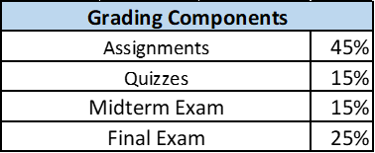

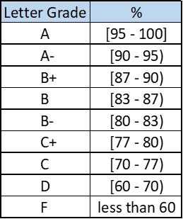

Schedule of Topics
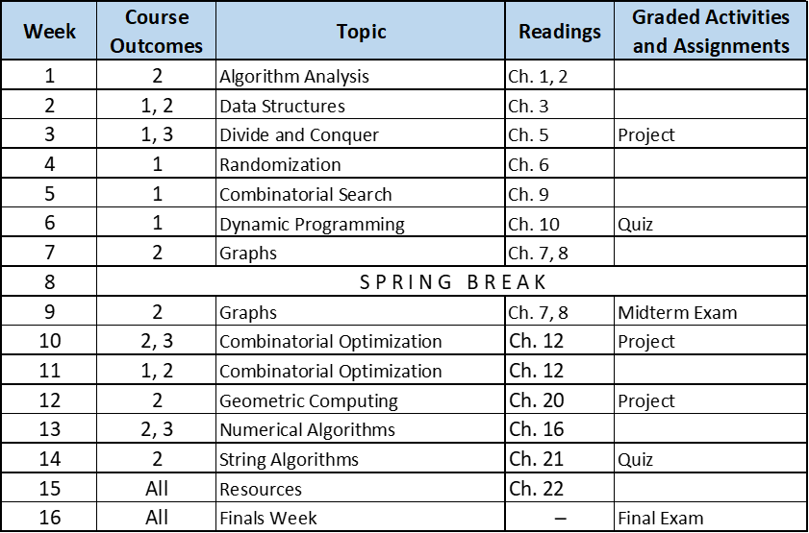
The instructor reserves the right to change this schedule at any time during the semester to better meet the needs of this class group.

Policies & Resources

Academic Integrity: All students are expected to abide by FIU’s Code of Academic Integrity.
Expected Classroom Behavior: Class participation, student interaction, and student engagement are important components of the active learning experience. Students are expected and encouraged to actively participate in the class tasks.

Nondiscrimination Statement
The Office of Civil Rights Compliance and Accessibility (CRCA) is responsible for ensuring that FIU maintains a workplace and learning environment free from

discrimination, where current and prospective faculty, staff, and students are treated equitably. If any student, employee, or applicant has a sincere and reasonable belief that they have been discriminated against or harassed based on age, color, disability, marital status, ethnic or national origin, race, religion, retaliation, sex, or any other protected category, they can report their concerns to the CRCA team through report.fiu.edu.

