

COT 4521
Introduction to Computational Geometry

Department or Academic Unit: Knight Foundation School of Computing and Information Sciences

Course Prerequisites
Course prerequisites, if any, are listed below. Prerequisites: COP 3530 or COP 3538

Course Description and Purpose
Study of efficient algorithms to solve geometric problems. Topics covered include convex hulls, Voronoi diagrams, Delaunay triangulations, arrangements, search and intersection, and motion planning. Prerequisites: COP 3530 or COP 3538

Textbook and Course Materials

COMPUTATIONAL GEOMETRY
Subtitle: ALGORITHMS AND APPLICATIONS
Required/Recommended: Recommended
Authors: MARK BERG, OTFRIED CHEONG, MARC KREVELD, MARK OVERMARS
Publisher: SPRINGER

Publication Date: 2008
Copyright Date: 2008
ISBN 10: N/A
ISBN 13: 9783540779735 (HARDCOVER)

COMPUTATIONAL GEOMETRY
Subtitle: ALGORITHMS AND APPLICATIONS
Required/Recommended: Recommended
Authors: MARK BERG, OTFRIED CHEONG, MARC KREVELD, MARK OVERMARS

Publisher: SPRINGER

Publication Date: 2008
Copyright Date: 2008
ISBN 10: N/A
ISBN 13: 9783540779742 (EBOOK)

Panther Book Pack

The Panther Book Pack rental program provides your required print and digital course materials at a flat rate of $20 per undergraduate credit hour. When you registered for your classes this session, you were notified via email of the required course materials that are included in the Panther Book Pack.
Make sure to review the pricing for all materials across your classes this semester and compare the cost to the Panther Book Pack flat rate. If the Panther Book Pack is not your best option, you may opt out up to three days after the add/drop deadline. The deadline to opt back into the Panther Book Pack is also three days after the add/drop deadline.
If you do not opt out of the Panther Book Pack rental program, you will be charged $20 per undergraduate credit hour for which you are registered and the course materials will be reserved in your name. For more details and to learn how to access your course materials, visit onestop.fiu.edu/bookpack.

Student Learning Outcomes/Objectives
Student learning outcomes allow faculty to assess the level of proficiency in content knowledge and skills that their students acquire in a course.
If the objective meets a special designation, you will see the code after the objective: University Core Curriculum: UCC
Gordon Rule Writing: GRW Global Learning: GL
Civic Literacy: CL

1. Define operations of geometric data structures. [Understand]
2. Build computational solutions to various geometric problems [Create]
3. Apply state-of-the-art computational solutions to a wide range of disciplines [Apply]

Expectations of the Course

Learning Management System

This course will use Canvas; all assignments are turned in via Canvas.

Language and Platform

The course will use the Java and C++ programming languages.

Instructional Method

The class is based on the concept of active learning. Active learning is an instructional method where students engage in the learning process, participating in discussions, problem solving, experimenting and other active activities, rather than passively listening

to long lectures. Students are expected to use their laptops in class, hence IDEs, compilers, etc. are to be installed to be able to develop programs and engage in the activities assigned in class.

Assignments

Projects: Projects will contain programming exercises.

Midterm Exam: students will have approximately one hour to complete it. It will be taken in the classroom, on the designated day.
Final Exam: the Final Exam will be comprehensive (i.e. cumulative) and students will have approximately two hours to complete it. It will be taken in the classroom, on the designated day.
LockDown Browser: all our tests will require the Respondus LockDown Browser.

Attendance: There is a positive correlation between attendance and academic success. Our class is face-to-face and meets twice a week; attendance to every class is strongly recommended. If you must miss a class due to an emergency, please do the best you can to keep up to date by using the materials posted in Canvas: class slides, assignments, and other classwork.
Late Projects: Projects submitted after the due date will receive a 10% grade deduction per day up to 3 days (i.e. 10%, 20%, and 30%, respectively). After the third day project assignments will not be accepted. At the instructor discretion, point deduction might be waived under extenuating circumstances. In case of an emergency, contact the instructor before the due date (or as soon as the emergency allows it) to obtain approval and discuss a plan if late submittal or make-up work is approved.
Incorrect Submissions: Projects incorrectly submitted (for example, blank projects, another course content, etc.) will be considered as not submitted. After submission, make sure you check to verify correct deliverables were uploaded in Canvas.
Missed In-class Tests: All tests are completed during class time, in the classroom. Students who have missed an in-class test may apply for a make-up test provided there is documented proof of a valid reason for the absence. Acceptable reasons include hospitalization, doctor’s certification that the student was unfit to take the exam, or subpoenas for court appearances. All make-up requests must be submitted in

writing/email, with the appropriate documentation submitted to the instructor within a reasonable time.

Policies & Resources
Academic Integrity: All students are expected to abide by FIU’s Code of Academic Integrity.
Expected Classroom Behavior: Class participation, student interaction, and student engagement are important components of the active learning experience. Students are expected and encouraged to actively participate in the class tasks.

Grading
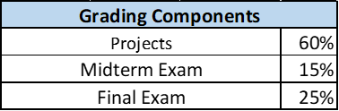
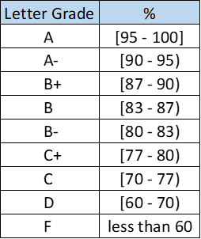

Note: [a, b] means grade ≥ a and ≤ b, and [a, b) means grade ≥ a and < b.

Schedule of Topics
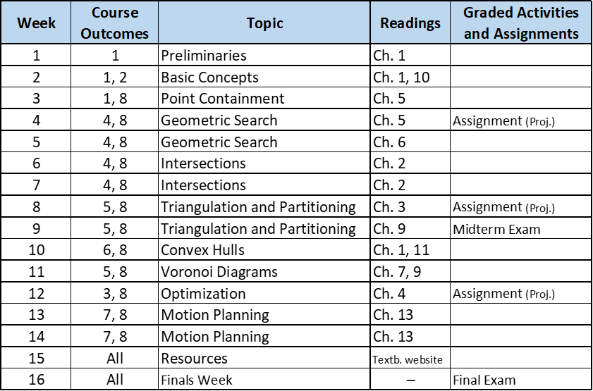
This is a tentative outline of the course. It is subject to change.

Nondiscrimination Statement
The Office of Civil Rights Compliance and Accessibility (CRCA) is responsible for ensuring that FIU maintains a workplace and learning environment free from discrimination, where current and prospective faculty, staff, and students are treated equitably. If any student, employee, or applicant has a sincere and reasonable belief that they have been discriminated against or harassed based on age, color, disability, marital status, ethnic or national origin, race, religion, retaliation, sex, or any other protected category, they can report their concerns to the CRCA team through report.fiu.edu.

