KF-SCIS Handbook for Submission of a Curriculum Proposal Through CourseDog
Authors: Trevor Cickovski and Nagarajan Prabakar
November 2024

CourseDog
Beginning in the Fall of 2024, Florida International University completed its migration from a paper-based submission process for curriculum proposals (this includes new courses, course and curriculum changes, etc.) to an entirely electronic procedure through the software CourseDog.
These guidelines are intended to inform faculty about KF-SCIS’ procedures for curriculum proposals in light of this migration and ensure compatibility with KF-SCIS’ current practices and approval processes.
Note: This file does not contain any documentation on using the CourseDog software. Faculty must attend at least one CourseDog training session (hosted by the University) to use the software.

KF-SCIS: Three-Phase Process
KF-SCIS curriculum proposals should proceed through three strictly sequential phases: Preparation, Submission, and Follow-Through.
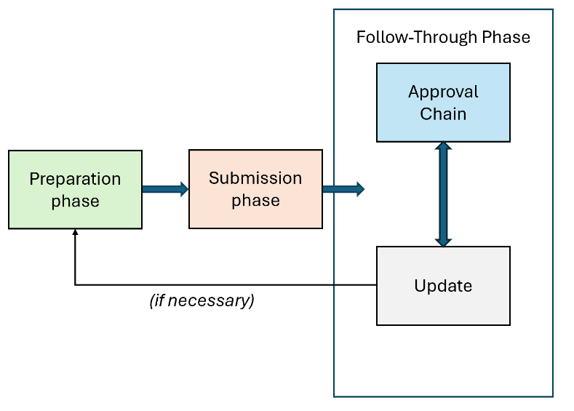
The Preparation phase takes place before CourseDog submission, the Submission phase takes place during CourseDog submission, and the Follow-Through phase takes place after CourseDog submission. We now outline each phase in more detail.

Before CourseDog Submission: Preparation Phase
The flowchart below summarizes the Preparation Phase. Each of these steps should be performed prior to CourseDog submission of any curriculum change:
Flowcharts
Identify Courses
PDF Files
Retrieve Syllabi
UPD/AD
Request Latest
Source File (Word)
Guidelines
Create/Modify Syllabus
& Justification
UPC/GPC
Submit the Proposal
Incorporate their recommendations
Attend Deliberations &
Revise Until Approved
by the Faculty

Prior to any curriculum change, faculty should identify their course in the KF-SCIS flowcharts for each degree program, and also retrieve the appropriate syllabus for their course. For new courses, faculty should still identify where their new course would fit in the degree flowcharts, and should retrieve one KF-SCIS syllabus as their new course syllabus will need to follow a similar template. At the time of this release, these are the links:
KF-SCIS Flowcharts: https://www.cis.fiu.edu/wp-content/uploads/undergrad-flowcharts/index.htm
KF-SCIS Syllabi: https://www4.cis.fiu.edu/courses/Syllabi/
The link above contains PDF files to all KF-SCIS syllabi. If a faculty would like to request a Word document for modification purposes, the Undergraduate Program Director (UPD) and Associate Director (AD) can provide these copies (at the time of this release, our UPD is Nagarajan Prabakar (prabakar@cs.fiu.edu) and our AD is Trevor Cickovski (tcickovs@cs.fiu.edu)).
KF-SCIS provides its own set of guidelines for curriculum changes. Faculty should follow these guidelines despite the University migration to CourseDog, as they ensure a uniform format that will facilitate readability for our Program Committees and faculty when they review the proposal. These guidelines are currently available here: https://users.cs.fiu.edu/~prabakar/upc/NewCourse/New_Course_Guidelines.pdf
Once the faculty member has completed their proposal according to KF-SCIS Guidelines, they should submit the proposal to our Undergraduate Program Committee (UPC) chair for undergraduate courses, our our Graduate Program Committee (GPC) chair for graduate courses. The respective chair will then add the item to the agenda of their committee, and reply to the faculty with an expected date for them to attend the meeting and discuss their proposal. At the time of this release, our UPC chair is Pat McDermott-Wells (mcdwells@fiu.edu) and our GPC chair is Deng Pan (pand@cs.fiu.edu).
Following approval by the (U/G)PC, the proposal will require approval from faculty, which will either take place at a faculty meeting or via e-mail with a specific amount of time (typically two weeks) to respond with objections. Any objections will then need to be resolved, and the faculty member will need to attend any subsequent delibrations with other faculty and/or the program committees.
Program committee approval, followed by subsequent faculty approval, marks the end of the Preparation Phase. At this point, the faculty can proceed with their submission to CourseDog.

During CourseDog Submission: Submission Phase
After the Preparation Phase is complete, the Submission Phase can commence.

As mentioned earlier, faculty must attend at least one CourseDog training session to submit any curriculum proposals using the software. CourseDog training videos are currently available here. Upon completion of the training, the faculty must complete an Access Request Form. Once approved, the faculty can commence submission of their curriculum proposal to CourseDog. The faculty can search the CourseDog training videos and watch the one for their particular curriculum change (i.e. new course, course change) to see how that process works in CourseDog. All subsequent questions should be directed to (at the time of this release) Alexis Gonzalez (almagonz@fiu.edu).
Video
Coursedog Training
Access Request Form
Complete
Proposal in Coursedog
Create & Submit
after Faculty approval
Contact:
Alexis Gonzalez
Coursedog Help
(Only once)

After CourseDog Submission: Follow Through Phase
The Follow Through Phase consists of two synchronous portions: The Approval Chain, and Update. The approval chain will direct the faculty’s CourseDog proposal to the appropriate personnel for final approval of their proposal. The Update portion will need to be performed by the faculty member, in response to any pushback during the approval chain. It is possible that during the Update portion, if changes are significant enough to impact KF-SCIS curricula on a global scale, these updates will need to be rediscussed with faculty and/or the program committees.
Below, we outline the current Approval Chain for CourseDog Proposals:
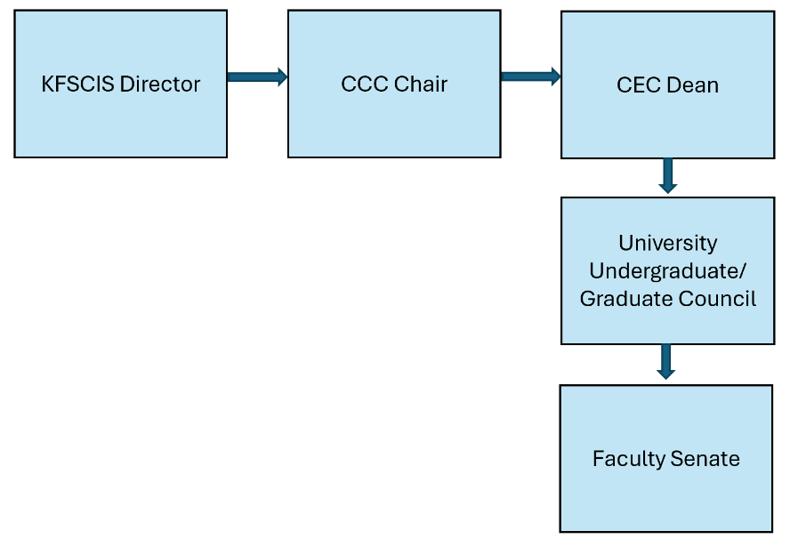
There are five total, but the first stop will be the KF-SCIS director (at the time of this release, Jason Liu, liux@cs.fiu.edu). If necessary, the director first will confirm Faculty approval of this proposal with appropriate personnel, and then pass the proposal to the College Curriculum Committee (CCC) chair. The ultimate approval of the curriculum proposal will reside with the Faculty Senate.
In the Update portion, the faculty should begin by monitoring their e-mail closely for any pushback regarding their curriculum proposal:
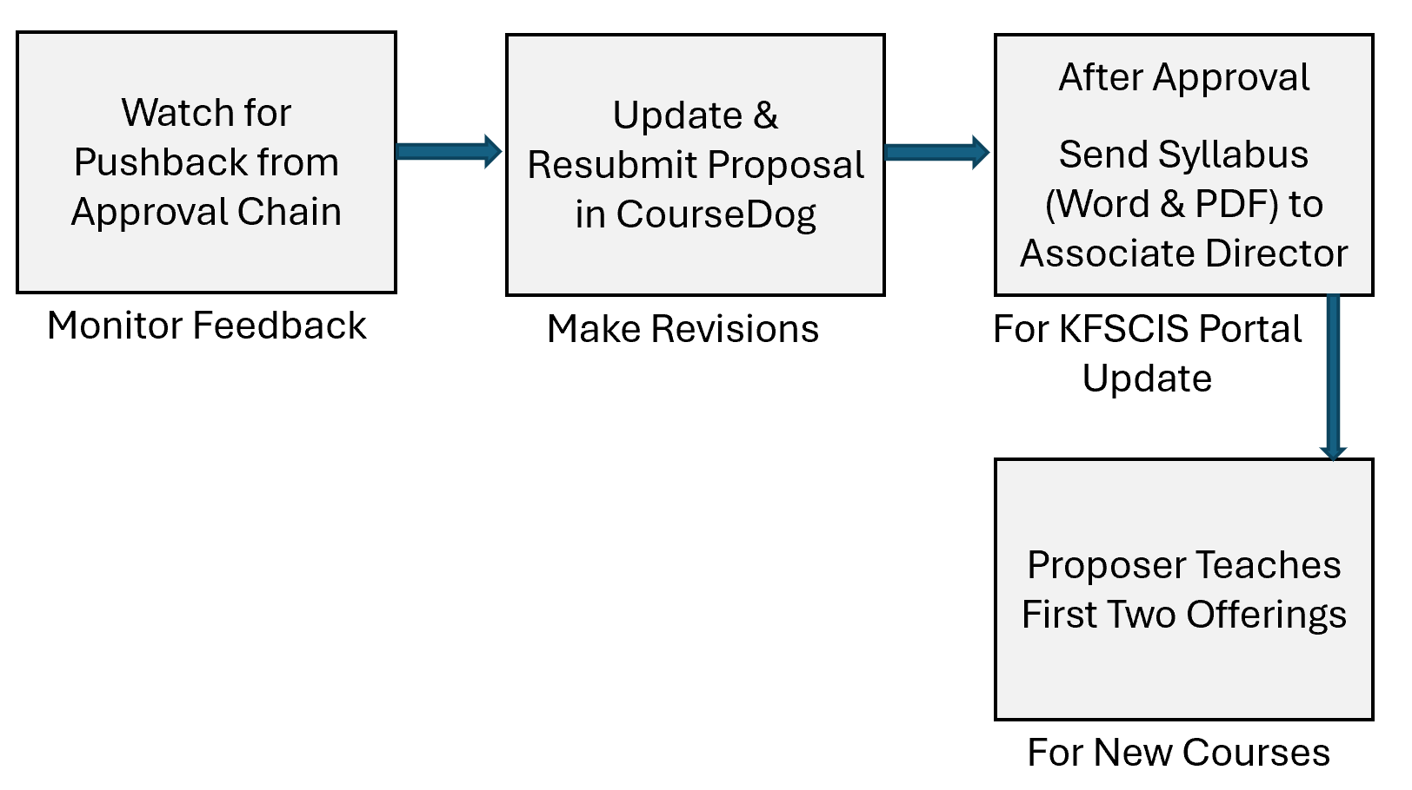
If any pushback to the proposal is encountered along the Approval Chain, the second step (updating and resubmitting their proposal in CourseDog) must be followed. The faculty may simply correct small syntax errors, but changes that impact KF-SCIS curricula need to be rediscussed with program committees and/or faculty prior to resubmission. If the faculty is uncertain as to whether or not this modification constitutes a need for rediscussion, they should reach out to the KF-SCIS Associate Director prior to resubmission in CourseDog.
Following approval, the faculty should send their approved syllabus (Word and PDF) to the KF-SCIS Associate Director, who will update the appropriate KF-SCIS portals. It is recommended that the proposing faculty subsequently teach the first two offerings of new courses.

