Created by: Michael Balewicz

2.1 Altiris

Altiris History
Altiris was started in 1998 by Jan Newman and Kevin Turpin. The duo worked at KeyLabs, which is a third party testing facility. The Altiris Software was created at KeyLabs to manage the computers and that software ultimately became Altiris.
Altiris continued to grow and market expansions. In 2007, Altiris was acquired by Symantec Corporation. This combination hoped to create a comprehensive approach to securing and managing endpoints. The Altiris Corporation is currently located in Utah.
Company Highlights
Altiris is a leading provider of service-oriented management solutions that help reduce the cost and complexity of IT ownership through automation. Their business challenge is to reduce costly manual processes, improve IT service levels, and to provide increased network security. Altiris recently merged with Symantec to combine endpoint management capabilities with the security and back up expertise of Symantec to deliver a greater set of unique solutions to today’s market.
- Altiris was named the fastest-growing software company on the 2007 Forbes 25 Fastest-Growing Technology Companies list [1].
The main IT automation products/solutions the company offers (along with a summarized description of each individual offering)
Asset Management Solution
- Tracks and manages the data associated with the IT assets in your environment throughout their lifecycle.
Backup Exec System Recovery Solution
- Allows administrators to meet strict recovery time objectives by recovering systems.
Client Management Suite
- “Automates tasks to minimize efforts and costs associated with deploying, managing, securing, and troubleshooting client systems so administrators can gain control of your IT environment [2].”

CMDB Solution
- A centralized repository that actively tracks, manages, and accounts for all configuration items, users, and business services that comprise an IT infrastructure. Provides visibility into relationships and dependencies between hardware and software.
Deployment Solution
- Reduces the cost of deploying and managing servers, desktops, notebooks, and thin clients from a centralized location in your environment. With Deployment Solution an administrator can schedule remote system upgrades, distribute patches and drivers, re-image computer hard drives, and migrate large groups of users to new computers.
- Altiris Deployment Server allows for executing client-side scripts. Once a script is created, Deployment Server is opened and can create a custom event. Add a run script task to the event. Then in “script task properties” dialogue box for the run script task, select the “run this script” option.
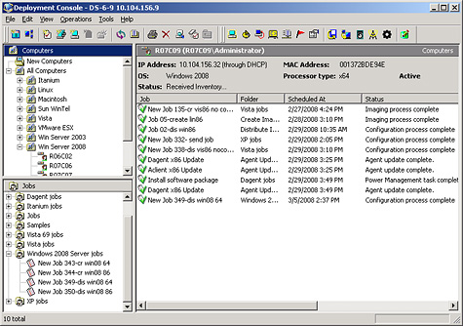
Help Desk Solution
- An incident management tool that allows you to ensure availability and raise service levels while reducing costs.

Inventory Solution (Must have Altiris Notification Server installed)
- Reduces the cost of identifying and managing devices throughout an enterprise. Tracks comprehensive hardware information, installed software packages, and operating system setting for all IT assets thought their lifecycle.
Security Expressions
- Supports and organization’s security processes through the implementation of sound security configuration baselines, proactive evaluation, and comprehensive reporting of application availability.
Server Management Suite
- Provides IT administrators with a solution for managing physical and virtual servers. Provides solutions to provision, control, automate, and measure servers from a central console.
Service & Asset Management Suite
- Asset and service management disciplines into a single Web-based architecture, repository, and console helping untie disparate departments and processes. Ultimately helping organizations eliminate unnecessary software and hardware costs and proactively manage vendor contracts.
Endpoint Virtualization Suite
- Serves the needs of traditional, virtual, and hybrid enterprise endpoints, providing high productivity with controlled, guaranteed access to any Windows application.
Total Management Suite
- Comprehensive suite of IT lifecycle automation solutions designed to help IT organizations manage, secure, and support all IT assets.
- License fee per machine is $203.50. A company of 2,500 machines will cost $508,750. In addition, $7, 180 in training costs per IT staff for the Notification Systems Foundation, Deployment Solution Foundation, Service & Management Suite User Essentials, and Help Desk Solution. An additional cost for total support from Altiris annually is $6, 875, which includes upgrades to any new version of the registered product that is released during the coverage period. There are also additional labor, hardware, and consulting fees.
Wise Installation Express, Wise Installation Studio
- Helps create basic desktop installations that support Microsoft Windows Installer and configuration requirements to support the latest technologies like Vista or 64-bit.
Workflow Solution
- Define, design, and deliver automated processes and workflows that drive business.
*The Altiris Complete Lifecycle Management
The lifecycle management addresses these core IT needs:
- Asset Management
- Client and Mobile Management
- Server Provisioning
The lifecycle management is an ongoing process that will manage an environment and adapt to structure change within an organization. Altiris’ individual solutions included with the Total Management Suite are all a part of the Complete Lifecycle.

2.1.1 Functional Coverage
- Show which operating systems are supported
Altiris can be deployed on Windows, Mac, and Linux. Although Altiris can be deployed on UNIX systems, there are drawbacks:
- Altiris Agent for UNIX and Linux does not currently support Wake-On-LAN requests.
- If you uninstall Altiris Agent for UNIX and Linux on a HP-UX server it is possible that all files and directories will not be deleted and must be removed manually.
- There are problems installing to custom directories when using Red Hat 8.
- All packages and servers must have the same version of the Altiris agent for the upgrades to work.

- Explain what underlying technology (agent, probe, etc.) is used to manage and monitor network with given solution
Altiris uses a Notification System, which is the heart of the entire Altiris Infrastructure. It contains the core components needed by the Altiris solution. The Notification Server is the key component for the Notification System. It installs and manages the Altiris Agent, and the Notification Database. One or more Notification Server can be installed at a corporation, based on the needs. Notification Server runs based on policies set by an administrator.
Components of the Notification System include:
- Altiris Agent
- Notification Server
- Notification Database
- Web-based management consoles
- Package Server
- Reports
- Inventory data forwarding
- Software delivery
- Notification Policies
Tasks performed by Notification Server:
Collects and stores Agent information in the Notification Database.

Forwards Agent inventory to SMS.
Sends policy enforcement criteria to Agents and responds to incoming events associated with these policies.

The Altiris Agent is a program that is installed on the managed computers, allowing Notification Server to gather information from and interact with the managed computers. Computers running the Altiris Agent are called Altiris-enabled computers. The enabled computers receive configuration information from and send data to the Notification Server. The Agent also helps in downloading files.
There are two main methods of installing the Altiris Agent to target computers:
• Agent Push Installation - This method is initiated from the Altiris Console. The Notification
Server pushes the Altiris Agent files to the target computers. You can choose to install the Altiris Agent to one computer at a time, or install it to multiple computers in one session.
• Agent Pull Installation - The Pull method requires a person, with root or root equivalent access rights, to log on to the computer needing the Altiris Agent. The user will go to a specific URL and pull the agent from the Notification Server.
*When Notification Server is installed, the Altiris Agent is installed automatically on the Notification Server computer.

- 2.1.1.1 Remote Control
Altiris utilizes the Deployment Solution to manage computers remotely. With Deployment Solution an administrator can schedule remote system upgrades, distribute patches and drivers, re-image computer hard drives, and migrate large groups of users to new computers.
- 2.1.1.2 Auditing & Asset management
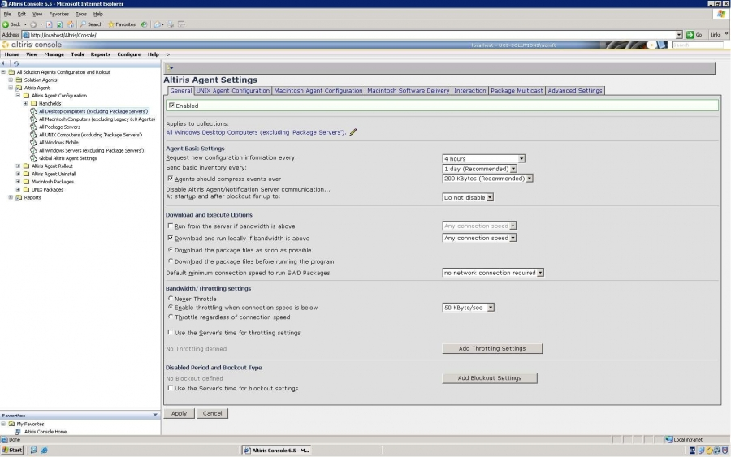
Altiris’ Inventory Solution is the program that conducts system audits and inventories. It gathers software and hardware data from any computer.
Inventory Solution data includes:

- PC Serial Number and BIOS details
- Comprehensive software auditing
- Disk, operating system, and system configuration settings
- Registry settings
- Full end user information (with Microsoft Exchange profiles)
- WMI objects
Inventory Solution can be deployed to a client computer in multiple ways. The methods that should be used depends upon a corporations particular needs. The deployment methods are:

- Logon Script
- E-mail (as a link or attachment)
- Web link
- Floppy disk
- Manual (through shared or mapped drive)
- Altiris Agent
Inventory Tasks provided by Altiris’ Inventory Solution:
- Hardware Inventory – Runs computer inventory on a daily schedule.
- Recreate Full Inventory – Runs a software audit, serial number, and computer inventory on a monthly schedule and sends all inventory data to the Notification Server. There is also a random schedule option that lets you run an inventory on different computers at different times.
- Recreate User Inventory – Runs end-user and exchange inventory on a monthly schedule and sends all inventory data to the Notification Server.
- Software Inventory – Runs a software audit, serial number, and computer inventory on a weekly schedule.
- User Inventory – Runs end-user and exchange inventory on a daily schedule.

- 2.1.1.3 Monitoring

Altiris’ site Monitor Solution ensures the availability of resources on a network. This solution allows remote monitor connection, ports, Web Pages, and performance, and will notify when problems arise. Resources include:
- Computers on a local network.
- Computers across a WAN.
- Computers running numerous operating systems (Windows, UNIX, Linux, MAC OS).
- Network Printers
- Network Devices (hubs, switches, and routers)
The Monitoring Solution lets IT Administrators monitor the following:
- Connectivity – Ping resources to ensure that they are available and respond in a timely manner.
- TCP/IP Ports – TCP/IP ports of interest on resources can be monitored for availability.
- Web Content – Web pages can be checked for availability and content to ensure that Web pages are available and the appropriate content is on the page.
- Performance – High level computer performance can be monitored to ensure that computers are performing properly.
All Site Monitor Solution monitoring is performed by the Site Monitor Agent. The agent can be installed on any computer from which you want monitored and that has the Altiris Agent installed.
2.1.1.4 Patch Management
The Altiris Patch Management Solution scans computers from security vulnerabilities, report on the findings, and automates the downloading and distribution of needed security patches. The solution reviews and downloads specific patches, creates collections of the computers that require a specific patch, and then applies the patch to the computers that need them.
A Software Inventory Agent gets installed on Altiris-enabled computers and sends back inventory specifically needed for managing software updates. The inventory includes:
- Software vendor
- Software release
- Service pack information
After Patch Management Solution is installed, it downloads complete software bulletin information from an Altiris Web site.
With Altiris, when you enable a software bulletin, each associated software update executable automatically gets downloaded from Microsoft. With the information in the executables, Patch Management Solution then creates a Software Update package for each software update.
Patch Management Solution features:
Feature | Description
Information Repository | The repository provides comprehensive data on software bulletins, updates, and inventory rules. The repository is specifically tailored to automate the patch management process.
Comprehensive Inventory | Discovers detailed information on the operating system and installed applications, as well as inventory on software update installations.
Software Repository | Automatically downloads all enabled software updates from the vendor site, allowing staging of software updates prior to distribution.
Software Update Analysis | Automated evaluation of patch dependencies to substantially reduce the labor requirements of patch management.
Simplified Distribution Tasks | Includes a wizard that simplifies the management of distribution policies. Can create a single policy for the software bulletin.
Recovery Solution Integration | Provides an agent option to automatically create a snapshot prior to software update installations. Allowing for effective rollback when a software update disrupts computer functions.

- 2.1.1.5 Backup & Disaster Recovery
Altiris’ Backup Exec System Recovery Integration Component lets administrators remotely run and manage backup policies on client computers from a central location. Backup policies and recovery point’s storage locations can be defined as:
- Daily, weekly, monthly, or quarterly backups and assign them to one or more collections.
- Creates full independent recovery points or recovery points sets with incremental.
- Define recover points destination on a network share or on a local drive on the client computer.
The Altiris Notification Server consists of two agents combined into one package. They are the BESR Task Agent and the BESR Policy Agent. Both agents are necessary components of Backup Exec System Recovery and must be installed on each computer that has backups to be managed. The agents publish a variety of event information to the Altiris Console such as the following:
- A list of recovery points and their storage locations.
- Backups assigned to the computer.
- Backup Exec System Recovery version.
- Any configuration changes that are made to the computer.

- 2.1.1.6 Endpoint Security
Altiris utilizes the Endpoint Security Solution that automatically adjusts security settings and user permissions based on the current network environment characteristics. A sophisticated engine determines the user’s location and automatically adjusts firewall settings and permissions for applications, adapters, hardware, etc.
A special agent, the Endpoint Security Agent is installed. The agent receives the configuration settings from the solution, which is then installed on the Notification Server and enforces the settings on the endpoint.

- 2.1.1.7 User State Management
The Altiris Application Management Solution lets you manage user applications in three ways:
- Software State Management
- Windows Installer Application Management
- Baseline Management
Software State Management provides software state management tools to maintain the desired state of packages on collections of computers. It does these using tasks that contain rules that selectively evaluate whether a package is installed properly.
Windows Installer Application Management helps maintain the state of applications that are installed with Windows Installer (MSI applications). Information is collected about MSI applications and reports the information to the Notification Database.
Baseline Management quickly and easily compares files and registry keys between different computers or track how computers change over time. A baseline is generated that identifies the files or registry settings on a computer at a given time.
Before the software state management is utilized, the Altiris agent and State Management Agent must be installed on the computers that will be managed.
The suite automates time-consuming and redundant tasks to minimize efforts and costs associated with deploying, managing, securing and troubleshooting client systems so you can gain control of your IT environment [3].

- 2.1.1.8 Help Desk
The Altiris Help Desk provides incident management tools to enforce workflow and the resolution of IT Help Desk issues. The Incident Management system utilized by Altiris can track any IT resource, create contacts, report and manage incidents that have been submitted to a Help Desk department.
Help Desk Features:
- Knowledge Base
- Registration of Tasks
- Inbound E-mail Support
- Enhanced Bulletin Board
- Quick Incidents
- Incident Rules
- Satisfaction Survey
- Improved Summary Pages
- Edit Multiple Incidents Capability
When Notification Server is installed (Help Desk), five groups are added to the Local Users and Groups for NT authentication. The groups are:
- Altiris Administrators
- Supervisors
- Guests
- Level 1 Workers
- Level 2 Workers
Administrators are granted all privileges, whereas other groups can create incidents, bulletins, and search the knowledge base.

- 2.1.1.9 Usability

The Altiris solution provides users with plenty of tutorials and aids, including a Quick Start Manager. Altiris has a very user-friendly interface which is easy to navigate. The end-user support allows the utilization of Altiris to be very easy to navigate.

- 2.1.1.10 Reliability

Once Altiris is installed on all machines, it is a very reliable IT solution. Machines utilizing Altiris will remain stable and reliable since each machine is configured to the end-users liking.

- 2.1.1.11 Performance

With Altiris, administrators will be able to utilize everything from Remote Control to Help Desk allowing for maximum performance according to the needs of the organization. There are some performance issues in regards to initial installation and the length of time it takes to complete some tasks (backup, audit).

- 2.1.1.12 Supportability

For Altiris users, there are various levels of supportability from Altiris/Symantec.
- Online Support - A complimentary online support service provided through the Altiris Service Center, which allows users to access resources via logging-on.
- Incident Support – For Wise software installations and provides the ability to work directly with a Technical Support Engineer via email or telephone.
- Basic Maintenance Services – Designed for organizations that run any Symantec products on a non-essential system(s).
- Essential Support Service – Provides 24/7 access to Altiris/Symantec’s support experts, version upgrades, and fast response times.
- Business Critical Service – The highest level of support provides personalized, proactive support from technical experts for enterprises.

Altiris vs. Kaseya Case Studies
Kaseya obviously seems to have an advantage over Altiris being more powerful, simpler, and more flexible. Advanced Motion Controls (AMC) which was utilizing Altiris claimed the solution cost was $50,000 plus additional services and training courses. The Kaseya solution came in less than $15,000 with less time spent managing the solution. With that being said, Kaseya would be the ultimate choice according to FIU’s budget standards. The Altiris solution also posed a problem with the finance department, presenting confusing bills that surprised the company.
Concluding the case study, AMC claims Altiris is a convoluted, irrational piece of software. “Altiris is made up of dozens of management modules that loosely fit together under a common interface, each module performing a separate function like patch management or remote control and spawning a new window when opened, causing confusion. Altiris also taxed the servers and the development workstations, affecting the performance of all applications on each system, causing the productivity of the engineering team’s performance to be in jeopardy. Ultimately, users started taking Altiris off of their systems [4].”
The North Conejos School District serves 1,200 students in Conejos County, Co. “The IT manager deployed now Symantec’s Altiris management software, but found that it couldn’t give him complete control over access into the distributed systems that he needed. It was also a pain to deploy widely and added unnecessary steps to basic maintenance. The software wouldn’t integrate seamlessly with his anti-virus and backup software [5].”
He switched to Kaseya and the solution took less than 24 hours to install on all 500 systems, a tenth of the time it took to deploy Altiris. The Kaseya agent is deployed on 10 servers and 490 workstations in five schools across the county. Kaseya automatically collects information on each system, including model number, OS, memory, RAM, installed software, security status, and peripherals, providing a complete snapshot of the environment in real-time and also assisting in annual audits as well as equipment procurement and lifecycle planning, all of which Altiris lacked. Kaseya has also saved this particular school district over $100,000 per year.
“Recently, vulnerability has been reported in Symantec Altiris Deployment Solution, which can be exploited by malicious, local users to gain escalated privileges. The vulnerability is caused due to an error in the Symantec Altiris Deployments Solution Server Agent, which can be exploited via shatter attacks to execute arbitrary code with escalated privileges [6].”
After reading many discussion forums about Altiris comparisons, Altiris seems to fail when installing on many machines that meet minimum system requirements. People in the business seem to lean toward other IT Automation software’s rather than Altiris even though Altiris has everything available for solutions. The main reason and drawback with Altiris was the value for the money because the Altiris’ price is indeed steep.

