2.2 Altiris
Overview: Altiris has 5 major products:
Asset Management Solution – Software which tracks and manages the physical, contractual and financial data associated with the IT assets in your environment throughout their lifecycle—from receiving through disposal. Actively manage software assets to ensure license compliance, reduce leasing costs, and avoid penalties. [1]
Client Management Suite - Suite enables administrators to deploy, manage, and troubleshoot systems from virtually anywhere. Some key features: [2]
• Central Web-based management console
• Role-and-scope-based security
• Zero-touch OS deployment and migration
• Integrated hardware and software inventory with Web-based reporting
• Policy-based software management
• Automated patch management
• Software license compliance and harvesting
• Centralized management of mixed hardware and OS environments
Inventory Solution - track comprehensive hardware information, installed software packages, and operating system settings for all IT assets throughout their lifecycle. Tools for aggregating data allow you to generate audit reports, assess security vulnerabilities and determine hardware needs and availability. Web reports allow you to identify hardware that requires upgrading or replacement. [3]
Helpdesk Solution - incident management tool that allows you to ensure availability and raise service levels while reducing costs. Built-in workflow automatically assigns and escalates tickets to the proper Helpdesk technicians. Helpdesk solution integrates easily with other data sources, including Microsoft Active Directory and Systems Management Server. [4]
Altiris bundles most of these product offerings into a solution called Altiris Total Management Suite.
Total Management Suite - suite of IT lifecycle automation solutions designed to help IT organizations manage, secure and support all IT assets, promoting effective service delivery. [5]
Some key features:
• Integrated IT lifecycle management solution
• Common, Web-based console
• Single, extensible repository and configuration management database
• Zero-touch OS deployment and migration
• Integrated hardware and software inventory
• Policy-based software management
• Automated patch management
• Automated application self-healing and configuration settings management

Background:
Altiris, Incorporated. is a leading provider of service-oriented management software that enables IT organizations to easily manage, secure and service heterogeneous IT assets. [18]They also provide software for web services, security, and systems management products. Altiris was established in 1998 when Jan Newman and Kevin Turpin spun off the software division of KeyLabs. [6] KeyLabs was and still remains a third party testing facility. On April 6th, 2007, Altiris was acquired by Symantec Corporation. Since Altiris was acquired by Symantec, Altiris has been integrating its IT solutions with Symantec products. [7] It is also important to note that “Altiris acquired Computing Edge in September 2000. Computing Edge's founder, Dwain Kinghorn, had come from Microsoft and helped to develop Microsoft's original Systems Management Server product (SMS).” [18]
Company Highlights:
- Have over 20,000 customers managing more than 3 million servers and 60 million desktops and laptops
- Have strategic alliances with key partners such as Oracle, Microsoft, Hewlett-Packard, Dell, Fujitsu, IBM, Cisco and VMware. An example of a benefit of its alliance is Altiris’s collaboration with Intel to use vPro Processor Technology in Altiris products
- Microsoft Gold Certified Partner

Functional Coverage: [8]
Server Minimum Requirements
- Processor—Pentium lll 800 MHz or faster
- Memory—1 GB RAM
- Hard drive—20 GB
- Operating system—Windows Server 2003 or Windows 2000 Server
- Database—Microsoft SQL Server 2000 SP3
- Browser—Microsoft Internet Explorer 6 or later

Altiris Agent Minimum Requirements
- Operating system—Windows 95 or later
- Available disk space—5 MB disk space for Altiris Agent, plus space to install required software
- Memory—64 MB RAM
- Browser—Microsoft Internet Explorer 4 or later

Supported UNIX/Linux Platforms
- Note: Not all Total Management Suite features are supported on all platforms.
- AIX
- HP-UX
- Red Hat Enterprise Linux
- Solaris
- SUSE Linux Enterprise Server
In order to communicate with Altiris servers, software agents are installed on client machines on the network.
Grouping Managed Devices: Altiris allows administrators to easily group any or all the devices on the network that have been imported into Altiris. Administrators can use the default device group names or create their own based on the operating system, department or location.

2.2.1 Remote Control (Rating: 5)
Altiris offers remote control capabilities as part of their Client Management Suite. Altiris calls their remote control tool Flexible Remote Assistance. With Flexible Remote Assistance, administrators can troubleshoot and fix client computers remotely. This reduces disruption to the end user and makes the administrators much more efficient in their day to day functions. [9] To facilitate remote control capabilities, Altiris uses Symantec pcAnywhere technology on the back end. Symantec pcAnywhere is a reliable, secure and proven remote control solution used throughout many organizations. Symantec pcAnywhere has support for the following features: [9]
  - Smart card authentication – ensures connections are extremely secure via strong authentication. In addition, pcAnywhere has support for Microsoft Active Directory authentication
  - File transfer – able to transfer files from the local machine to remote machine
  - Support for multiple platforms - Users can connect to and manage computers running Microsoft® Windows®, Linux®, Mac OS® X Universal, or Microsoft Pocket PC operating systems
Below is a screenshot of pcAnywhere user interface.
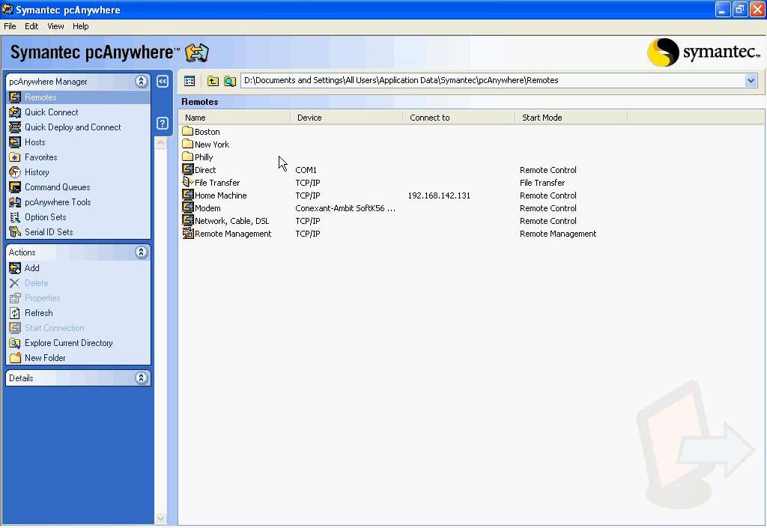

2.2.2 Auditing & Asset management (Rating: 2)
Presently, Altiris has the ability to attain auditing and asset information but in a limited form. Through Altiris’s Asset Management Suite, administrators are able to actively manage the entire asset lifecycle. [10]In addition, the suite helps organizations eliminate unnecessary software and hardware costs. As far as auditing is concerned, Altiris does not currently offer an auditing solution. Below is a screenshot of Altiris asset management console.
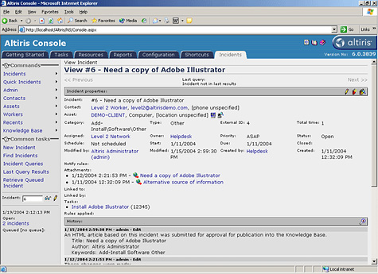
2.2.3 Monitoring ( Rating: 3)
As part of Altiris Total Management Suite, Altiris has a tool to address monitoring of systems. This suite ensures server and client machines are kept up and running by proactively monitoring the health of these machines. [11]Additionally, administrators can configure Total Management Suite to send alerts given defined events. Below is a screenshot of Altiris performance monitor and alerting console.
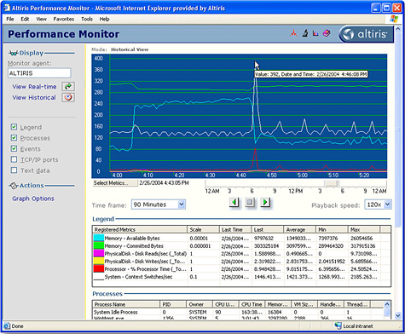
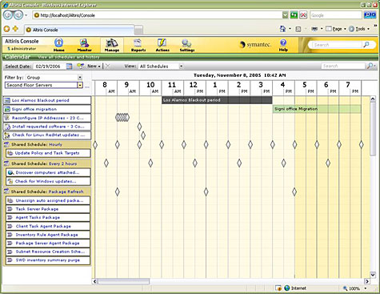

2.2.4 Patch Management (Rating: 4)
With Client Management Suite, you can deploy and update software to any computer in the organization through targeted policy based deployments. This helps ensure clients have the latest software and operating system updates. Patch management can be controlled by the administrators or updates can be requested by end users via a self service portal. [12]Updates can be assigned to groups, locations, or departments. Below are screenshots showing the concepts of deploying updates with Client Management Suite and requesting software via the end user portal.
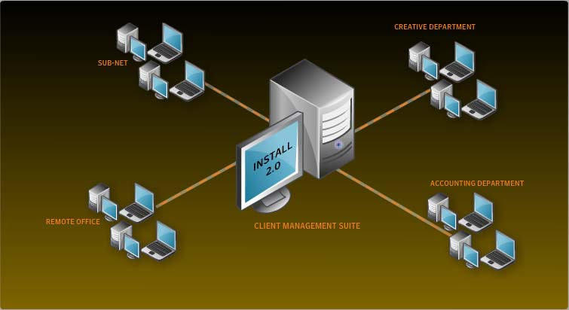
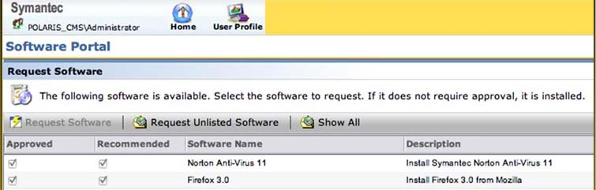
2.2.5 Backup & Disaster Recovery (Rating: 4)
Because Altiris is a subsidiary of Symantec, Altiris offers an add-on to its Total Management Suite for the purpose of backup and disaster recovery. This add-on uses and integrates Symantec Backup Exec System (BES) into Altiris Total Management Suite. Symantec Backup Exec System is considered by many in the IT industry as the standard in backup and disaster recovery. BES allows administrators to restore complete Windows desktop/laptops in minutes, even to dissimilar hardware or virtual environments. [13]Furthermore, BES has new functionality to automate physical to virtual conversions for immediate system recovery. With BES administrators can create real-time, while-you-work recovery points of the entire system and save to any disk-storage device. [13]Moreover, Client Management Suite can also incorporate Symantec Ghost Solution Suite technology. So imaging and deployment of operating systems can also be implemented. Below is a screenshot of BES scheduling that shows the status of the backups.
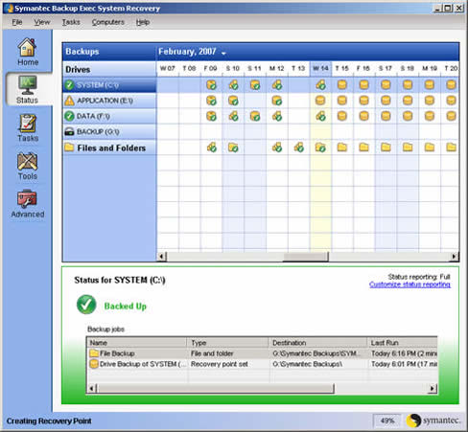

2.2.6 Endpoint Security (Rating: 3)
Altiris offers an add-on to its Total Management Suite for the purpose of endpoint security. This add-on uses and integrates Symantec Endpoint Protection (SEP) into Altiris Total Management Suite. Symantec Endpoint Protection has several security features that will help keep you network safe and secure. Here are several features: [14]
  - Seamlessly integrates essential technologies such as antivirus, antispyware, firewall, intrusion prevention, and device and application control.
  - Requires only a single agent that is managed by a single management console.
  - Provides unmatched endpoint protection from the market leader in endpoint security.
  - Enables instant NAC upgrade without additional software deployment for each endpoint.
SEP stops malware such as viruses, worms, Trojans, spyware, adware, bots, zero-day threats and root kits. [14]Below is a screenshot of network settings in SEP.
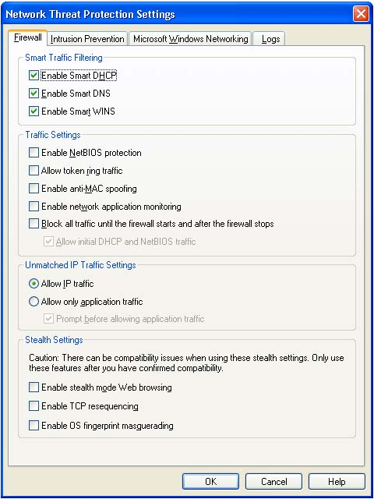

2.2.7 HelpDesk (Rating: 3)
Altiris Helpdesk Solution is a powerful incident management tool that allows you to ensure availability and raise service levels while reducing costs. Some key benefits are as follows: [15]
- Complete incident management and resolution capabilities right out of the box
- Web reports ensure quality of service and efficient IT operations
- Easy to install, implement and maintain
- Conforms to common IT standards for security, manageability, scalability and usability
- Built-in workflow to automatically assign and escalate tickets to the proper Helpdesk technicians
- Reports provide dashboard of information, including incidents assigned to or owned by you.
- Integrated server and site monitoring
- Integrates easily with other data sources, including Microsoft Active Directory and Systems Management Server
Below is a screenshot showing a service request.
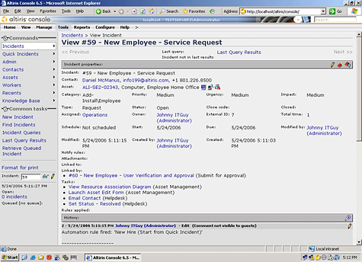

2.2.8 Usability (Rating: 3)
Administrators familiar with Symantec products should find the learning curve for Altiris Total Management Suite to be very minimal. Symantec has been improving cohesiveness between Symantec and Altiris solutions. However on the flip side, administrators unfamiliar with using Symantec products may require some time learning and configuring Altiris. The look and feel of the user interface is very inviting and friendly with its use of pictures and wizards. Nevertheless, the interface cannot be altered in any way and at times some settings can be hidden under many sub menus.

2.2.9 Reliability (Rating: 4)
Dependability of Altiris is quite high since they are owned by Symantec which means Altiris products will have great support for the foreseeable future. Altiris’s web based interface is efficient, stable, and highly available. Total Management Suite integration with heavily utilized IT products such as Symantec Endpoint Protection and Symantec Backup Exec System make it a vastly reliable IT automation solution.
2.2.10 Performance (Rating: 3)
Performance is on par with other IT automation solutions.
2.2.11 Supportability (Rating: 5)
Altiris solutions have support for practically every operating system. Altiris supports Windows 95 or later and many Unix/Linux platforms such as AIX, HP-UX, Red Hat Enterprise Linux, and SUSE Linux Enterprise Server. [8] Symantec offers two packages in terms of support. The first package is basic support. Basic support consists of full support but only Monday through Friday during normal business hours. The second package is essential support. Essential support defers from basic support in that Symantec provides full support twenty four hours a day / seven days a week. Symantec charges $210 per node for basic support and $220 per node for essential support.

Altiris Acknowledgements: The Altiris screenshots shown in section two were taken from Symantec’s website and the exact links can be found in the references section of this document. I would like to thank Derek Allred. Derek is a Symantec sales representative who covers our region. Derek provided me with some valuable input towards my research and directed me to trial versions of Altiris software.

