System Design Document for IT
Management & Automation of Ruben Dario
Middle School

Group # 4
Rafael Diaz
Eric Enriquez
Suylleng Padilla
Sandor Rodriguez (Team Manager)

Advisor:
Dr. S. Masoud Sadjadi
School of Computing and Information Sciences
Florida International University

Contact Information: sadjadi@cs.fiu.edu,
More information: http://www.cs.fiu.edu/~sadjadi

April 22, 2009

1 Introduction
Ruben Dario is a middle school that is suffering from the lack of an automated system that can manage and control the whole system, and at the same time needs to make it more accessible to the staff. The middle school suffers from vulnerability of the system against intruders; in the same manner backups have also been a problem for the school, backups have been lost due to down servers and lack of a monitoring system. Moreover, almost all the computers in the middle school have not received updates since they were first installed. In this document we will evaluate four different IT solutions (N-able, Track It, Level Platforms and Microsoft System Management Server [SMS]) and compare them to come up with the most suitable solution for the middle school.

1.1 Purpose
The purpose of the system design document (SDD) is to evaluate different IT solutions available nowadays, and come up with the most suitable solution for the client, in this case being Ruben Dario Middle School.

1.2 Audience
This System Design Document is made for the following audience: the Project Manager who makes sure everyone is on task working on their areas, three IT managers that provide inside information into the design and the working face of the system, and one Advisor who provide ideas and on how the system should be and what should it do depending on the problems that it needs to solve.

1.3 Design Goals
The goals of this design is to provide Ruben Dario Middle School with a system that automates features like monitoring, backups, patch management, audit & asset management, security, remote control and help desk. The monitoring goal is to enable administrators to easily evaluate all operations going on specific machines and be able to anticipate machines problems. Backups’ goal is to enable professors and staff to confidently save important information and have easy accessibility to it. The objective of patches is to maintain computers up to date so teachers don’t have to lose time during classes for updates. Asset management’s goal is to enable administrators find out easily what is inside every machines and also keep them alert about software licenses and warranties. Provide a better level of security and maintaining all computers secured with antivirus and making sure their definitions are updated. The remote control‘s goal is to allow administrator assist teachers in case of problems so there would not be a need for physical visits. The main goal of the help desk is to provide the middle school with a system that would assist them in case of any problem.

2 Overview and Comparison of IT Management and Automation Solutions/Tools
Ruben Dario Middle School currently does not have any automated system that manages all the networking and computing system of the middle school. In this paper we will discuss four IT solutions (N-able, Track It, Level Platforms and Microsoft System Management Server [SMS]), and evaluate which one will best suit the middle school.

2.1 N-able (Sandor)
Background:
N-able Technologies was founded in March, 2000 on Ontario, Canada. The company is one of the leading providers, providing different clients with the service of managing their system remotely by providing Security, Backup, Patch Management, Monitoring, and Helpdesk among other things. The company has more than 1,300 partners around the world, which means they are providing their services to 36,000 customers. [SR1]

2.1.1 Functional Coverage
2.1.1.1 Remote Control
N-able remote control enables the technicians to fix any problem quickly before the problem gets worse. The remote control is fast and allows the technicians to get access to the customer’s machine from anywhere in the world and allow them to troubleshoot any type of problems and fix them most of the time without going to the customers location. “N-central is a tool that N-able contains that lets anyone remotely control any Windows-base device (2000/2003/NT/XP), and this doesn’t depend on open external ports or VPNs, increasing the efficiency of technicians’ work and lowers the operational costs.” [SR2]

2.1.1.2 Auditing & Asset Management
Auditing & Asset Management is not provided in N-able.

2.1.1.3 Monitoring
In monitoring N-able offers almost all the same functions and tools as other software solutions by having similar features like automatic device discovery, auto deployment, and monitor with agents and proves. The only thing is that that N-able doesn’t have a well-balanced user friendly graphical interface. N-able’s GUI is not straightforward; in order to find monitoring features, the user has to spend some time to discover them.

2.1.1.4 Patch Management
N-able provides patch management by connecting directly to the WSUS server and automatically creating a WSUS computer group for each customer monitored, reducing the amount of time it takes to set up and configure WSUS. You can then monitor and report on patch levels for those devices, and set up alerts for machines that are falling behind. N-able is simple software that is not as user friendly as other solutions in the market. [SR3]

2.1.1.5 Back Up & Disaster Recovery
Backup is not provided in N-able.

2.1.1.6 End Point Security
End point Security is not provided in this software.

2.1.1.7 Help Desk
Help Desk is found on N-able. It offers great Help Desk features, providing online chatting, remote control, voice and video communications. N-able has something that other solutions might not have which is a Multi-platform support which include Windows, Linux, Mac and multiple mobile devices. At the moment N-able doesn’t offer a ticketing system but if the customer has one, it could be send to N-able to be integrated with the system.

2.1.2 Non-functionalities
2.1.2.1 Usability
N-able is not as user friendly as other IT software solutions because the person using it has to go through a lot of steps to accomplish a simple task. The software menu is not easy on the eyes because the user has to go to different places to do a task and the functions are not upfront on the menu.

2.1.2.2 Reliability
The system is reliable to be used to improve network performance and increase productivity through the continuous monitoring, management and optimization of IP-enabled devices and IT infrastructure.

2.1.2.3 Performance
N-able is able to remotely control any IP-enabled device as well as any device integrated with Intel vPro and instant remote monitoring. The setup and rollout time takes only minutes, when while ago used to take hours.

2.1.2.4 Supportability
N-able is able to support Windows 95 to Vista, Mac OS X, Novell, SUSE, and Redhat Linux.

Table:

IT Solutions | N-able
Remote Control | - Control any Windows-based device (2000/2003/NT/XP)  - Increases technician utilization rates by reducing on site management. Seamlessly integrated remote control solution that doesn't rely on open external ports or VPNs.
Audit & Asset Management | - Not Provided.
Monitoring | - Monitors from Workstations and Servers to almost any IP enable device.  - Industry standard protocol supported: (SNMP, Log file analysis, TCP/IP, WMI, Syslog/SNMP Traps, ODBC, and EDF.  OS Monitoring:  - Windows 95 to Vista  - Mac OS X, Novell, SUSE and RedHat Linux.
Patch Management | - Uses WSUS (Windows Server Update Services) Cost-effective patch management.
Back Up Disaster Recovery | - Not Provided.
End Point Security | - Not Provided.
Help Desk & Ticketing | - Offer a great service by having a good help desk which could answer and clear any questions that any customer could have.  - Currently there is no integrated ticketing system, however if the customer has one, it could be integrate via email.  - Powerful and easy-to-use chat  - Drawing tools  - Sound alerts  - Voice and video communications

Screenshots:

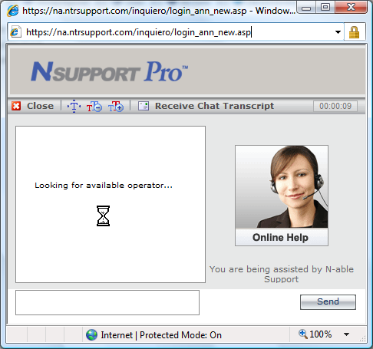
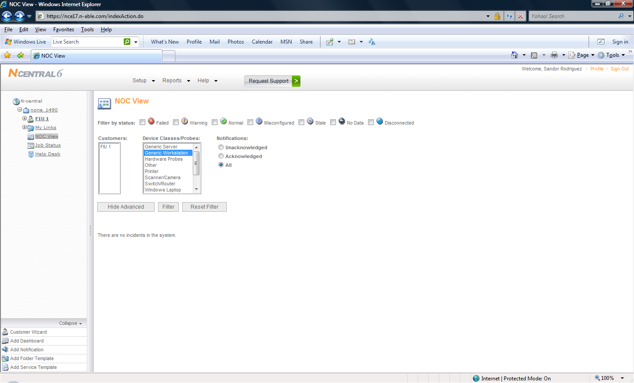

2.2 Track It (Eric)
Background:
Numara Software was founded in 1991 as Blue Ocean Software. The company’s main focus was the Help Desk and gained a lot of popularity in the business market for its automated features. In 2002 was acquired by a company named Intuit. The company was then known as Intuit IT Solutions, and kept its focus on help desk but were starting to broad their solutions offered; they started adding asset management, software for patch & deployment and network monitoring features. In December of 2005, the company was renamed; its new name was Numara Software. [E1]

2.2.1 Functional Coverage
2.2.1.1 Remote Control
Track It provides high security levels. Track It uses Advanced Encryption Standard (AES) with key lengths up to 256 bits. Track it offers Collaborative Problem Solving where different technicians can work on the same remotely connected computer, while one can control the mouse another can control the keyboard. Track It offers support for webcam video. Track It uses TCP (IPv4 and IPv6) and UDP including Dial-up networking, IPX, NetBIOS, Windows modem, Serial modem, ISDN CAPI, Infrared and Terminal Server [E2]. Track It provides also a scripting feature where you can schedule file transfers or other actions.

2.2.1.2 Auditing & Asset Management
Track It uses asset discovery to find out all devices and PCs in the network. This system provides users with information about software, licenses, CPUs, memories, etc. Track IT offers options to select a specific IP address range to scan for new devices. Track IT uses the Selectable Client Update feature that allows you to choose which machines are going to get agents. Track It also provides “What-if” Planning Tools, templates and specific wizards for hardware and software [E3].

2.2.1.3 Monitoring
In the monitoring area Track IT provides different options depending on the needs of the business (Network Monitor Standard and Network Monitor Professional). The Professional version provides the use of Visual Basics scripts to manage and reporting Web traffic. Track It provides SNMP support. Track It uses Auto discovery Wizard to discover new devices in the network. It uses The Performance Counter Engine (similar to Perfmon in windows), and uses Event Log Monitor to distribute agents to targeted machines [E4]. Track It offers a wide range of pre-configured scripts where you can select the objects and counters and select your own thresholds to assign to the machines and take specifics actions if the thresholds are reached.

2.2.1.4 Patch Management
Track It offers agentless support, making deployment of patches quicker and simpler. Track It offers the creation of patch groups where you can select specific patches and assign them to specific operating systems. It offers patches to Microsoft operating systems, such as x64, XP and Windows Vista, as well as older Microsoft systems and applications, such as Windows NT 4 and Office 2000. It also offers a wider range of extensions (HTML, XML, PDF, RTF, TSV, TXT, TIF or XLS) to export reports [E5].

2.2.1.5 Back Up & Disaster Recovery
As of now this feature is not being implemented by Track It.

2.2.1.6 End Point Security
End point security is not offered at this time by Numara Software.

2.2.1.7 Help Desk
Help Desk & Ticketing support is the strongest feature in Track It. Track It presents a really user friendly interface like Google search engine with support of full text search capability of work orders, assets, knowledgebase [E6]. Track It offers Email Request Management engine that allows administrator to design a workflow for emails request that are sent to the help desk.

2.2.2 Non-functionalities
2.2.2.1 Usability
Track It offers a very friendly user interface. The user interface has the look and feel of Microsoft Outlook, hence enabling users to quickly get acquainted with the program [E6]. The system also enables the user to customize the UI to adopt the way the user likes to work.

2.2.2.2 Reliability
Track It is a very reliable system. With the use of the feature Asset Tracking Template, tracking and managing asset is very reliable; anything with an IP address can be discovered. In the same manner, it allows administrators to have software and hardware categorized by Approved, Permitted, Prohibit, Unidentified, and Alert. Track It provides a web interface option that if enabled allows administrators to fix issues when they are away from their workplace.

2.2.2.3 Performance
Track It runs very smoothly on systems. The new version of Track It 8.5 reduced server memory consumption by 87%, by reducing the number of server’s services. The program itself has become a lot faster because the company incorporated 8 different core services into 1 governing service. [E7]

2.2.2.4 Supportability
Track It offers support for the following audited platforms: Windows 2003 32 and 64 bit Servers, Windows 2000 32-bit Server and Advanced Server, Windows Vista, Windows XP, Windows 2000 32-bit with SP4, Windows NT4 Spa, Windows ME, Windows 98SE, Mac® 10.5.2, Mac 10.4.8, Mac 10.3.9, Mac 10.2.8, Mac 10.1.5, Mac 9.2.8[E8].

Table:
IT Solutions | Numara Software (Track It)
Remote Control | - Complete Control of user’s mouse & keyboard.  - Advanced Encryption Standard (AES).Key lengths up to 256 bits.  - Stores user screen activities in a file for later replay.
Audit & Asset Management | - PCs and servers, network printers and switches.  - Personally-owned IT gadgets such as PDAs and USB sticks.  - “What-if” Planning Tools including built-in templates to run queries, and hardware and software wizards.
Monitoring | - Use Auto Discovery Wizard to quickly and easily discover your network objects and populate your map.  - Use the Performance Counter Engine (similar to a PerfMon native in Microsoft operating systems).  - Select from a wide range of pre-configured scripts to look at specific aspects of a given service.
Patch Management | - Agentless Support.  - Create patch groups to automatically update certain types of patches.  - Microsoft Operating Systems, such as x64, XP and Windows Vista, as well as older Microsoft systems and applications, such as Windows NT 4 and Office 2000.
Back Up Disaster Recovery | - Not Provided
End Point Security | - Not Provided
Help Desk & Ticketing | - Quickly and accurately log tickets in support of password reset and new hire tasks with the work order templates.  - Pre-populates repetitive work orders quickly and easily.  - "Google™-like" search engine. With support of full text search capability of work orders, assets, knowledgebase.

Screenshots:

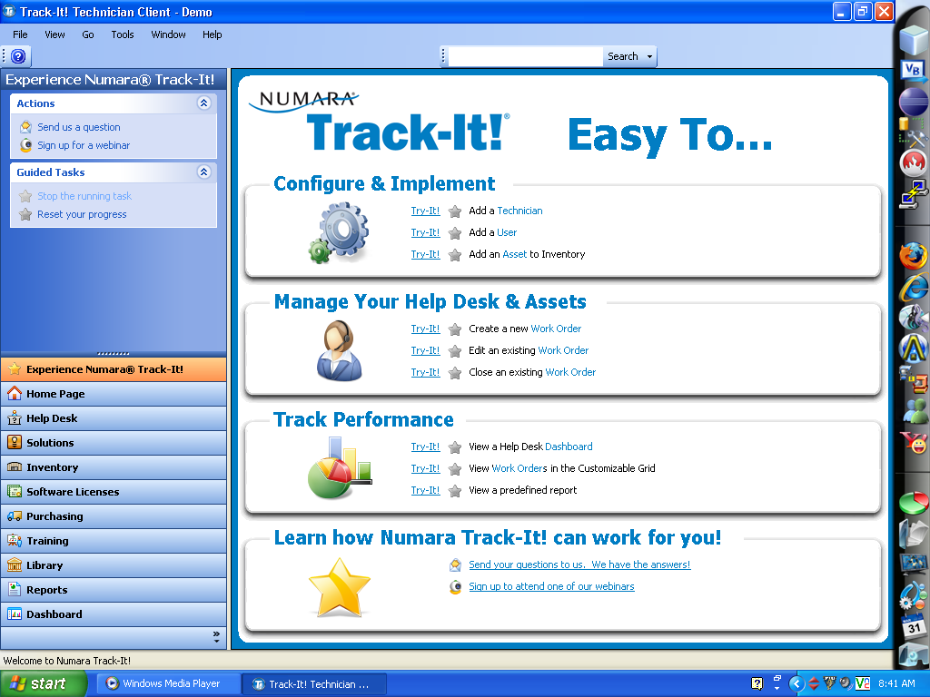

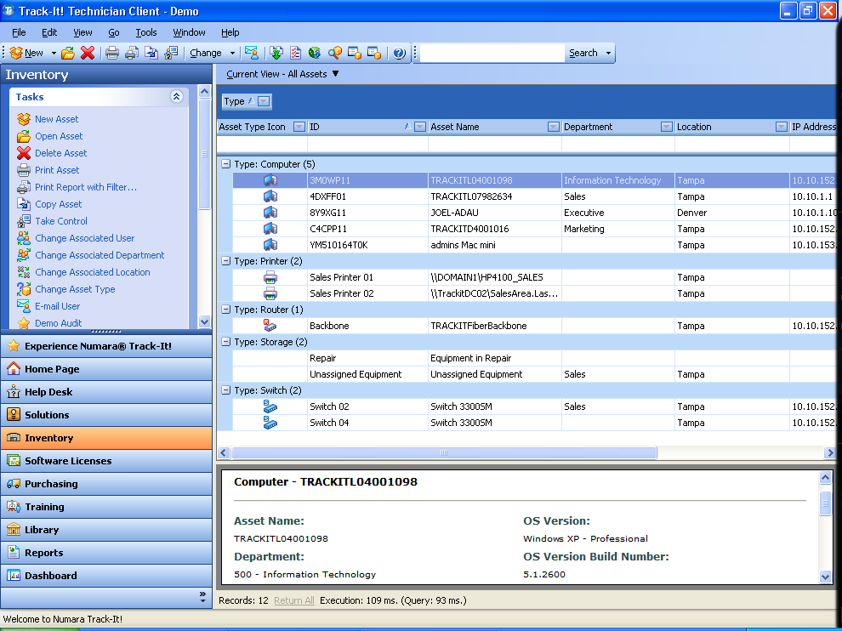

2.3 Level Platforms (Suylleng)
Background:
Level Platforms was founded on 1999 by Peter Sandiford who is actually the CEO of the company. Pete was convinced that small businesses needed a “level platform” to distribute IT at the same cost and same quality as larger enterprises have accomplished [SP1]. Level Platform is associated with ASCII, CompTIA, IAMCP, ITA, MSPAlliance, MSP Partners, PartnerPoints, The Professional Computing Association, and Microsoft System Center. “Managed Workplace 2009 is the next evolution of the award-winning remote monitoring and management (RMM) platform.” [SP2]

2.3.1 Functional Coverage
2.3.1.1 Remote Control
The remote control in this solution saves time and increases efficiency because it has an integrated VNC solution that automatically pushes the client to the remote machine.

2.3.1.2 Auditing & Asset Management
“The asset inventory is collected at regular user-defined intervals and ensures that both the managed service provider and their customers always have access to up-to-date asset inventory information.” [SP3]
2.3.1.3 Monitoring
It provides monitoring for devices, services, software and websites. It offers strong and reliable remote monitoring systems. Managed Workplace allows you to become proactive and eliminate problems before they occur. Integrated monitoring and alerting against Managed Workplace features are highly configurable to suit your needs including customizable alerts, alert categories, views and groups. Managed Workplace has a robust notification engine to keep technicians informed when problems are identified in an environment. The alerting engine is closely tied to the monitoring engine. The high configurability that this solution provides allows you to modify it to meet your needs. [SP4]

2.3.1.4 Patch Management
Manage Workplace, which is a registered trademark of LPI Level Platforms Inc, helps you practically defend against outdated software versions and network threats by providing fast and reliable patching capabilities on workstations and servers. Simplified per customer view and automatic patch scanning, identity and deployment are offered to administrators by the Patch Management functionality. This product works on any Windows operating system and/or Microsoft based application. [SP]

2.3.1.5 Back Up & Disaster Recovery
Level Platform has an ecosystem of integration with backup and recovery among other features. It supports major operating systems, applications, servers, PCs, network and security devices, VoIP, backup and recovery and more. [SP]

2.3.1.6 End Point Security
As of now, Level Platform does not provide endpoint security feature.

2.3.1.7 Help Desk
The alerting and monitoring engine from the Managed Workplace software is provided with an integrated trouble ticketing system attached to it granting for instant productivity and helping provide a single source to manage systems.

2.3.2 Non-functionalities
2.3.2.1 Usability
The system has the ability to easily create and deploy custom scripts; “Managed Workplace offers unlimited capability to automate your managed services operations.” [SP5] Scripts can be deployed remotely via an interactive interface or through scheduling. [SP5.1]

2.3.2.2 Reliability
There is a strong and reliable remote monitoring provided through Managed Workplace, which allows you to become proactive and eliminate problems before they occur. It’s capable of getting warranty expiration dates by running sites and device specific reports. “Identify network equipment with expired warranties which should be covered under revenue generating maintenance contracts.” [SP6]

2.3.2.3 Performance
Managed Workplace is a high performance, scalable and easy to use platform. Fast connections to any Windows and/or network device at any customer’s site are offered for this system from any computer with an Internet connection. Abilities to perform remote monitoring and management are provided by Out-of-band management for when the computers and devices are normally off. The enhanced Remote Control gives real-time remote Power control.

2.3.2.4 Supportability
The system is supported by any Windows operating system or Microsoft based application. [SP]

Table:
IT Solutions | Level Platforms
Remote Control | - Level Platforms Software provides integrated support for multiple remote control solutions (including RDP, VNC, Telnet, PuTTY and SSH)  - Integrated VNC solution that automatically pushes the client to the remote machine saving you time.
Audit & Asset Management | - Collected at regular user-defined.  - Ensures that both the managed service provider and their customers always have access to up-to-date asset inventory information.
Monitoring | - Level Platforms Software provides unique features such as Service Grouping.  - Extensible alert rules and thresholds that provide optimum flexibility and ease of use.  - Performance and availability monitoring for devices, services, software and websites. Integrated monitoring and alerting against Managed Workplace features  - Highly configurable to suit your needs including customizable alerts, alert categories, views and groups.
Patch Management | - Managed Workplace uses extensive automated patching capabilities for Microsoft systems and software based on Windows Software Update Services (WSUS).  - Achieve LAN speed patch deployment.  - Configures patches for automated deployment or prior approval.  - Automation of discovery, deployment and patch approvals with manual override capabilities.
Back Up Disaster Recovery | - Level Platform has an ecosystem Integration with backup and recovery among other features.  - Major operating systems, applications, servers, PCs, network and security devices, VoIP, backup and recovery and more.
End Point Security | - Not Provided.
Help Desk & Ticketing | - Managed Workplace includes an integrated trouble ticket system.  - Like other features, the trouble ticket system is also included in the reporting engine for advanced cross management analysis, post-incident management and trending.

Screenshots:
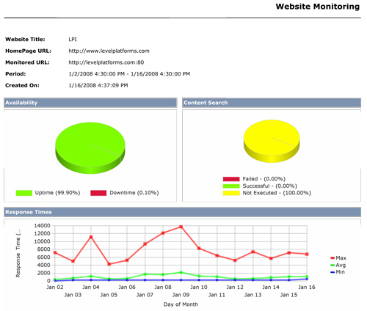

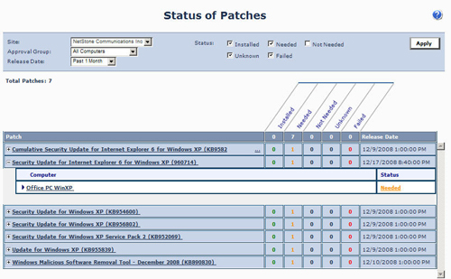

2.4 Microsoft SMS (Rafael)
Background:
The company behind Microsoft SMS as the name says is Microsoft. The company was founded by Bill Gates around 1975. Microsoft owns many products that they have developed along all the years of work. This company has helped many companies grow; improve the quality and the speed of the business. One of the tools is SMS Configuration Manager that provides remote control, patch management, software distribution, operating system deployment, and hardware and software inventory. The history behind SMS Software and the different versions since it was made in 1994 goes as follow. [R1]

“1994 — Microsoft Systems Management Server 1.0
1995 — Microsoft Systems Management Server 1.1
1996 — Microsoft Systems Management Server 1.2
1999 — Microsoft Systems Management Server 2.0
2003 — Microsoft Systems Management Server 2003
2006 — Microsoft Systems Management Server 2003 R2
2007 — Microsoft System Center Configuration Manager 2007
2008 — Microsoft System Center Configuration Manager 2007 SP1
2008 — Microsoft System Center Configuration Manager 2007 R2” [R1]

2.4.1 Functional Coverage
2.4.1.1 Remote Control
Microsoft SMS offers remote control. That is a feature that is really needed by all system administrators and also by all computer technicians. This system offers a unique remote access console that allows the user to connect to any machine at any time with an internet connection. It allows file transfer and all the full functionalities of an operating system when connected remotely. Microsoft SMS remote connections are called Windows XP remote Assistance, it gives full access to the customer pc or any pc we need to access but the customer needs to be present for the connection to take place. [R2]

2.4.1.2 Auditing & Asset Management
Microsoft SMS offers a tool called Usability that audits the advertisements, reports, queries, and over hundreds of other accessibility to accommodate many industries and companies. It includes a utility called Performance that improves when an inventory is performed by taking out the windows directory during the inventory software scans. This system will also control the bandwidth utilization by specifying the desired data size packages also by using pulse mode to define the time between packages when sending data between sites. They also improved the client inventory performance that helps minimize the user interruption during hardware scans. [R2]

2.4.1.3 Monitoring
Asset Management for application usage and monitoring is widely offered by Microsoft SMS. Monitoring tools included in the system will help with just about anything that is needed to keep up with any pc changes and software updates. Also it includes antivirus and other software related protections and issues. In addition, Microsoft SMS offer a system called Inventory Tool for Customer Updates, this tool offers an Integrated Scanner that checks software updates. Then it has a Publishing Tool that will make a catalog with all the necessary updates then the system will use them as needed. This could be for windows updates or any other software that the customer requires. This monitoring tool makes detailed reports and summaries for the applications used by users. The report will include how long they were in use and on which managed system they were used. [R2]

2.4.1.4 Patch Management
Patch management is one of the main characteristics that SMS offers. Microsoft offers many solutions to track changes in systems, which will be fixed thru patches. One of the main tools offered is the Vulnerability Identification which is a Microsoft security tool. It uses Microsoft Baseline Security Inventory Analyzer and the Office inventory tool for updates which enables the administrator to inventory the system for patches and vulnerabilities. This patch can also be located in a main server or data base to be used in the future when needed. Microsoft SMS has a Patch deployment wizard that allows administrators to easily deploy patches once they have been recognized by the system. The vulnerability identification is the one that finds those missing patches and then they are loaded as needed. [R2]

2.4.1.5 Back Up & Disaster Recovery
Backups can be done to the systems and also for user files, emails and other data of interest. In the Microsoft SMS system there was no specific mentioned backup tool. This could be beneficial so changes could be rolled back and data would never be altered. In this case backups are mostly done by the actual servers and users but it will be nice to have an automatic system that can do this even to a remote location before a disaster occurs. [R2]

2.4.1.6 End Point Security
Microsoft offers an Advanced Security Mode that consists on Active Directory-based site boundaries, this are site boundaries that can be based on Active Directory site names, rather than on Internet Protocol subnets. Also it offers the previously mentioned Security Mode which is built into the computer and local system accounts that can be used for all server functions (such as database access), dramatically simplifying the management of accounts and passwords within SMS 2003 and making the enterprise more secure by not creating extra high-rights accounts. [R2]

2.4.1.7 Help Desk
When using Microsoft SMS, help desk can be easily provided. Ticketing is widely used. Help desk offers some customer support and ticketing to make the reports and charts, to show clients what we have done it on the systems so we can charge the work. Those tickets are really efficient and summarize every work that has been done to a specific system. Then Microsoft SMS uses a utility called Usability that makes charts and reports for many companies, institutions and even the government. [R2]

2.4.2 Non-functionalities
2.4.2.1 Usability
Categorize queries, packages, advertisements, reports, and software metering rules easily with the addition of folders in the Administrator Console, also with the addition of over 100 accessibility changes to meet the needs of government and private industry. [R2]

2.4.2.2 Reliability
Microsoft SMS barely goes down. The company behind it is Microsoft who has 24 hour services and is always available to respond and help also act in a moment of disaster. Most important the company that will provide the services will also be there in case of any abnormality. [R2]

2.4.2.3 Performance
They improved client inventory performance to minimize user interruption during hardware inventory scans. In addition they also improved inventory performance by excluding the Windows Directory during software inventory scans. Among other making the SMS interface is faster and more reliable. [R2]

2.4.2.4 Supportability
Supported Operating Systems: Windows 2003 SP1, Windows 2003 R2, and Windows XP SP2 [R2]

Table:

IT Solutions | Microsoft SMS
Remote Control | - Full remote control (Windows XP remote assistant)
Audit & Asset Management | - Usability tool.
Monitoring | - Inventory Tool for Customer Updates  - Page File  - Backup  - Hardware changes
Patch Management | - Security Patch management  - Schedule Updates & Scans  - Weekly basis  - All approved
Back Up Disaster Recovery | - Not Provided
End Point Security | - Configuration Changes utility Spyware  - Antivirus, Worms, Trojans, etc.  - E-mail Protection
Help Desk & Ticketing | - Uses an Usability tool

Screenshots:
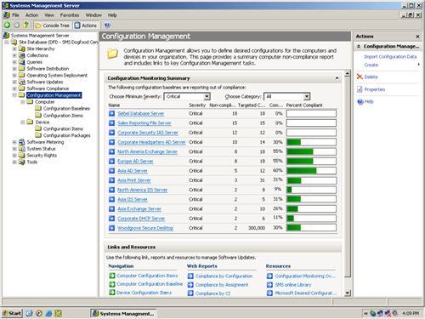

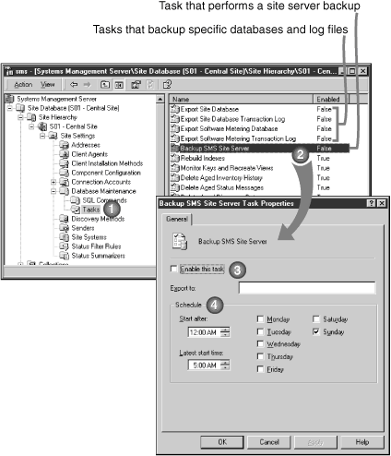

2.5 Kaseya
Background
Kaseya was formed when specialist in networking, security and desktop help management came together to develop a solution that put together knowledge of customer’s problems and the managing of networks with the required security. Kaseya’s target is the mid size business market. They offer Kaseya IT Automation Framework, which is a web - based platform. This model remotely manages computers, data, and environments for mid size companies.

2.5.1 Functional Coverage
2.5.1.1 Remote Control (Sulleng)
Kaseya provides easy, secure, and fast remote control management to all your managed computers from anywhere. Administrators have complete control over remote control functions including passwords, notification method, screen mode and control level. Administrators also have the ability to manage remote computers that are not part of their managed infrastructure thru video streaming and can also utilize the video streaming feature for training sessions or to a handle a quick support call. There is a secure online Chat that can be used exclusively between the end users and support personnel. Secure Broadcast Messaging is also provided to the agented computers from administrators. Kaseya's remote control software is easy to deploy and it can be done in minutes. It can be accessed from anywhere and does not require special servers or reconfiguration of you existing computing infrastructure. The Kaseya Web based, integrated IT application delivers a complete, fast and secure remote access and pc remote control solution for you and your users even behind firewalls and NAT. [SP7].

2.5.1.2 Auditing & Asset Management (Eric)
Kaseya provides automated audits to all machines (servers, machines, remote computers) that you have in a network. Since Kaseya is a web-based system, it allows you to view the content of any computer’s hardware and software information at any given time from anywhere in the world. Kaseya even allows you to find devices that are behind NAT and Firewalls [E9]. Kaseya provides you with pinpoint failures classified by manufacturer and model. It’s very easy to learn and has a friendly user interface. Kaseya provides information regarding licenses of software installed, memory information, and allow you to create comprehensive and inventory reports.

2.5.1.3 Monitoring (Eric)
Kaseya provides an impressive monitoring system. It also provides SNMP monitoring. Kaseya lets you monitor the Windows event log and customize alerts whenever a pre-configured object reaches a specific threshold. Kaseya has a LAN Watch feature that will allow the user to discover machines and devices connected in the network; it also allows the user to set a specific range of IP addresses to scan. LAN Monitoring Alerts allow users to know whenever a new device is detected. Kaseya also has a Live Connect feature that shows you in real time performance information about objects. Kaseya let the user use or create monitor sets and then assign to specific machines. Moreover, it enables the user to run scripts when certain condition happens. Kaseya’s monitoring system is very easy to use and user friendly [E10].

2.5.1.4 Patch Management (Sandor)
The kaseya patch Management offers a rapid deployment that reduces the amount of time need it to accomplish tasks, is very user friendly by having all the different functions that it offer upfront and easy to find in the menu, and automatically discovers and deploy patches quickly and efficiently.

2.5.1.5 Back Up & Disaster Recovery (Sandor)
The back up and Disaster Recovery offers customers the ability to do Incremental, Forever and Synthetic Full Backups for efficient offsite replication and user-defined archival capabilities, Complete disk Imaging which will transfer the information from one disk to the other in a short time, and also offers universal restores among other things which make a fresh image by scheduling an auto restore, and this minimizes regular maintenance. [SR6]

2.5.1.6 End Point Security (Rafael)
Kaseya has a really good endpoint security design. They will analyze and detect unwanted executable applications that may be spyware, adware etc, and then it will remove these programs or block access to them. Also offers computer security software like an antivirus or spyware system can be scan for suspicious entries specially the system registry also for temporary Internet files and tracking cookies. They offer a centralized managed security profiles that are defined and deployed to the managed computers using the Kaseya console interface as needed. These profiles are mainly used to create better ways to maintain the managed systems always running smoothly, and viruses and spyware free. This Endpoint Security also offers a logger that all information detected is logged within the system and available for administrative summary and thorough management reporting. Kaseya also provides automatically daily schedules for scanning and updating, and allowing the users or system administrators to create custom-scheduled events. [R5]

2.5.1.7 Help Desk (Rafael)
Help desk is one of their main characteristics they will create and track issues in detail. Will offer configurable alerts based on issue creation and update. Complete issue history tracking with user, date and time stamp and support for file attachments and screen shots. They also have configurable online views accessible from anywhere using a standard Web browser Knowledge base. The users have immediate access to support personnel. One of their main characteristics also is that it is secure and limited to the organization with no additional software or network configuration required. They warrantee that any system will be up and running in minutes with easy administration of users and policies. They enface that there are no long training cycles or consultants required. Most importantly they will offer integration for Overall Productivity, flexible Configuration, and comprehensive Reporting. [R6]

2.5.2 Non-functionalities
2.5.2.1 Usability (Suylleng)
Kaseya is easy to deploy and administer. It supports monitoring for processing large log-data across a large number of monitored machines. It's able to simultaneously change multiple tickets on multiple computers. It's also able to format and customize ticket notification emails. It provides ability to schedule a patch scan as part of a custom script.
2.5.2.2 Reliability (Sandor)
Kaseya is very Reliable by being user friendly, by keeping the system administrators informed on how the system is running, by keeping the agents running on the computers to stored data which shows how the system is behaving, and the system is web-base, so it does not have to be downloaded and install in a main location, and important information could be viewed from anywhere.

2.5.2.3 Performance (Eric)
Since Kaseya has a web-based platform, it provides a fast well balanced system. Kaseya’s patented connection algorithms and patented Virtual System Administration (VSA) methods, allow the system to work very smoothly. Agents are very light weighted on the system’s resources. Since there is no need of address management or the need for a VPN connection to all the sites, Kaseya is more efficient [E11].

2.5.2.4 Supportability (Rafael)
The software will install on most Windows based operating system. They offer support for many operating system like Windows NT, 98, Server and any other needed. When it comes to patch management, Kaseya will install patches depending on the required software. Their platform is widely used by many administrators and users around the world, that’s why they have made it so open for different operating systems.

Table:

IT Solutions | Kaseya
Remote Control | - 256 bit RC4 encryption for all sessions.  - Access computers behind gateways NAT without port mapping.  - It uses WinVNC, pcAnywhere, RAdmin and Terminal Server.
Audit & Asset Management | - CPUs, PCI cards, memory and drives with user notes.  - Licenses, version numbers, path and description.  - Local, WAN and gateway IP addresses. DNS, WINS, DHCP, and MAC address.  - CPU, RAM and Disk Volume details.  - Printers, local and network.
Monitoring | - Alert on hardware and software changes. Alert on specific file changes and protection violations.  - Automatically discover all devices on the network.  - Comprehensive Reports.  - Monitor computer online offline status Know if a server goes down.  - Export to HTML, Microsoft Word or Excel.
Patch Management | - Scheduled or ad hoc.  - Identifies which patches are installed and date installed Determines which patches are needed.  - Approve or deny selected patches.  - Support for Windows 2003, 2000 , NT, XP, 98 and 95.  - Security and policy control.
Back Up Disaster Recovery | - Full Back Up.  - Incremental Back Up.  - Last Differential.
End Point Security | - Complete issue history tracking with user, date and time stamp.  - Easily pinpoint hardware and software changes.  - Integrated Online Chat.  - E mail alerts to support personnel based on issue criteria and computer groups.
Help Desk & Ticketing | - Anti-Virus.  - Anti-Spyware.  - Rootk it.

2.6 Comparison and Discussion
In the next section we use a ranking system from 1 to 5, 5 being the highest ranking value. The ranking is based on the system’s performance, usability, supportability, and functionalities themselves. A system is considered to be acceptable when it has an overall ranking of 3.

2.6.1 Evaluating and Discussing [N-able]
The Remote Control of N-able works with all Windows based systems, and is able to increase technician utilization by reducing the on-site management which uses a remote control solution that doesn’t depend on open ports or VPNs. Is able to monitor any device with an IP device and can be used with almost type of operating system, and also is provides more detail information about the status of a device. It uses a WSUS server and automatically creates a WSUS computer group for each customer monitored, reducing the amount of time it takes to set up and configure WSUS. Helpdesk is really good because it contain different ways of providing help to their customers thru online chatting, remote control, voice and video communications. Based on the information above N-able will get a ranking score of 4.

Remote Control  Rating: 4 | I give function a rating of 4 because if works with all windows base systems but not with Linux or other types of systems. Increases technician utilization rates by reducing on site management seamlessly integrated remote control solution that doesn't rely on open external ports or VPNs.
Audit & Asset Mgt  Rating: NA | It’s not offered.
Monitoring  Rating: 5 | IT can monitor any IP enable device, monitors the following operating system: Windows 95 to Vista, Mac OS X, Novell, SUSE and Redhat Linux. It provides more detail data about the status of the device that its monitoring for example whether a device is normal, failed, nearing failure, miss, disconnected, reporting stale data or not reporting data at all, this speeds up the repair time.
Patch Mgt  Rating: 3 | N-able provides patch management by connecting directly to the WSUS server and automatically creates a WSUS computer group for each customer is monitored, reducing the amount of time it takes to set up and configure WSUS. You can then monitor and report on patch levels for those devices, and set up alerts for machines that are falling behind.
Backup & Disaster Recovery  Rating:NA | It’s not offered.
Endpoint Security  Rating: NA | It’s not offered.
HelpDesk  Rating: 5 | It offers a great Help Desk by providing online chatting, remote control, voice and video communications which respond back very quick and they are very efficient in troubleshooting a problem. N-able has Multi-platform support which includes Windows, Linux.
Usability  Rating: 3 | N-able is not as user friendly as other IT software solutions because the person using it has to do a lot of steps to accomplish a specific task. The menu design is not easy on the eyes because the user has to go to different places to do a task and the functions are not upfront on the menu.
Reliability  Rating: 4 | The System is reliable to be use to improve network performance and increase productivity through the continuous monitoring, management and optimization of IP-enabled devices and the IT infrastructure in any type of location.
Performance  Rating: 4 | Nable is able to remote control any type IP-enabled devices as well as any device with integration with Intel vPro and instant remote monitoring. The setup and rollout time takes now minutes instead of taking hours like it used to be.
Supportability  Rating: 4 | Nable is able to work well with almost all operating Systems like Windows 95 to Vista, Mac OS X, Novell, SUSE, and Redhat Linux.

2.6.2 Evaluating and Discussing [Track It]
Track It offers great security in their systems by using Advanced Encryption Standard (AES). This system offers great auditing & asset management, and monitoring features, anything with an IP address would get picked up by the system. Track It offers great bandwidth by diminishing network overhead using bitmap catching. Main weaknesses of Track It include: not supporting end point security and backups. This system is a very efficient automated solution, very easy to learn and really user friendly. Based on this, Track It will get a ranking score of 3 as an overall solution.

Remote Control  Rating: 4 | It does not have strong video capabilities.  It stores screenshot activities so they could then be replay.  It provides AES for security purposes. With key lengths up to 256 bits.
Audit & Asset Mgt  Rating: 5 | It provides a “What if” planning tool that allow the user to behave one way if something is found. Excellent monitoring reports.
Monitoring  Rating: 4 | It provides the Performance Counter Engine that works like perfmon in Windows. It offers a wide range of pre-configured scripts that would work with specifics objects.
Patch Mgt  Rating: 4 | It gives the user options to create patch groups so you can then apply to selected machines.  It offers patch for older windows operating systems like NT, but also offers new x64 based operating systems.
Backup & Disaster Recovery  Rating: NA | It is not offered.
Endpoint Security  Rating: NA | It’s not offered.
HelpDesk  Rating: 5 | It provides a great UI; it has the touch and feel of Microsoft Outlook. It offers Google-like search engine. With support of full text search capability of work orders, assets, knowledgebase.  It pre-populates work orders so the user can easily find orders.
Usability  Rating: 5 | It is an amazingly easy program to learn.  Great color-coding, that allows the user to better find features.  It allows the user to customize the way his workstation looks.
Reliability  Rating: 4 | It offers great reliability; auditing features like Asset Tracking Template make the program very reliable; anything with an IP address will be discovered.  It also provides a web interface that when enabled allows administrators to work from anywhere with just a web browser.
Performance  Rating: 4 | It works very smoothly.  It reduced server consumption by 87%.  It combined 8 server’s services into one.
Supportability  Rating: 4 | It provides support for:  Windows 2003 32 and 64 bit Servers.  Windows NT4 Spa, Windows ME, Windows 98SE.  Mac® from 9.2.8 up to 10.5.2

2.6.3 Evaluating and Discussing [Level Platforms] (Suylleng)
Level Platforms is a very easy to learn and use solution; it offers everything a managed services provider needs to remotely monitor and manage end customers through dashboard. This central dashboard presents integrated performance and security monitoring, availability status, real-time alerting, graphical performance reporting, trouble ticketing, and asset inventory and includes monitoring of local and hosted web sites. There are some things that are not so good about this solution like that many services require on-site access and long-term service contracts. Solution providers also run the risk of failing to provide adequate services by relying on strangers in this marketplace. Another weakness is that it doesn’t provide an endpoint security feature. Because of these reasons Level Platforms will get a ranking score of 4.

Remote Control  Rating: 4 | Level Platforms provides a very good remote control feature. It offers lightning fast connections from any computer with an Internet connection to any Windows or network device at any customer’s site.
Audit & Asset Mgt  Rating: 4 | Ensures that both the managed service provider and their customers always have access to up-to-date asset inventory information.
Monitoring  Rating: 5 | It is mostly known for its monitoring feature. It provides strong and reliable remote monitoring for devices, websites, software, and services to be able to prevent problems before they occur. It’s exceedingly configurable to go with your needs together with customizable alerts, alert categories, views and groups. Optimum flexibility and ease of use are provided with extensible alert rules.
Patch Mgt  Rating: 5 | It helps you practically defend against outdated software versions and network threats. It works on any Windows Operating Systems and/or Microsoft based application.
Backup & Disaster Recovery  Rating:4 | Level Platforms offers the most complete managed services platform available today, allowing solution providers to monitor backup as well as an unparalleled roster of vendor technologies and other IT functions through a single web-based central dashboard.  The combination of Level Platforms and Asigra*, delivers a secure online/offsite backup.
Endpoint Security  Rating: NA | As of now, this feature is not offered by this solution.
HelpDesk  Rating: 4 | Its integrated trouble ticket system provides instant productivity and helps provide a single source to manage your business
Usability  Rating: 4 | Very easy to learn, create, and deploy scripts. Deployment can be done remotely through scheduling. LPI allows solution providers to create and modify any default template.
Reliability  Rating: 4 | Its strong and reliable remote monitoring helps eliminate problems before they occur.
Performance  Rating: 5 | Its enhanced remote control gives real time power control.  High performance, scalable, and easy to use.
Supportability  Rating: 4 | LPI Level Platforms provides support for:  Microsoft HyperV and Virtual Server,  VMware, Citrix XenServer,  Citrix MetaFrame Presentation Server,  and Windows Terminal Server

2.6.4 Evaluating and Discussing [Microsoft SMS]
Microsoft SMS one of the best tools a company could use to maintain and keep track of their servers. That is the down part, only works with servers, any company that has only workstations cannot use the software. A small company that does not require a server to work or keep their files will not be able to install the software. The companies that can use it will have a great opportunity to experiment and use, a software that helps keep track of employees, security, and help desk among others. This is a software that has been developed and perfected along the years and every time they have made it easier to use and install. Companies that do get to implement and work with it have shown an increase in their security and also in their productivity level. Based on this information, Microsoft SMS will have a ranking score of 4.

Remote Control  Rating: 3 | The user needs to be present to make a remote desktop connection.
Audit & Asset Mgt  Rating:4 | Offers a tool called usability that audits the advertisements, reports, queries, and over hundreds of other accessibility.  An utility called performance that improves when an inventory is performed.
Monitoring  Rating: 3 | SMS has some tools included in the system that will help with just about anything that is needed to keep up with any pc changes and software updates. Also offers an Inventory Tool for Customer Updates. Makes detailed reports and summaries for the applications used by users. Report will include how long they were in use and on which managed system they were used.
Patch Mgt  Rating: 5 | Patch management is one of the main characteristics that SMS offers. They offer many solutions to track changes in systems, which will be then fixed thru patches. This patch can also be located in a main server or data base to be used in the future when needed.
Backup & Disaster Recovery  Rating: NA | The servers are the one that do backups. SMS does not make it automatically, but is a feature that can be added or used if the administrator connects remotely and sets it up from windows himself.
Endpoint Security  Rating: 3 | They have an active Directory-based site boundaries, security mode is a built-in computer and local system accounts that can be used for all server functions, dramatically simplifying the management of accounts and passwords within SMS 2003
HelpDesk  Rating: 3 | Some help desk is provided by SMS. Ticketing is widely used. Help desk offers some customer support and ticketing to make the reports and charts to show clients what we have done on the systems so we can charge the work.
Usability  Rating: 3 | SMS groups queries, packages, advertisements, reports, and software metering rules easily with the addition of folders in the Administrator Console. They made some changes to meet the needs of government and private industry.
Reliability  Rating: 4 | This system is really reliable since Help desk can be provided at any time. The PCs need to be online then the rest is simple. 24/ 7 and due to any errors can be contacted by emails.
Performance  Rating: 5 | SMS provided a new and improved client inventory performance to minimize user interruption during hardware inventory scans. They also added and improve inventory performance by excluding the Windows Directory during software inventory scans.
Supportability  Rating: 4 | This software is mainly for windows server the supported Operating Systems: Windows 2003 SP1, Windows 2003 R2, Windows XP SP2.
Remote Control  Rating: 3 | Remote control is not a 5 since the user needs to be present to make a remote desktop connection.

2.6.5 Evaluating and Discussing [Kaseya]
Kaseya offers all the automated features that any company would need in order to have their systems remotely controlled. Kaseya offers a great monitoring system, proving support for SNMP devices. It offers great remote control support using 256 bit RC4 encryption for all sessions; the system can even find computers behind NAT and firewalls. End point security allows user to specify the level of intensity that virus scans will have. It offers audit & asset management that will give not only the assets of the company but it will give comprehensive information about those assets. Providing different types of backups, kaseya has all functions of IT covered. Based on this information Kaseya gets an overall ranking of 4.

Remote Control  Rating: 4 | Provides 256 bit RC4 encryption for all sessions.  It allows user to access computers behind NAT and firewalls.
Audit & Asset Mgt  Rating:5 | Easy access to comprehensive information.  Access to CPUs, PCI cards, memory and drives information  Compound audit reports.
Monitoring  Rating: 5 | Configurable alerts when a hardware or software changes.  LAN alerts when new devices are discovered in the network.  Allows the user to create monitors sets and specify thresholds.
Patch Mgt  Rating: 5 | Allows the user to create policies and select the systems that belong to certain policies.  Allows the user to accept, deny, or have pending patches.  Lets user schedule patch deployment by time or computers groups.
Backup & Disaster Recovery  Rating: 4 | Protects servers, workstations, and laptops.  After a full back, it offers users the choice of just backing up changes.  It allows the user the option to schedule auto recovery mode from any backup.
Endpoint Security  Rating: 4 | Provides protection against viruses, worms, trojans, and rootkits.  Allows the user to select from different levels from virus scans.  Supports Microsoft Outlook, providing complete secure for incoming and outcoming e-mails.
HelpDesk  Rating: 4 | Keeps history with time stamp of problems and their respective solutions.  Easy to configure alerts that are based on issues and updates.  It provides immediate remote control to the user computer directly from the problem view.
Usability  Rating: 5 | Nice upfront features in the menu that allows users to easily access them.  Easily customization of features, policies, interfaces options to match to better suit user’s need.  Easy configuration of agents to deploy them with pre-configured setting for the selected machines.  Does not require special training cycles for users.
Reliability  Rating: 5 | Very reliable server system.  Comprehensive information in real time that allows users to have up to date information.  Kaseya’s web interface is maintained by the patch management feature, where scans are ran every day on the server to keep it up to date.
Performance  Rating: 5 | Fast and secure web-based platform.  The systems uses Kaseya’s patented connections algorithms to obtain great performance, also provides Virtual System Administration methods to better exploit the system.
Supportability  Rating: 4 | Provides support for most windows based operating systems.  New version 4.7 provides support for 64-bit windows operating systems.

Rating Results:

 | N-able | Track It | Level Platforms | Microsoft SMS | Kaseya
Remote Control | 4 | 4 | 4 | 3 | 4
Audit & Asset Management | NA | 5 | 4 | 4 | 5
Monitoring | 5 | 4 | 5 | 3 | 5
Patch Management | 3 | 4 | 5 | 5 | 5
Backup & Disaster Recovery | NA | NA | 4 | NA | 4
Endpoint Security | NA | NA | NA | 4 | 4
HelpDesk | 5 | 5 | 4 | 3 | 4
Usability | 3 | 5 | 4 | 3 | 5
Reliability | 4 | 4 | 4 | 4 | 5
Performance | 4 | 4 | 5 | 5 | 5
Supportability | 4 | 4 | 4 | 4 | 4
Availability | 4 | 4 | 4 | 5 | 5
Price | 5 | 4 | 4 | 3 | 4
Total | 41 | 47 | 51 | 46 | 59

3 Selecting a Solution Tool
Target Organization’s Problem Overview
Ruben Dario Middle School suffers from the lack of an automated system that can manage and control the whole system, and at the same time needs to make it more accessible to the staff. The middle school suffers from vulnerability of the system against intruders; in the same manner backups have also been a problem for the school, backups have been lost due to down servers and lack of a monitoring system. Moreover, computers in the middle school have not received updates since they were first installed.

3.1 Remote Control
3.1.1 N-able
N-able remote control enables the technicians to fix any problem quickly before the problem gets worse. The remote control is fast and allows the technicians to get access to the customer’s machine from anywhere in the world and allow them to troubleshoot any type of problem and fix them most of the time without going to the customers location. Also would allow the teacher’s access to the students’ computers only and the System Administrator would have access to all the machines in the school.

3.1.2 Track It
Track It can offer administrator screenshots that could then be replayed. It also enables administrators to have completely control over keyboard and mouse over remote machines. It also offers a Collaborative problem solving feature that allows multiple administrators to take over a remote machine.

3.1.3 Level Platforms
Level Platforms provide a silent or shared remote session support to adapt specific needs. Level Platforms offers out of the box integrated support for multiple solution remote control including VNC, PuTTY, SSH, Telnet, and RDP. It also facilitates administrators to completely control remote machines allowing them to fix any problems without going to the actual location, just by using a computer with Internet access.

3.1.4 Microsoft SMS
SMS remote control will help the school in case of a system failure to connect to any other work station and try to fix software issues and printing issues, basic stuff that will help the school continuing working without having to send a tech to the field or have the school wait several days. This feature will reduce the down time and is more cost efficient for any company, in this case for the school is really more important because classes need to continue and no program, school program, can fall behind.

3.1.5 Kaseya
Kaseya allows the professors to easily contact the administrator and administrators their end users by using their secure online chat or messaging option on the agent. Administrators can manage and control all managed computers from anywhere where there's a computer with Internet access.
Comparison Table for Remote Control:
 | N-able | Track It | Level Platforms | Microsoft SMS | Kaseya
Remote Control | 5 | 4 | 5 | 3 | 5
Explanation | Controls any windows base device.  Increases technician utilization rates by reducing on site management | Uses Advanced Encryption Standard  Multiple.  Administrators can work on a remotely connected computer.  Low network overhead. | It is the world leader in remote monitoring and management software | Need an static IP. Usually user needs to be present and give permission for the connection to take place. | Easy to use and can be put to work really quick without any type of delayed  Provides of the best securities by using 256 bit RC4 Encryption.

3.2 Auditing & Asset Management
3.2.1 N-able
This function is not offered and so it wouldn’t help solve the school problems in any way.

3.2.2 Track It
The school’s needs regarding audit & asset management are covered by Track It. Track It offers options that allow administrator to select specific range of IP addresses to scan for new devices. Track It offers “What If planning” that could help administrators get information about teacher’s computers, and take specifics actions if any hardware or software in particular is found. Anything with an IP address would be detected by the system, so all printers, routers, switches, servers and machines could be easily discovered and accessed. The system also provides information about the software licenses and when they need to be renewed; the school encountered a problem with a Microsoft Office license that was incorrectly being used, so this kind of problems can be easily avoided by having an automated solution.

3.2.3 Level Platforms
The Managed Workplace comprehensive asset management benefits from automatic discovery of assets at customer sites and accurate information. It optimizes configurations; easily identify obsolete, underutilized and over-stressed assets. It also identifies maintenance information. Audit & asset management covered by Level Platforms will be suitable for Ruben Dario Middle School’s needs.

3.2.4 Microsoft SMS
SMS offers detailed inventory for hardware and software that will help maintain updated all of the school systems. Also, keeps track of any changes made in the machines themselves like hardware and mostly software. Furthermore, it will provide a detailed track and tickets of the school system inventory for software renewals. Will provide administrative tools to make queries and report in case some billing need to be done. It will show in detail users information and changes that they have done to the machines.

3.2.5 Kaseya
Kaseya would offer administrators of the middle school the ability to control everything that there is to manage in regards with hardware and software. In the current system since students have complete access to the computers, they are installing messengers without permissions; also the typing program used by the middle school is being uninstalled from the computers, causing class time to be lost. The school had license problem with Microsoft Office 2003, where many copies were distributed without proper licensing. Kaseya would offer the administrator with information regarding software’s licenses, and when they need to be renewed.

Comparison Table for Audit & Asset Management:

 | N-able | Track It | Level Platforms | Microsoft SMS | Kaseya
Audit & Asset Management | NA | 3 | 3 | 4 | 5
Explanation | It is not Provided. | Work on most platforms.  Great Web Based reports.  Provides information about software licenses, etc. | Appropriate for the middle school not the best solution for it. | Detailed reports for hardware and software.  Easy inventory for the school system. | Gathers information of systems without physically doing it.  Maintains records of all the software installed in the machine and the licenses available.

3.3 Monitoring
3.3.1 N-able
N-able offers great monitoring functions because it’s compatible with all the operating system which means it could be used either for the school computers or for the servers. It provides different functions like automatic device discovery, auto deployment, and monitor with agents and proves that would help to detect if the system needs improvement or problems are present by finding out if the teachers or students computers are running out of space, or they need more RAM capacity because they are using programs which use great amounts of RAM, and also would monitor the Server to check the capacity of the hard drives and would have an alarm that would alert the System Administrator when the Hard Drives reaches a specific capacity like 10% to empty so that way they could put another hard drive and provide more capacity

3.3.2 Track It
Monitoring is a very important aspect of the automation system for the Ruben Dario Middle School. The school needs a system to monitor servers all the time as well as students’ machines. Track It offers basics operational features for the system’s needs. It offers a Performance counter that would monitor servers and students machines as desired. Track It allows the administrator to set up the system in such a way that whenever a threshold is reached an alert would be sent to the system administrators.

3.3.3 Level Platforms
Managed Workplace offers support for the best practices of monitoring and management of everything you will find in any environment. Ruben Dario Middle school strongly needs a monitoring function to help them perform well and to be monitored in case of partial or complete damages. Running out of memory or even deleting essential software or programs can affect the computer performance. To avoid this, the computers for Ruben Dario Middle school have to be frequently monitored.

3.3.4 Microsoft SMS
SMS offers some tools to know and make reports of the user’s time in the systems. Will also control their usage and make sure they do not do anything inappropriate. Microsoft SMS will monitor for system updates as well. In sum will report any change made to the managed system.

3.3.5 Kaseya
Kaseya would allow teachers and administrators to have more control over machines. Currently students have access to add or remove programs without permission; kaseya can alert administrators in case any change happens in the software or hardware. Kaseya would enable administrator to better anticipate problems with computers based on performance; the middle school has had problems with applications like Microsoft Word and Power Point, where these application have failed and kept running in the back hence consuming unnecessary computer’s resources.

Comparison Table for Monitoring:
 | N-able | Track It | Level Platforms | Microsoft SMS | Kaseya
Monitoring | 5 | 4 | 5 | 3 | 5
Explanation | It monitors all devices from a workstation to a server.  Works with all the following OS:  Windows 95 to Vista ,Mac OS X  Novell,SUSE and Redhat Linux. | Provides Performance Counter Engine.  Easy to use interface.  Allows the user to customize his environment.  Supports SNMP v1 and V2. | Level Platforms is the leader in remote monitoring and management software. | Tracks user time in the system and what they have done. Also will make sure for updates and monitors every system separate. | Monitor all types of event and maintains logs of errors and security events  Easy to use and doesn’t require long training.
3.4 Patch Management
3.4.1 N-able
“N-able provides patch management by connecting directly to the WSUS server and automatically creating a WSUS computer group for each customer monitored”. [SR3] This would make sure all the computers in the school would have the correct patches and security issues reducing security and technical issues.The system would alert administrators and users of security issues or updates to the applications and systems they support and use.

3.4.2 Track It
Track It offers patch group policy that would allow administrators to better manage the patches and then just select the machines that will fall into the patches’ groups. Track It also offers patches to old Microsoft products (Microsoft Office 2000), which in this case is installed in some computers, but in some others they have Microsoft Office 2003, so with the patch group it will allow them to better manage all patches.

3.4.3 Level Platforms
Level Platforms works on any Microsoft based application and or Microsoft Operating System. It helps to practically defend against out to date programs and software versions. It also offers patch deployment failures alert and summary reports. Their plan over time is to add support for additional Microsoft products without the need to deploy or update Windows Services Update Server. It also provides support for Microsoft Office 2003 which is the productivity suite mostly used at the Ruben Dario middle school.

3.4.4 Microsoft SMS
SMS has many tools for updates and patch management. Tools for system updates and also for software updates will make reports and have updates in a central database and use them for each computer depending on their specific needs. Users will not need to go online and get different updates every time. SMS will provide this great tool for the school since they have multiple workstations and most of the time they will need the same updates. Remember not all of them will be implemented the same way so this tool will help give updates to the machines at a different time depending on the machine needs.

3.4.5 Kaseya
By using the automatic discovery function of Kaseya Patch management it will fix the problem that the school is having by doing automatic updates on a specific time of new updates and bug fixes for the operating systems, and antivirus software. Also the Machine History function provides information of all the updates installed and need it to be install and how urgent and important they are, this feature shows the condition of the computers updates.

Comparison Table for Patch Management:

 | N-able | Track It | Level Platforms | Microsoft SMS | Kaseya
Patch Management | 4 | 4 | 5 | 5 | 5
Explanation | Uses WSUS (Windows Server Update Services)  Cost- effective patch management | Provides patch group policy.  Agentless Support.  Support for non-Microsoft products ( Firefox, Adobe Readers, RealPlayer, QuickTime, iTunes, Adobe Flash, WinZip) | It helps defending against outdated versions of software.  It also provides management for Microsoft Office 2003 mostly used by the middle school. | Great tools and centralized console for all updates and patches | Patches can be schedule to be installed at a predetermine time that would not interfere with other activities.

3.5 Back Up & Disaster Recovery
3.5.1 N-able
This function is not offered and so it wouldn’t help solve the school problems in any way.

3.5.2 Track It
Track It is not offering at the moment Back Up & Disaster Recovery.

3.5.3 Level Platforms
Level Platforms by itself provides backup through an ecosystem integrated with other features. But together with Asigra, which is the technology specialist in agentless remote backup and recovery software solutions, Level Platforms delivers a secure online/offline backup which can suit the school from losing major data information.

3.5.4 Microsoft SMS
Microsoft SMS does not offer a backup system. The main backup is usually done by the server.

3.5.5 Kaseya
Kaseya offers a great Back UP and Disaster Recovery that will fix the problems the school is having. For example the problems that the school and the professors are having of loosing information like student grades, attendance, exam templates, and other things could be fix by using the real-time auto disk back up that will do backups of the information more often than before in a predetermine time which would be in the weekends.

Comparison Table for Back UP & Disaster Recovery:

 | N-able | Track It | Level Platforms | Microsoft SMS | Kaseya
Back Up & Disaster Recovery | NA | NA | 4 | NA | 4
Explanation | It is not provided. | It is not provided. | Secure online/offsite backup. | Only windows offers backups, in the servers and the servers to the workstations | Provides real-time automatic disk back-up.  Specific volumes of a hard drive can be selected to a back-up.  Shows the status of the back-up indicating if the back-up was completed or not and why.

3.6 End Point Security
3.6.1 N-able
This function is not offered.

3.6.2 Track It
Track It does not offers End Point Security.

3.6.3 Level Platforms
Level Platforms does not offer End Point Security.

3.6.4 Microsoft SMS
Endpoint security is built into the platform. This increases the security in the servers, as well as the machines itself. There will be also local security like antivirus on the workstations and will be managed remotely or automatic from the SMS console. Mayor security will be implemented on the servers and system administrator side. The system will be very vigilant for intruders. When it comes about the security for the education, the system can never be too careful.

3.6.5 Kaseya
Kaseya offers good quality end point security features to the Ruben Dario Middle School. The middle school is currently having problems with the security in the computers, students are accessing messengers and any kind of web pages without any kind of restrictions; in this mater, kaseya analyzes and it’s able to block applications or unwanted programs. The middle school has an e-mail server. Kaseya offers different levels of virus checks, using different plug-ins when scanning incoming and outgoing e-mails. Moreover, since the school has most of its computers working during the week, kaseya let’s you schedule virus scan for different computers at different time using different levels of scanning. Kaseya also offers automatic healing of infected files, spywares, trojans, worms, Rootkits, etc.

Comparison Table for End Point Security:

 | N-able | Track It | Level Platforms | Microsoft SMS | Kaseya
End Point Security | NA | NA | NA | 5 | 4
Explanation | It is not provided | It is not provided. | It is not provided. | This is the most important due to data can never be compromised. Machines can be replaced and fix but data is priceless. | Provides protection against Trojans, spywares, Worms, Rootkits.  Different levels of virus checks.  Provides email virus scan protection.

3.7 Help Desk
3.7.1 N-able
It offers a great Help Desk providing online chatting, remote control, voice and video communications which could help the students and teachers with any questions and troubleshooting problems they would encounter without actually going to their location. The help desk would help the System Administrator and the technicians to troubleshoot and fix problems quicker and more efficient by keeping history of troubles and their solutions from the past.

3.7.2 Track It
In case that teachers or staff have any problem, Track It offers a great number of features that would allow teachers to resolve their problems. They offer Google like search engine that can help better find tickets or work orders for problems already in the system. They offer automatic organization of common problems like password reset, etc allowing the system to pre-populate solutions for specific problems for faster processing.

3.7.3 Level Platforms
Level Platforms help desk provides the end users a central point to receive help on diverse computer issues that they can encounter at the middle school. There are features to help the administrator organize incidents to enable streamlines business practices and quick response time. The following features allow this to happen: multiple priorities, categories and severities.

3.7.4 Microsoft SMS
Help desk with the appropriate follow up will be offered. All companies need to have support at any time and reliable so help desk will always be present in case of an emergency. Will be offered over the phone and if it needed there will be personal assistance as well. They will include reports and all kind of charts needed to follow up the process and progress of the company or in this case school.

3.7.5 Kaseya
Kaseya offers great features with respect to help desk & ticketing. Since the system keeps detailed information of issues, it allows teachers or support personnel to better manage a problem, and eliminating unnecessary visits to the location. Teachers have lost their passwords and they have had to wait for somebody to come and fix the problem, using kaseya this kind of problems would be completely eliminated. Kaseya allows user to have immediate access to support personnel in case of any problem. This system allows administrator to configure it so in case something happens they can get alerts based on specifics problems.

Comparison Table for Help Desk:

 | N-able | Track It | Level Platforms | Microsoft SMS | Kaseya
Help Desk | 5 | 5 | 4 | 4 | 4
Explanation | Helpdesk offers online chatting, remote control, voice and video communications which responses very quickly.  Very efficient in troubleshooting a problem. | It provides a Field Tech Web Interface.  Auto populates work orders.  Allow users to create business policies.  Great efficiency and performance. | Quick response time.  Offers Remote control and online chatting. | Help is offered by phone most of the time but if errors occur and cannot be fixed in person assistance will be offered. | It keeps track of issues with information about user and time stamp.  Online Chat Support.  Easy and fast deployment.  Configurable e- mail alerts.

3.8 Usability
3.8.1 N-able
N-able is not as user friendly as other IT software solutions because the person using it has to go through a lot of steps to accomplish a simple task. The software menu is not easy on the eyes because the user has to go to different places to do a task and the functions are not upfront on the menu.

3.8.2 Track It
Track It offers great usability for the teachers, because it has a really friendly UI. Track It has a Microsoft Outlook feel and touch, so teachers can really adapt to the system really easily. In the same manner, the program offers a great coloring code that make features stand out more. The program allows the teachers to customize their working environment the way they want it to look.

3.8.3 Level Platforms
LPI allows solution providers to create and modify any default template making it more user-friendly. This will help the person in charge of resolving the computer problems at the middle school, to accommodate the template for his/ her better understanding.

3.8.4 Microsoft SMS
SMS along the years has implemented its console and now is more user friendly. They provide queries and added folders and other utilities to the console designs. When it comes to the school, there will be the need to train and certify the administrators. Also the teachers will receive tutoring in how to use and manipulate the system. This will help the school maintain its flow and the users will be at ease doing it. Now will be easier to track and maintain records and students doing their work.

3.8.5 Kaseya
Kaseya is an easy to follow system. As easy to deploy and administer as the software is, Kaseya will help the administrator or even the professors to simultaneously install the same or different programs to the computers with same or different roles, just as student roles, professor roles, etc. From the Web user interface, you can instantly view the complete inventory of all networked devices including workstations, servers and mobile devices.

Comparison Table for Usability:

 | N-able | Track It | Level Platforms | Microsoft SMS | Kaseya
Usability | 3 | 4 | 4 | 4 | 5
Explanation | Is not as user friendly as other solutions in the market because the user has to do multiple steps to accomplished any task while other programs are faster in this aspect. | Very user friendly and easy to use.  Microsoft Outlook graphical interface. | It lets the provider change and modify templates. | User friendly and easy access for teachers, will develop a friendly ambience in the school system. | User friendly.  No long training cycles needed.  Allow user to customize agents for deployment.

3.9 Reliability
3.9.1 N-able
The system is reliable to be used to improve network performance and increase productivity through the continuous monitoring, management and optimization of IP-enabled devices and IT infrastructure. This system is web-base so it would be available all the time, secure all the time, and preventing any type of information from being lost which is ideal for the school.

3.9.2 Track It
Features like Asset Tracking Template make the program very reliable; anything with an IP address will be discovered. The web interface option would make the program reliable, because if you are not in your work place you can still maintain the system up to date from anywhere in the world.

3.9.3 Level Platforms
With its strong and reliable remote monitoring feature, Managed Workplace will help eliminate any problem at the middle school even before they appear. Even before professors and/or students notice there is a problem.
3.9.4 Microsoft SMS
SMS will offer the school a system that will change the way they saw the technical teams. They Will be there in any disaster as well as in the phone in case of any system malfunction. The company will work around the schedule 24 hour a day on call and 7 days.

3.9.5 Kaseya
The software is very reliable in the sense that could always be running and providing information about the system to administrators of the school. Teachers would be able to access any information about the students and the school as need from any location because they would have remote control permission to enter the servers of the school at any time. The functions of Kaseya would help in backing up all the information once a week to prevent the loss of any data relating to the school.

Comparison Table for Reliability:

 | N-able | Track It | Level Platforms | Microsoft SMS | Kaseya
Reliability | 4 | 3 | 4 | 4 | 5
Explanation | The system is reliable to be used to improve the performance and increase productivity of networks | Web interface feature.  Provides features like asset tracking template to better organize and manage assets in the environment. | Strong and reliable remote monitoring. | No down time, will connect in seconds to any workstation in need. Will always answer the phone. | Great Help Desk features keeping history if issues.  Web –based platforms.  Provides “one touch” approach avoid processing errors.
3.10 Performance
3.10.1 N-able
N-able is able to remotely control any IP-enabled devices as well as any device integrated with Intel vPro and instant remote monitoring. The setup and rollout time takes only minutes when while ago used to take hours, this means that System Administrator and the technicians jobs would be finished quicker and would reduce any downtime they might need to fix any problems in the system. The system is quick, so it wouldn’t slow down at any time the teachers or the students in the computers.

3.10.2 Track It
Since the middle school has a lot of computers that would be kept working probably the whole week, the system needs to have great performance. The last released version of Track It improved server performance by 87%. Also, other services were combined into one making the system work smoothly.

3.10.3 Level Platforms
Managed Workplace is a high performance, scalable and easy to use platform. The system offers lightning fast connections to any Windows or network device, fair enough to resolve the middle school issues. Computer management, backups and audit and assets management can be done during off hours when students and professor are not using the lab, or even when the school is closed because there’s no need to go personally to the school, with Managed Workplace everything can be remotely completed.
3.10.4 Microsoft SMS
SMS will improve their inventory scans and all of their system performance will be increased notably. It will help the school perform at it best in the peak of the day when is most needed. It will help with inventories and tracking every piece of equipment and software. Using fewer resources of the machines will increase the speed of all the systems and SMS have enhanced their programs for a superior support in the fields.

3.10.5 Kaseya
Kaseya would be maintained through agents, hence causing the system to run very smoothly yet managing every single feature provided by Kaseya. Since these are classroom’s computers, they are always on. The system would enable the teachers and administrator to manage and watch the machines performance, alerting them in case any computer or server goes down. Backups and computer’s scans would be scheduled to run on weekends so the performance of the computers during the week would not get damaged.

Comparison Table for Performance:

 | N-able | Track It | Level Platforms | Microsoft SMS | Kaseya
Performance | 4 | 4 | 5 | 5 | 5
Explanation | The setup and rollout time takes only minutes. | Uses bitmap catching to reduce network bandwidth overhead.  Combined 8 services into one governing service. | High performance, scalable and easy to use platform | Less resources used in inventory scans and superior support in the machines. | Fast deployment system.  Gives the user the flexibility to custom the application to meet their needs.

3.11 Supportability
3.11.1 N-able
This program is able to support Windows 95 to Vista, Mac OS X, Novell, SUSE, and Redhat Linux which means that it would be compatible with all the machines and server in the school without causing any problems.

3.11.2 Track It
Track It supports the operating systems that the middle schools has. Windows 2003 32 and 64 bit Servers, Windows 2000 32-bit Server and Advanced Server, Windows Vista, Windows XP, Windows 2000 32-bit with SP4, Windows NT4 Spa, Windows ME, Windows 98SE, Mac® 10.5.2, Mac 10.4.8, Mac 10.3.9, Mac 10.2.8, Mac 10.1.5, Mac 9.2.8.

3.11.3 Level Platforms
Level Platforms is supported by any Windows Operating System or Microsoft based application, which means that we would not have any problem using this solution for the middle school.
3.11.4 Microsoft SMS
The software will install on all the windows platforms including the following: Windows 2003 SP1, Windows 2003 R2, Windows XP SP2, with the presence of a windows server machine. The domain needs to be present but for the school this will be no problem since there will be two main servers and all the machines are windows XP. The administrator machines will be XP professional which is also ok for the software.

3.11.5 Kaseya
Kaseya gives support to major Windows operating systems. With its new version 4.7, kaseya offers support for 64-bit Microsoft systems. Kaseya has already made public that they will soon support Mac OS and Linux systems. Kaseya’s support for operating systems would suit the middle school’s needs.

Comparison Table for Supportability:

 | N-able | Track It | Level Platforms | Microsoft SMS | Kaseya
Supportability | 4 | 4 | 4 | 4 | 4
Explanation | This solution is able to work with almost all Operating Systems. | Supports most Microsoft OS including 64-bit editions.  Performs audit management features on Macintosh systems. | Any Windows OS is supported | This is a software developed only for windows servers. | Provides support for Microsoft operating systems.

3.12 Summary of IT Automated Solutions
N-able
N-able offer remote control to help gain access to the school computers from another location, Monitoring would help the technicians monitor all the computers for errors and security events and show them where a problem is present, Patch Management would give access to manually or automatically put up-to-date all the computers with the current patches and security updates, Help Desk and Ticketing offer great customer support that would answer any technical questions or troubleshooting problems that the school may encounter. N-able is not as user friendly as other software which mean that would be more difficult for the customer to use it. N-able doesn’t offer Audit & Asset management, Back Up Disaster Recovery, and Endpoint Security which would not provide a adequate solution for the school problems, so for that reason N-able will get a ranking score of 3.

Track It
Track It would offer great aspects of IT automation to the middle school, great monitoring features like the Performance Counter Engine to keep administrators alert about machines’ performance. Track It also provides great performance on the systems because they have combined many services into one governing service, hence making the performance better. On the other hand Track It does not provide end point security and backup, which are the main weaknesses of the system. Based on the information Track It will get a ranking score of 3 in regards to the functionalities and non-functionalities of the middle school. Since this a middle school, it needs most of the information to be backed up (student’s information, grades, etc), Track It does not suit Ruben Dario Middle School’s basics needs.

Level Platforms
Level platform is one of the most complete solutions that we decided to study in our group. It provides most of the features needed to support and maintain end user’s computers. But, it does not provide something that is extremely important for Ruben Dario Middle School, which is endpoint security. One of the main issues of the school is that the level of security of the computers is not as high as it should be. Students can easily access and modify all the computers’ configurations without using an id or password. Not having enough security allows students and anyone else to change important settings and to add or remove software causing the system to slow down and even freezing. Based on this, Level Platforms will get a rank of 4 in regards to the middle school. Level Platforms was not selected as the final solution because it does not provide everything that is needed.

Microsoft SMS
Microsoft SMS was not selected due to the cost. Also there needed to be servers on all the classrooms for the system to be effective. This kind of power was not needed for the school. They like the idea and the company is a great choice but the school is like a small business they only need few servers and low power to maintain the workstations. They suggested a lower price alternative. Microsoft SMS will have a ranking score of 4 in regards with school functionalities and non-functionalities.

3.13 Selecting a Solution:
After some serious considerations and decisions we have decided that Kaseya is the most suitable solution for the school because Kaseya offers all the function needed to fix all the problems that the school is encountering, the program is easy to use and very cost effective. Unlike the other solutions like N-able, Track It, Level Platforms, and Microsoft SMS which don’t offer all the functions required to solve the problems that the school is experiencing.

RAD-Based Comparison Rating System Table
 | N-able | Track It | Level Platforms | Microsoft SMS | Kaseya
Remote Control | 5 | 4 | 5 | 3 | 4
Audit & Asset Management | NA | 3 | 3 | 4 | 5
Monitoring | 5 | 4 | 5 | 3 | 5
Patch Management | 4 | 4 | 5 | 5 | 5
Backup & Disaster Recovery | NA | NA | 4 | NA | 4
Endpoint Security | NA | NA | NA | 4 | 4
Help Desk | 5 | 5 | 4 | 4 | 4
Usability | 3 | 4 | 4 | 3 | 5
Reliability | 4 | 3 | 4 | 4 | 5
Performance | 4 | 4 | 5 | 3 | 5
Supportability | 4 | 4 | 4 | 4 | 4
Availability | 4 | 3 | 4 | 4 | 5
Learning Curve | 2 | 5 | 5 | 3 | 5
Price | 5 | 4 | 5 | 4 | 5
Total | 50 | 47 | 57 | 48 | 65
4 Glossary
GUI – Graphical User Interface
SDD – System Design Document
SMS – System Management server
SNMP – Simple Network Management Protocol

5 References
N-able
N-able Screenshots
https://na.ntrsupport.com/inquiero/login_ann_new.asp
https://nce17.n-able.com/indexAction.do
Online URLs:
[SR1]http://www.n-able.com/about/corp_background.php
[SR2]http://www.n-able.com/products/remote_control.php
[SR3]http://www.n-able.com/software/features/patch-management/
[SR6]http://kaseya.com/products/backup-disaster-recovery.aspx

Track It
Track It Screenshots
Track It was installed. Screenshots are from the program’s main screen and inventory tab.
Online URLs:
[E1] http://numarasoftware.com/About.asp
[E2]http://numarasoftware.com /helpdesk/resources/Remote_Management.pdf
[E3] http://numarasoftware.com/pdf/AM_BR_Overview.pdf
[E4]http://numarasoftware.com/helpdesk/resources/Network_ Monitor.pdf
[E5] http://numarasoftware.com/helpdesk/resources/Patch_Management.pdf
[E6] http://numarasoftware.com/helpdesk/resources/Track-It_Help_Desk_ Software_Overview.pdf
[E7]http://numarasoftware.com/helpdesk/resources/Track-It_Help_Desk_Whats_ New.pdf
[E8] http://support.numarasoftware.com/support/docs/2/85/1/8.5UpdateSysReg.pdf
[E9] http://kaseya.com/products/software-inventory-audit/features.aspx
[E10] http://kaseya.com/products/system-monitoring-alerts/features.aspx
[E11] http://kaseya.com/technology.aspx

Level Platforms
The Level Platforms section was partially done using different press releases from their official website because I was not able to install the software. For the same reason, the screenshots were taken from the website.
Online URLs:
[SP] http://www.levelplatforms.com/default.aspx
[SP1] http://www.levelplatforms.com/Company/Management.aspx
[SP2] http://www.levelplatforms.com/files/PDF/MW2009R1_Feature_Benefit.pdf
[SP3] http://www.levelplatforms.com/Product/Asset_Management.aspx
[SP4] http://www.manageditservices.org.uk/monitoring.html
[SP5] & [SP5.1] http://www.levelplatforms.com/Product/Scripting.aspx
[SP6] http://www.levelplatforms.com/Product/asset-tags.aspx
[SP7] http://www.kaseya.com/products.aspx
Microsoft SMS
Microsoft SMS Screenshots
http://bink.nu/photos/microsoft_it_forum_2005_barcelona/images/11233 /500x375.aspx
http://technet.microsoft.com/en-us/library/Cc750104.f13xx05g_big(en- us,TechNet.10).gif
Online URLs:
[R1] http://en.wikipedia.org/wiki/Systems_Management_Server
[R2] http://technet.microsoft.com/en-us/sms/bb676790.aspx
[R5] http://kaseya.com/products/endpointsecurity/features.aspx
[R6] http://kaseya.com/products/help-desk/features.aspx

