System Design Document for

IT Management and Automation of

Superior Pharmacy

Developed by:
AJ Munive
Jonathan Sanchez (Project Manager)
Jose Roman
Fernando Valladares
Sajjad Zaidi

Advisor:
Dr. S. Masoud Sadjadi
School of Computing and Information Sciences
Florida International University

Contact Information: sadjadi@cs.fiu.edu,
More information: http://www.cs.fiu.edu/~sadjadi

April 13, 2009

1. Introduction

Now that we identified the problems of the system that is currently running Superior Pharmacy, the next step is to introduce the solution for that current system. We identified the functional requirements that are essential to the success of implementing an effective solution. The following functions are: Remote Control, Asset & Audit Management, Monitoring, Patch Management, Backup & Disaster Recovery, End Point Security, User State Management and Help Desk. We will offer a few solutions that will cover all of these functions in the form of installation software, open-source and web-based. Our main goal is to implement a system that allows the IT Administrator to have access to all workstation thru a central console, in order to achieve that, it is best to redesign the current system. The following links are the solutions that we have researched:

http://www.numarasoftware.com/Track-It.asp?

http://www.landesk.com/

www.nagios.org

www.n-able.com

1.1 Purpose of the system
The purpose of this system is to redesign Superior Pharmacy's IT department so that they can perform IT automation tasks as efficient as possible. The final solution will be able to take care of Superior Pharmacy's remote control, audit and asset management, monitoring, patch management, backup & disaster recovery, endpoint security, user state management, and help desk needs. The solutions picked for the final system will be based on a numbered scoring system to see which is most effective and suitable to meet the needs of Superior Pharmacy.

1.2 Audience of this document

The target audience for the System Design Document is the IT Administrator for Superior Pharmacy; the IT Administrator will be responsible for designing and implementing the IT solution.

1.3 Design goals
The main goal of the system design is to make the job of the IT Administrator easier. By easier we mean to implement a better solution than what’s already in place at Superior Pharmacy, one way is to have a help desk that will notify the IT Administrator when a workstation is down. Sometimes calling the IT Administrator is not the best option since he could be out of the office or attending an important meeting, a ticketing system would be a perfect solution. To install the latest patches or service packs, the IT Administrator would have to go to the actual workstation to install the updates. A better solution is to install all updates for all workstations from a central console. All of the workstations hardware and software should be documented, filed and kept for save keeping, incase of the need to replace a workstation. Logging into another workstation remotely can become a hassle, especially when you have to input the IP address for each workstation that needs to be access remotely. A better solution is have the capability to access all workstations from a central console, and instead of logging in by inputting the IP address; logging in by computer name is more efficient. A better monitoring system needs to implemented, to eliminate the users from logging into Facebook and watching the hard disk space for each workstation. Since all the users have Admin access, it’s better to have some sort of restriction for each department, to ensure that users are not able to access different aspects of data that they don’t have access to. On top of the monitoring, each workstation should have the latest virus definitions.

2. State-Of-The-Art IT Management and Automation Solutions
We will now introduce the solutions that were researched, we did a thorough investigation on the five solutions that we thought will improve on the current system that Superior Pharmacy has implemented. All of the solutions that we researched have the requiring functionalities that will help the IT Administrator as well as Superior Pharmacy. We will give you a brief background and overview of each solution, as well as the system requirements that are needed. We will then give a depth view of each of the required function: Remote Control, Asset & Audit Management, Monitoring, Patch Management, Backup & Disaster Recovery, End Point Security, User State Management and Help Desk. Each solution is different from each other, in the sense that some of the solutions are web-based; others are installed thru a CD. During these hard economic times, we know that companies may not be able to afford these types of solutions, so we came up with an open-source solution that will be easy on the budget.
2.1 Numara (Jonathan Sanchez)
Overview:
Numara Software has a wide collection of IT Automated Solutions, the software company is known for its Help Desk software, Numara Track-It! In addition, the software company also has add-ons for Numara Track-It!
Numara Patch Manager, which scans for missing / updated patches; Numara Network Monitor, monitoring workstations health and performance; Numara Remote, connecting to a host workstations remotely; and Numara Deploy, creating and install packages to any workstation connected to your network.

Background:
Before the company changed its name to Numara Software, the company went by the name Blue Ocean Software when it was founded in 1991. Since then, Numara Software grew in popularity, due to the success of Numara Track-It! It was widely used in all small and medium businesses worldwide. Numara Software tried to distance itself from the pack when the company announced the acquisition of Umpires Software, who created FootPrints, a web-based help desk solution, which was properly named, Numara FootPrints. With the success of Numara Track-It! And the acquisition of FootPrints, Numara Software established itself as a dominant leader in the competitive help desk market.

Functional Coverage:
Numara Track-It! Is an IT Help Desk and Asset & Audit Management software tool whose GUI is very similar to Microsoft Outlook (see Figure 1). Additional add-ons are available for Numara Track-It! Numara Patch Manager, Numara Deploy, Numara Network Monitor and Numara Remote. These add-ons are purchased and installed separately. One of the functionalities that Numara lacks is the omission of Backup & Disaster Recovery; that will have to be acquired from a different vendor.

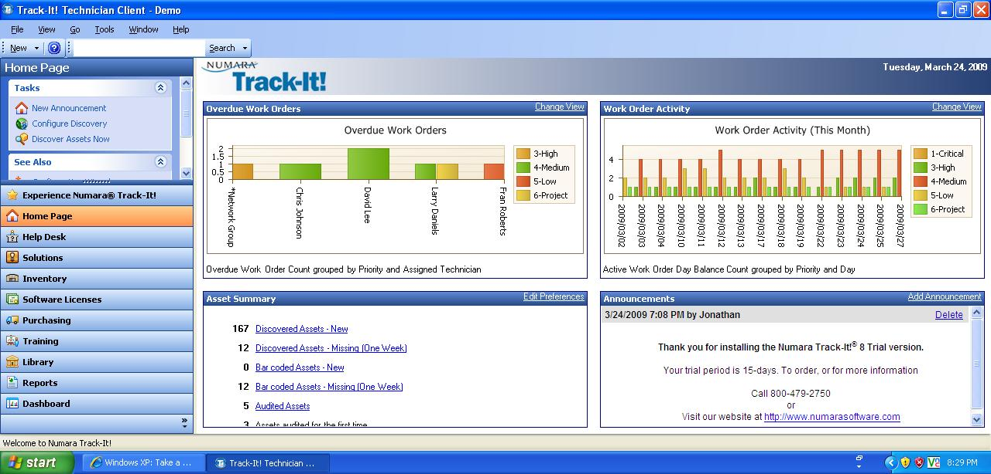
Figure 1 – Numara Track-It! User Interface

With the lack of backup and disaster recovery in Numara Software, an alternative solution is provided for Superior Pharmacy. Since the pharmacy runs on Windows XP, you can use the Windows XP Back up function. For disaster recovery, you can go with a web-based solution, Norton Online Backup.

The system requirements to install the Numara Track-It! is:

Windows Server
- Windows Server 2000 w/ SP4
- Windows Server 2003 w/ SP1 (Standard, Web, Enterprise, and Small Business)

Database Server
- Microsoft SQL Server 2000 w/ SP4
- Microsoft SQL Server 2005 (Standard, Express, Enterprise and Workgroup)

The system requirements to install Numara Deploy are:

Deploy Console – Supported Platforms
- Windows 2000
- Windows XP
- Windows Server 2003

Deploy Client & Package Builder– Supported Platforms
- Windows 2000
- Windows XP
- Windows Server 2003
- Windows Vista

The system requirements to install Numara Remote are:

Supported Platforms
- Windows Vista
- Windows Server 2003 (Standard, Web, and Enterprise)
- Windows XP
- Windows Server 2000
- Windows 2000 Professional
- Windows NT 4.0 Terminal Server w/ SP4
- Windows ME
- Windows 98SE

The system requirement for Norton Online Backup is:

Web Browser
- Internet Explorer 6 or 7

Supported Platforms
- Windows Vista
- Windows XP
- Windows Server 2000 Family
- Windows Server 2003 Family

Grouping Managed Devices:
Numara Software has the capabilities to group every workstation at Superior Pharmacy. This is mostly done thru Numara Patch Manager, you can group the workstation located at each of the five locations. If you plan to scan the workstations, you don’t have to scan each one individually; instead, you can scan a location that has ten workstations for each location. You can also group all the workstation for the entire company that is under the same network. For Numara Network Monitor, you can group all the workstations under the same network, as well as group all the routers and switches in the same network.

2.1.1 Remote Control
Numara Remote allows taking full control of a workstation from remote locations. In order for you to successfully log-in remotely to another workstation, you will need to install the Host Interface and Guest Interface. The Host Interface is installed on all workstations and servers that need to be controlled, while the Guest Interface is installed on the workstation (IT Administrator) that would want to access the Host workstations or server. Numara Remote allows you to collaborate with other IT professionals; it is capable of allowing multiple users in viewing the same remote workstation. If you need to communicate with the users, you can communicate using the audio/video chat capabilities. In regards to retrieving data, since Numara Remote have scripting capabilities, you can schedule a file transfer or you can choose the drag and drop function that allows you to copy, sync, and move and transfer data on a split screen.

2.1.2 Auditing & Asset management
You can capture the hardware information of any workstation, server, printer, router, switch, and laptop. You can do an audit check either on the spot or scheduling one to capture the asset information at a later date. Each asset is assigned an “Asset Type Icon” which has an icon of a computer, printer, router, etc. so each asset can be easy to identify and categorized. They also have an ID number attached to it as well as the name of the asset, the department and location of the asset. When you capture the asset information in regards to a workstation, it displays the OS version, the OS Service Pack, CPU, network, the software installed as well as the hardware (see Figure 3). You can assign a user that uses that specific workstation that was audited. After you completed the audit, you can print out a report of that asset as well (see Figure 2). You can have separate inventory for software only, you can keep the software’s serial number, activation key and when it expires.

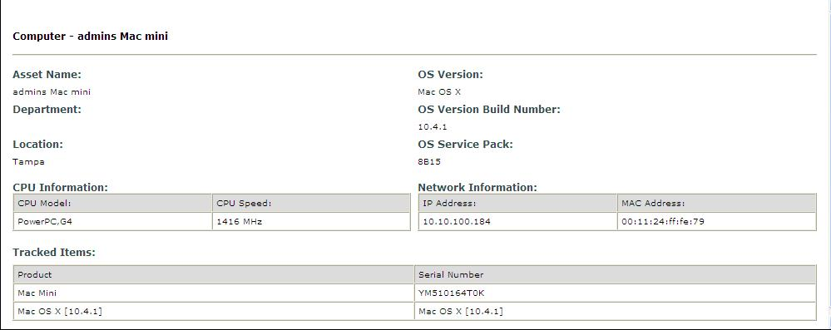
Figure 2 – Asset Information

2.1.3 Monitoring
Numara Network Monitor monitors the health and performance of the network that if unchecked, can be detrimental to a business. When there is an issue with the health and performance of the network, Numara will isolate the problem and assist you in trying to find a solution. Numara Network Monitor has a user-friendly GUI that is easy to follow, the network layout of a company can be mapped and displayed visually (see Figure 3). With the Auto Discovery Wizard, it will scan the specified IP range that you provided and gather information about the device found (routers, hub, servers, and workstations). After Auto Discovery Wizard completes the scanning, the map will populate automatically, another option is to create the map from scratch. In the device Properties table, you can create a device name; input the IP address, serial number and the location. When it comes to actually monitoring the workstations and seeing if there is a problem with the network, you can use ping command to see if a workstation is up and running. You can monitor the disk space of the workstation to see if its running low in the form of scripts, these scripts can be assigned in the properties table of that specific device. When there is a problem with the network, any of the devices that are mapped will turn to the color red (see Figure 5), notifying you that there is a problem with the network.

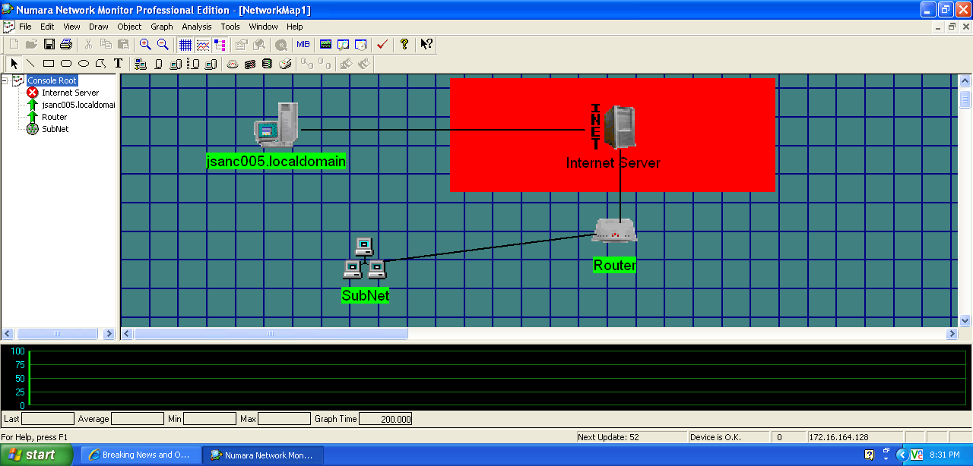
Figure 3 – Mapping of Network & Error on Internet Server

2.1.4 Patch Management
Numara Patch Manager allows you to scan patches for Microsoft Operating System and applications. You can scan for patches to any workstation from a central console, eliminating the process of physically being in front of a workstation. There are multiple ways to scan a workstation: scanning the workstation itself, by domain name, machine group, the IP address of that workstation, or selecting an IP address range. You will have the option to set a date and time when you want to schedule a scan, you can also set a recurring schedule (daily, weekly, monthly). A scanning template is also a viable option; with it you can apply restrictions, like deciding what you are planning to scan (i.e. missing security patches, installed security patches, non-security patches, WUScan). After scanning is complete, the next step is to install the patches, which you can design a deployment template. If you know a patch that requires a reboot after installation, than create a template that reboots after installing the patch. Once scanning is complete, you will receive a summery of the patch scan (see Figure 4), it will identify all the missing patches and service packs, it then groups the critical and important patches together. If you want to be notified that the deployment was successful, you can design a template that notifies you via email about the installation. You can keep a log of all the actions you took in regards to scanning and deploying the patches so you won’t repeat scanning the same workstation or server twice.

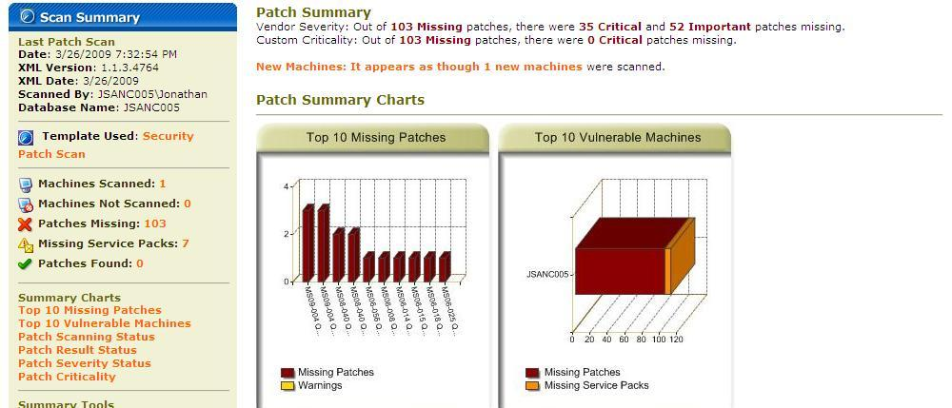
Figure 4 – Patch Summary

2.1.5 Backup & Disaster Recovery
Norton Online Backup (see Figure 5) is a web based backup solution that backs up all your files to a remote location. In case of a hard drive failure or natural disaster, since all files are stored online, retrieving the files will be quick and easy. The files are not just stored on one secure location, but multiple locations, so if a natural disaster where to occur in one location, you can be assured that the data is stored safely at another remote location.

Getting started, you first have to create an account, install the Symantec Protection Network agent to the workstation that needs the backup, and then start selecting the files that you need to backup. You can schedule a specific time when you want the backup to occur, and once that backup is complete an Alert is sent to you notifying you that the backup was complete or unsuccessful. You also have the option to generate reports of all Alerts and Backup history in PDF format.

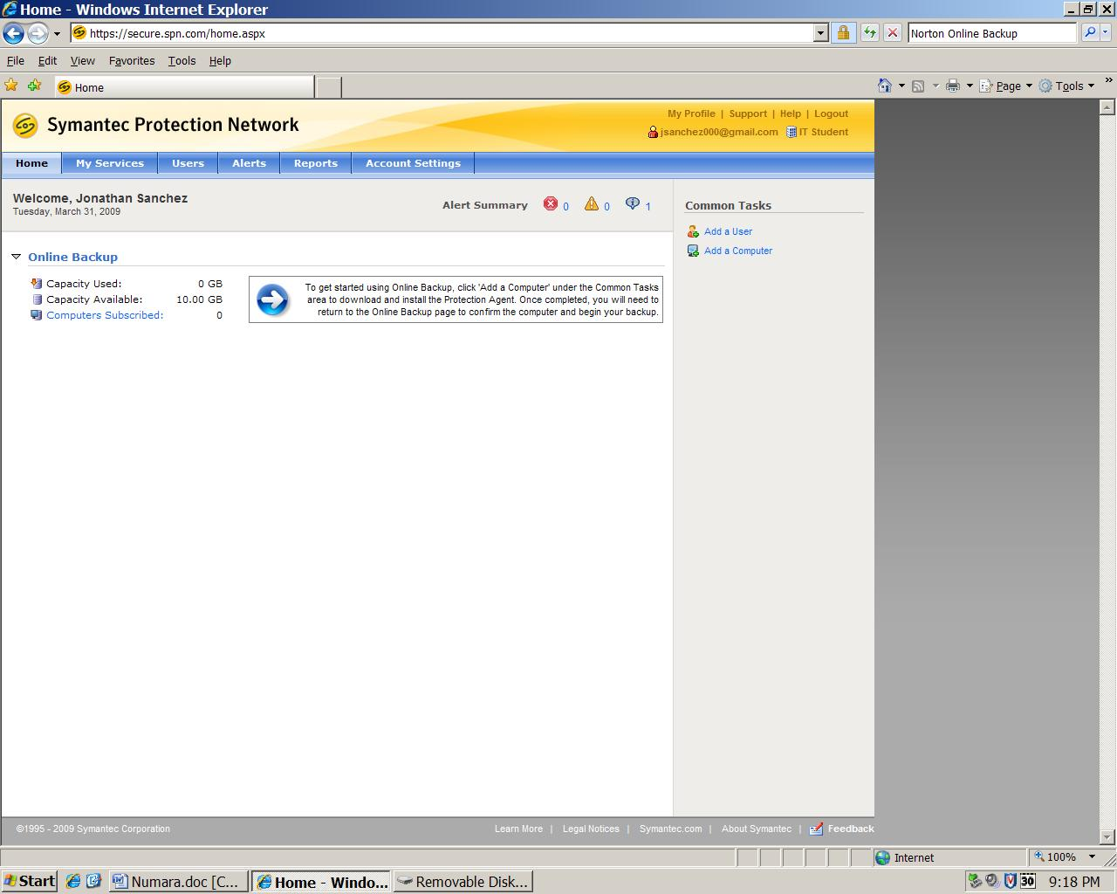
Figure 5 – Norton Backup

2.1.6 Endpoint Security
You can use both Numara Remote and Numara Patch Manager to secure all workstations, with Numara Remote
you can restrict any outside connection that is trying to access a user workstation (Host). One way is by checking a predefined MAC/IP Address list that checks the MAC/IP Address of all the workstations that are trying to connect to the user workstation. The user workstation also has the option to deny any access any workstation that is trying to connect from the outside, the user can run on stealth mode as well. With Centralized Authentication, every company that uses Active Directory, will be able to authenticate the Guest will be authenticated against the server. You can prevent unauthorized change of the users configuration; you can prevent the user from deleting the Host Interface and stopping communication to the Host workstation. With Numara Patch Manager, you can install the latest security updates and virus definitions to keep the workstations safe and secure from viruses and intruders.

2.1.7 User State Management
You can keeps logs of all Internet activities that are occurring in each workstation, whenever a user surfs the Net, the activity will be logged to a Windows Event Log. If you have Active Directory all ready in place, you can add permissions to a user, you can restrict downloads and websites that users visit while at the job. You can also create security policies for each workstation, restricting some of the workstations capabilities.

2.1.8 Help Desk
With Numara Track-It! you are able to stay in touch with the IT Administrator as long as a user has Numara Track-It! Installed on there workstation. When it comes to being notified in regards to potential problems or a reminder about a meeting, the IT Administrator is notified via a ticketing system known as “work order” (see Figure 6). A work order is a message that is viewed on the Help Desk menu; each work order is assigned its own ID number and a priority number (5-Low, 4-Medium, and 3-High) that identifies the level of importance. You are able to see the user who sent the work order, as well as the date it was sent, you also keep an audit trail in regards to all the modifications you did to the work order. You can create a policy that defines the due dates, notifications and escalations of a work order that matches specific criteria. There are other ways to communicate with users besides a work order, Numara Track-It! Gives you the option send emails.

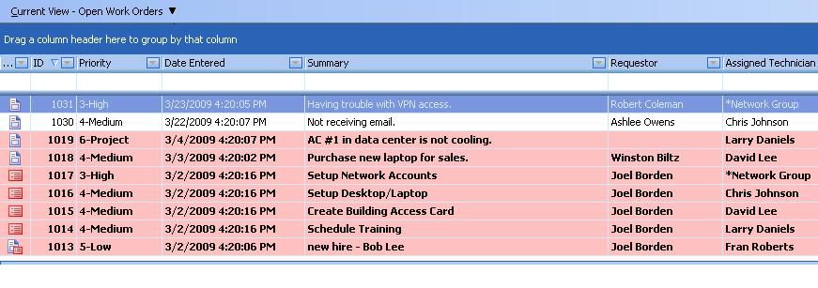
Figure 6 – Work Orders

2.1.9 Usability
You can have icons on your desktop for Numara Track-It! and its add-on’s, so you can have easy access to all Numara Software. You can run all the applications simultaneously, one on top of each other without any interference. Only Numara Track-It! requires a Log-in user name and a password, the other applications will start automatically.

2.1.10 Reliability
Numara is reliable in all of its functionalities, though, it is important that all of the workstations are functioning properly. Numara searches for all the missing patches thoroughly and monitors the entire network with out missing a beat. During our research, not once did any of the Numara software, crash.

2.1.11 Performance
Numara is a very powerful tool, to reap its full benefits, make sure before installing, that you meet all the minimum requirements for each individual software.

2.1.12 Supportability
Since the Numara Track-It! and the additional add-on’s are either installed via a CD or downloaded directly from the website, each software is has its own system requirements. The majority of the software is supported, Windows Operating System, Windows Server 2003 Family and Microsoft SQL Server. None of the Software is supported by MAC OS.

Acknowledgement
I would like to thank the Numara Regional Sales Team for supplying the trial version for Numara Track-It! , Numara Patch Manager and Numara Monitor, this is where most of my research came from, the screenshots came from the trial versions. I would also like to thank Tony Thomas, the Senior Network Engineer and Product Manager of Numara Software, he was able to provide me the information that I needed for remote control, end-point security and user state management, no trial version was available for Numara Remote, so I had to rely heavily on their information:
http://www.numarasoftware.com/pdf/whitepapers/Secure_Remote_Control_WhitePaper.pdf
http://numarasoftware.com/helpdesk/resources/Remote_Management.pdf
Since the trial version for Numara Monitor was very limited, I had to go with that I knew from trial version as well as the pdf file that was supplied to me by Numara Software:
http://numarasoftware.com/helpdesk/resources/Network_Monitor.pdf
I will also like to thank Symantic for providing me with a trial-version of Norton Online Backup, which is were I got the screenshots from.

2.2 Nagios (Jose Roman)
Overview:
Nagios is a system and network monitoring solution. It watches hosts and services that you specify, and then lets you know when things get bad or when they return to a properly functioning state. Nagios was originally designed to run under Linux, but it said to be able to run on other unices (Linux/Unix like operating systems). It can monitor Windows, Linux/Unix, Routers, Switches, Firewalls, Printers, Services, and Applications. The operating systems are monitored by having a custom made agent installed on the machines depending what operating system they are running. Some of the key features included in Nagios are its ability to monitor network services, and host resources. Its simple plug-in design allows users to easily develop their own service checks. It can do parallelized service checks (run service checks simultaneously). In addition, it can define a networks host hierarchy using “parent” host, which allows detection of and distinction between hosts that are down and those that are unreachable. When a service or host problem occurs and gets resolved it can use contact notifications to let the administrator know the status of the issue via email, pager, or a user-defined method.

Background:
It was originally created under the name NetSaint (later the name was changed to Nagios because of a trademark issue), and was written and is maintained by Ethan Galstad (founder and lead developer of Nagios Enterprises) along with a group of other developers. The word Nagios is a portmanteau of two words, network and hagios (which can also be spelled as agios) which means saint in Greek. It has also been used as a recursive acronym (N.A.G.I.O.S.) which stands for “Nagios Ain’t Gonna Insist on Sainthood”, sainthood being a reference to its original name NetSaint.

Since 2005 Nagios has been receiving awards. The awards include:
- Project of the Month" on SourceForge.net in June, 2005
- Rated by eWeek Labs as one of several enterprise-class "Must Have Tools"
- Finalist in the "Best Tool or Utility for SysAdmins" category of the 2007 SourceForge.net Community Choice Awards
- Won the LinuxQuestions.org 2007 "Monitoring Application of the Year" award
- Rated by LinuxWorld.com as one of the "Top 5 Open Source Security Tools in the Enterprise"
- Rated by eWeek as one of "The Most Important Open-Source Apps of All Time"
- Honored as being one of InfoWorld’s Best of Open Source Software ("BOSSIE") 2008 Award winners
- Won the LinuxQuestions.org 2008 "Monitoring Application of the Year" award two years in a row.
Functional Coverage:
Nagios can monitor Windows, Linux/Unix, Routers, Switches, Firewalls, Printers, Services, and Applications. The operating systems are monitored by having a custom made agent installed on the machines depending what operating system they are running. Nagios can also monitor a variety of services. It can monitor network services such as SMTP, POP3, HTTP, NNTP, and Ping just to name a few. What services are monitored all depend on the administrators needs. There are many plug-ins supported and developed by the Nagios community that help expand Nagios’s monitoring capabilities. For example, if you need to monitor the status of an antivirus program running in windows, there is plug-in for that called “check_antivirus” that will determine whether or not windows security center says that the antivirus software is up to date and active on each windows workstation.

OS | Monitoring | Nagios Installation
Linux | √ | √
Unix | √ | √
Windows | √ | ×
Netware Server | √ | ×

As mentioned before it was designed to run on Linux, so the only requirements needed for Nagios are a Linux/Unix based machine that has a C compiler and TCP/IP configured. It is not required to use the CGIs(Common Gateway Interface) that come with Nagios, but if you do decide to you use them you will have to install a web server (Apache is recommended), and Thomas Boutell’s gd library version 1.6.3 or higher, which is required by status map and trends CGIs).

The image below shows some of the services Nagios was monitoring on my network. Local host refers to the workstation that is hosting Nagios (where I have it installed) and the host named Ashley is my sister’s workstation that is being monitored. Ashley is running on windows, and as you can see I am monitoring the C: drive for space, how much the CPU is being used, if Explorer is running, the memory usage, what version on the agent I’m using, and the Uptime of her system. Furthermore, if you look at local host, you can see that there is a red cell in the status column with the word critical written in inside of it. This means that there is something wrong with that service. The reason why it’s red is because I don’t have SSH enabled on Ubuntu. 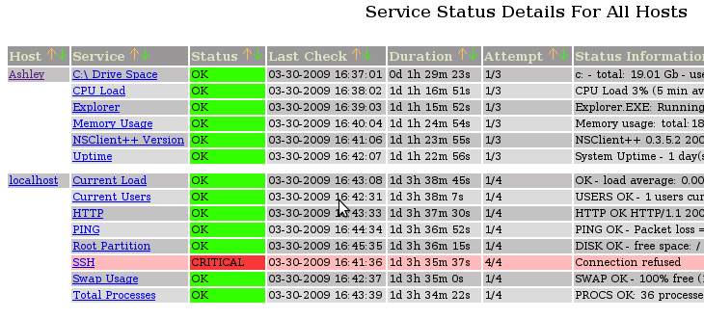
Figure 1 - Nagios Service Details.

As far as what can’t be monitored, it’s a very vague question. The reason why it’s so vague is because there are a lot of possibilities as to what can be monitored. There are vast amounts of plug-in that monitor different services. And if something doesn’t exist it can be easily (depending on how experienced an administrator is with C, shell, perl, and python) be created to customize what needs to be monitored. The website http://nagiosplug.sourceforge.net/developer-guidelines.html hosts the Nagios plug-in development guidelines.

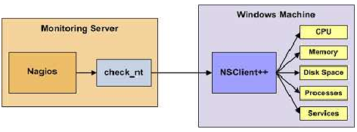
Figure 2 - Nagios monitoring on Windows workstation.

Monitoring private services requires the installation of agents on workstations. The type of agent you use depends on what type of operating system you are monitoring. Take windows for example, Nagios uses a plug-in called check_nt that communicates with the NSClient++ agent installed on the windows machine. Configuration of the agent isn’t too difficult, but you must also configure firewall settings on the windows workstation in order to make sure it communicates properly with the workstation hosting Nagios.

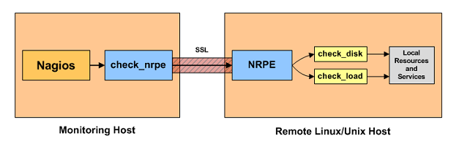
Figure 3 - Nagios monitoring Linux/Unix workstation.

Linux/Unix workstations use an agent called NRPE, this is a bit more time consuming to install because you have to download, and configure the NRPE in a Linux/Unix environment which might be challenging to someone without experience in that OS. For Netware servers MRTGEXT.NLM is the agent that is used to collect data and pass it along to Nagios. The data collected can then be read and interpreted by nwstat or with the MRTG plug-in in Nagios.

Grouping Managed Devices:
As far as grouping is concerned, Nagios can be configured to separate the devices being monitored into groups. This can be done in the main configuration file. The picture below illustrates just that. Nagios separated my sister’s computer which was a windows machine into a separate table from my Linux machine running ubuntu. It created a Linux servers group and a Windows servers group.

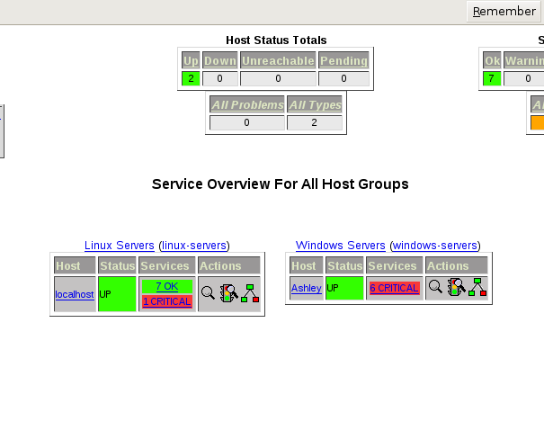
2.2.1 Remote Control
Nagios does not come with remote control software. This might be viewed as a handicap right off the bat, but let’s keep in mind that Nagios is running on a Linux/ Unix style system, and most if not all distributions come equipped with Rdesktop. Rdesktop, according to www.rdesktop.org, is an open source client for Windows Terminal Services that is capable of natively speaking Remote Desktop Protocol (RDP) in order to display the windows user’s desktop. The supported servers include Windows 2000 server, Windows Server 2003, Windows Server 2008, Windows XP, Windows Vista, and Windows NT Server 4.0. Not to mention that it also allows access to Linux/Unix machines also running the service.

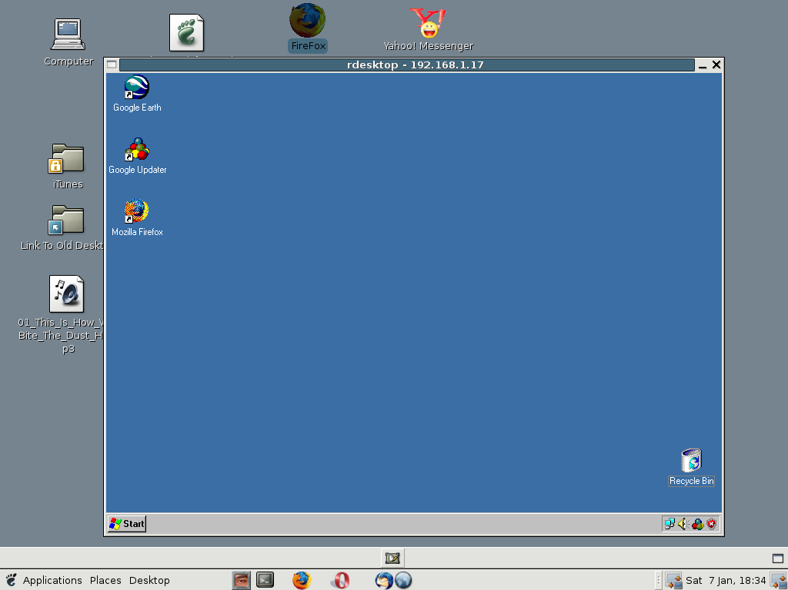
Figure 4 - Rdesktop being used on Linux workstation (Picture from website[1], see references).

2.2.2 Auditing & Asset management
Nagios does not come with Auditing and Asset Management built-in capabilities. But from the information I gathered online, Nessus can be used as a possible alternative to gathering system auditing data. According to Nessus‘s website, it does not use agents to relay data back to the server. Instead it scans the workstations and can retrieve missing security patches and vulnerable system settings, compliant and non-compliant configuration settings, and can perform a sophiscated remote scan that audits Unix, Windows, and network infrastructures identifying in them operating systems, applications, databases, and services running on the assets.

2.2.3 Monitoring

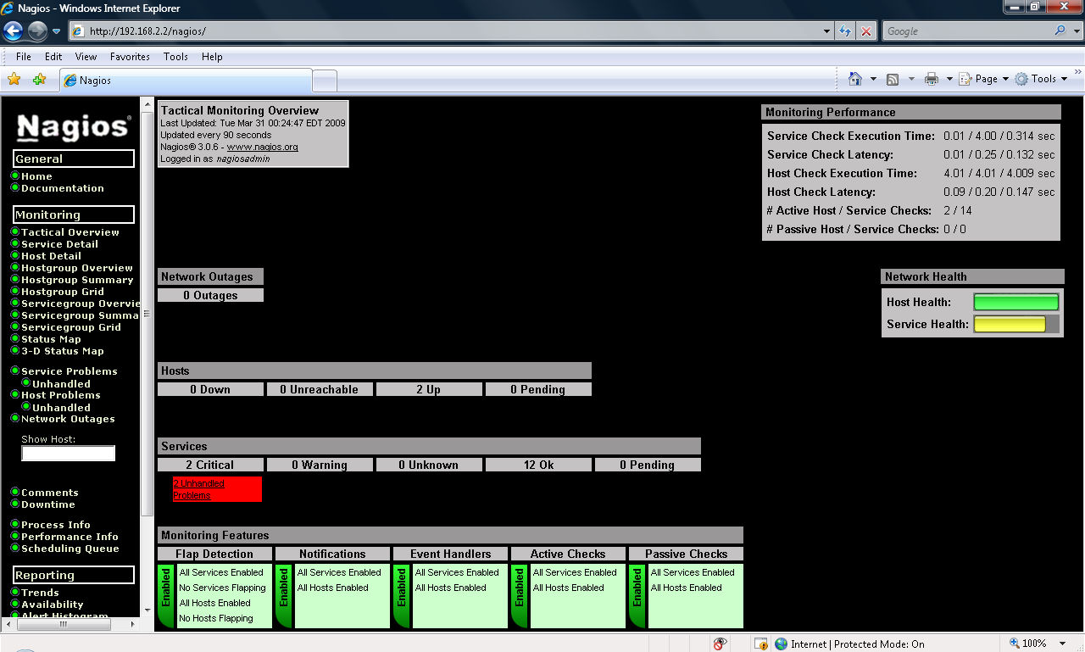
Figure 5 - Nagios web interface.

Nagios monitoring is accomplished via plug-ins and agents. The type of agents installed on the workstations depends on what operating system they are using. Once the agents are installed Nagios can perform the various systems checks. Nagios uses a plug-in called check_nt that communicates with the NSClient++ agent installed on the windows workstation. Configuration of the agent isn’t too difficult, but you must also configure firewall settings on the windows machine in order to make sure it communicates properly with Nagios.

According to the pdf on Nagios installation that I read, Linux/Unix workstations use agent called NRPE that is used to facilitate monitoring of the workstation. This is a bit more time consuming to install because you have to download, and configure the NRPE in a Linux/Unix environment which might be challenging to someone without experience in that OS. For Netware servers MRTGEXT.NLM is the agent that is used to collect data and pass it along to Nagios. The data collected can then be read and interpreted by nwstat or with the MRTG plug-in in Nagios.

There are all kinds of services that can be monitored, on a windows machine, for example, Nagios can monitor the C: drive for space usage, how much the CPU is being used, if Explorer is running, the memory usage, and what version of the agent it is running. In addition to that there are plug-ins that can be downloaded to monitor other services such as SMTP, POP3, HTTP, NNTP, PING and many other network services. Documentation also states that routers, printers, firewalls, switches, and applications can be monitored as well. So the possibilities on what can be monitored are endless. It all depends on whether or not a plug-in exists that can monitor what you need it to monitor, and if it doesn’t then the administrator can develop it.

Nagios uses a web interface to display monitoring results. The Tactical Overview link shows you network outages, hosts (which are up, down, unreachable, pending), Services (critical, warning, unknown, ok, and pending), and below that you have the Monitor features. (See image below.)

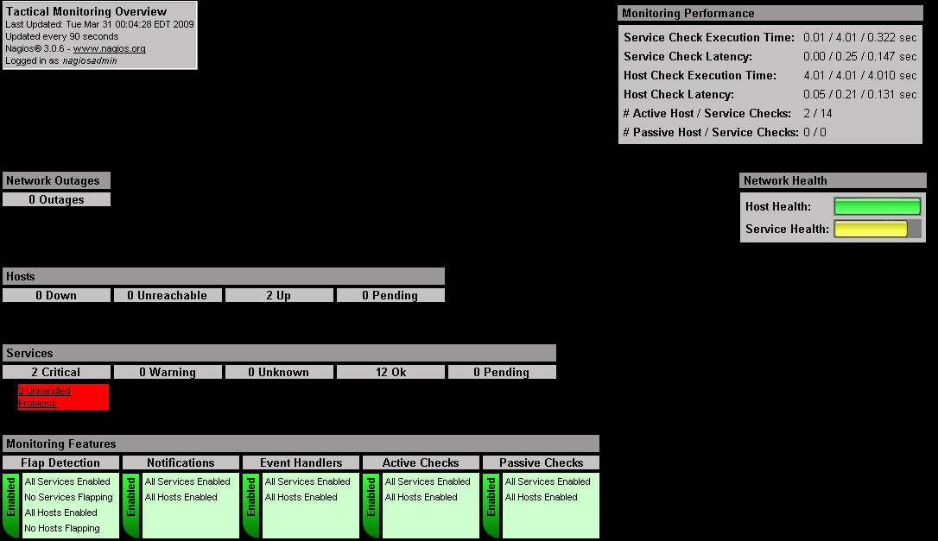

Other links include Service Detail, which shows you a table of the services that are being monitored on each workstation, their status, when they were last checked, the duration, the attempts, and the status information. (See image below.)

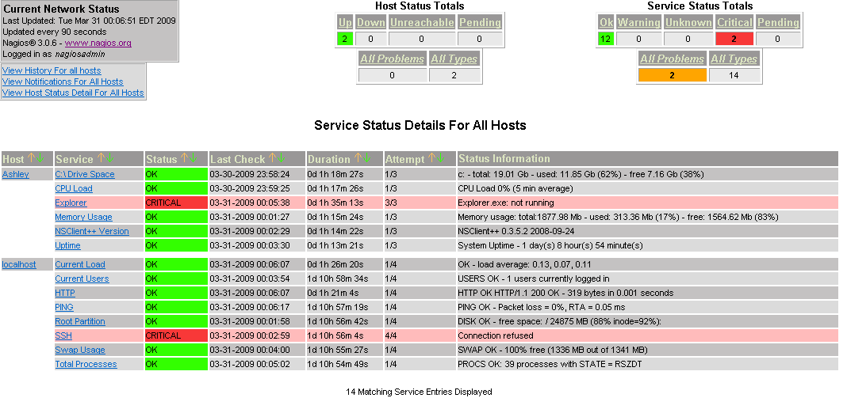
When you click on the host detail link it lets you know which workstations are up, when they were last checked, the duration, and more status information. (See image below.)

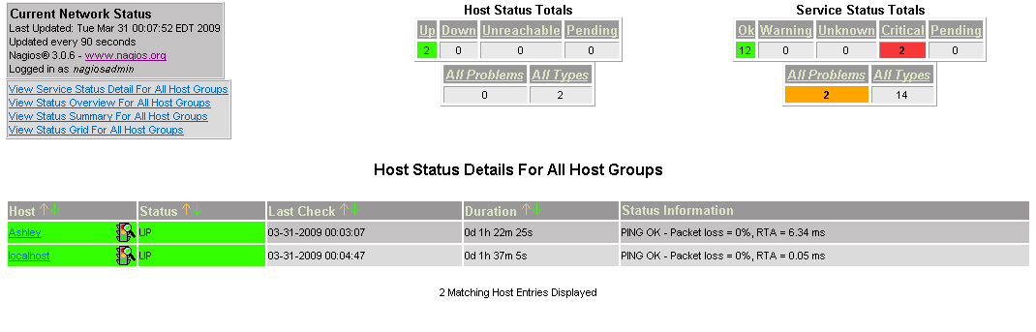

Under the host group overview link, it separates the workstations by operating systems. (See image below.)

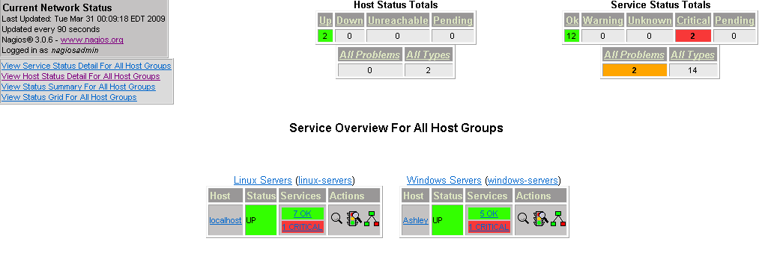

And then the status map link shows you a graphical representation of the network with the systems either up or down. (See image below.)
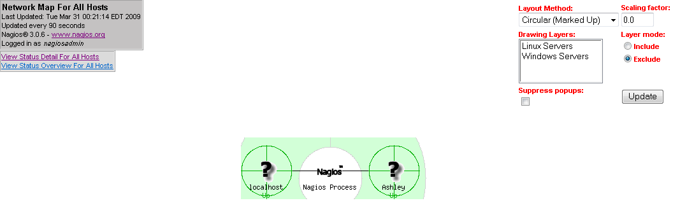

2.2.4 Patch Management
Although Nagios does not come with built in support for patch management, an administrator can configure Nagios to use the NSClient++ plug-in to check for windows updates. A sample of what the configuration might look like to accomplish such a task is below:

define command{
command_name check_nt_windows_update
command_line $USER1$/negate $USER1$/check_nt -H $HOSTADDRESS$
-v PROCSTATE -d SHOWALL -l wuauclt.exe

Similar plug-ins exist for Linux workstations such as check_apt, that will check for software updates on Linux systems that use apt-get command found in Debian Linux. So monitoring patch management is a possibility if the correct plug-in can be developed, but to actually apply patches the administrator would need to seek a different solution.

2.2.5 Backup & Disaster Recovery
Nagios does not come with backup or disaster recovery built in, but you can use an open source backup solution known as Bacula. From the information I read online, Bacula is a solution that allows a system administrator to manage backup, recovery, and verifaction of computer data across the network. It supports Linux, Solaris, FreeBSD, Windows, MacOS X, AIX and many others. The data can be backed-up on various types of media, including tape and disk. It is client/server based and since it’s modular it can be used on a single computer system or on hundreds of networked computers. Nagios can also communicate with the bacula via the check_bacula plug-in.

2.2.6 Endpoint Security
Nessus can once again be used to supplement Nagios with endpoint security. According to the information displayed on Nessus’s website it can perform sophisticated remote scans and audits of UNIX and Windows workstations. It can then be used to discover network devices and identify the operating system, applications, databases, and services running on those workstations. Any workstations running P2P, spyware, or malware (worms, Trojans) will be detected and identified. Nessus is capable of scanning all ports on every device and issue what recommended actions to take. In addition to Nessus, Kaspersky can also be used to protect the workstations from viruses and other malware.

2.2.7 User State Management
Nagios does not perform any form of user state management. To compensate for that, I did a bit of research online and found that third party applications such as smbldap-tools, Samba, and OpenLDAP combined can offer central authentication such as a Domain Controller would, and file and print sharing for windows and Linux/Unix workstations. More thorough information on how this can be accomplished can be found in the following link: http://download.gna.org/smbldap-tools/docs/samba-ldap-howto/#htoc12.

2.2.8 Help Desk
Nagios does not come with a help desk solution. But other software such as Eventum can be used to support with help desk. According to Eventum’s wiki, it is a web based application and issue tracking system that can be used to track technical support requests and can prioritize and organize the issues.

2.3 LANDesk (Alfonso Munive)
Overview:
LANDesk comes in different suites, which are LANDesk Management Suite, which provides systems management, and LANDesk Security Suite, which provides endpoint security management. In addition there are multiple subscription services that you can add to the Management Suite which are LANDesk Antivirus, LANDesk Patch Manager, and LANDesk Process Manager.

Background:
LANDesk is one of the most powerful IT Automated solutions that is available. It was founded in 1985 and was known as LAN systems. In 1991 Intel Corporation acquired the company, and in 2002 LANDesk left Intel and operated independently. In 2006, it became a subsidiary of Avocent, and has established itself as a leader in the industry innovating both product and technologies for IT professionals.

Functional Coverage:
The system requirements to install LANDesk Management suite are as follows:

Core Server Requirements:
- The Core server needs to be dedicated to hosting the LANDesk Management Suite
- Supported Windows Server Operating Systems:
  - Windows Server 2000 (Running SP4)
  - Windows Server 2003 (Running SP1 or SP2)
- Microsoft Simple Network Management Protocol (SNMP)
- Static IP address

Databases:
- Microsoft SQL Server 2005 Express Edition
- Microsoft SQL Server 2005 (SP2)
- Microsoft SQL Server 2000 (SP4)

Supported Client Platforms:
- Windows
  - Windows 95 B with Winsock 2
  - Windows 98 SE
  - Windows NT 4.0 Workstation SP6a
  - Windows 2000 Professional SP4
  - Windows XP Professional SP1 or SP2 or SP3 Windows Vista
  - Windows Vista SP1 (64-bit)
  - Windows Vista Business/Ultimate/Enterprise SP1 (32-bit)
- Apple
  - Mac OS X 10.5.x (Leopard)
  - Mac OS X 10.4.11 (Tiger)
  - Mac OS X 10.3.9 (Panther)
  - Mac OS X 10.2.8 (Jaguar)
  - Mac OS Classic 9.2.2
- Novell
  - NetWare 6.0, 6.5

- UNIX and Linux
  - Red Hat Linux Enterprise 3, 4, 5 WS
  - Red Hat Linux 7.3, 8.0, 9.0
  - SUSE Linux Professional 9.1, 10
  - Ubuntu
  - Mandriva Linux 10.1

Grouping Managed Devices: All devices in Superior Pharmacy would be grouped on their roles. We would have a role for regular workstations, and a role for the servers.

2.3.1 Remote Control
The LANDesk Management suite provides a powerful remote control and problem solving solution which help you reduce costs, and decrease the demand on help desk resources. With LANDesk’s remote control, you can perform maintenance and repairs anytime on the network with remote reboot, remote wake and remote application launch. It has integrated file transfer capabilities, and you can instant message/chat with the remote client (Figure 1).

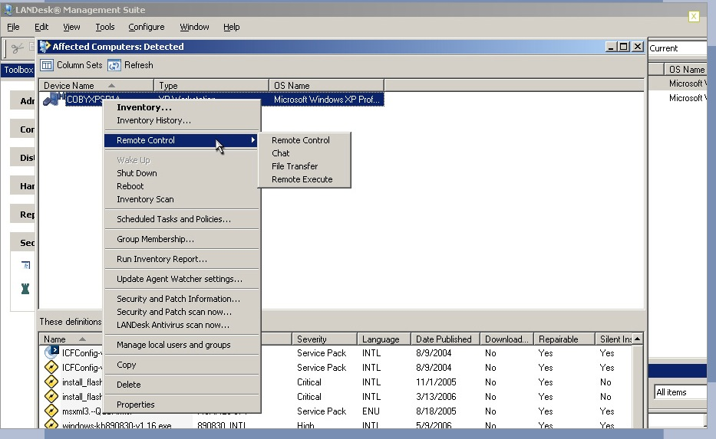

Screen-shot of Demo Figure 1
In addition there is a drawing tool where you can draw on the remote clients screen to illustrate actions, and with remote program execution you can run applications such as an anti-virus program (Figure 2). For increased security you can shut down the screen on the remote client, so the end-user doesn’t see what actions are being performed.

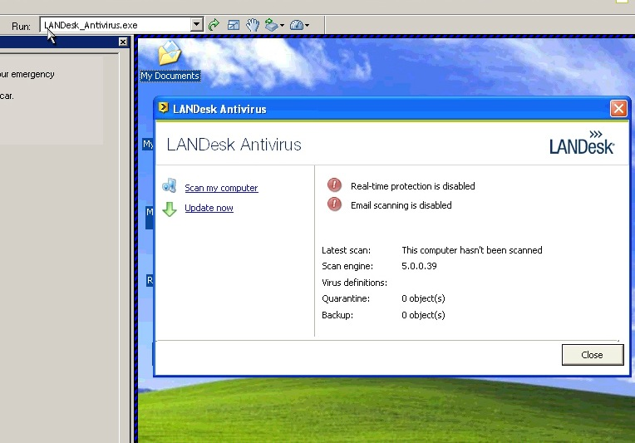

Screen-shot of Demo Figure 2

With LANDesk Management gateway the IT administrator can remotely log into any machines, which are not onsite, only needing an Internet connection. Management gateway allows you to manage outside devices such as laptops, and machines on different networks. There is no need for VPNs and the gateway gives you a secure SSL connection on both ends.

2.3.2 Auditing & Asset management
LANDesk has a powerful IT asset management utility, which you can add to LANDesk Management suite, which helps you manage devices across your network. You can easily plan upgrades and respond to audits in an efficient manner. You can easily track both hardware and software inventory, and track software usage accordingly (Figure 3). You can get data from multiple sources such as the service desk, finance programs, and systems management programs and group them all together. You can easily view any type of information on any machine such as the OS, CPU, RAM, the end user associated with the machine, the software installed, number of times the software was used and a time log for the software. This provides efficient asset monitoring such as warranty information for all machines, lease expirations dates and define which software is being used the most.

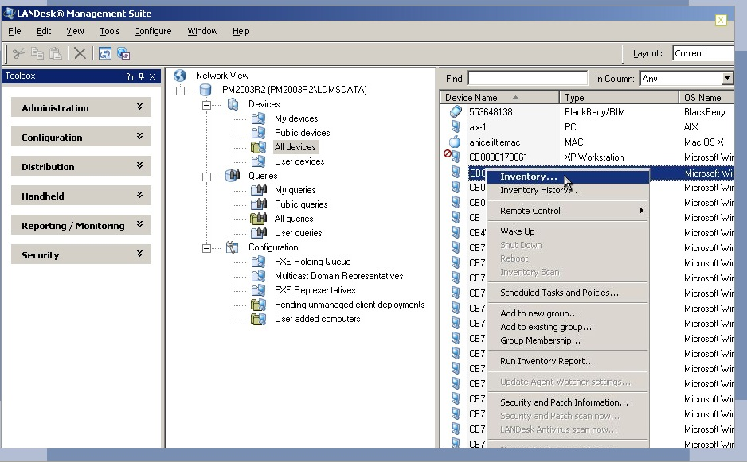
Screen-shot of Demo Figure 3
LANDesk Asset Lifecycle Management is more than just a tracking program. You can add information such as the original purchase order when the hardware or software was bought, to the day its expired or sent out for service.

2.3.3 Monitoring
LANDesk System Manager maximizes computer performance, availability and security. You can extract data directly from the system hardware, OS and software components in real time. You can track anything from CPU usage, to different voltages, to fan speeds. You can capture this data over time so you can predict trends and avoid problems before the system crashes. You can setup custom alerts when machines fail or system performance falls below expectations so once again you can be prepared if any problems occur. You can maintain all machines by using remote application launch, and file transfers. You can track different peripherals attached to USB ports such as keyboards and monitors. You can track when users install or remove applications and be alerted via email, fax or text message. You can create custom scripts let you create, edit and delete any console group operation, including unmanaged device discovery, client deployment. In addition you can create custom scripts that check for software updates to one or all the machines on the network, just once or on a recurring schedule.

2.3.4 Patch Management
LANDesk Security Suite offers a comprehensive patch management solution that lets you keep up to date across all OS platforms (Figure 4). You can automatically deploy patches using LANDesk’s vulnerability assessment and patch database, which fit the company’s needs. Policy based management allows you to download, target and install patches based on IT defined rules, or you can deploy them manually for more control. The patch management tool uses LANDesk’s Targeted Multicast and LANDesk’s Peer download technologies lets you speed patch manually for more control. The patch management tools uses LANDesk’s Targeted Multicast and LANDesk’s Peer download technologies lets you speed patch deployments to multiple targets while minimizing the bandwidth used to reduce total network traffic without using dedicated hardware.
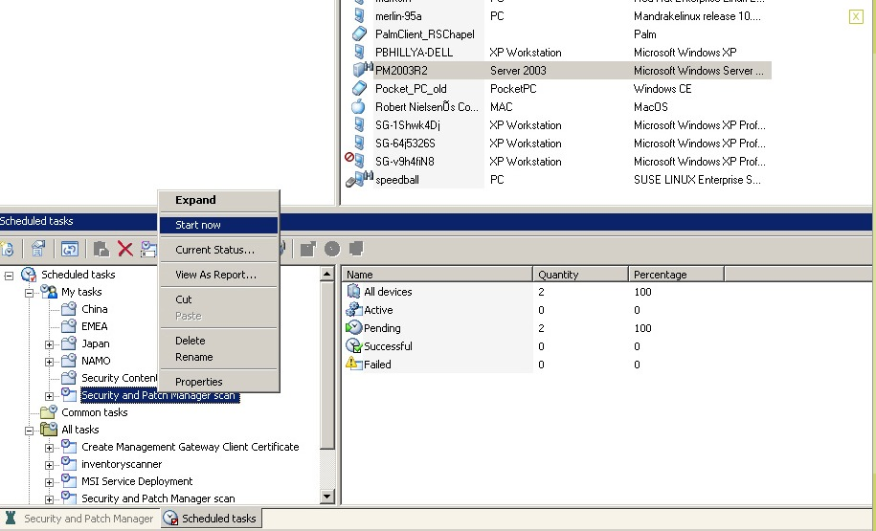
Screen-shot of Demo Figure 4

2.3.5 Backup & Disaster Recovery
LANDesk does no offer a fully offer a backup and disaster recovery utility, but instead uses the LANDesk Management suite tool called Imagew.exe. It is a tool that can capture an image of a hard drive while Windows is currently running. In order to do this, PHYLock must be installed and any process that prevents such a lock needs to be stopped. PHYLock is a tool that stabilizes the files that are in use while they are being captured. PHYLock provides a method to lock files so that imagew.exe can capture a file in a constant state, which allows for an image to be captured while in windows.

2.3.6 Endpoint Security
LANDesk’s antivirus is part of the Security Suite and can prevent your system from malware attacks such as Spyware, Rootkits, Trojans, Worms, and Viruses. The LANDesk antivirus works alongside standard industry software so you can use antivirus solutions you already have like Norton and AVG. In addition it helps you determine whether scanned files are up to date and whether real time protection is enabled on each managed machine. LANDesk antivirus has a tool called Virus Pilot Deployment which allows you to selectively and rapidly deploy virus definitions files on a limited basis so you can validate whether the integrity of the definitions are valid (Figure 5). Like the Antivirus, LANDesk’s spy ware removal tool is accessed through a centralized console and detected spy ware is grouped into different families to help you quickly identify the type of threat. The removal tool is automatic, and it helps you protect the systems in real-time with access to live LANDesk databases that are regularly updated.

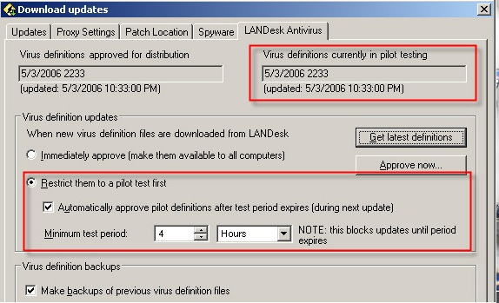

Screen-shot of Demo Figure 5

2.3.7 User State Management
LANDesk doesn’t include any built in user state management, but by using Active Directory Application Mode (ADAM) we can control resources, services and users. We can implement policies amongst users and control what resources are available to every user.

2.3.8 Help Desk
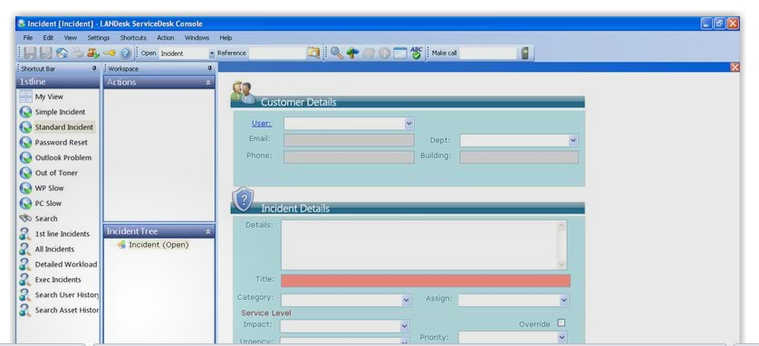
LANDesk Service desk provides a better solution than previous help desk solutions by consolidating call logging, incident management and workflow management issues. You can prioritize by policy driven incident reporting which helps you improve productivity and reduce costs. For example the user interface that the end user has, it lets them input their name, the type of hardware they are the using, and a quick description of the problem. Once they enter this, it searches the database for a possible solution and tries to solve the problem (Figure 6).
Screen-shot of Demo Figure 6

Acknowledgement
I would like to acknowledge and extend my gratitude to the LANDesk team and Avocent, for making the completion of this research possible. I also want to thank my research team and colleagues for their contribution to this report as well.

2.4 N-Central 6.5 (Sajjad Zaidi)
Overview:
IT industry is evolving at the speed of light and the complexity of the service demands more time and effort to solve modern day IT Issues. In today’s complex or simple business model, IT is the spinal cord and in order to grow and survive business’s wants fast on demand services. IT managers are looking for many solutions that are available in the market to do this said job. Among these many solutions three products have made their mark on MSP’S. N-able along with its competitors have achieved recognition and is competing with it competitors like Kaseya and Level Platforms.

N-Central current version 6.5 has probe-bases agent that can detect all IP based devices and can build inventory in seconds. THIS brings system management into a simplified solution. Any devices outside the network can be monitored with the help of physical agent installation (N-Central ™ 1).

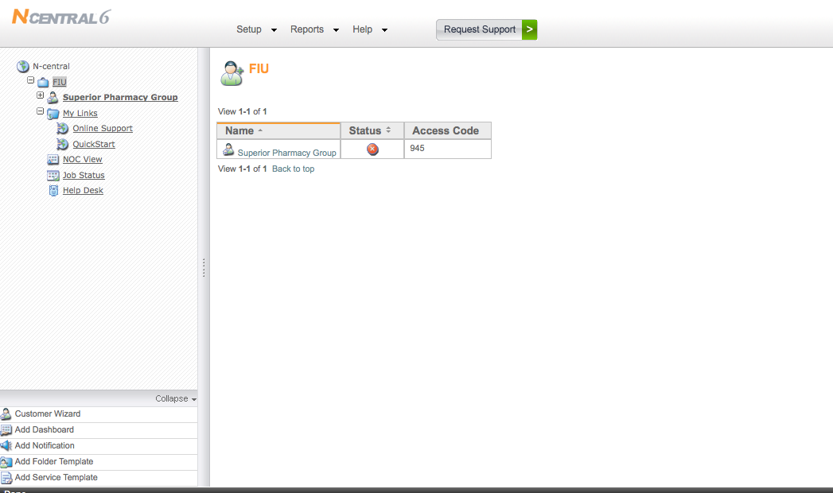
Screen-shot of the Trial Version

Functional Coverage:

System Requirement
A web enable monitoring interface makes N-Central easy to manage and its implementation even simpler. This MSP can take over the system with in minutes and helps to manage inventory (N-Central ™ 2).

Supported Client Platforms
- Windows 2000/2003/2008/XP/Vista, 2008 Small Business Server
- Novell 6.5 SP 1a / SP 2 / SP 3 / SP 4
- Red Hat Linux AS/ WS/ ES 3.0, 4.0, 5.0
- Mac OSX 10.4, 10.5

Features
The interface has a console where a comprehensive dashboard with useful features can monitor networks and devices from a single Web UI called a dashboard. The system sends alerts via SMS, email and pager. N-central can also send alerts, warnings or failures that may occur (N-Central ™ 3).

Operating Systems and Protocols

N-Central provides a platform where al IP activated devices can be monitored

Protocols that are supported:
- SNMP
- Log file analysis
- TCP/IP
- WMI
- Syslog/SNMP Trap
- HTTP/HTTP(s)
- ODBC
- EDF

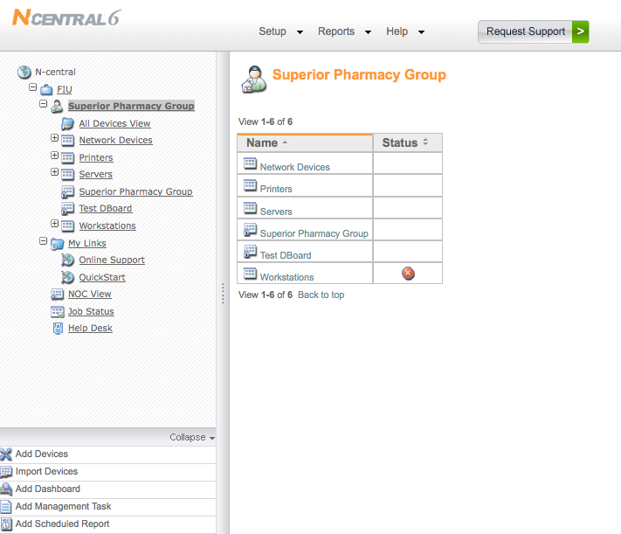
Screen-shot of the Trial Version

2.4.1 Remote Control
N-central has a remote control that can troubleshoot and resolves issues from a single WEB UI dashboard. The feature gives the flexibility and can also address specific support needs. The proprietary remote control agents has unique feature that can probe a system and is able to resolve issues. N-Central also has other easily available third party software that can also perform the task.
Using this functionality provides a remote control over any OS. N-central features an integrated remote control capability that allows control over any OS especially Windows-based device (2000/2003/NT/XP) under management by N-central. The unique feature does not relay on open ports or VNC (N-Central ™ 4).

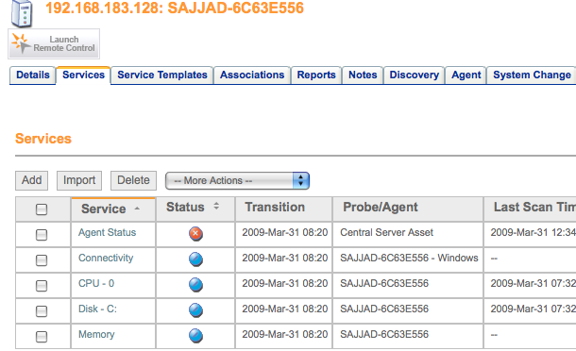
Screen-shot of the Trial Version Used

2.4.2 Asset, Audit, License Management:
Inventory management is not only easy to mange but it takes it to the next level. This feature allows the IT Admin jobs much easier and does not require manual labor. The built in tool that probes the specified IP range makes it inventory of all hardware and software with in seconds. In order to manage networks effectively, a proper asset management must be in place and N-Central can deliver. N-central's has an asset management features that builds proper inventory and makes a complete list that tracks applications and can safeguard computers from unauthorized installation and use of software. License Compliance is also a provided and useful feature that monitors compliance and future purchases if are planed. N-central can also monitor hardware components of each individual device to record and reports any hardware changes (N-Central ™ 5).

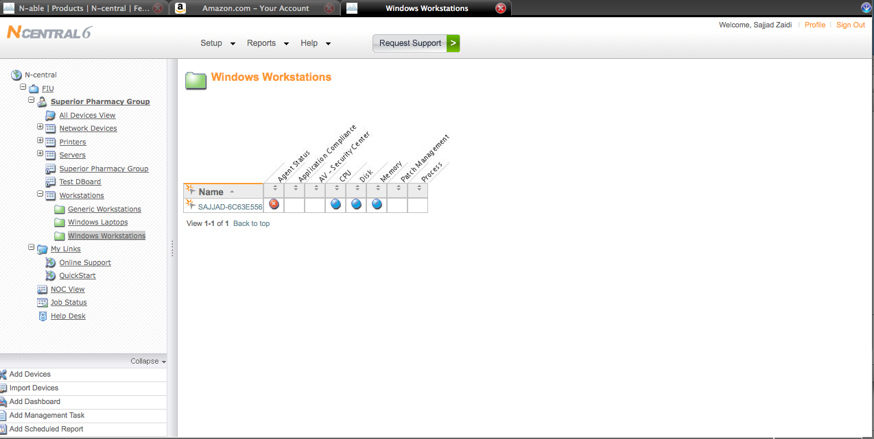
Screen-shot of the Trial Version Used

2.4.3 Monitoring (N-Central ™ 6):

IP Network Monitoring
N-Central automates and monitors a specific IP enabled device or a range of IP can be input to get the desired results. It can Monitor routers, switches, firewalls and servers for:
- Ethernet Errors
- Traffic
- Bandwidth
- Frame Relay
- TCP
- SNMP

Network Monitoring
Automatically discover devices on a network, which allows the monitoring of devices. The Servers and Workstations can be monitored for the following:
- Application compliance
- Connectivity
- CPU
- Disk
- Disk Queue Length
- Event Log
- File Size
- Local IP
- License compliance
- Memory
- Patch level
- Process

Agent Deployment
N-central probe and agents can be deployed via login scripts, Group Policy Objects or other agent called N-able's Remote Environment Manager or Microsoft Systems Management Server. When an agent is installed, they discover themselves, contact N-central and create a new device to begin monitoring themselves. This can also be automated agent deployment using retry logic and PSEXEC as a helper application. This increases reliability and ensures that agents will be installed, even if the target device is powered off at the time the deployment is initiated. Unlike other solutions, N-central shows whether a device is normal, failed, nearing failure, misconfigured, disconnected, reporting stale data or not reporting data. Also helps in building the probe can detect asset changes and updates monitoring appropriately, including reconfiguration due to agent or probe additions (N-Central ™ 7).

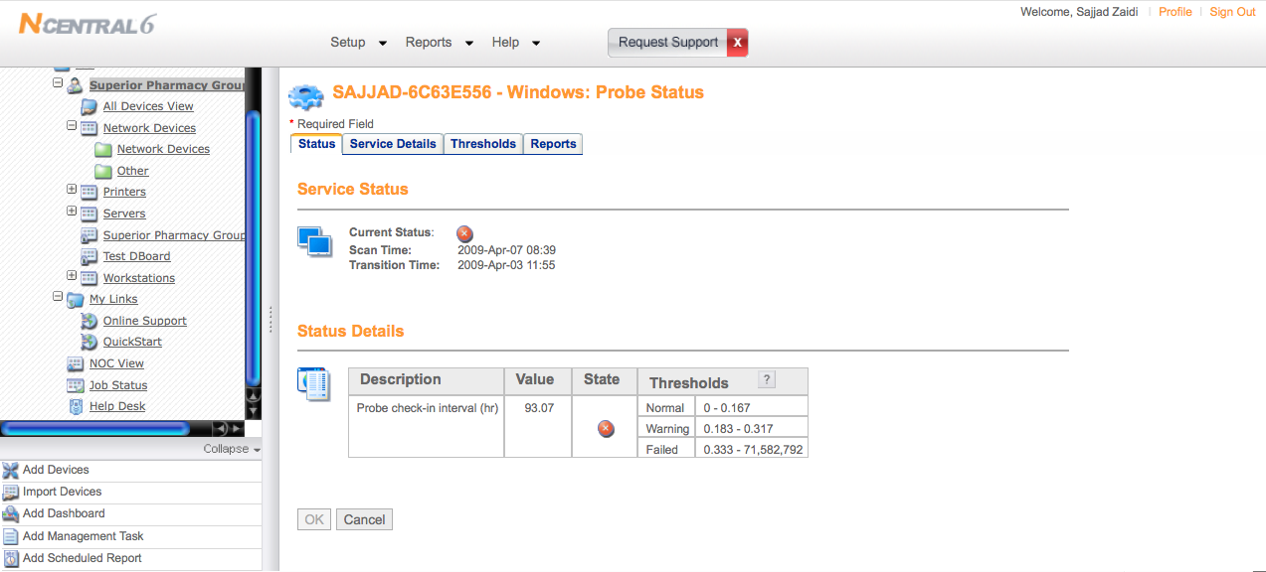
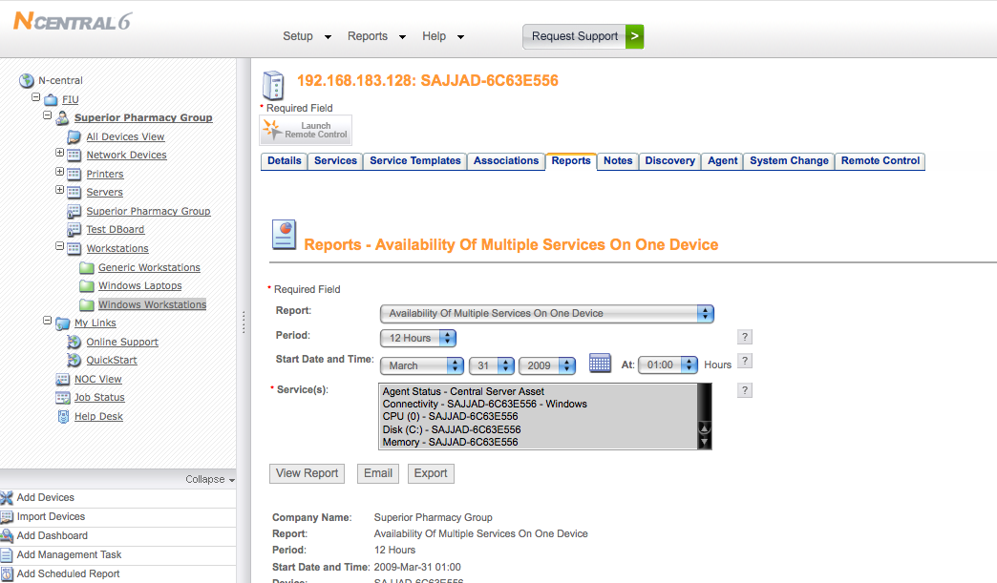
Screen-shot of the Trial Version Used

2.4.4 Patch Management
For a secure network patch Management s. N-central can interoperate with Microsoft Windows Software Update Services (WSUS) to provide patch management. With N-central easy WSUS configuration is possible, as well as monitoring and reporting of patch levels across WSUS-enabled devices. N-central can be connected directly to the WSUS server and automatically creates a WSUS computer group. It also monitors and reports on patch levels for devices, and set up alerts for machines that are not updated (N-Central ™ 8).
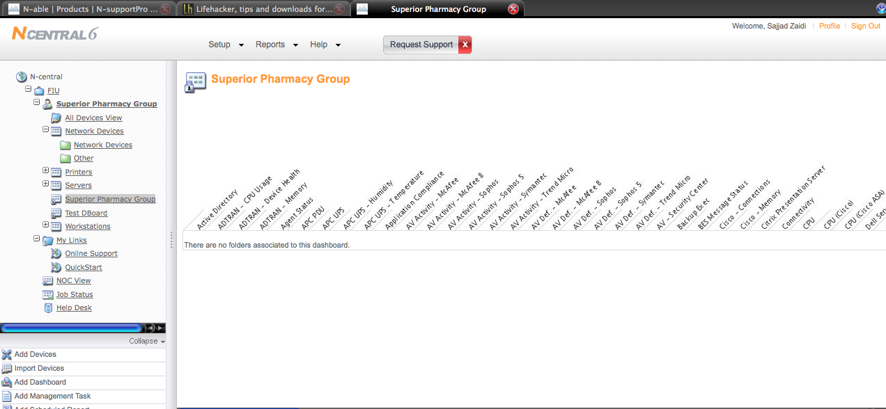
Screen-shot of the Trial Version Used

2.4.5 Backup And Disaster Recovery:
For backup N-Central relies on a product call Backup Exec. This tool comes with the entire data tools available to perform this task. What N-Central is lacking is the built in too that can select the individual volumes. Data recovery and Back has to go through this program, which is a comprehensive solution to perform this task. Backup Exec provides three different layers and can be customized:
- Data Protection
- System Recovery
- Extended Backup Capabilities

The Backup Exec tool is highly customizable software, which gives the user the power of managing data recovery with minutes. System experiences no downtime and can be up and running with in minutes (N-Central ™ 9).

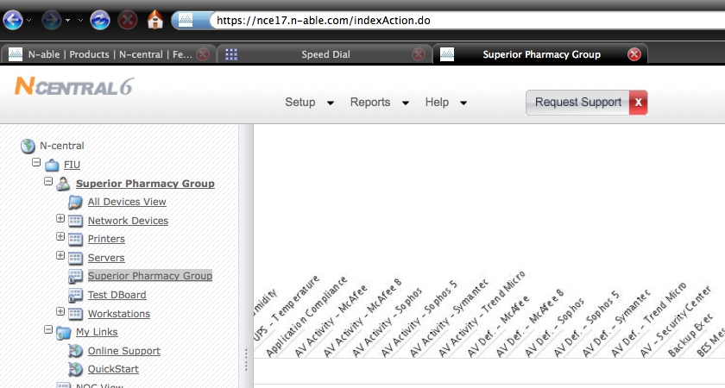
Screen-shot of the Trial Version Used

2.4.6 End Point Security
N-Central Proactively monitors and manage multiple security appliances and applications to minimize IT infrastructure downtime. It manages different security services from one location. It can monitor anti spam, spyware and virus services to ensure that IT infrastructure is protected. It monitors that application compliance can also detect by remotely detecting non-approved applications. It also Monitors and manages firewalls and intrusion detection systems and can receive alerts upon their attack. It also tracks security devices to ensure adherence to software licensing and IT governance (N-Central ™ 10).

Numerous tools are provide to perform this task and are not limited to the MSP’s capabilities. Few of them are:
- McAfee
- Trend Micro
- Symantec

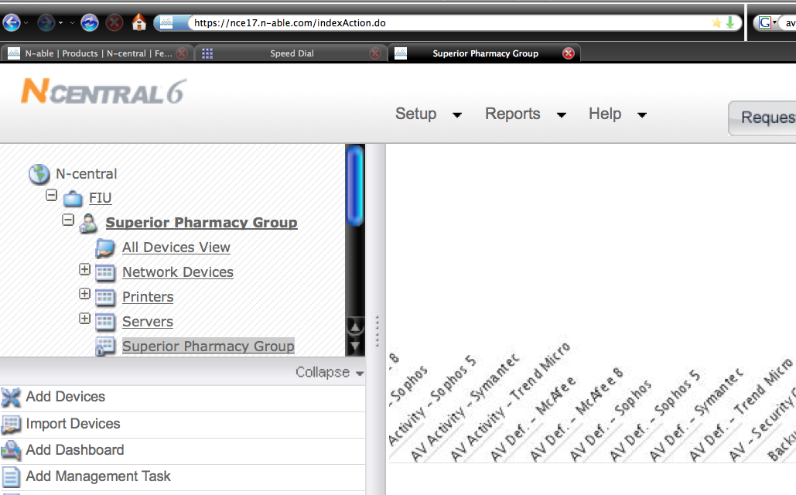
Screen-shot of the Trial Version Used

2.4.7 User State Management:
The cost benefits of User state management cannot be ignored and in today’s IT infrastructure. Focused today on energy efficiencies and cost, the power management feature can remotely shut down idle machines. Remote Environment Manager also allows controlling and preventing access to USB and peripheral storage devices that can bring viruses also. The USB and Port Security option can control read and write access to USB ports, storage and communication devices on the desktop. This is an important feature for differentiation and especially for customers with critical information on their database (N-Central ™ 11).

Remote Support Manager works with any Java-enabled browser and can manage:
- Point-to-point file transfers
- Services, processes and drivers
- File System and the Registry
- Installed applications
- Open files, DLLs and registry keys
- Tasks and alerts

N-Central can create multiple profiles that can be applied based on patented validation logic that allows determining which users and computers receive which configuration settings. There are built in validation tools and can also be customized. Remote Environment Manager is fully integrated with Active Directory and administrators can also use this feature to configure individual user profile (N-Central ™ 12).
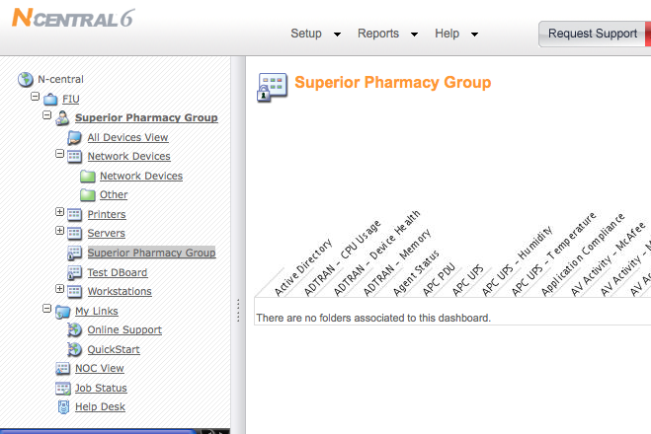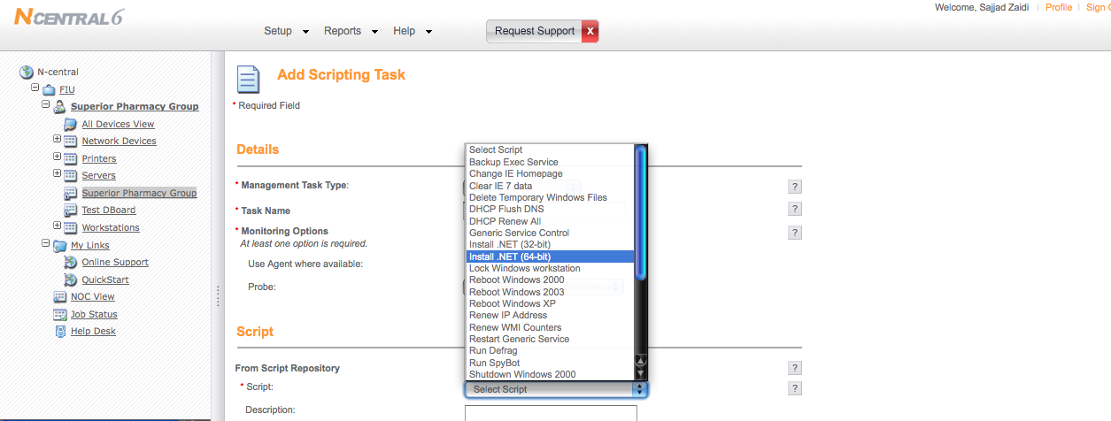
Screen-shot of the Trial Version Used

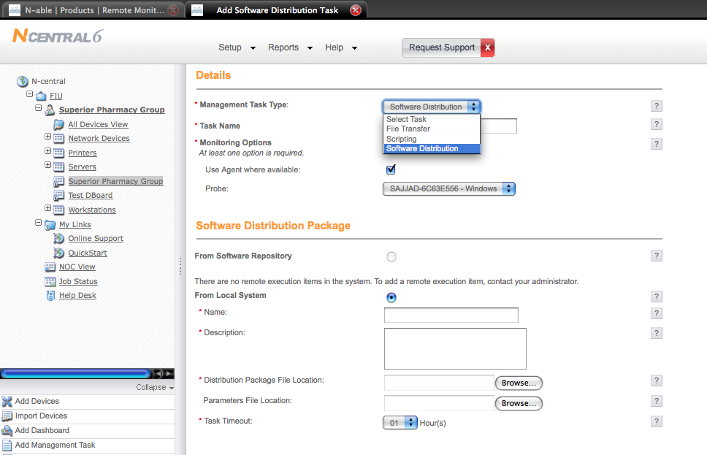
Screen-shot of the Trial Version Used

2.4.8 HELP DESK:
Help Desk can be provided either by N-Central or it can be used by sys admin. Help-desk is NAT and proxy-friendly and makes connecting easy. Users can get help via one-click or an active chat session can be used for this task. The feature available through helpdesk is automated ticket and email dispatch. Remote file transfer or remote monitoring is also available (N-Central ™ 13).

Other Features Include
- Powerful and easy-to-use chat
- Drawing tools
- Sound alerts
- Voice and video communications
- Pre-session surveys to route requests
- Post-session surveys to gauge satisfaction

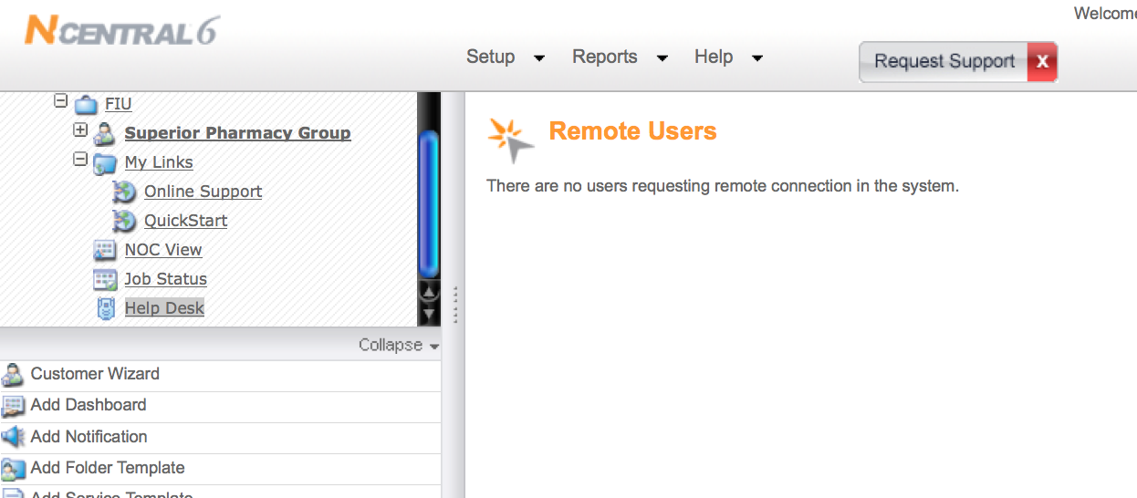
Screen-shot of the Trial Version Used

2.4.9 Usability
A user-friendly web access provides a powerful interface to manage and handle form a complex to a simple task in a very easy manner. The system can be access from a web browser, which does not require any complicated installation.

2.4.10 Reliability
Since the service is accessed through web it is extremely reliable and can be accessed from anywhere, which makes it easier for a Sys administrator’s job extremely easy. All web based MSP’s have the edge over all other solutions that require actual physical installation and are hardware dependent.

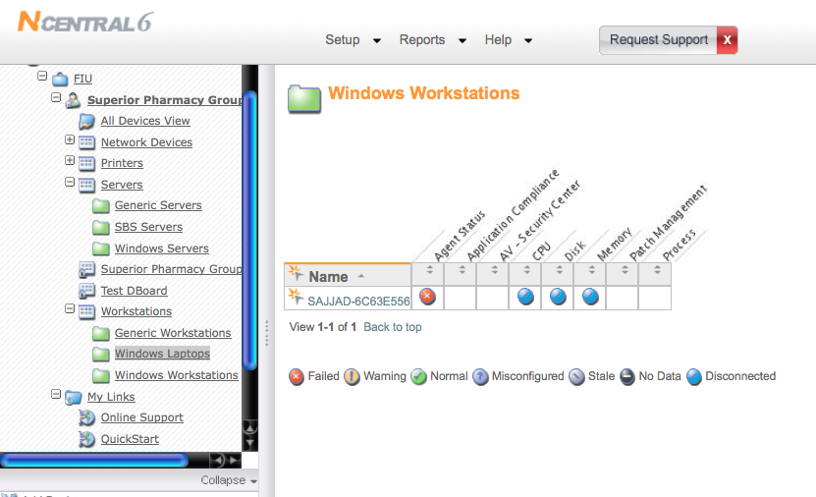
Screen-shot of the Trial Version Used

2.4.11 Performance
Since it is a web based tool all the requirements can be fulfilled without extensive hardware requirement.

2.4.12 Supportability
N-Central Supports all OS platforms, which makes the job easier for as compared to non web-based MSP’s. In short all MSP’s will be providing web-enabled console to better service.

Acknowledgement
I would like to thank NCentral6 for the trial version available free of their website.

Disclaimer
All the information and material obtained for this document is through the software manufacturers website. The trial version used is available free off N-Able’s website. All screenshots posted in this document are obtained after the testing phase. Due to limited recourses at my disposal all the aspects as mentioned in this document have not been tested. The trail version was tested on Mac OSX™ and Windows XP ™.
2.3 Open Source (Fernando Valladares)
Overview:
During hard these hard economic times alternatives need to be found that can fulfill a growing businesses automation needs. Below is a compilation of open source, free ware, and low budget software that can full fill these needs. Open source has been around since the late 1950's with the IBM OS and has led to great accomplishments such as the Internet. Though not all software that will be discussed is free I have made sure to only include software that can be purchased with a one time fee & mostly unlimited in licensing.

2.1 LogMeIn Free (Fernando Valladares)
LogMeIn was developed in Budapest as the Remotely Anywhere product by 3am Labs BT and in 2006 changed its name to LogMeIn Inc. They currently service over 60 million computers & still remain free-ware.

2.1.1 Functional Coverage
This Product works by installing a client on the end users computer. They will then have and icon on the bottom of their screen with the option to enable or disable remote access to their machine (Figure 1.1). This enable option can be locked by adding a password.
Figure 1.1 - showing the disable function of LogMeIn

LogMeIn Free Supports Windows & Mac end stations, as well as PDA devices to actually do the remote control. This version software lack the ability to map drivers, transfer files, or share files but does have another free product that gives you these abilities.

2.1.1.1 Remote Control
In order to remote into the clients you must first log into LogMeIn.com using your registered account. From there you will be given a list of clients that are online, offline, and in session (Figure 1.2).
This can be done through any browser and no manipulation of the router or firewall needs to be made. The reason for this is that the client sends out the signal on port 80 which is typically never blocked going outwards. Another advantage of this software is that multiple people can be logged into a single sessions. As far as security the connection is made through secure 128/256 encryption and you can make as many accounts as you please. This ability to make multiple accounts is important because if one gets compromised the others are safe as long as you use different passwords.
2.2 LogMeIn Himachi
This product was released in 2006 by LogMeIn, Inc. and is free-ware for up to 16 licenses per network. This is not a big draw back for you really only need to have 1 computer per site in with this software in order for this product to be minimally effective.

2.2.1 Functional Coverage
Works by installing the client on the machines you want connected to each other and is compatible with Windows 2000 through Vista, Mac OS-X, & Linux 2.4.

2.2.1.1 Remote Control
This product allows a VPN connection between computers and not having to configure the router or firewall. Simply install the software, which will add a nic card called Himachi (Figure 2.1), and join the specified network which the admin has password protected, and later most accept you request (Figure 2.2).
Figure 2.1 (Above) – View of Himachi NIC next to a regular NIC
Once in the network you must still know the User/Password of the computer to be able to access the files. This product allows drive mapping, sharing & file transfers between computers which makes up for what LogMeIn Free lacks.
2.3 Belarc Advisor
The manufacturer is Belarc whose current president is Gary Newman & Chairman is Sumin Tchen. This product is used on over 20 million PC's worldwide & still remains completely free.

2.3.1 Functional Coverage
This product displays a one time system Audit and is supported on Windows 95 to Vista. This products only flaw is that it lacks an ongoing Audit, but it is perfect for a hard copy of an Audit when a system if first put in place or if it is to be run once a month just to verify any updates it may lack. One can schedule the .exe to run the morning after service pack Tuesday.
2.3.1.2 Auditing & Asset Management
This product works by running a scan on your computer then submitting the information to your browser (Figure 3.1). This is valuable because you can save this scan as a hard copy in case you need some sort of Audit proof later on.
Figure 3.1 – view of Belarc after a scan on Mozilla Firefox
Belarc Advisor displays the OS, Service patches installed & missing, Make & model of the mother board, Memory, CPU, Hard-Drives, Licenses, & Software. At the top of the page one sees the system security status; Bench mark score, Anti Virus, & Missing patches. Below (Figure 3.2) is a close up of Figure 3.1 where one can see that Belarc is informing the user it is still missing 2 windows updates.
Figure 3.2 – Close up of the top right hand corner of the scan
Below this (Figure 3.3) one can find the system information such as the computer name, the date the scan was taken, the version of Belarc, and the user that made the scan.
Figure 3.1 – Audit displaying some of the Hardware
2.4 Advance Network Host Monitoring
The manufacturer is KS-soft and this product is used in over 82 countries, 173banks and 138 universities. Its cost is $300 yearly or you can pay a one time fee of $2,400 which can be used and updated unlimitedly.

2.4.1 Functional Coverage
This software works by installing the client, called the RMA, on the machines you want connected to each other. It supports Windows 2000 and up, Mac OS-X, & Linux 2.4 and is monitored locally on the computer of your choice.

2.4.1.2 Auditing & Asset Management
As you will see below in section 2.4.1.3 this software can actively monitor certain hardware components maintaining an up to date Audit on your systems hardware. For example if you run a daily scan on memory if is missing memory you will get notified via email with a custom message you can make. Figure 4.1 demonstrates the main interface window where one can see current hardware audits.
Figure 4.1 – Line 4 shows the boot drive which you could consider an Audit

2.4.1.3 Monitoring
This product offers 60 tests, 30 alerts, & logging. Some examples of what it can monitor are drive space, memory usage, CPU usage, services, processes, & log files. It also has a built in multi scheduling that you can define and apply to any method being monitored. This is perfect if any sort of maintenance is being performed, for example if you have a method that states that if CPU runs at 80%+ for more then 2minutes send and email. If you are running a Virus scan this can cause your CPU to function high, this would be a perfect example of the multi schedule so that you can turn off monitoring for the CPU during a daily scan (Figure 4.2).
Figure 4.2 – This is the schedule window, green means monitor and red means don't monitor during that specific time frame

2.5 Windows Automatic Updates
Microsoft update was first introduced in windows 98, 13 years after the first version of Windows was released. Windows update can update Patches, Service packs, Drivers and any other Microsoft related software. In 2000 windows introduced Automatic Updates which scheduled updates to be looked for once a day and installed if need be.

2.5.1 Functional Coverage
This software comes on Windows 98 and higher and can pretty much take care of itself. As long as the user schedules automatic updates and makes sure that the PC is not shut off during the time it is suppose to do its updates there should be no problem (Figure 5.1).
Figure 5.1 – typical setup for automatic updates
2.5.1.4 Patch Management
Using automatic updates everything Windows related is patched when new releases come out. Window Automatic Updates how ever does not patch software updates from other vendors so that is something that must be patched manually.

2.6 KLS Back-Up 2008
KLS Soft is a software company founded in 2004. They support only windows products and currently offer KLS Mail Back-Up which is actually not a mail server back up but a profile back that be made from outlook, windows profiles, Mozilla profiles, and internet explorer profiles.

2.6.1 Functional Coverage
KLS Back-Up is installed locally on a user machine where it is configured to run on a specific schedule according to your needs. It is compatible with Windows 200 through windows Windows Vista 32/64 bit. The only feature this software does not have is the ability to do a snapshot of the system. It costs $60 for unlimited licenses.

2.6.1.5 Backup & Disaster Recovery
Some this products key features are: Folder synchronization, Registry Back Up, back up to FTP, & back up plug ins. With its multi scheduling capability you can back up locally on certain days and over a network on the weekends. It also has the capability to do incremental or differential copies and specify the maximum amount of copies to store. This software runs with low CPU usage which is perfect if other programs are running such as a late virus scan. Back ups can also be zipped & password encrypted by KLS upon completion to further increase security. Figure 6.1 – Screen shot of KLS interface where you add files and folders to be backed up.

2.7 Paragon Partion Manager
Paragon Software Group was founded in 1994 in USA, Germany, Japan and Russia. They are partners with Dell, Toshiba, Nec, Siemens, Phoenix, Microsoft, Motorola, and Nokia.

2.7.1 Functional Coverage
This product must be installed on a Windows machine, how ever it can back up any time of drive. It does this by copying every single sector from one drive tot he other. This product has a one time fee of $130 for unlimited licenses.

2.6.1.5 Backup & Disaster Recovery
Like stated above this product can make clone copies of drives by copying sector by sector. This product can also make snap shots of drives, resize, defragment, do a secure whisp (writing zeros on the drive), and much more.
- Figure 6.1 – This is an example of how you would see drive information
This is an advantageous product if you wish to partition drives and store a snap shot of itself on that 2nd partition. If the drive ever goes down you can simply boot into safe mode and restore from the image to the boot partition.
Figure 6.2 – This is the interface where you can restore from one partition to the other
2.8 Microsoft Firewall
Was released with Windows XP & Server 2003 and has been included in all windows new releases since then.

2.8.1 Functional Coverage
The rules in Windows Firewall are not complicated but they do the job for a very reasonable price, free. This product does lack more complicated rules but it really does do the job.

2.8.1.6 End point Security
There is not much to say about this product except that it a software based firewall that allows program and port blocking. It also allows the user to view the logs.

2.9 AVG Free Edition & File Server Edition
Founded in 1991 and have offices in the US and UK. They currently have more than 80 million active users around the world and support multiple OS systems.

2.9.1 Functional Coverage
The free version of AVG can only be installed on end stations, thus a second copy needs to be installed for the servers. 10 copies of the server edition cost you $100 a year.

2.9.1.6 End point Security
This software is used with real time security a long with scheduling of what folders and drives you would like scanned. The built in schedule allows you to customize the scan priority, path (Figure 9.2), along with the days and times you would like the scan to take place. This is extremely convenient because it will not hinder your work flow.
2.10 Corendal Directory
This project was originally started in 2005 and is open source; with version 3.0 released November 29th 2008.

2.10.1 Functional Coverage
It is written in Java and can be used on MySQL and Oracle database environment on a Unix, Linux, or Server 2003 machine. This is perfect if you are using both Linux and Windows systems because you would not need to learn another product, where as if you used Active Directory you would need to learn yet another program if you decided to move to Linux Server.

2.10.1.7 User State Management
Corendal Directory, unlike Active Directory, allows you to view the users including pictures of them (Figure 10.1).
Figure 9.1 – View of a user account along with contact info and pic
This is extremely helpful if there are 2 people in the network with the same first and last name because what Admin is going to memorize someone’s employer ID? Through this software one can edit contact information, change passwords, view groups & members of that group, search for other accounts/contacts, and search for groups, create new accounts/contacts, edit many account/contact attributes, change or unlock passwords.
2.10.1.8 Help Desk
This product handles not only the Use State Management but also Help Desk (Figure 10.2). It has the ability to search for contacts within your business and add notes. There is nothing more convenient then contacting a user who has been locked out and already being able to unlock their account with one click.

Figure 10.2 – Search screen for user information

LogMeIn Free & LogMeIn Himachi™ Acknowledgement
I would like to thank LogMeIn for the free version of their remote control and himachi
https://secure.logmein.com/products/free/
https://secure.logmein.com/products/hamachi/vpn.asp
Disclaimer
All the information and material obtained for this document is through the software manufacturers website. The free version used is available off LogMeIn website. All screen-shots posted in this document are obtained after the testing phase. The free version was tested on Ubuntu Linux, Windows 2000 Professional & Server, and Windows XP ™.

Belarc™ Acknowledgement
I would like to thank Belarc for their free-ware Belarc Advisor
http://www.belarc.com/free_download.html
Disclaimer
All the information and material obtained for this document is through the software manufacturers website. The free-ware used is available off the Belarc website. All screenshots posted in this document are obtained after the testing phase. The free version was tested on Windows 2000 Professional & Server, Windows XP, and Windows Vista Home™.

KS-Soft Advanced Host Monitor™ Acknowledgement
I would like to thank KS-Soft for the free trial version of their host monitoring
http://www.ks-soft.net/hostmon.eng/
Disclaimer
All the information and material obtained for this document is through the software manufacturers website. The free trial version used is available off LogMeIn website. All screen-shots posted in this document are obtained after the testing phase. Due to limited recourses at my disposal all the aspects as mentioned in this document have not been tested. The free version was tested on Windows 2000 Professional & Server, and Windows XP ™.

Microsoft ™ Automatic Updates & Firewall Acknowledgement
I would like to thank Microsoft for their free-ware of Windows patch management.
http://support.microsoft.com/kb/306525
http://update.microsoft.com/
http://support.microsoft.com/kb/875357
Disclaimer
All the information and material obtained for this document is through the software manufacturers website. The free-ware used is available off the Microsoft website. All screen-shots posted in this document are obtained after the testing phase. Automatic updates were tested on Windows 2000 Professional & Server, and Windows 2003 Server & XP ™. Microsoft Firewall was tested on Windows 2003 Server & XP Professional ™.

KLS Backup 2008™ Acknowledgement
I would like to thank KLS for the free trial version of their Backup software.
http://www.kls-soft.com/klsbackup/
Disclaimer
All the information and material obtained for this document is through the software manufacturers website. The free trial version used is available off the KLS website. All screen-shots posted in this document are obtained after the testing phase. Due to limited recourses at my disposal all the aspects as mentioned in this document have not been tested. The free trial version was tested on Windows 2000 Professional & Server, and Windows XP ™.

Paragon Partition Manager™ Acknowledgement
I would like to thank Paragon for the free trial version of the partition backup software.
http://www.paragon-software.com/downloads/demo.html
http://www.paragon-software.com/downloads/manual.html
Disclaimer
All the information and material obtained for this document is through the software manufacturers website. The free trial version used is available off Paragon website. All screen-shots posted in this document are obtained after the testing phase. Due to limited recourses at my disposal all the aspects as mentioned in this document have not been tested. The free trial version was tested on Windows XP ™.

Corendal Directory Acknowledgement
I would like to thank the open source community for this open source project
http://sourceforge.net/projects/corendaldiry/.
http://java.dzone.com/announcements/corendal-directory-open-source
Disclaimer
All the information and material obtained for this document is through the Javalobby website. The open source software used is available off Sourceforge website. All screen-shots posted in this document are obtained from Javalobby. Due to limited recourses & complexity of this software all the aspects as mentioned in this document have not been tested. The open source software was tested on Windows XP ™.

2.6 Comparison and Discussion
Now that we thoroughly identified all of the required functions for each solution, we will now evaluate all of the functions and discuss what stands out about each function. We will use a rating system for the evaluation, the system will have a rating range from 1-5 with: 1-BAD, 2-FAIR, 3-GOOD, 4-VERY GOOD, and 5-EXCELLENT.

2.6.1 Evaluating and Discussing: Numara
Numara has all the necessary IT Automation tools that a company needs, from patch management, to remote control, to even asset management. But one thing that Numara lacks is a Backup & Disaster Recovery tool, another draw back is that you need to install Numara Track-It! as well as all the additional add-ons with a CD, or by downloading the trial version and then purchasing a license.

Remote Control  Rating: 4 | This gets high mark just for its simplicity, installing the Guest/Host interfaces are easy, for the Guest, just go to the toolbar to install it. As for the Host interface, you send and email to the user that has a link for further instructions on how to download. After you finished installing both interfaces, you will need the IP address of the workstation you are trying to access, and then you are ready to connect.
Audit & Asset Mgt  Rating: 4 | You are one click away from getting software and hardware information on a workstation in a matter of seconds. This function is not only limited to workstations, you can get information from routers, printers, laptops, etc. You can assign an icon t o each asset and group them with each respected icon, so you can group all the workstation together, as well as grouping the routers and printers.
Monitoring  Rating: 3 | Its best feature really is its mapping; the Auto Discovery Wizard will automatically scan your entire network (as long as you supply a range of IP addresses) and will populate the entire map. You can keep a close eye on all the workstations hard drive space via scripts, when a workstation goes down, you can be notified on your smart phone that the network is down.
Patch Mgt  Rating: 4 | The templates are a nice feature running on Numara Patch Manager, you can apply restrictions on what you want to scan as well as setting a schedule on when you want the workstation scan. The GIU is very easy follow, naming the workstations and applying the IP address for each workstation is fairly quick and easy. When scanning is complete, the summary page can be very helpful as it states all the critical and important patches that are missing.
Backup & Disaster Recovery  Rating: 3 | Affordable and easy-to-use, Norton Online Backup stores your files at an off-site location, so if a disaster were to occur, you can retrieve the files anywhere, from any computer, as long as you have the required web browser.
Endpoint Security  Rating: 3 | Numara really cares about its security and does everything possible to make sure you are protected. It makes sure that every Host workstation is protected against unauthorized access by checking to see if every MAC/IP address is allowed permission to connect to your computer via a restricted predefined list of all the MAC/IP address that are not permitted to access the host. If a company uses Active Directory, the guest will be authenticated against Microsoft Server 2003.
User State Mgt  Rating: 3 | With a combination of Numara Remote and Active Directory, you can manage any workstation the way the company sees’s fit. With Active Directory, you can restrict downloads and websites, by adding Numara into the mix, you can keep a Windows Event log that keeps tabs on all the websites that users have visited.
HelpDesk  Rating: 5 | An easy to follow user interface, if you had experience with Microsoft Outlook. The help desk ticket system (work orders) is top notch, very easy to use and follow, identifying which work order was viewed and which wasn’t can be easily followed. The priority numbers are a really nice touch, you can view which of the orders are of importance. The solution function is a plus, you now have the option to save and make accessible to other users the solution to problem.
Usability  Rating: 3 | You can run all of the applications simultaneously without any lag whatsoever. All the applications are very user friendly; each application has its own wizard, showing you a step-by-step procedure on how to manage each application.
Reliability  Rating: 3 | Numara is reliable in all of its functionalities, though, it is important that all of the workstations are functioning properly. During the investigation, not once did the Numara software crash.
Performance  Rating: 3 | Since Numara Track-It! and its additional add-ons are installed thru CDs, you have to make sure that you meet the minimum requirements for Numara to run smoothly, if you don’t, the applications can be a little sluggish.
Supportability  Rating: 4 | Numara Software’s support anything that is Windows based (i.e. Windows XP & Vista, Windows Server 2003, etc.), but Numara does not support MAC OS and Linux.

2.6.2 Evaluating and Discussing: Nagios
For what Nagios was intended to do (monitoring), it does a fairly good job. Some of the strengths it has are it easy to use interface and very simple to understand scheme. If something that is being monitored goes bad, it turns red and the word critical is written in it, if something is good it turns green, plain and simple. The weaknesses though I must say outweigh the strengths. For starters, it isn’t an all in one solution. The administrator has to look into other solutions to take care of various other aspects such as remote control, auditing, patch management, backups, end point security, user state management, and help desk. If it came integrated it would be a better deal. There is one thing that goes both ways, it can be considered as a weakness and also strength, and that is its ability to be customized in regards to what it monitors. It goes both ways because for somebody that needs a solution to be up and running out-of-the box it’s a nightmare, but for someone that has the patience and needs to customize monitoring then this is a perfect tool for that individual.

Remote Control  Rating: 3 | Nagios does not come with built in Remote Control features. Rdesktop would be the next best thing since it usually comes pre installed in most Linux distributions. If not it’s a simple download and a very straight forward application. The only other configuration would have to be turning on the remote desktop feature on the workstations running windows.
Audit & Asset Mgt  Rating: 4 | Nagios does not come with Auditing and Asset Management built-in capabilities. But, from what I read Nessus can be used as a possible alternative to gathering system auditing data. Nessus receives a high rating because from the information gathered I realized that it’s a very powerful tool. It’s capable of gathering an extensive amount of information when it comes to enumerating a workstation.
Monitoring  Rating: 4 | Nagios’s main feature and what it was designed to do. The reason I gave it a four is because it has a very easy to use web based interface. You click on a link and it displays the information on the web browser in a very clean and easy to understand format. It also has a four because it’s very customizable when it comes to what you want it to monitor. The flexibility in monitoring is due to the fact that there are various plug-ins that can be downloaded and configured to whatever service it is that you want to monitor.
Patch Mgt  Rating: 2 | Although Nagios does not come with built in support for patch management, I read online that an administrator can configure Nagios to use the NSClient++ plug-in to check for windows updates. I gave it a rating of 2 because it’s not a very user friendly feature. The administrator has to configure the patch in order to make it have that feature. Other solutions might have this feature out of the box and might require less work. And even with the notification of the patches that are needed, the administrator would still have to find a way to apply these patches.
Backup & Disaster Recovery  Rating: 3 | Once again Nagios fails to impress me with the lack of a backup and disaster recovery solution already implemented into the program. The administrator is forced once again to search elsewhere to find a solution to take care of backup and disaster recovery. One recommended solution to counter the lack of backup and disaster recovery would be Bacula.
Endpoint Security  Rating: 3 | Nagios fails us once more with the lack of an integrated endpoint security system. To make up for it the administrator has to seek help elsewhere. Nessus as mentioned before can be used as a great auditing tool, and also as a vulnerability scanner. So with the combination of Nessus and perhaps virus scanner such as Kaspersky , the administrator could have his bases covered when it comes to endpoint security.
User State Mgt  Rating: 2 | User state management is another feature not included in Nagios. But there is hope if you look into other separate solutions that can assist you alongside Nagios and provide user state management functionalities. Smbldap-tools, Samba, and OpenLDAP combined and when configured properly, according to the website in the reference, can be used as to assist you in user state management.
HelpDesk  Rating: 3 | Nagios does not come with a help desk solution. But other software such as Eventum can be used to support with help desk. Eventum, according to the it’s wiki website, is a web based application and issue tracking system that can be used to track technical support requests and can prioritize and organize the issues. It’s seems very simple, looks like it has a very user friendly interface and alongside Nagios and ten other different tools it should make a great solution for help desk.
Usability  Rating: 3 | Once Nagios has been installed it is fairly simple to use. You open up a web browser and type the url that is hosting Nagios. After that you are prompted with a window to enter a user name and password, and then you are in. The web interface is really clear and the information displayed is comprehensible. It serves its purpose as a monitoring solution and has very simple take on letting you know if something is wrong (usually something displayed in red). The only usability issue that I have with it is the constant having to configure components, such as the Nagios configuration file, plug-ins, and agents. This can go both ways because it can be great if you need to customize the software and tailor it to your monitoring needs, but then again if you need a more complete out-of-the-box solution this doesn’t really help.
Reliability  Rating: 3 | I’d say It’s reliable for the monitoring it does. Every once and a while though, during its refreshing state Nagios tends to switch around the status of the items being monitored. It could be due to network performance and the refresh rate.
Performance  Rating: 3 | As mentioned before it’s a simple web based application. As long as there is good network connectivity and the system that is on isn’t lagging, it works like a charm.
Supportability  Rating: 1 | Nagios is supported by the developer’s website, but you have to pay to get the support.

2.6.3 Evaluating and Discussing: LANDesk
LANDesk has extensive IT Automation tools that any company would want from comprehensive patch management, accurate asset management, and great add-on services that extend IT automation possibilities. On the contrary, it lacks an adequate backup and disaster recovery tool and makes you have to look into third-party backup tools.

Remote Control  Rating: 5 | The LANDesk Management suite provides a powerful remote control and problem solving solution which help you reduce costs, and decrease the demand on help desk resources. With LANDesk’s remote control, you can perform maintenance and repairs anytime on the network with remote reboot, remote wake and remote application launch.
Audit & Asset Mgt  Rating: 4 | LANDesk has a powerful IT asset management utility, which you can add to LANDesk Management suite, which helps you manage devices across your network. You can easily plan upgrades and respond to audits in an efficient manner. You can easily track both hardware and software inventory, and track software usage.
Monitoring  Rating: 3 | LANDesk System Manager maximizes computer performance, availability and security. You can extract data directly from the system hardware, OS and software components in real time. You can track anything from CPU usage, to different voltages, to fan speeds, and even if different users remove peripherals from the machines.
Patch Mgt  Rating: 4 | LANDesk Patch Manager lets you actively scan your managed computers to identify application and operating system vulnerabilities.
Backup & Disaster Recovery  Rating: 1 | Has no built-in backup and disaster recovery tools.
Endpoint Security  Rating: 5 | LANDesk has a very powerful security suite and its vulnerability scanning lets you detect threats. Custom scans let you define the specific conditions scanned for, and the Virus Pilot Deployment tool allows you to selectively and rapidly deploy virus definitions files on a limited basis so you can validate whether the integrity of the definitions are valid.
User State Mgt  Rating: 2 | By implementing Active Directory Application Mode (ADAM) we can control resources, services and users. We can implement policies amongst users and control what resources are available to every user.
Help Desk  Rating: 4 | LANDesk has a very easy user interface the clients can use to log and ticket potential problems. The problem database is useful because users can find answers to their problems if they have been logged in before.
Usability  Rating: 3 | LANDesk is very easy to use, and once you incorporate all the services that you can subscribe to, it’s a very powerful tool for any company.
Reliability  Rating: 3 | LANDesk seems like a very reliable IT automation option, but could be too intricate for the needs at superior pharmacy.
Performance  Rating: 3 | As long as a dedicated server is used to run the LANDesk Management Suite, no lag should be expected.
Supportability  Rating: 3 | LANDesk supports all types of major operating systems.

2.6.4 Evaluating and Discussing: N-Central
N-central has all the necessary IT Automation tools that a company needs, from patch management, to remote control, to even asset management. The missing element is that it’s the complete package and lacks built-in backup and endpoint security solution. This aspect is achieved through the installation of third party solutions such as Backup Exec and Trend and McAfee. Even though these services provide complete solutions in their areas of expertise but it spikes up the cost and may get out of clients budget.

Remote Control  Rating: 3 | The proprietary built in Java based client is an excellent tool that enables excellent remote mentoring capabilities and also has common across the board clients
Audit & Asset Mgt  Rating: 3 | Probe based agent picks up all IP enabled devices and its convenient and easy to build Assets within Minutes
Monitoring  Rating: 4 | Its best feature really is its mapping, the Auto Discovery or probe will automatically scan your entire network (as long as you supply a range of IP addresses) and will populate the entire map. You can keep a close eye on all the workstations hard drive space via scripts, when a workstation goes down, you can be notified on your smart phone that the network is down.
Patch Mgt  Rating: 3 | The GIU is very easy follow, naming the workstations and applying the IP address for each workstation is fairly quick and easy. When scanning is complete, the summary page can be very helpful as it states all the critical and important patches that are missing.
Backup & Disaster Recovery  Rating: 3 | Does not provide built in client but third party software are enabled to perform the task
Endpoint Security  Rating: 4 | Trend, McAfee third party solutions are integrated which may or may not be cost beneficial but are complete solutions with respect to their areas of expertise
User State Mgt  Rating: 3 | N-Central implements and applies numerous options for MAC/IP monitoring as well as Active Directory integration. This makes is easier to configure and control access control to the subnet
HelpDesk  Rating: 3 | Easy to access Helpdesk and remote management. Where useful features like Chat, Drawing tool ad file transfer makes it a user friendly feature
Usability  Rating: 3 | Operates on all Major OS and web based console provides access to a system from any where.
Reliability  Rating: 3 | Non Hardware dependence makes N-Central state of the art secure and reliable web enabled console
Performance  Rating: 4 | Zero hardware depended web based console has flawless performance.
Supportability  Rating: 3 | Supports all Major OS in the market and has scalability of major platform update

2.6.4 Evaluating and Discussing: Open source, free ware, low budget
This bundle of software’s is the perfect solution for a facility looking to save up as much money as possible in the long run. What ever money that is spent in this package is mostly one time fees for unlimited computers, which is a smart investment. Some may argue that having multiple software’s is bad due to the learning curve that is required, but there are plenty of benefits in a multi software environment to the company supporting it. Having multiple software’s not only assures job security but also system up time. It assures job security because learning the software takes time that many companies may not want to spend time and money on. It assures system up time because if for example an “all in one solution” gets corrupted you lose all functions. In a multi software environment the corruption of one software does not hinder the other IT Automation solutions.

Remote Control  Rating: 3 | This combination of software gets the job done and having one account per site assures security. It is versatile in the sense that almost any browser can be used to remote in to Mac & Windows machines. The only thing this lacks is the ability to transfer files from a computer outside the VPN. This can also have a problem if the client is ever un-installed from the computer.
Audit & Asset Mgt  Rating: 4 | This combination of software’s ensures that not only the client knows if there is a problem but also prompts the IT department as well via emails. Belarc can be scheduled to run on specific day of the week to notify users that they may be missing patches. Belarc can also be run upon on-site installation of the PC to take note of what hardware is installed. After the 1st audit is made the information can then be plugged into Advances Network Host Monitoring to perform daily audits of the hardware on the machine
Monitoring  Rating: 4 | This software’s ability to actively monitor hundreds of computers, have individual schedules per location and PC, and receive emails depending on your rules make this software very complete. The price on this software is also decent $2,400 for unlimited computers & the license never expires. Personally if this software was open source it would have won a Rating of 5.
Patch Mgt  Rating: 3 | This comes default with windows and works well most of the time if the computer has a scheduled update and install date. Users must make sure to leave their computers on so that the schedules can take place. The only draw back is that the IT department has no real way to know if the installation took place or not. It is left up to the user and the Belarc audit pop up.
Backup & Disaster Recovery  Rating: 5 | This combination of software costs $90 for KLS Back Up Pro & $75 for Partition Manager is honestly the best back up soft ware I have ever used. Not only does it have very detailed scheduling on the KLS side but Partition Manager can do so many operations I would need another report on just it. This combination is the perfect duo for backups and disaster recovery.KLS should be set up to back up data bases and Partition Manager set up to do OS back ups.
Endpoint Security  Rating: 4 | This combination is the bare minimum that the facility should have but it does have a very appealing price, free. I have been using AVG for years and it does a really decent job of protecting against viruses. As far as Microsoft Firewall goes it also does a decent job of blocking programs that should not be running. This combination is good for saving money and protecting your client’s information. The worst thing that can happen is that a system does get infected and you get an AVG pop, then you just restore the OS image and you’re good once again.
User State Mgt  Rating: 4 | Through this software one can edit contact information, change passwords, view groups & members of that group, search for other accounts/contacts, and search for groups, create new accounts/contacts, edit many account/contact attributes, change or unlock passwords. This product is honestly in my opinion better then active directory.
HelpDesk  Rating: 4 | This software has a decent help desk. It has the ability to look up contact information and since it has a build in user state Management you can fix the problem quickly while you are on the phone with the client.
Usability  Rating: 3 | Since there are multiple software’s running together there is a steep learning curve. You need to have plenty of time to fully learn the programs and later explain how to use it to the ends users.
Reliability  Rating: 4 | This is really reliable since you are not fully dependent on just one software. If like stated in his intro one software stops working not all functions are lost. The fact that you lose you backup doesn't mean you lose your remote log in ability, thus you can log in and fix the back up.
Performance  Rating: 3 | This software compilation performs well but does have the drawback that CPU usage can interfere with each of the programs performance. If you are running a back up and AVG kicks in then your back up might take a lot longer.
Supportability  Rating: 2 | The supportability of this compilation is a bit hectic. If multiple software’s have a problem you are stuck calling multiple support number and turning a 1 hour phone call into multiple hour phone calls.

Rating Results Explanation/Discussion:
Individual Solution Comparison Rating System Table
 | Numara | Nagios | LANDesk | N-Central | Open Source
Remote Control | 4 | 3 | 5 | 3 | 3
Audit & Asset Management | 4 | 4 | 4 | 3 | 4
Monitoring | 3 | 4 | 3 | 4 | 4
Patch Management | 4 | 2 | 4 | 3 | 3
Backup & Disaster Recovery | 3 | 3 | 1 | 3 | 5
Endpoint Security | 3 | 3 | 5 | 4 | 4
User State Management | 3 | 2 | 2 | 3 | 4
HelpDesk | 5 | 3 | 4 | 3 | 4
Usability | 3 | 3 | 3 | 3 | 3
Reliability | 3 | 3 | 3 | 3 | 4
Performance | 3 | 3 | 3 | 4 | 3
Supportability | 4 | 1 | 3 | 3 | 2
Availability | 2 | 5 | 3 | 3 | 4
Price | 1 | 5 | 1 | 2 | 4
Total | 45 | 44 | 44 | 44 | 51

3. Selecting a Solution

Target Organization’s Problem Overview:
Superior Pharmacy Group is a chain of five small independent pharmacies that are both closed, and open door pharmacies. The pharmacies have been operating for about three years and have a total of five thousand patients. At the five locations, there are a total of ten user stations (Windows XP), and two servers (Windows Server 2003), a domain controller and an application server. The pharmacy relies heavily on IT because all the workstations are used daily for data entry, accessing patient databases, accounting files, managing inventory, and accessing the internet to look up patient insurance and third party information. There is an average of 100 claims every hour per workstations, so any potential downtime on the internal network or on the workstations themselves can be detrimental to productivity resulting in major problems such as insurance claims back-ups while in queue. Consequentially, the pharmacy is then unable to be reimbursed appropriately, leading to poor customer service and a reduction in profit, both are something a pharmacy needs to avoid in order to remain viable. The pharmacy, at this point, has poor security management regarding patient databases, which can cause major issues with HIPAA regulations. Other issues that can be detrimental to Superior Pharmacy is the lack of disaster recovery plan in place, no snapshots are taken for each workstation and no UPS system in place. Logging in to each workstation to gather data can be tedious, the IT Administrator would have to know the IP address of the workstation he is trying to access, log in to the server, then log in to the workstation. Workstations located at one of the locations were infected by Trojans, due to its out-dated virus definitions, many users were downloading files from peer-to-peer sites like Bit Torrent, increasing the risk of getting infected by a virus. If it wasn’t downloading files from Bit Torrents, then it was listening to music from iTunes, or logging in to Facebook. Since none of the workstations were monitored, the iTunes library was using a lot of the workstations disk space.

3.1 Remote Control
Logging into a workstation remotely can be very tedious, first, the IT Administrator would have to know the IP address of workstation, second, you would have to log in to the server, and third, log in to the workstation.

3.1.1 Numara
The IT Administrator will need to deploy a Guest Interface on his workstation as well as a Host Interface on the workstations and domain server to initiate remote access between Guest (IT Administrator) and Host (user). You can still connect remotely thru IP address, but it’s more efficient to use computer names for each workstation and server for each site. To retrieve files at a more efficient rate, you can create a script to back up the files from a workstation to the domain server, so you won’t need to log in individually to all the workstations to retrieve the data.

3.1.2 Rdesktop (Nagios)
Rdesktop would be able to address the pain of logging into remote workstations. All the administrator would have to do is figure out the IP address of the workstation he needs to log into. The only downfall would be the ability to transfer files to and from the workstation. Rdesktop does not support file transfer.

3.1.3 LANDesk
With LANDesk’s remote control, you can perform maintenance and repairs anytime on the network with remote reboot, remote wake and remote application launch. This would be a great help to superior pharmacy since all locations are spread throughout the city and application installation would be an ease.

3.1.4 N-Central
Probe enabled remote control has the ability to configure discover and manage all IP enabled devices on the network. This makes it easier to build, monitor and do asset management not time consuming. This feature also allows remote discovery of assets not connected to network at all times.
3.1.5 LogMeIn Free & LogMeIn Himachi
This combination of solutions is perfect for Superior Pharmacy since they have 5 locations they can create 5 accounts, 1 per location. The creation of multiple accounts ensures that if Site A's account gets hacked the others are not compromised. If files need to be transferred they can use Himachi to transfer them. LogMeIn free can pretty much be used by anyone who has the slightest bit of IT knowledge. This software is perfect if you don't want to spend time setting up firewall setting in order to allow remote access.

 | Numara | Nagios | LANDesk | N-Central | Open Source
Remote Control | 4 | 3 | 3 | 3 | 4
Explanation | See Above | See Above | See Above | See Above | See Above

3.2 Auditing & Asset Management
There is no hardware inventory management on the current systems. Workstations use QS1 PrimeCare that requires a minimum of 1GB of memory. Several months ago, one of the memory sticks failed. This slowed down the workstation causing a lag that resulted in the dispensing of prescriptions to be delayed by one hour. Another example, Site C purchased new workstations that needed to install QS1 PrimeCare. The IT administrator had a difficult time with the installation since the computer did not have the minimum requirement needed for optimal operation. QS1 PrimeCare requires Windows XP SP2 which was already installed in the current machines, but the new workstations came with Windows XP SP1 pre-installed resulted in the IT administrator occupied at Site C, unable to manage any other sites if problem occurred there.

3.2.1 Numara
The asset management function already included in Numara Track-It! is perfect for keeping inventory on all the hardware and software in Superior Pharmacy. You should capture all the hardware information and software installations for each workstation and server, properly name the computer and assign the user who uses that specific workstation and print out a report so you can keep for future reference, so the next time you need to purchase a new workstation for a specific user, you will have the documentation of what the previous workstation had and eliminating the problem that occurred in Site C.

3.2.2Nessus (Nagios)
Superior Pharmacy might definitely benefit from using Nessus as an audit and asset management solution. Their website had examples of extensive and finely detailed reports generated by Nessus that would greatly aid Superior Pharmacy’s administrator in keeping track of what operating system is installed, if it has the correct service packs needed and give him an account of what hardware is installed on any given workstation.

3.2.3 LANDesk
LANDesk has a powerful IT asset management utility which would benefit superior pharmacy. Its in depth capabilities would help track all types of hardware audits, and most importantly it would help the IT administrator monitor software licensing.

3.2.4 N-Central
SPG will be able to monitor Hardware installed software and keep and maintain the Licenses. In order to be HIPPA compliant the software should be up to date and will be provide the administrator the exact know how if the mission critical software up-to-date
3.2.5 Belarc & Advance Network Host Monitoring
Using Belarc when the new PC was installed in place would have let the IT department know right away that the computer was missing a service pack & perhaps maybe some memory. If Advance Network Host Monitoring would have been in place the IT department would have received an email notifying them that the computer was missing memory, therefore deducting that the memory had gone bad or had been taken.

 | Numara | Nagios | LANDesk | N-Central | Open Source
A&A Management | 4 | 4 | 4 | 3 | 3
Explanation | See Above | See Above | See Above | See Above | See Above

3.3 Monitoring
The lack of monitoring has caused issues in the past such as workstations running out of hard disk space due to peer-to-peer downloads from Bit Torrent. One of the workstations located at Site E had an iTunes library utilizing 5GB of hard drive space. Low hard disk space can result in issues when trying to access the pharmacy’s software, QS1 PrimeCare. Some users were logged into social networks, like Facebook, chatting online with there friends, instead processing patient prescriptions.

3.3.1 Numara
Numara Network Monitor is able to monitor the health and performance of the network. Since some workstations in Site E had disk space used up by the iTunes library, being able to monitor the disk space for each workstation is key for better workstation performance. You can do a “search and destroy” on the Site E workstation that had iTunes and remove the software, a good way to free up space on the hard drive. You will be able to keep in check the users who log in to “Facebook” on their workstations by viewing the Windows Event Log that is created. You can also create security policies thru Active Directory, restricting the access to those types of social network websites.

3.3.2 Nagios
Nagios is a perfect tool for monitoring Superior Pharmacy’s network. In the past they mentioned they had issues with running out of disk space. Nagios can not only monitor the disk space usage, but it can be configured to alert you whenever it reaches a predefined amount of free space left.

3.3.3 LANDesk
LANDesk System Manager maximizes computer performance, availability and security. You can extract data directly from the system hardware, OS and software components in real time. You can track anything from CPU usage, to different voltages, to fan speeds. You can capture this data over time so you can predict trends and avoid problems before the system crashes. This would be an asset to superior pharmacy because we can’t afford to have any potential downtime at any of the pharmacies.

3.3.4 N-Central
With inventory of all available hardware and software this feature will allow SPG to monitor if any un authorized software is installed and in use which is using system resources. This is the most beneficial feature available that must be implemented for unauthorized or unlicensed use of software that can cause system crash, which usually occurs at SPG’s remote locations. HIPPA compliance is the most important aspect of Superior Pharmacy and this feature implementation is a must.
3.3.5 Advance Network Host Monitoring
With this software you can quickly tell if a hard-drive is low on space because that is one of the many tests you can perform. Superior Pharmacies can have their memory, network, websites, hard drives, CPU monitored constantly. This will assure that the pharmacies are running at optimal performance and that clients will not have to be waiting long periods of time because systems are acting erratically.

 | Numara | Nagios | LANDesk | N-Central | Open Source
Monitoring | 3 | 4 | 4 | 4 | 5
Explanation | See Above | See Above | See Above | See Above | See Above

3.4 Patch Management
Workstations are not up-to-date with software updates. New workstations purchased for Site C did not have the latest service packs installed, Windows XP SP3, but instead came with Windows XP SP2. This service pack is important because Windows XP SP3 is one of the requirements for installing QS1 PrimeCare. When the user tried to install QS1 PrimeCare it resulted in an error, and not until the third try did the user contact the IT Administrator. This slowed down productivity, delaying the processing of the patient’s prescription even further.

3.4.1 Numara
With Numara Patch Manager, you no longer have to be physically in front of the workstation scan and see if it is missing any patches. You can scan for patches for any workstation that is connected to the network from a central console. Since Superior Pharmacy uses Microsoft XP on workstations and Microsoft Server 2003 on their servers, on the second Tuesday of each month, Microsoft releases there security patches. So it would be best to schedule a recurring scan on the second Tuesday of each month, after working hours. The workstations that were missing the latest Service Pack will now be updated, thus able to install QS1PrimeCare. Setting up a patch scan other than patch Tuesday would be necessary, since a few workstations had out dated virus protection, the workstations will be up-to-date with the latest virus definitions.

3.4.2 Nagios
Nagios is definitely not that strong when it comes to patch management. I read that there was a plug-in that can alert you when there are new patches available, but to do the actual patching on the system, you would have to remote into the computer and update it manually. So this solution would definitely not be able to help Superior Pharmacy.

3.4.3 LANDesk
LANDesk’s Security Suite offers a comprehensive patch management solution that lets you keep up to date across different operating systems. You can easily automate the patch management process with the inclusion of LANDesk Process Manager Automated Patch Deployment. You can set up new patches to automatically update and include this as part of your on-going process at different pharmacy locations.

3.4.4 N-Central
SPG’s backbone software QS1 PrimeCare requires XP service pack 3 to run efficiently and if and all any of the patches missing can be detected by N-Central that will eliminate the hassle of SYS admin manually updating each machine. N-Central unique WSUS feature will get the job done.

3.4.5 Windows Update
If Windows updates had been properly configured on the QS1 PrimeCare stations this problem would not have occurred. Windows would have done its usual update and install, thus patching all the machines in the network. As long as the IT audits the machines on a regular basis for patches this is a completely viable solution.

 | Numara | Nagios | LANDesk | N-Central | Open Source
Patch Management | 4 | 2 | 2 | 3 | 2
Explanation | See Above | See Above | See Above | See Above | See Above

3.5 Backup and Disaster Recovery
We encountered a frail disaster recovery plan in place. Back ups are being performed every Sunday at 2 AM & there are no snapshots of user workstations. This can lead to a huge problem because if a server loses its data drives all the patient information for that week would be permanently lost. One of the pharmacies encountered a power failure and after the power came back, the user’s hard disk was hit by a surge of power, rendering it useless. This situation could have been avoided by using a UPS. Since there is no snapshot of the drive, everything had to be manually re-installed and reconfigured. This took up two days of the IT administrator’s time, compromising all the other sites whereas if the proper procedures for recovery had been in place, the situation could have been resolved in a few hours.

3.5.1 Windows XP Backup & Norton Online Backup
With Windows XP Backup you can backup all the important files to either a hard drive or CD, you can set a recurring time for each backup. As far as disaster recovery, instead of going with a UPS to avoid the possibility of a power surge, you can use Norton Online Backup. This solution is web-based, so the files will be backed up to a secure site at a different location.

3.5.2Bacula (Nagios)
Superior Pharmacy lost one of their hard drives with all the data inside of it due to a power surge. This could have been avoided had they had a backup and disaster recovery solution such as Bacula. Bacula would have backed up any irreplaceable data in another server, or network drive. They would also benefit from Bacula because it’s free and is supposedly a complete backup solution.
3.5.3 LANDesk
LANDesk does not offer a fully offer a backup and disaster recovery utility, but instead uses the LANDesk Management suite tool called Imagew.exe. It is a tool that can capture an image of a hard drive while Windows is currently running. The problem with this is that you need to install additional tools so the process can work. At superior pharmacy it’s crucial for an efficient backup, and this does not seem like a valid option for the pharmacy. We would need a more detailed backup solution , for example one that can provide incremental backups.

3.5.4 Backup Exec (N-Central)
QS1 PrimeCare requires hourly backup incase the data is lost. In case of power surge or any other disaster Backup Exec feature will help restore data with in no time and pharmacy will be up and running. This way there will be no downtime and orders will not pile up.

3.5.5 KLS Back Up & Partition Manager
KLS Backup can perform FTP Backups removing any need of backing up to a local USB hard-drive which is what is currently in place. If the server is hit by a surge of power not only the local drives can go bad but also the USB one hooked up to it, so you can see the FTP backup though slower is much safer. If the machines hard-drives are ever compromised again Partition Manager can be used to restore a snapshot of the OS, bringing the Pharmacies Server or PC back up in no time. This is crucial because if the server goes down the pharmacy loses business till it comes back
 | Numara | Nagios | LANDesk | N-Central | Open Source
Backup & Disaster | 2 | 3 | 1 | 3 | 5
Explanation | See Above | See Above | See Above | See Above | See Above

3.6 End-Point Security
Complying with HIPPA is the most critical aspect of the pharmacies IT policy management. Data handled by all pharmacies is extremely important and breach can lead to major lawsuit and financial penalties. Strict policies are required for handling sensitive data and encrypting software is required for this task. Site C had none of its virus definitions updated. Three of the technician workstations were infected with a Trojan because of forwarding infected emails. An up-to-date virus protection solution would have scanned the file and let the user know of the security risk. This is the first line of defense, followed by the system monitoring as stated in issue two. Without these systems in place, the patient information is at risk as and the workstation is unproductive until all viruses are eliminated.

3.6.1 Numara
Complying with HIPPA is crucial; a breach of patient data can lead to possible lawsuits and financial penalties. With the security provided by Numara Remote, the user can block an outside intruder trying to log in to the workstation. The user can deny any request, especially from an IP address that you don’t know. With Numara Deploy, you can install the latest virus updates for the workstations without interfering with the work environment, since the installation will occur in the background. Having the latest security patches for the operating system is important; with Numara Patch Manager you can scan the machines that are missing the security patches for Windows XP.

3.6.2 Nessus/Kaspersky (Nagios)
Nessus might serve as a superb solution for end-point security at Superior Pharmacy. It is said to have a security scanning feature that lets you ultimately know what operating systems patches your system needs and what vulnerabilities exist on each workstation. In combination with Kaspersky as an auto updating anti-virus, Superior Pharmacy would better protect in case of any future security threats.

3.6.3 LANDesk
LANDesk’s antivirus, which is part of the security suite, works alongside standard industry software so you can use antivirus solutions you already have like Norton and AVG. In addition it helps you determine whether scanned files are up to date and whether real time protection is enabled on each managed machine. LANDesk antivirus has a tool called Virus Pilot Deployment which allows you to selectively and rapidly deploy virus definitions files on a limited basis so you can validate whether the integrity of the definitions are valid. Since none of the machines at any of the pharmacies are currently patched, this would greatly help.

3.6.4 Trend Micro, Symantec and MacAfee (N-Central)
With the latest Antivirus software feature available like Trend Micro, MacAfee and Symantec the IT infrastructure will be safe and SPG will benefit from it by keeping its database QS1 PrimeCare safe. This will ensure HIPPA compliance.

3.6.5 Microsoft Firewall & AVG Anti Virus
At site C the problems could have been avoided by installing AVG & configuring the firewall to block common torrent software such as bit torrent. Patient information is really sensitive and having virus protection, even free software is vital. From experience AVG does a really decent job in not only updating but scanning as well. Superior Pharmacy can save money and not compromise security by installing this software.

 | Numara | Nagios | LANDesk | N-Central | Open Source
End Point Sec. | 4 | 3 | 3 | 4 | 3
Explanation | See Above | See Above | See Above | See Above | See Above

3.7 Users-State Management
All the workstations in Superior Pharmacy had Admin Access, users had access to all software and were running applications like Bit Torrent. If for any moment the user(s) were careless, the torrents could be infected with a virus. Some users were logged in to Facebook while they were still on the clock, while others were listening to music on their iTunes application.

3.7.1 Numara
One of the aspects of Numara Remote is user state management. Each location at Superior Pharmacy will have its own standard workstation; you will be able to apply security policies that comply with HIPPA regulations. Internet access will be restricted to some users; all workstations will not be aloud to download anything that’s iTunes and Bit Torrents. You can keep a close eye on all website activity going on with the Windows Event log.

3.7.2 Smbldap-tools, Samba, and OpenLDAP (Nagios)
The combination of Smdldap-tools, Samaba, and OpenLDAP combined, from what I read on their website (see reference) would be able to provide a user-state management solution for Superior Pharmacy. But if they had to choose between said solution and just configuring user accounts on each individual workstation, I’d say I recommend them going with the other.

3.7.3 LANDesk
All computers in superior pharmacy group use the built in administrative account, and this is an issue because they can install and download whatever applications they want. By using active directory, we can create user accounts, and restrict access to certain users.

3.7.4 N-Central
With this feature in place Superior pharmacy remote locations can be monitored with ease. N-Central can deploy script that can monitor remote locations of SPG and can also reduce power cost.

3.7.5 Corendal Directory
The ability of Corendal Directory to handle accounts with such easy and detail makes it a very powerful solution. If Superior Pharmacy needs to have Bit Torrent and other programs blocked quickly, it can be done with just a few clicks. The IT administrator can change multiple users into a restricted group where they have no right to install software. To further productivity you can restrict the Internet using Conrendal in case employees keep abusing the Internet.

 | Numara | Nagios | LANDesk | N-Central | Open Source
Users-State | 2 | 2 | 2 | 3 | 4
Explanation | See Above | See Above | See Above | See Above | See Above

3.8 Help Desk
There is only one IT Administrator on the payroll for Superior Pharmacy, and each location is spread out from a 30-mile radius, so it is difficult to monitor all workstations at once. Multiple system failures at different locations can hinder productivity. When a workstation is down, it can take hours before the IT Administrator is informed and is able analyze the system failure.

3.8.1 Numara
By using Numara Track-It! the work load for the IT Administrator will be reduced. When there is a problem with one of the workstation, the user sends a work order to the IT Administrator via Numara Track-It! Since Superior Pharmacy is broken up into five locations, Numara Track-It! should be installed on one workstation per location. The IT Administrator will create a user account for all five locations, so the user can have access to Numara Track-It! If you Superior Pharmacy decides to out source additional IT professionals, than the IT Administrator can create a technician account for the IT professionals. The user can also send the IT professionals work orders, if they choose to, or the IT Administrator can divide the work orders with other IT professionals.

When you add on Numara Remote, you can access each workstation and server remotely. When you receive a work order in regards to a workstation having problems printing a page, etc., you can access the workstation remotely to see what the problem is. If multiple workstations malfunction, and they need to be looked at immediately, you can pass it off to the IT professionals, give them access so they can remotely log in to the workstations.

3.8.2 Eventum (Nagios)
According to the online Eventum wiki, it is a web based application and issue tracking system that Superior Pharmacy can use to track technical support requests and prioritize and organize the issues that may occur on the network. The end user would simply fill out a ticket and submit it via the web. The administrator would then react to the issue accordingly.

3.8.3 LANDesk
Using the help desk application that LANDesk provides would be an asset to all the pharmacies. This would greatly help the IT Adminstrator handle problems efficiently, and since the application is very easy to use, pharmacy staff won’t have any problems getting accustomed to the help desk software. All the problems would be emailed by the application and the IT administrator would handle the problems accordingly.

3.8.4 N-Central
By Using N-Central remote management and ticketing system can reduce the workload of SYS admin. Either this feature is used through N-Central’s Help desk or managed by SPG’s own IT department. Remote login and ticketing will reduce downtime, which will improve efficiency.

3.8.5 Corendal Directory
Taking user state management one step further with Corendal is it’s built in Help Desk. Once a problem is fixed by the IT they can quickly call up the user since all the user contact information shows up on the Corendal info page. The single IT Admin that handles all the pharmacies now unlock accounts & contact users more quickly and efficiently.

 | Numara | Nagios | LANDesk | N-Central | Open Source
Help Desk | 5 | 3 | 4 | 3 | 4
Explanation | See Above | See Above | See Above | See Above | See Above

3.9 Usability
The current systems usability is questionable. All the issues that plague the system slow down productivity and in turn make the company look bad.

3.9.1 Numara
Numara has a very short learning curve, so it would be easy for the IT Administrator to get used to the functionalities that Numara uses. The IT Administrator won’t need to use all of the functionalities, he would only need to the use the ones that are important to successfully automate Superior Pharmacy.

3.9.2 Nagios
Nagios is a fairly simple solution to use once it’s up and running. The only problem with it has to constantly configure it when you want to add new features. Superior Pharmacy’s administrator might not be to keen on this idea. There is also the fact that it has delay sometimes when the agents try to communicate with the server.

3.9.3 LANDesk
LANDesk could be trivial at first, but once the management suite is up and running it shouldn’t be hard for any IT administrator to use. The only setback could be the understanding of all the different packages LANDesk offers, from the security suite to the process manager. In my opinion I wish LANDesk just offered one complete solution..

3.9.4 N-Central
N-Central can be used with any Java based web browser making it efficient and easy to use. IT admin can monitor SPG’s infrastructure from anywhere.

3.9.5 Open Source / Free Ware / Low Budget Package
Superior Pharmacy has no time to be down so using multiple products assures the fact that if one program is not running they still have the other 9 that keep their business running. The biggest draw back the IT administrator will have is that he will needs to spend plenty of time learning all the different software’s. If he is up to the ask of spending little amounts of money but lots of his time then Superior Pharmacy will save lots of money. Going this route will also make the Admin less expendable in case there need to be people laid off.

 | Numara | Nagios | LANDesk | N-Central | Open Source
Usability | 3 | 3 | 3 | 3 | 2
Explanation | See Above | See Above | See Above | See Above | See Above

3.10 Reliability
The current system is not very reliable because there is only one IT Administrator that has to monitor five different locations. The task have become overwhelming, if the administrator where to get sick or is in a meeting he wouldn't be able to take care of any pressing issues that might come up. As it is, there a various machines missing updates and patches, there is no real back up plan, and there are computers that have been infected with Trojans and have no end point security. The reliability of the current system is unacceptable.

3.10.1 Numara
Numara is used as a buffer between the IT Administrator and the workstation, when it comes to the IT Administrator updating all of its patches, having Numara is a lot more reliable. Since you are updating all of the patches thru a central console, the IT Administrator doesn’t have to be in front of every workstation to update the patches.

3.10.2 Nagios
Nagios reliability in terms of being used as a solution for Superior Pharmacy is questionable. From time to time due to certain communication issues from the workstation to the server hosting Nagios, the administrator might experience erroneous alerts. This is something that might alert the administrator and make him waste time looking into a service those 10 minutes later might go from a critical state to being ok.

3.10.3 LANDesk
LANDesk is a very reliable solution, but could be too much for superior pharmacy. Since there only fifty machines spread throughout the pharmacies, a less intricate solution could be an option.

3.10.4 N-Central
Since N-Central is not hardware dependent monitoring MSPs the extremely reliable. Interims of SPG’s issues IT manager can remotely monitor all devices and can provide effective solution, which will eliminate downtime.

3.10.5 Open Source / Free Ware / Low Budget Package
This is really reliable packaged solution since you are not fully dependent on just one software. If like stated in he intro one software stops working not all functions are lost. The fact that you lose you backup doesn't mean you lose your remote log in ability, thus you can log in and fix the back up. This is crucial for a pharmacy such as Superior Pharmacy since they are competing against places like Wal-Mart who also sell cheap pharmaceuticals. If the server in one of the sites go down they can only refer the customers to another site or to Wal-Mart, this could mean the loss of a regular client

 | Numara | Nagios | LANDesk | N-Central | Open Source
Reliability | 3 | 3 | 3 | 3 | 4
Explanation | See Above | See Above | See Above | See Above | See Above

3.11 Performance
Since there is only one IT Administrator, if multiple workstations were to malfunction, the IT Administrator would have to go to each workstation to assess the problem. After the IT Administrator finished, then he would have to go to the next and so on. This hindered productivity, since users had to wait for the IT Administrator to come to there workstation and see what the problem was.

3.11.1 Numara
One of the things that Numara prides itself is productivity, with Numara, if multiple workstations were to malfunction, then the IT Administrator would first try to log-in to the workstation remotely and see if he can fix the problem from there. If it is possible to fix it remotely, then he would move to the next workstation. By cutting out the traveling from workstation to workstation, this would increase the productivity for the company.

3.11.2 Nagios
The performance of Nagios is mediocre because of its reliability issue described above. Other than that if Superior Pharmacy’s administrator has the patience to deal with it, then it runs pretty smoothly. It would assist Superior Pharmacy in keeping tabs on the many workstations that are being monitored.

3.11.3 LANDesk
LANDesk offers very reliable performance for any IT automated environment.

3.11.4 N-Central
The performance of N-Central is exceptional and tools provided by this MSP will eliminate up 95% of the problems that SPG’s IT infrastructure faces. N-Central is scalable and can address Superior Pharmacy Group growth need if occurs.

3.11.5 Open Source / Free Ware / Low Budget Package
Individually this software’s work very well, how ever all implemented at once they may cause some performance issues at the different sites. They should work well as long as you don't schedule more then one task to run at the same time, which is difficult because since they are all different software’s they run different schedule windows. To solve this problem the IT Admin can make and excel of the planned scheduled task. Superior Pharmacy should not run into any performance issues in regards to the software, it has been tested thoroughly on even low end machines.

 | Numara | Nagios | LANDesk | N-Central | Open Source
Performance | 3 | 3 | 3 | 3 | 4
Explanation | See Above | See Above | See Above | See Above | See Above

3.12 Supportability
Basically, the IT Administrator is the support, since Superior Pharmacy is lacking any uniform system; it is up to the IT Administrator to handle all the IT issues at Superior Pharmacy. If there’s an issue at a workstation, the IT Administrator would have to be in front of the workstation to see what the problem is.

3.12.1 Numara
With Numara, the IT Adminstrator will have additional support. The majority of the IT issues will be handled from a central console, so if there is a problem with a workstation, with Numara Remote, the IT Administrator can log-in to the workstation remotely.

3.12.2 Nagios
Nagios would definitely provide support for superior pharmacy in regards to monitoring and keeping tabs on the workstations. The only problem with Nagios as a solution is that it would only provide that. Unfortunately extensive monitoring is not the only thing that Supreme Pharmacy needs. So finding a better-rounded solution is recommended.

3.12.3 LANDesk
LANDesk offers great supportability for superior pharmacy. With its great remote control ability, any situation would be an ease for the IT administrator.

3.12.4 N-Central
A central console, which can be access through any browser, will not only benefit SPG. N-Central can also provide support through its own network.

3.12.5 Open Source / Free Ware / Low Budget Package
Supportability is the only drawback to this solution compilation. Though generally not all software tends to fail at once, there is the possibility bad sectors. If this occurs it is very possible to have multiple software’s fail. This is a problem because rather then just calling up for support on one product the IT Administrator will spend time calling up multiple support numbers rather then taking care of his sites. This is a very big problem when dealing with Superior Pharmacy because not only do they have just one IT Administrator, but one IT person period.

 | Numara | Nagios | LANDesk | N-Central | Open Source
Supportability | 3 | 1 | 3 | 3 | 1
Explanation | See Above | See Above | See Above | See Above | See Above

3.13 Summary of the Rating and Selecting a Solution
Due to the tight budget constraints, we couldn’t just go with one solution because it would exceed the budget that Superior Pharmacy gave us. So when it came to selecting multiple solutions, the first thing that came into mind was the budget, then Superior Pharmacy’s need of the functionality, meaning that not all solutions are suitable for Superior Pharmacy. For Help Desk, Audit & Asset Management, Patch Management and End-Point Security we went with Numara Software; and for Remote Control, Monitoring, Backup & Disaster Recovery, and User-State Management we decided to go with Open-Source & low budget solution.
The main reason why we chose Numara for Help Desk and Audit & Asset Management was because they are both bundled up in the Numara Track-It! software and because of the performance of each functionality. Numara Track-It! offers a top of the line ticketing system in comparison to the other available solutions. For Audit & Asset Management, it surpasses the other solutions due to its simplicity, the different devices that you are able to audit, and the ability to print out a detailed report on the hardware and software of each workstation. The Patch Management and End-Point Security go hand in hand, with Numara Patch Manager, you can scan all the workstations without ever installing an agent on the workstation. All that is needed is the IP Address of the workstation, and you are ready to scan any workstation. Since Numara Patch Manager is able to install updated security patches and the latest virus definitions, each workstation will be protected from any unknown virus or intruder.
For monitoring we decided to go along with Nagios. since it’s an opens source network monitoring solution designed to run on Windows workstations. Since the network at Superior Pharmacy is mostly composed of Windows machines, Nagios is perfect for the monitoring job. With small tweaks and proper configuration settings for Nagios, Superior Pharmacy’s IT administrator will be able monitor the Windows workstations, and get notified whenever the status of a monitored item goes from OK to CRITICAL on any workstation.
Open source can really be a savior for a company that needs to watch its financial position. Using LogMeIn, Corendal Directory, and Himachi will help save Superior Pharmacy hundreds if not thousands of dollars. The IT administrator has informed us that he really does just basic remoting into computers and rarely transfers files. LogMeIn was chosen because of its compatibility (works on PDA Devices), Ease of use, and Price. LogMeIn's lack of file transfer ability is made up by its free integration with Himachi, who will create a VPN between the main servers in order to share files. The files shared by Himachi can be easily be accessed later from other computers via the Internal IP of the server and the port file browsing is set to. LogMeIn Free & Himachi also offer a great amount of security. Creating one account per site assures that if one site is hacked the other 4 remain safe. As well as with Himachi the ability to turn on/off the VPN with just a simple mouse click. As far as open source user state management Corendal Directory does an amazing job. Though its Help Desk is not as advanced as that of Numara it still offers a pretty good and quick way to contact employees while you work on their system. Since Numara is being used the Administrator would just quick facts about the user such as first & last name and their phone number. Corendal seems to be able to do things efficiently and simpler then Windows Active Directory.
Low budget software was chosen for the rest of the missing parts. KSL Back-Up 2008 & Partition Manager 9.0 Pro would only cost a total of $150 for unlimited life time licenses. KLS Back-Up will do an amazing job of performing on site backup as well as off site FTP Backup to a storage location of the Administrators choice. When first implementing a new system, or just to have a copy of it, Partition Manager can perform multiple tasks. You can use its advance MBR Defrag as well as its Drive Defrag. You can also use the Sector scan and attempt to fix any bad sectors. Finally when those things are done, to ensure your drive image will be 100% error free, you can resize your partition and store and image of itself on it. As long as the back up drive image is not on the boot system partition Paragon Partition Manager can even restore it.

RAD-Based Comparison Rating System Table

 | Numara | Nagios | LANDesk | N-Central | Open Source
Remote Control | 4 | 3 | 3 | 3 | 4
Audit & Asset Management | 4 | 4 | 4 | 3 | 3
Monitoring | 3 | 4 | 4 | 4 | 5
Patch Management | 4 | 2 | 2 | 3 | 2
Backup & Disaster Recovery | 2 | 3 | 1 | 3 | 5
Endpoint Security | 4 | 3 | 3 | 4 | 3
User State Management | 2 | 2 | 2 | 3 | 4
Help Desk | 5 | 3 | 4 | 3 | 4
Usability | 3 | 3 | 3 | 3 | 2
Reliability | 3 | 3 | 3 | 3 | 4
Performance | 3 | 3 | 3 | 3 | 4
Supportability | 3 | 1 | 3 | 3 | 1
Availability | 2 | 1 | 3 | 3 | 4
Learning Curve | 4 | 1 | 3 | 3 | 1
Price | 1 | 5 | 1 | 2 | 4
Total | 47 | 41 | 42 | 46 | 50

4. Glossary
Admin – abbreviation for Administrator or Administration.
Administrator – individual responsible for the installation, management, and control of a network.
Administrator Access – In windows machines means that a person has full control of installing programs and can change anything in the system.
Antivirus - software that is used to detect, delete and or neutralize computer-based viruses.
Bandwidth - a data transmission rate; the maximum amount of information (bits/second) that can be transmitted along a channel.
Bit Torrents - An effective tool for sharing large files based on peer-to-peer connections. Different parts of files are distributed in chunks and then reassembled on the receiving machine.
CGI (Common Gateway Interface) - A protocol that allows a Web page to run a program on a Web server. Forms, counters, and guest books are common examples of CGI programs.
Facebook - a free-access social networking website.
Hard Drives - computer hardware that holds and spins a magnetic or optical disk and reads and writes information on it.
HIPAA - Health Insurance Portability and Accountability Act.
Help Desk - a service that provides information and assistance to the users of a computer network.
IT – Information Technology.
Memory – Hardware used by computers which can be used by programs to perform necessary tasks while the computer is on.
OS – Operating System
Social network - a web-based service that provides ways for users to interact, such as file sharing, blogging, and discussion groups, to build communities of people who have common interests.
T1 - An AT&T term for a digital carrier facility used to transmit a DS-1 formatted digital signal at 1.544 megabits per second.
Trojan - Malware that appears to perform a desirable function but in fact performs undisclosed malicious functions.
Unices - A Unix-like (sometimes shortened to *nix to circumvent trademark issues) operating system is one that behaves in a manner similar to a Unix system, while not necessarily conforming to or being certified to any version of the Single UNIX Specification.
UPS - uninterrupted power supply.
Virus - a software program capable of reproducing itself and usually capable of causing great harm to files or other programs on the same computer
Virus definitions – Lists that carry virus signatures for detection.
WS – Workstation.
Workstation - a desktop computer.

5. References
“Numara” Help Desk Software and Asset Management Solution.
2008. 3 April 2009. <http://numarasoftware.com/>.

“Numara” Brief History of Numara Software.
2008. 3 April 2009. <http://www.linkedin.com/companies/numara-software >.

“Norton Online Backup” Web-Based Online Backup Solution.
2008. 5 April 2009. <http://www.symantec.com/norton/online-backup>.

“N-Able.” Network and Systems Management Software for Professionals.
2008. 14 April 2009. <http://www.n-able.com>.

“Nagios” Open-Source Monitoring Solution
2008. 5 April 2009. <http://www.nagios.org/>.

“Nessus” Solution for System Audititng
2008. 15 April 2009. <http://www.nessus.org/nessus/>.

“Bacula” Open-Source Backup Solution
2008. 15 April 2009. <http://www.bacula.org/en/dev-manual/What_is_Bacula.html>.

“Smbldap-Tools, Samba, and OpenLDAP” Central Authentication Solution
2008. 15 April 2009. <http://download.gna.org/smbldap-tools/docs/samba-ldap-howto/#htoc12>.

“Eventum” Support for Help Desk
2008. 15 April 2009. <http://eventum.mysql.org/wiki/index.php/Main_Page>.

“Rdesktop” Open-Source client for Windows Terminal Services
2008. 15 April 2009. <http://www.rdesktop.org/>.

“LANDesk” IT Management Solution, End Point Security, IT Process Automation, Service Desk
2008. 15 April 2009. http://www.landesk.com/

“LogMeIn Free & LogMeIn Himachi” Secure, On-demand Remote Access & Support
2008. 7 April 2009. <https://secure.logmein.com/>.

“Belarc Advisor” Free Personal PC Audit
2008. 7 April 2009. <http://www.belarc.com/>.

“KS-Soft Advanced Host Monitor” Highly scalable network monitoring
2008. 7 April 2009. <http://www.ks-soft.net>.

“Windows Automatic Updates & Firewall” Microsoft Windows Patch Manager & Firewall Security
2008. 7 April 2009. <http://update.microsoft.com/ >.

“KLS Backup 2008” Professional Backup Archive System
2008. 7 April 2009. <http://www.kls-soft.com>.

“Paragon Partition Manager” Professional Partition Managing
2008. 7 April 2009. <http://www.partition-manager.com/>.

“McAfee” Virus Protection Software
2008. 7 April 2009. <http://www.mcafee.com/>.

“Backup Exec” Data Backup and System Protection
2008. 7 April 2009. <http://www.symantec.com/>.

“Trend Micro” Anti-Virus & Security Protection
2008. 7 April 2009. <http://us.trendmicro.com>.

“Corendal Directory” Open Source User State Management & Help Desk
2008. 7 April 2009. <http://sourceforge.net/projects/corendaldiry/>.

