  - LANdesk Management Suite & Security Suite Solution w/ Management Gateway
Overview:

LANDesk offers a multi-tier solution for network automation, control, and security. The automation occurs through two products primarily, Management Suite and Security Suite. Management Suite offers the ability for a secure management interface over the Internet, manages software licenses, and improved software package distribution to client machines. Along with that it offers profile migration making it easier to migrate from one OS to another, integrated remote control, inventory asset management, multiple device support for handhelds, desktops, and laptops across multiple platforms, also showing off support for Intel vPro Support. Security Suite offers excellent endpoint protection. Management is also available over the Internet, this suite offers multiple protection levels. It uses Advance Vulnerability Detection, looking for areas of your network that are open for attack. Industry standard Host Intrusion Prevention, it integrates well with the patch management feature offered in management suite to offer excellent enforcement of policies for all machines on your network.

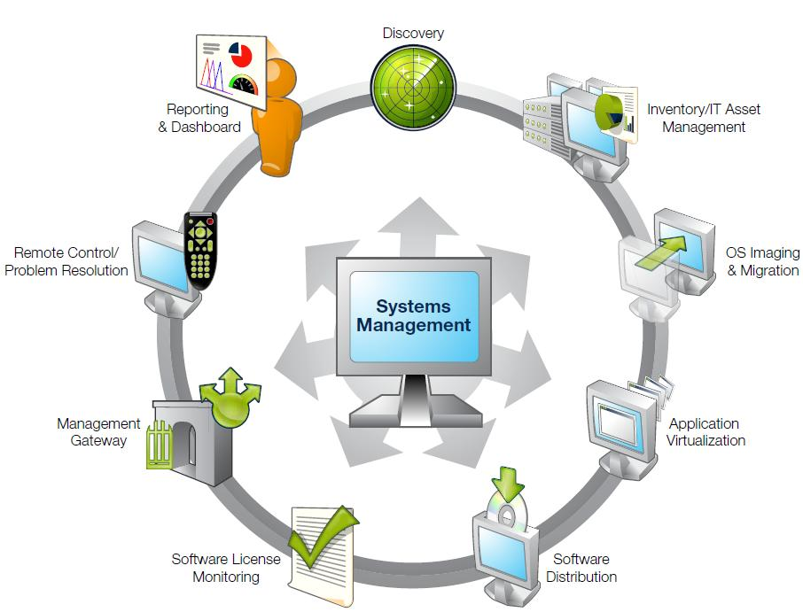

Background:
Originally founded in 1985 as LAN Systems, LANDesk was acquired by Intel Corporation in 1991. In 2002, LANDesk was established as a standalone company. Then, in 2006, LANDesk was acquired by Avocent. The foundation for LANDesk’s leading IT management solutions was laid more than 20 years ago. And LANDesk has been growing and innovating the systems, security, service and process management spaces ever since. Our singular focus and our commitment to understanding customers’ real business needs—and to delivering easy-to-use solutions for those needs—are just a few of the reasons we continue to grow and expand.

LANDesk pioneered the desktop management category back in 1993. That same year, IDC named LANDesk the category leader. And LANDesk has continued to lead the systems configuration space: pioneering virtual IT technology in 1999, revolutionizing large-packet distribution with LANDesk® Targeted Multicast™ technology and LANDesk® Peer Download™ technology in 2001, and delivering secure systems management over the Internet and hardware-independent network access control capabilities with LANDesk® Management Gateway and LANDesk® Trusted Access™ Technology in 2005.

In 2006, LANDesk added process management technologies to its product line and began integrating the systems, security and process management markets. LANDesk also extended into the consolidated service desk market with LANDesk® Service Desk, and was acquired by Avocent to operate as an independent division.
Today, LANDesk continues to lead the convergence of the systems, security, process and service management markets. And our executives, engineers and other professionals work tirelessly to deliver leading solutions to markets around the globe.
(This part was taken directly from LANDesk website)

Functional Coverage:

The LANDesk solution on the systems is managed via an agent client that sits on the client machines. The solution is a cross-platform covering Windows, Mac OS, and Linux based operating systems. The agent client is installed on any computer running one of these operating system, mobile devices however are limited in management and are not agent controlled.

Grouping Managed Devices:

LANDesk can manage typical systems such as laptops and desktops, along with mobile devices. Along with what devices it can cover it can manage systems locally or remotely anywhere where the device has a connection to the internet back to the management server. It also allows for multiple methods for grouping and filtering managed systems. It can manage and group systems based on what subnet they are in or a user defined group, which the administrator(s) would setup and move computers into the group. You can also define group and filtering based on the roles of the machine: server, clients, share drives, special such as software that runs off of them shared over the network.

    - Remote Control

LANDesk Management Suite offers a centralized console based remote control system. Which connection is secure over you network and has the ability to be very robust in low-bandwidth or dial up situations. Because of the simplified and full encompassed audit trail, you know what has been done already and what needs to be done and it can mean quicker resolution times.
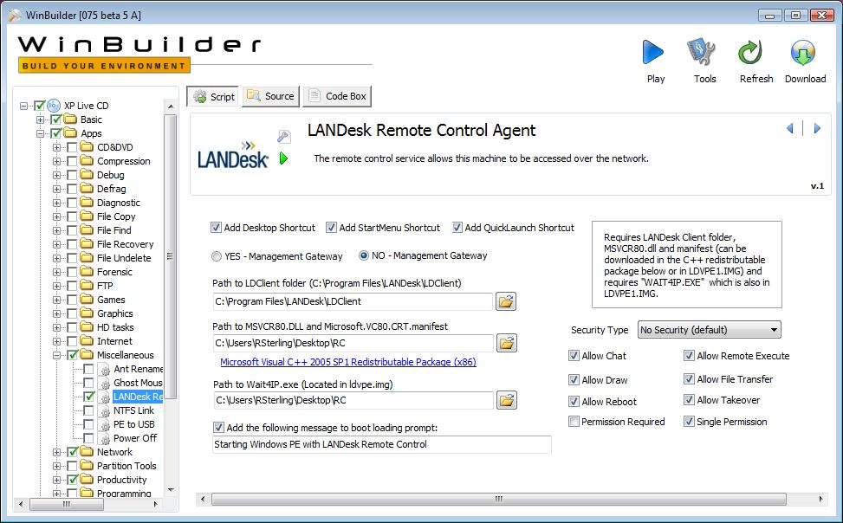

    - Auditing & Asset management

LANDesk Management Suite offers a scalable asset management option with this software package. Reports are offered in multiple formats such as doc, pdf, html, xls, and rtf. It allows for discovery of inventory even if it is unmanaged and offers easy integration into planning upgrades. Multiple features across this suite make auditing and reports easier to poll and to produce and read.
    - Monitoring

Management Suite in coupling with Security Suite offer the best monitoring possible. Management Suite offers Software License Monitoring, through this tool you can prevent users even while offline or if they change the program's name from running or even being installed. You can also manage the licenses to your software, and generate reports to audit your machines. You have the option of also logging though the Internet. This offers a secure connection method through the software to provide you a secure method without having the added cost of dedicated lines and the security loop hole of a VPN opening ports on the firewall. Remote users can be managed through the Internet as well. The Security Suite offers strict monitoring of your network and individual client computers security state.
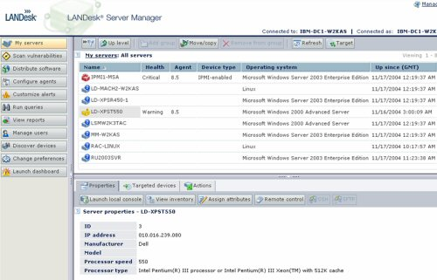

2.1.4 Patch Management

Security Suite offers Patch management as part of a regular security standard. Using policy standards, all client machines are issued policies, which are continuously checked to make sure all clients are in the policy and compliant. If a machine is not compliant, it brings it back into sync. The patch management feature offers details on new patches and what vulnerabilities it might cause and what dependencies it might need including their vulnerabilities. Custom packages may also be built depending on your organization structure and can be protected from unintentional or malicious tampering with MD5 hashing algorithm encryption. Obsolete or older patches still remain available, but are removed from distribution for a faster up-to-date patch process. The patch management feature can handle the OS and additional software.
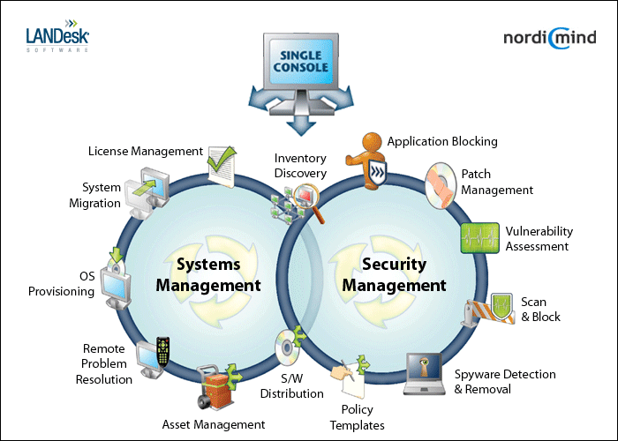

2.1.5 Backup & Disaster Recovery

The LANDesk Management Gateway offers an Enterprise level product that Includes automatic redundant backups to ensure configuration and log information is always available. The hardware uses two redundant disks to ensure the data backup and in case of a disk failure on one of the drives.

2.1.6 Endpoint Security

LANDesk's Endpoint Solution is called LANDesk Security Suite. The product key features offer IT professionals a list of critical tools and abilities in the security of their network. It allows IT Administrators the ability to manage over the Internet, Security Suite has Advanced Vulnerability Detection. This feature identifies possible areas that are compromised including non-compliant machines. When this happens, it brings the client computer back into sync with the security policies. Further to that it offers a zero day protection feature built into the AV client. This feature has the AV look for behavior typical of malicious code and/or software to prevent and limit damage to system(s). It also employs Host Intrusion Prevention, and as stated earlier its security policy abilities focus on Antivirus and Firewall enforcement. The firewall feature also allows freeing resources from a client machine and having one point for a firewall rather than managing multiple machines firewall policies.
2.1.7 User State Management

The Management Suite's Enterprise Scalability features allow administrators the ability to take repetitive tasks such as migrating users, creating new users, and other tasks related to this field and make them automated via scripts and better console management through LANDesk.
2.1.8 Help Desk

The Help Desk aspect is handled by the integration of detailed auditing tools and various other administrators’ tools through LANDesk Management software and Security Suite. Also for all computers that are Intel vPro compatible offer the ability for out-of-band discovery, remote heal ability despite of the OS that is loaded or whatever state the system is currently in.
2.1.9 Usability

LANDesk products Management Suite, Security Suite, and Management Gateway offer very user friendly GUI for configuration and management. Obtaining Audits and Reports from the products were easy to run and to read after they were compiled. Setup was straight forward and the use and configuration was the same. In my opinion an entry level IT Administrator would be able to learn how to use the product to its full potential and makes it easy for end-users productivity.

2.1.10 Reliability

The LANDesk products used proved to be very reliable. The management suite and security suite did not crash and neither did the agent sitting on the managed machines. The policies and processes set up were enforced and carried out over the network without a problem. All machines were always in compliance.

2.1.11 Performance

Management Suite and Security Suite did not impact client or server machines greatly in resources to run and maintain running. Program responded and deployed patches, polices, and software in a quick turnaround time. Compared to features offered products installed performed up to par. All products are fairly easy to use and configure making it an efficient IT automation suite.

2.1.12 Supportability

LANDesk can be deployed to manage mobile devices, desktops, and laptops. The software can go across multiple platforms such as Windows, Linux, and Mac. The use of the security suite and management suite integrate well to manage cross platform networks.

