2.3 LANDesk (Alfonso Munive)
Overview:
LANDesk comes in different suites, which are LANDesk Management Suite, which provides systems management, and LANDesk Security Suite, which provides endpoint security management. In addition there are multiple subscription services that you can add to the Management Suite which are LANDesk Antivirus, LANDesk Patch Manager, and LANDesk Process Manager.

Background:
LANDesk is one of the most powerful IT Automated solutions that is available. It was founded in 1985 and was known as LAN systems. In 1991 Intel Corporation acquired the company, and in 2002 LANDesk left Intel and operated independently. In 2006, it became a subsidiary of Avocent, and has established itself as a leader in the industry innovating both product and technologies for IT professionals.

Functional Coverage:
The system requirements to install LANDesk Management suite are as follows:

Core Server Requirements:
- The Core server needs to be dedicated to hosting the LANDesk Management Suite
- Supported Windows Server Operating Systems:
  - Windows Server 2000 (Running SP4)
  - Windows Server 2003 (Running SP1 or SP2)
- Microsoft Simple Network Management Protocol (SNMP)
- Static IP address

Databases:
- Microsoft SQL Server 2005 Express Edition
- Microsoft SQL Server 2005 (SP2)
- Microsoft SQL Server 2000 (SP4)

Supported Client Platforms:
- Windows
  - Windows 95 B with Winsock 2
  - Windows 98 SE
  - Windows NT 4.0 Workstation SP6a
  - Windows 2000 Professional SP4
  - Windows XP Professional SP1 or SP2 or SP3 Windows Vista
  - Windows Vista SP1 (64-bit)
  - Windows Vista Business/Ultimate/Enterprise SP1 (32-bit)
- Apple
  - Mac OS X 10.5.x (Leopard)
  - Mac OS X 10.4.11 (Tiger)
  - Mac OS X 10.3.9 (Panther)
  - Mac OS X 10.2.8 (Jaguar)
  - Mac OS Classic 9.2.2
- Novell
  - NetWare 6.0, 6.5

- UNIX and Linux
  - Red Hat Linux Enterprise 3, 4, 5 WS
  - Red Hat Linux 7.3, 8.0, 9.0
  - SUSE Linux Professional 9.1, 10
  - Ubuntu
  - Mandriva Linux 10.1

Grouping Managed Devices: All devices in Superior Pharmacy would be grouped on their roles. We would have a role for regular workstations, and a role for the servers.

2.3.1 Remote Control
The LANDesk Management suite provides a powerful remote control and problem solving solution which help you reduce costs, and decrease the demand on help desk resources. With LANDesk’s remote control, you can perform maintenance and repairs anytime on the network with remote reboot, remote wake and remote application launch. It has integrated file transfer capabilities, and you can instant message/chat with the remote client (Figure 1).

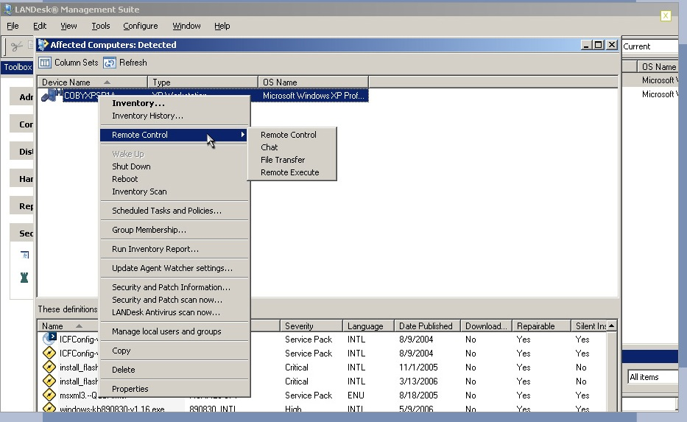

Screen-shot of Demo Figure 1
In addition there is a drawing tool where you can draw on the remote clients screen to illustrate actions, and with remote program execution you can run applications such as an anti-virus program (Figure 2). For increased security you can shut down the screen on the remote client, so the end-user doesn’t see what actions are being performed.

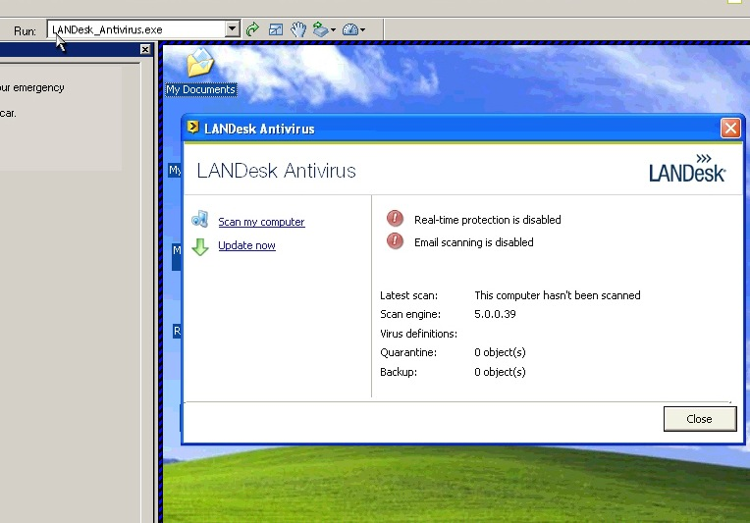

Screen-shot of Demo Figure 2

With LANDesk Management gateway the IT administrator can remotely log into any machines, which are not onsite, only needing an Internet connection. Management gateway allows you to manage outside devices such as laptops, and machines on different networks. There is no need for VPNs and the gateway gives you a secure SSL connection on both ends.

2.3.2 Auditing & Asset management
LANDesk has a powerful IT asset management utility, which you can add to LANDesk Management suite, which helps you manage devices across your network. You can easily plan upgrades and respond to audits in an efficient manner. You can easily track both hardware and software inventory, and track software usage accordingly (Figure 3). You can get data from multiple sources such as the service desk, finance programs, and systems management programs and group them all together. You can easily view any type of information on any machine such as the OS, CPU, RAM, the end user associated with the machine, the software installed, number of times the software was used and a time log for the software. This provides efficient asset monitoring such as warranty information for all machines, lease expirations dates and define which software is being used the most.

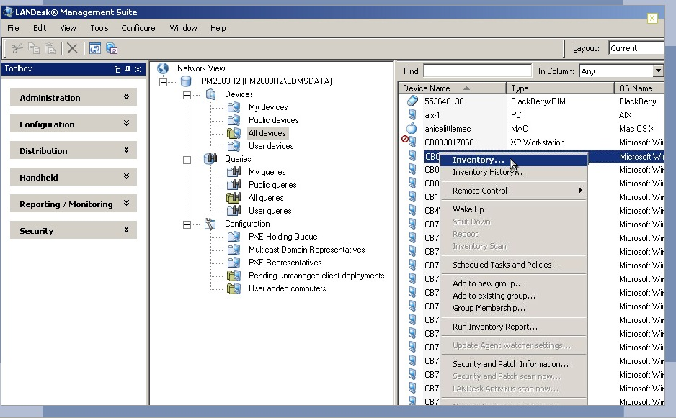
Screen-shot of Demo Figure 3
LANDesk Asset Lifecycle Management is more than just a tracking program. You can add information such as the original purchase order when the hardware or software was bought, to the day its expired or sent out for service.

2.3.3 Monitoring
LANDesk System Manager maximizes computer performance, availability and security. You can extract data directly from the system hardware, OS and software components in real time. You can track anything from CPU usage, to different voltages, to fan speeds. You can capture this data over time so you can predict trends and avoid problems before the system crashes. You can setup custom alerts when machines fail or system performance falls below expectations so once again you can be prepared if any problems occur. You can maintain all machines by using remote application launch, and file transfers. You can track different peripherals attached to USB ports such as keyboards and monitors. You can track when users install or remove applications and be alerted via email, fax or text message. You can create custom scripts let you create, edit and delete any console group operation, including unmanaged device discovery, client deployment. In addition you can create custom scripts that check for software updates to one or all the machines on the network, just once or on a recurring schedule.

2.3.4 Patch Management
LANDesk Security Suite offers a comprehensive patch management solution that lets you keep up to date across all OS platforms (Figure 4). You can automatically deploy patches using LANDesk’s vulnerability assessment and patch database, which fit the company’s needs. Policy based management allows you to download, target and install patches based on IT defined rules, or you can deploy them manually for more control. The patch management tool uses LANDesk’s Targeted Multicast and LANDesk’s Peer download technologies lets you speed patch manually for more control. The patch management tools uses LANDesk’s Targeted Multicast and LANDesk’s Peer download technologies lets you speed patch deployments to multiple targets while minimizing the bandwidth used to reduce total network traffic without using dedicated hardware.
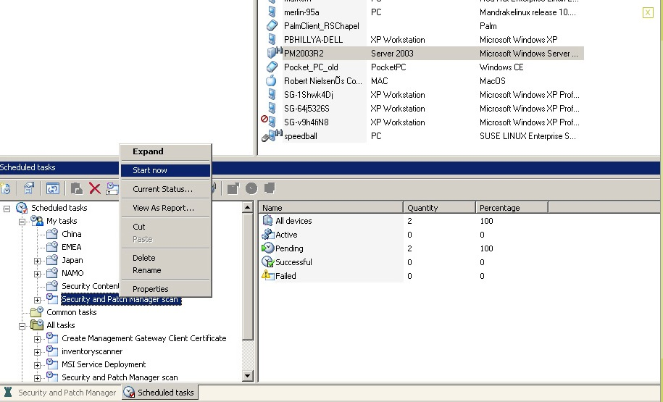
Screen-shot of Demo Figure 4

2.3.5 Backup & Disaster Recovery
LANDesk does no offer a fully offer a backup and disaster recovery utility, but instead uses the LANDesk Management suite tool called Imagew.exe. It is a tool that can capture an image of a hard drive while Windows is currently running. In order to do this, PHYLock must be installed and any process that prevents such a lock needs to be stopped. PHYLock is a tool that stabilizes the files that are in use while they are being captured. PHYLock provides a method to lock files so that imagew.exe can capture a file in a constant state, which allows for an image to be captured while in windows.

2.3.6 Endpoint Security
LANDesk’s antivirus is part of the Security Suite and can prevent your system from malware attacks such as Spyware, Rootkits, Trojans, Worms, and Viruses. The LANDesk antivirus works alongside standard industry software so you can use antivirus solutions you already have like Norton and AVG. In addition it helps you determine whether scanned files are up to date and whether real time protection is enabled on each managed machine. LANDesk antivirus has a tool called Virus Pilot Deployment which allows you to selectively and rapidly deploy virus definitions files on a limited basis so you can validate whether the integrity of the definitions are valid (Figure 5). Like the Antivirus, LANDesk’s spy ware removal tool is accessed through a centralized console and detected spy ware is grouped into different families to help you quickly identify the type of threat. The removal tool is automatic, and it helps you protect the systems in real-time with access to live LANDesk databases that are regularly updated.

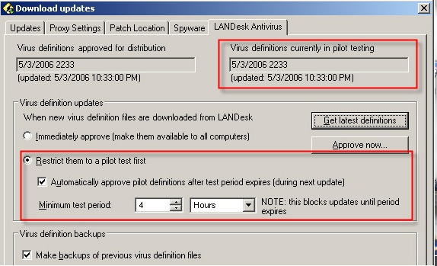

Screen-shot of Demo Figure 5

2.3.7 User State Management
LANDesk doesn’t include any built in user state management, but by using Active Directory Application Mode (ADAM) we can control resources, services and users. We can implement policies amongst users and control what resources are available to every user.

2.3.8 Help Desk
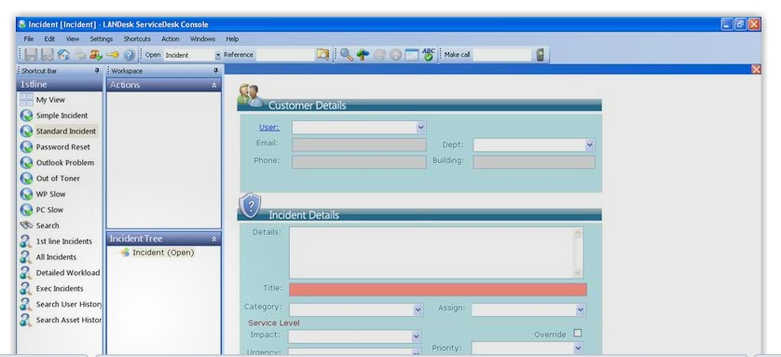
LANDesk Service desk provides a better solution than previous help desk solutions by consolidating call logging, incident management and workflow management issues. You can prioritize by policy driven incident reporting which helps you improve productivity and reduce costs. For example the user interface that the end user has, it lets them input their name, the type of hardware they are the using, and a quick description of the problem. Once they enter this, it searches the database for a possible solution and tries to solve the problem (Figure 6).
Screen-shot of Demo Figure 6

Acknowledgement
I would like to acknowledge and extend my gratitude to the LANDesk team and Avocent, for making the completion of this research possible. I also want to thank my research team and colleagues for their contribution to this report as well.

