Created by: Jermaine Dixon

2.4 Lab Tech

Solution Tool Lab Tech Software
“Lab Tech manages an entire technology infrastructure with an integrated central management interface that provides the necessary maintenance and automation for System Administrators. Lab Tech has provided powerful capabilities for administrating technical support software for Enterprise level businesses, and small businesses as well [13]”.
“Greg Burek and Jim Bell were the founders of Lab Tech in July of 2005[12]”. The first version of the software was coded by Greg Burek and Josh Bucher and released in January of 2007. “Lab Tech was designed by System Administrators with the purpose to solve IT problems and better correct necessary solutions [12]”.
Lab tech offers various solution tools for Remote Control and Background troubleshooting, Managed Service Deployment, Information and Reporting, and People and Process Management
Features and Functional Coverage
Remote Control and Troubleshooting
2.4.1 Remote Control and Troubleshooting and Background Troubleshooting
Lab Tech provides two ways to deliver support through remote sessions, 1) Remote Control troubleshooting, and 2) Background troubleshooting. One of the surprising features in using the Background troubleshooting session is that it allows the technician to work behind the scenes and solve in any problems with remote control without interrupting the user.
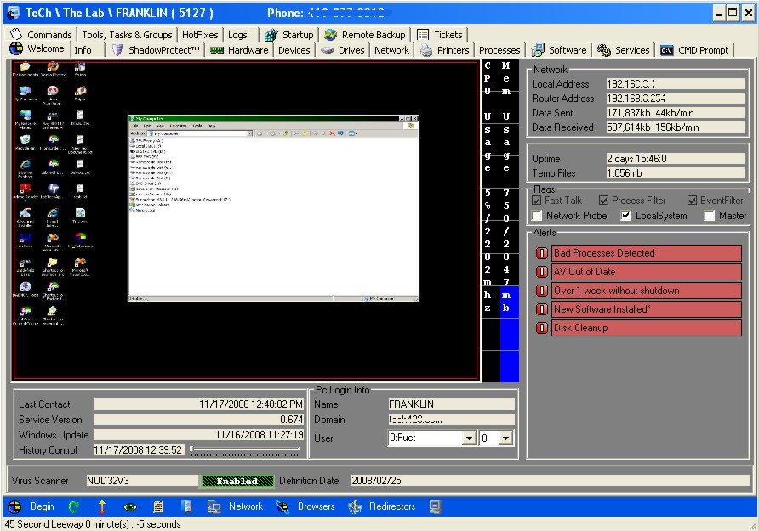Lab Tech Computer Screen

Functionality in using these options:
Remote control has a built-in Imbedded VNC Viewer provides the capability to allow users with access to remote into any computer on the network, as well as providing the capability of allowing the users to walk through the steps necessary and learn the process.
Using other Remote Control Tools provides the user with option to use any Remote Control software tools to access the individual computers on the network.
Citrix and Terminal Server Management
“Using the computer screen on a Terminal Server or Citrix Server, you can jump into a user's session through Lab Tech by selecting the user in the PC Login section of the Computer Screen [1]”.
Most of the functionality is on the computer screen above:
Detachable Screens and Increase Multitasking Ability
The Multitasking ability allows technicians and administrators to work in an environment with multiple screens under one control center, providing no limitations to working on multiple systems at one time.
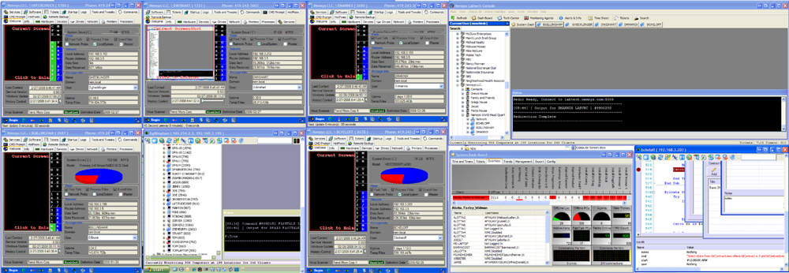Lab Tech Multitasking Windows
Multiple Screens opened for Multitasking purposes
Options that Lab Tech for Remotely Controlling Servers and Workstations Lab Tech provides VNC Imbedded Viewer, Remote Control with Remote Desktop, Radmin, Dame Ware, and other tools that may assist with remote connection over the network, including remote sessions with Citrix sessions using Terminal Servers.
Information and Reporting
2.4.2 Asset and Audit Management
Lab Tech collects lots of information so that it may be shared. Lab Tech collects information on system logs and configuration data automatically, and allows storage of saved passwords, documents, contact information, product keys, and much more. Information can be accessible to view in the Control Center, Windows Mobile Device, or through the Lab Tech web interface. Reports are generated in Crystal Reports for querying and sorting information that has been collected from the database.
Password Management
“Passwords can be added to a client, location, or computers. All required login information can be saved in the appropriate location, so when login or support is required, the information is readily available. Additionally, the passwords for the users on the computer or domain can be reset using the Computer Screen of the Control Center [2]”.
License, Product and Serial Number Management - Software information are stored and are associated with Locations and Clients.
Document Management
“Lab Tech stores all the information required to contact the users of the systems you are supporting. Lab Tech has a Microsoft CRM synchronization tool that can reduce double entry of contact information. Contacts can be associated with Clients, Locations, and Computers. When support tickets are sent in, if the email is associated with a contact, the information about the contact will be on the support ticket [2]”.
Managed Service Provider Reporting
The Control Center offers you a very flexible report generation. Lab Tech allows for you to script and email reports automatically to the NOC, your clients, or your management team. The most important report is the report that you send to your client base. Lab Tech has a Management Report that can be sent to your client base to show them the status of their network and your support process.
People and Process Management
“Lab Tech has a fully integrated helpdesk system. The system has security built in that only allows the various IT professionals access to the systems they are allowed to support. Lab Tech has the ability to associate support tickets with projects. Lab Tech also has a time-keeping system that can be used to associate time with the various tickets and projects. If time billing is used, the time can be exported to Time slips, Quick books, and many other accounting and billing systems. There are many dashboards in Lab Tech that can be used to track what your IT staff is working on or has worked on [2]”.
Network Troubleshooting
Lab Tech provides many network troubleshooting and maintenance tools, such tools include:

Network Sniffing and Reporting and Wake on LAN
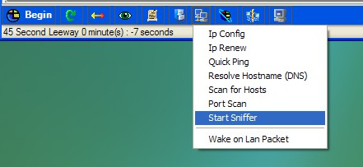
From the Computer Screen, click the network icon and select Start Sniffer
If problems occur on the network, the administrators or technicians can get to the main source of the problem by using the network Sniffer, to analysis network traffic passing through the network connection or segment of a local area network. The Network Sniffer allows you to select the local machine the Remote Agent is operating on, or allow you to select another IP address to sniff. The report data is sent back to the Remote Agent, and copied into the shared directory with the file name of the current computer.
From the Computer Screen, click the network icon and select Wake on LAN Packet to initiate. Any computer that may seem to be on standby or is currently off at the moment on the network can wake up. A computer on the network would send a wake on local area network as a packet to wake that machine.

Security Analysis on Open Ports
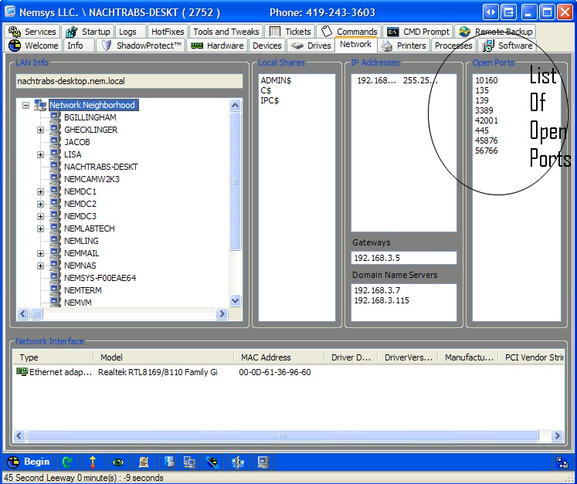
You can view all open ports on the computer using the Network Tab of the Computer Screen in the Control Center
If there are any problems with security, you can check the open ports on the Computer Screen, using the Network Tab in the Control Center
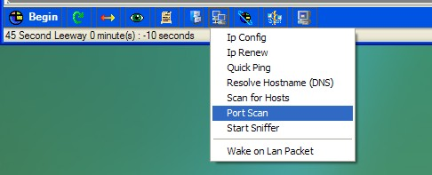
Network Monitoring
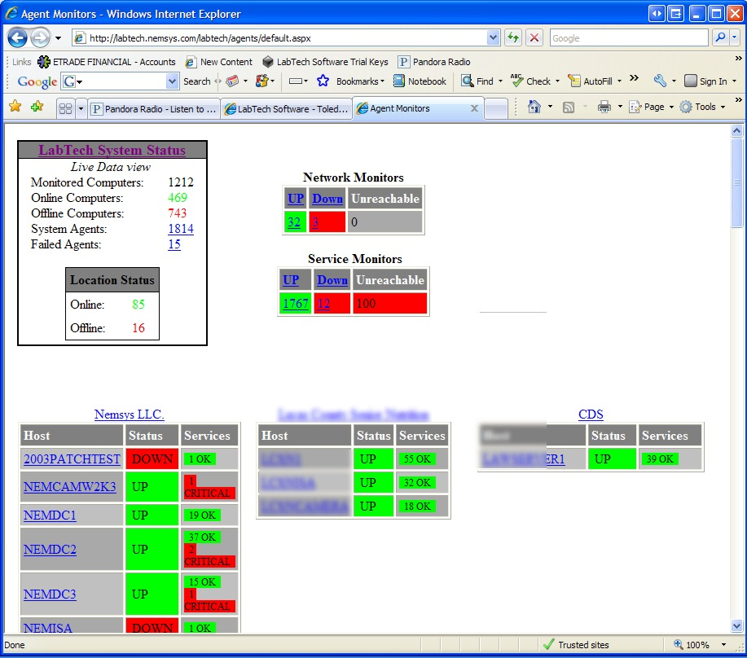
Lab Tech Network Monitoring Tool
There are two extreme benefits when using Lab Tech monitoring. First, the network bandwidth that is utilized by the monitoring is reduced because only failures are reported to the central Lab Tech Servers. Secondly, it simplifies the complexity for most monitoring tools, because the local agent monitors everything on the local network, and a remote agent monitors the status of the agent, therefore requiring less time to configure all the monitors to check individual local machines. The Lab Tech monitoring tool monitors all ping connections and SNMP. Monitor alerts can be received through email, phone, text and pager for notification status. Through ticketing administrators can solve immediate problems that may occur. If the alert has a script available to automatically fix or diagnose, the system can automatically fix and check diagnostics and send any results back to the administrator.
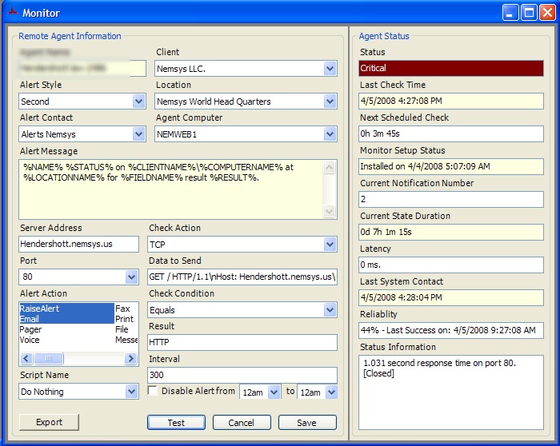
Network Probe with SNMP Traps
“Any agent configured can be a network probe [15]”. The purpose of the network probe is to discover the networking devices on the network. Information can be retrieved from those networking devices and monitors can be set to determine and detect any signs of outage. If one or more of the devices have SNMP configured, the probe can gather information on SNMP trap.
Managed Service Deployment
Computer Groups and Searches
As the number of client computers, networks, and other devices continue to grow in a business it becomes more complex to manage. Systems and tasks become more difficult to manage as well. Lab Tech has made this management process more flexible for users allowing them to search and apply scripts, commands, applications deployment, monitoring, and etc.

Groups Defined
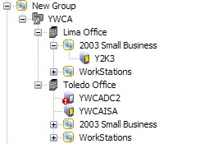
“Groups are logically defined as containers of computers. Groups can also be categorized as groups, clients, and searches [16]”.
Searches Defined
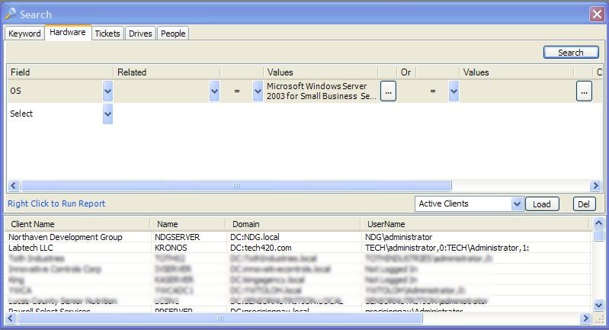
Searches Defined are saved queries that

Group Maintenance Configuration
Items are organized into groups to logically apply automation. Group Maintenance Configuration is used to determine group policies.
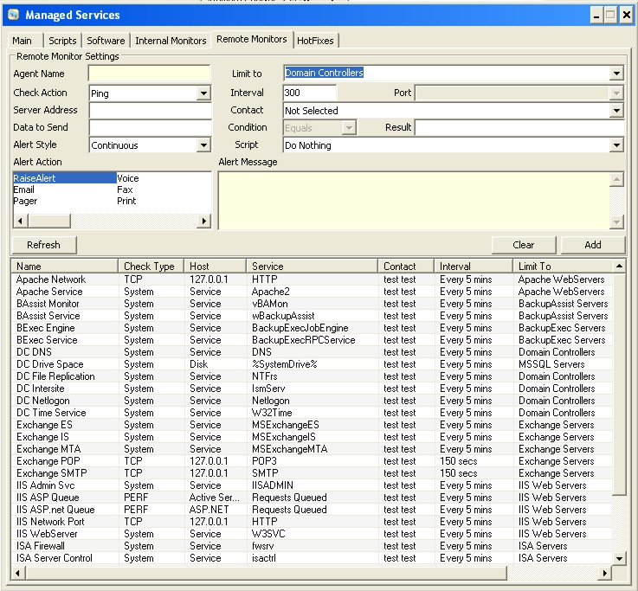
Remote Agent Configuration
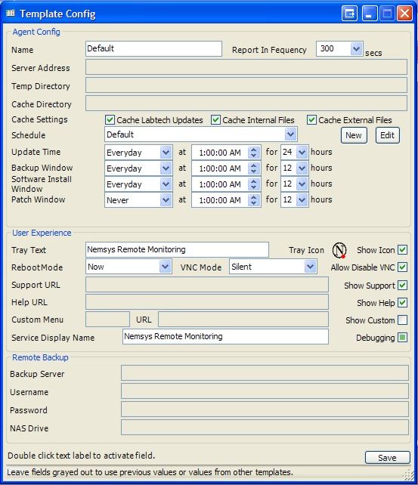
The remote agents can be configured and applied to groups throughout the template

Group Creation Wizard
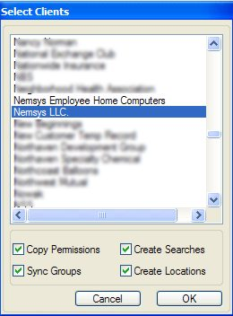
When a group is created, a wizard runs to determine what local machine gets added to the group. Additional items in the group are checked along with the wizard.
Lab Tech Scripts
Lab Tech Scripting uses advance automated scripting, which can run on computers, groups, or searches or on a schedule basis. The scripting provides a number of check conditions that are available within the script, avoiding the need to hundreds of scripts to accomplish a simple task. Lab Tech has more than 20 if conditions and over 80 script commands. Most of the scripts are powerful to call programs.
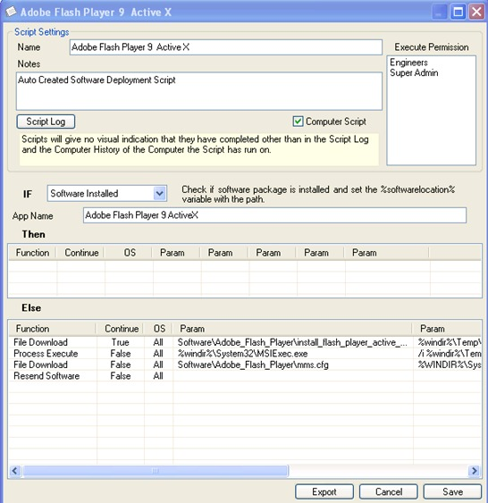

Script Organization and Execution
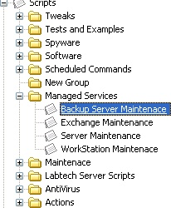
Scripts are organized in hierarchy tree view with multiple levels. These scripts are organized in this manner so that you can locate them and edit them if possible.
Scripting Execution Configuration
Configuring Scripting Lab Tech allows you to have full control over the scripting engine by setting the values and parameters to the scripting engine.
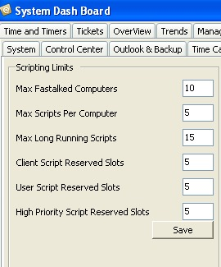
2.1.3 Monitoring
Active Network Monitoring
“Active monitors can alert based on values returned from machines or devices on the network. Lab Tech can monitor TCP, UDP, SNMP, Performance Counters, Services, File Size, Disk Space, Registry Key, or Process Running. Lab Tech has a unique approach to Network Monitoring. Every Remote Agent is a fully featured monitoring system. Every Remote Agent reports back to the central Lab Tech database, so alerting rules can be executed and the data is visible in the Control Center. This solution offers great flexibility, power, and drastically reduces network chatter [3]”.

Group Based Active Monitors
“A common theme throughout Lab Tech is that automation and monitoring can be set up and maintained across groups. Monitors can be set up to run on all systems within the group and only run on systems that match with a search. This is a very powerful feature, so to understand this best, check out the quick demonstration file [3]”.
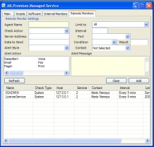

Internal Monitoring
“Internal monitors directly query the Lab Tech database for conditions, so alerts can be created when the conditions are met. Internal monitors can also be used to initiate automation (i.e. initiate defragmentation when drive is 10% fragmented.) Any data collected by Lab Tech out of the box or custom fields that have been added can be monitored. Internal monitors are created from the Monitor Agents screen [3]”.

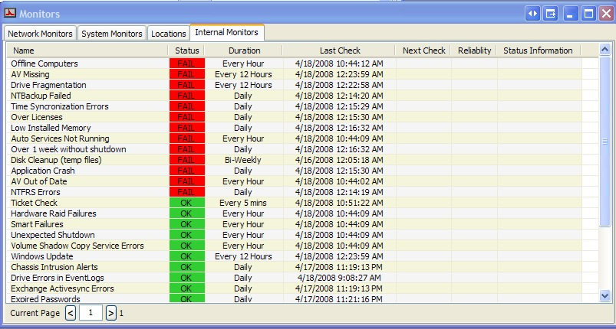

The Lab Tech Dash Board
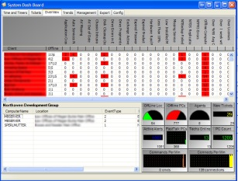
2.4.4 Patch Management
The primary tool used in patch management is the Hot Fix Manager under each group. The patch management supports the use of WSUS Server and regular windows updates.
The Hot Fix Manager can be accessed through the Dash Board under Management Tab. The administrator or technician can be tested and run through scripts.
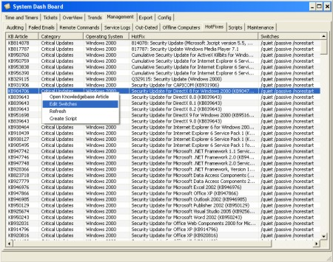

Approving Hot Fixes
Hot Fixes are set and approved for groups of computers. Patches can be rolled out for all groups.
Software Deployment
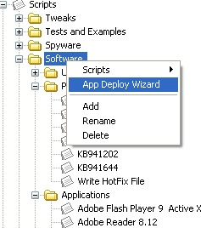
Lab Tech has various ways of deploying software over the network. For individual application that needs to be deployed, you must go through the Application Deployment Wizard.

Application push to a single Computer, Group, or Location
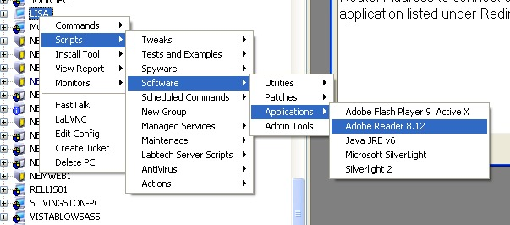
“Lab Tech offers many ways to deploy applications to the computers you support. If an application is required on a particular computer, you can simply right click and navigate to the script for that application [4]”.
Managed Service Application Deployment
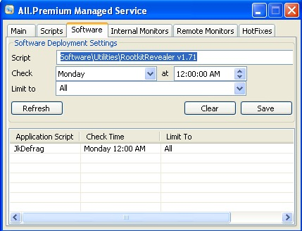
2.4.5 Backup and Disaster Recovery Management
Two options using backup and recovery. The first is simple backup procedure that is applied to computers and groups. “The second option uses Storage Crafts Shadow protect to take images of the entire computer [5]”.
Simple Backup and Recovery
The Simple backup and recovery is configured on the Remote Backup tab of the computer screen. My document files can be backed up, and it can also be configured to backup to a local share or FTP Directory. You specify absolute or relative path to store backups.
Image Based Backup and Shadow Protect
“Shadow Protect tab provides tools for backup images to be restored on any computer, even if the hardware is completely different. It also provides a powerful tool for performing migrations of servers. With the Shadow Protect you can organize, schedules, executables, or delete backup jobs [5]”.
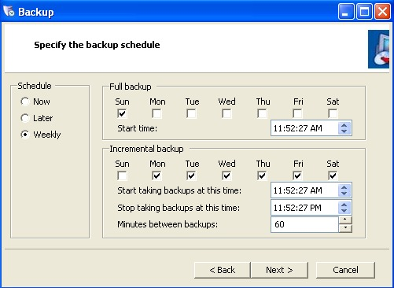
2.4.6 Endpoint security
Advanced Security and Rights Management
“Each Technician has permissions and a client list. The tech can be limited to a specific client or group of clients. The permissions are MYSQL enforced so the system is very secure even if the Control Center is bypassed [6]”.
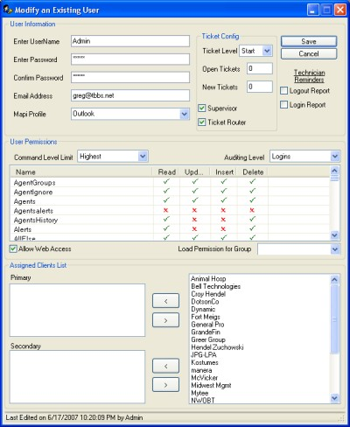
“Groups can be created and used as templates for a user's permission or the user can have custom permissions. You can have unlimited groups and techs in the system [6]”.
“The Technicians can be listed according to their status. The list will indicate if the tech is busy, at lunch or at a client's site. The location can be set from in the control center and from the Lab Tech Mobile Interface [6]”.
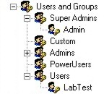
2.1.7 User State Management
Lab Tech Dispatching and Management Screens
“Lab Tech has two main screens that assist in giving a scheduler, manager, or dispatcher a good, upper-level view of the status of operations. Both screens are accessible using the dashboard. The first screen is Time and Timers. Studies have shown that using timers to start and stop a task are much more accurate than simply reporting the time spent in a ticket. Some system administrators gain over 25% in billable time by simply running timers. In order to help enforce a timer policy which requires a timer to run at all times, you have to be able to manage the timers. From the Time and Timers screen, you can see how much billable time your staff has on any particular day. You can quickly look at all the timers everyone has running. By using only one screen, this allows you to instantly know what your entire operations are [9]”.
Time Keeping and Management
“Technicians can create Active Time Slips for recording time. Once an Active Time Slip is created it can be started and stopped repeatedly before being finished and entered as a new time slip. Active Time Slips can be created from both the Control Center and Lab Tech Mobile [7]”.
“Technicians can add time to every ticket item and instantaneously create a time slip or they can enter time manually from their time sheet. The sheet is broken down to week, month and billed time slips [7]”.
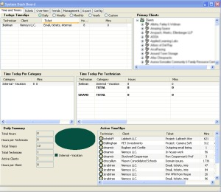
2.4.8 Help Desk
Ticketing, Scheduling and Dispatching
Lab Tech control center supports ticketing. Users can add new tickets by email or the System Monitors tray program. Tickets support attachments, levels, and limits. The Tech Center provides a way to view and assign tickets, alerting clients, providing day to day performance.
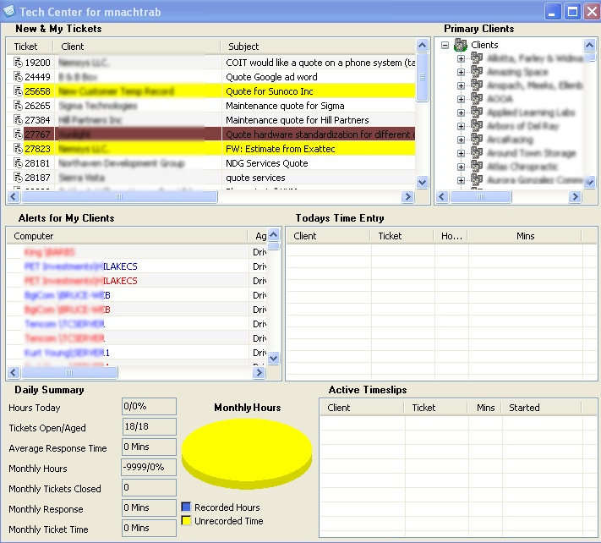
Lab Tech Scheduling
“Using Lab Tech ticket screens, the ticket can be scheduled for a system administrator. From the ticket, you can open the system administrator's Outlook Calendar. When the scheduled time is saved, it saves in the appointment in Lab Tech and in the Outlook Calendar [9]”.

2.4.9 Usability
The solution tool for Lab Tech is simple to install. Lab Tech provides user information providing learning for interaction with the system to become more familiar with the system.
2.4.10 Reliability
Lab Tech provides on centralized Solution tool for performing multiple system administrative tasks, rather other software tools which you may need to purchase as an additional integration package. The advantage of having this solution is that it is more reliable to operate on all operating systems including Windows, Mac, and UNIX.

Flexible for businesses because it allows your company to adjust to the needs necessary to automate and manage IT tasks for day to day operations.

2.4.11 Performance
The Lab Tech Performance tool provides a powerful tool for maintaining and automating all aspects of the IT infrastructure.

2.1.11 Supportability
Lab tech MSP Support
Online Documentation Reference for the Users’ Manual
http://www.labtechsoft.com/wiki/index.php?title=Main_Page

