2.1 Level Platforms Inc
Overview: As a managed service provider (MSP), Level Platforms (LPI) serves as the liaison between service providers and their customers. Because each customer’s need may vary, LPI allows for the customization of services and its providers. Since the introduction of their award winning product, Managed Workplace in 2004, LPI has teamed up with top service providers such as Microsoft, Cisco, Citrix, Acronis, and Ingram Micro. This collaboration has given Level Platforms the flexibility that many of its clients seek. LPI integrates the client’s services into a single customized solution that is managed through a web based console on their site. A hosted version of Level Platforms, called Service Center is also available by vendors, Ingram Micro.

Background: Level Platforms is a managed service provider MSP that was founded by developers in Ottawa Canada in 1999. Utilizing an outsourcing approach Level Platforms brings together a number of service providers that provide end-to-end remote monitoring and management of workgroup devices, servers, and networks. Level Platforms has 3000 partners in 30 countries. Recipient of various awards including multiple awards in 2008, level Platform is one the most comprehensive and effective automation solutions today.

Functional Coverage: Currently Level Platforms provides functional coverage in the areas of remote control access, patch management, asset management, user state management, and monitoring. Back up and disaster recovery and endpoint security services are not directly built into Level Platforms. Instead third – party integration is available from many supported vendors. Managed Workplace provides services on a pay-as-you-use basis for one subscription price per month per customer site. There are no additional charges. Licenses are fees ranged from $20 to $70 per customer, depending on the number of servers and desktops being monitored. Billed monthly, subscription includes all updates, support, and maintenance. LPI's software, Managed Workplace, consists of two components, a Service Center server that is installed at the MSP's facility and an Onsite Manager client that is installed on a customer’s network. The Service Center software is responsible for sending and receiving data. Built on the .NET platform, Level Platforms uses a Probe-based platform that does not require the use of agents. Instead predefined templates written in XML, issue ICMP, SNMP, and WMI which read requests to the network nodes via TCP/IP, then gathers state information on the devices and Windows applications on the client’s system. The nodes return data collected by their probe. Based on input gathered by its probes, a node may generate an alarm to indicate an unusual condition or activity. The templates have all the alerts and monitoring rules required to detect problems in devices and applications. Based on the client’s need, LPI allows for the creation and modification of its default templates. A catalog

of templates provided by vendors, are openly available to all users for free. The onsite manager component of Managed Workplace contains a dashboard that provides a seamless user interface that allows clients to manage their system. Services are deployed with the templates that are included with the software.
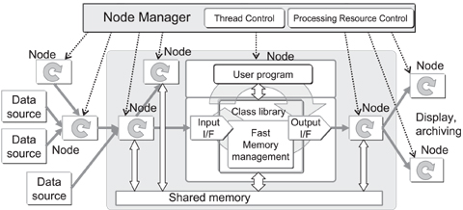

Grouping Managed Devices: Capable of supporting Windows, UNIX, Solaris, Linux, and Mac systems, Managed Workplace can deliver end-to-end remote management of workgroup networks including monitoring of all devices. Manage Workplace allows for manual, automatic or alert-based actions for any device or group of devices predefined. Devices such as servers, printers, PCs, network devices, IP telephony, and applications running on systems can be managed and maintain through LPI’s Central dashboard. Monitoring network services include POP3, HTTP, HTTPS, FTP, Telnet, SMTP, DNS, NNTP, IMAP, LDAP, and custom TCP ports.

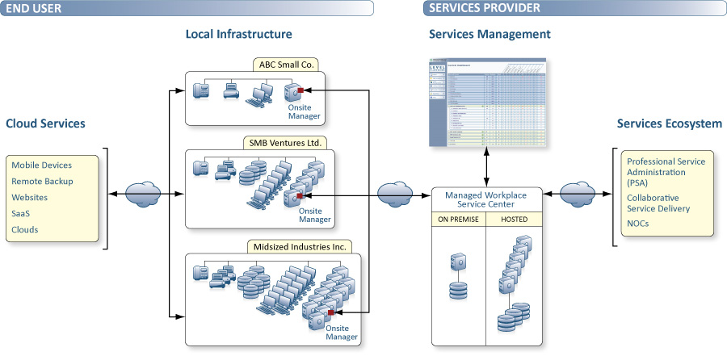

2.1.1 Remote Control
Through the device page in the Managed Workplace interface, service technicians can easily open remote connections using SSL tunneling to go directly to a customer’s site. Telnet, VNC, or any client used by customers can be used to connect to devices needed to solve a problem. Technicians can have direct or shared control of any device at the customer’s site.

Key features

- Multiple co-current remote control sessions per client site is supported
- Integrated VNC solution that automatically pushes the client to the remote (including RDP, VNC, Telnet, PuTTY and SSH)
- No firewalls changes at the client locationOne default TCP port to be open at the Service Center system
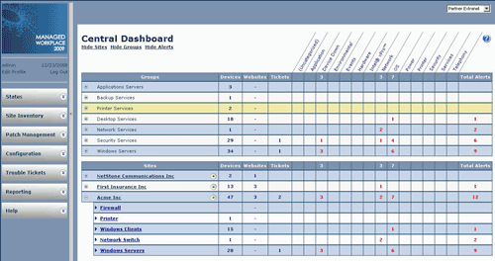
- Support for multiple remote control solutions
2.1.2 Auditing & Asset management
Onsite auto-discovers access all the assets of a network by using ICMP, SNMP and WMI. The Onsite manager also performs asset discovery queries and configures all hardware, including CPUs, memory, drives, installed software, and patch information. Inventory is gathered at regular user-defined intervals. Changes in assets can easily be reflected in detailed asset reports. The addition or removal of devices is automatically taken account for and added to the inventory.

Features

- Includes full hardware and software discovery
- Auto-discovery and updating.
- Detailed asset reports.
- Additional features such as devices alias
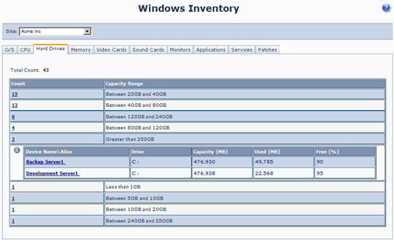
2.1.3

Monitoring
Managed Workplace provides extensive monitoring of networks, routers, switches, and firewalls. Workplace also provides monitoring of web sites and some of applications running on them. Also validates and monitors the performance and the availability of Web site contents. Known virus signatures, spywares, and P2P clients can be detected based on the alert rules specified in a template. Events that occur in an application is also monitored with full automated alerting and reporting through custom log monitoring

Key features

- Custom Alerts notification by Alert rules
- Alert History and alert history logs
- Alert when Web site is down
- Alert when a Website is slow to respond. Custom threshold setting
- Performance and availability monitoring for devices, services, software and websites
- Over 100 predefined best-practice management templates
- Monitor http and https sites and password protected web sites.
- Measures host response times
- Search for certain content in Web pages (regex supported)
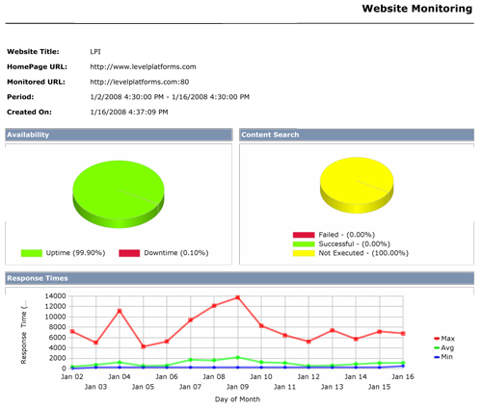

2.1.4 Patch Management
Managed Workplace utilizes a device page for distributing and managing patches. The software uses Microsoft Windows Services Update Server through On-site Manager so customers do not have to install a server to schedule updates. Complete patch distribution for all Pc’s, workgroups, and servers Managed Workplace also provides a library of scripts to update any non-Microsoft software. The patch management function scans the client’s system and identifies the necessary patches. A customer has the option of selecting which patches they do or do not want to deploy.
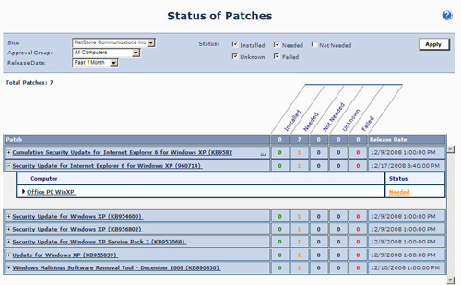
Key features

- Patch Status Alert when alert fail, installed, downloaded or needed
- Scripts to deploy patches may be modified or customized to meet customers’ needs
- Scripts may be created or modified to address a customer’s needs.
- Scripts maybe ran to resolve problems that are reported to the help desk via a ticket.
- Run scripts on single devices or groups of devices
- Integration as a self heal option within the monitoring and alerting engine to quickly resolve problems
- Scripts can be deployed remotely. A public accessible library of over 50 scripts is easily available to be deployed quickly through the service center
- ability to easily create and deploy custom scripts

2.1.5 Backup and Disaster Recovery
The backup and recovery features are not built. Alternatively clients that require back up functionality may choose to utilize third-party vendors such as CompuVault to provide online backups. They also have the option to use their personal software within Workplace's dashboards as long as the backup vendor is supported by a template.

2.1.6 Endpoint Security
For security, On-site Manager outsources to uses Microsoft Baseline Security Analyzer to perform periodic audits. The agent-less client also seeks out known virus signatures and detects spyware and P2P clients. Connected to an Alert Scheduler and the monitoring system, clients and their service providers are immediately notified when there are any flags triggered.

2.1.7 User State Management
Level Platforms allows users to customize their Dashboard according to their preferences. Color schemes, pre-defined template skins, settings, and other user environments are easily adjusted and modified. Migration between workstations is simple and allows users preferences to remain intact during the process. Various roles can be created and assigned to different users or groups based on their company’s permission levels.

2.1.8 Helpdesk
- Although not built into Level Platform , helpdesk services can be obtained through third part integration with one of it providers such as Microsoft CRM, Auto task, or ConnectWise

Level Platforms provides a ticketing system to connect to a third party helpdesk system
Data collected from the system’s probe triggers alerts that may identify potential failures. Automating help-desk procedures defined in a template creates a trouble ticket that is sent to the appropriate service provider’s. From their location they are capable of accessing the client’s network through the use of remote control access. When the ticket is resolved it automatically closes the alert inside Workplace. Level Platforms utilizes the Microsoft’s SQL Reporting Services to generate within a web browser. Detailed reports are sent to customers’ e-mailed to customers weekly, monthly, or one-time. The reports can be prioritized and dispatched to the appropriate technician to be resolved. Reports are available in HTML or .pdf formats.

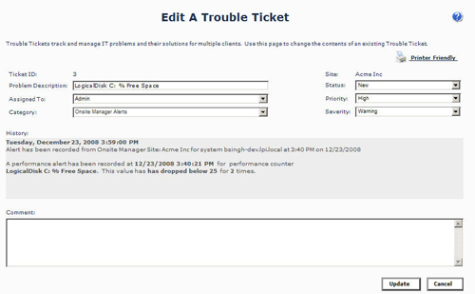
Features

- Problem management and trend analysis enabler
- Integration with Microsoft CRM, ConnectWise and AutoTask
- Multiple priorities and categories to sort incidents
- Multiple severity types
2.1.9 Usability
- Web based dashboard console accessible from any browser
- Easy to navigate tabs
- Seamless integration with both built in and outsourced services
- Descriptive error messaging
- Easy to use and install
- Simplifies tasks
- Color-coded alerts for quick and easy visual assessment

2.1.10 Reliability
- Access up-to-date, comprehensive, detailed
information through the web-based central dashboard
- deliver rapid remediation
- 24/7 monitoring
- Implements best practices policies
- Trained and certified technicians available to assist
- System alerts with detailed information

2.1.11 Performance
- Problem tickets are resolved quickly with the ticketing system and remote control access
- Library of templates and scripts provide fast solutions and updates from vendors
- Fast remote control access connection for speedy service provider assistance
- Fast remote control connections
- LAN speed patch deployment

2.1.12 Supportability
- Collaboration with well known partners and vendors
- Public Library of scripts and templates
- Compatible with various servers, printers, PCs, network devices, and applications
- New devices are easy to add on without any disruptions
- Online case studies and updates on research progress
- Online training provided
- Partner Portal containing discussion forums, technical support, product downloads and upgrades and technical documents
- Supports Windows server or XP workstation including MAC OSX, Linux, Unix and WIN
- Remote Control can be performed on non Windows devices by using VNC

