Created by: Lamont Mackey

2.2 N-able
- The IT automation solution- The IT Automation solution I chose was N-able.
- A brief background of the company’s history- N-able Technologies enables customers with management software for managed services and IT governance. The company's software manages IT and security services regarding performance, availability, and multiple-customer management. Mark Scott and Gavin Garbutt founded N-able in 2000 with its headquarters in Ottawa, Ontario Canada.
- Company highlights- N-able is a company with numerous distinctions such as:
N-able earns a spot on CRN's list of upstart vendors making a name for themselves on the channel in June 2008 [1].
N-able is named one of Canada's fastest-growing companies for the second straight year in June 2008 by Profit 100 magazine.
N-able was named one of North America's top IT vendors by Everything Channel for the fourth year in a row in March 2008 [2].
N-able is ranked as of the 500 fastest growing technology, media, telecommunications, and life sciences companies in North America in October 2007 by Deloitte Technology Fast 500.
Engineers of CRN reviewed four MSP vendors (Kaseya, Level Platforms, AdventNet and N-able) on key features and N-able comes up a winner in September 2007. The list of categories ranged from Automation, Ease of Deployment, Remote Management Capabilities, Integration with Business Platforms, Ease of Use, Management and Reporting and lastly Profit Potential [3].
N-able Wins Best Service Award at TechSelect Partner Conference [4].

- The main IT automation products/solutions the company offers (along with a summarized description of each individual offering).
Remote Monitoring- Monitoring is a very effective method of examining and preserving your customers’ IT infrastructure.
IP Network Monitoring- With the use of this feature, the user is able to characteristically find devices on a customer network that is within network range, that’s makes way for providing an inventory of devices that you the user can monitor.
Windows Network Monitoring- Constructing a list of inventories to monitor can be made easy using this tool because with it, the user can automatically discover devices on a customer's Windows network.
Here is a screenshot of the N-central Customer Wizard:
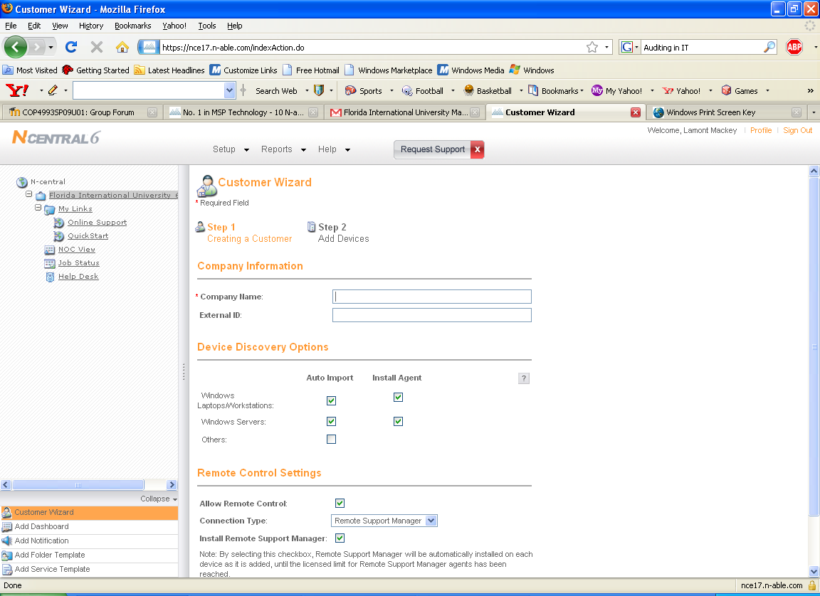
Fast, Easy Deployment- Customers are quickly added and new customers are effiently configured by the Customer Wizard through 4 simple steps:
- Set up the customer account.
- Configure the customer by creating the needed Smart Folders from the Folder Templates.
- Configure the probe and Auto-Discovery task and install the probe on the customer network.
- Execute the Auto-Discovery task.
N-central then transfers the devices into the appropriate Smart Folders. After which, The Service Templates along with the Notification Profiles are then automatically applied. In approximately 5 minutes, the user will then see information that was in the customer site, now onto the N-central dashboards.
The following is a look at the N-central Architecture:
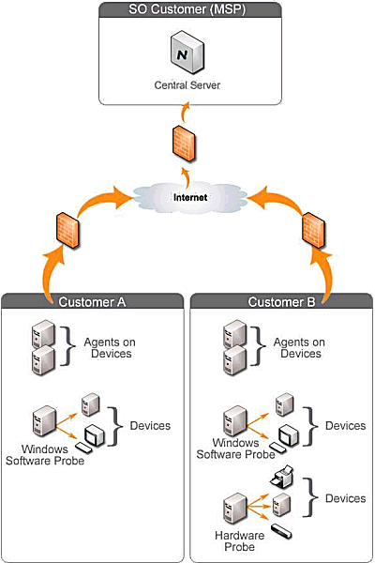
Flexible Web-Based Administration- This feature enables technicians to have custom views of customers' networks. For instance, views of multiple devices controlled by numerous clienteles can all be seen at once. Therefore, allowing technicians to have an overall assessment of the customers’ systems.
Alerting- If user defined barriers are breached, N-central provides an automatic alert for the user to assess the situation. Such barriers may consist of lost availability, capacity limits, network events, predicted failures or performance issues.
Remote Management- Services costs can be lowered as well as provide increased support levels by automating habitual tasks and remotely fixing and preventing issues that can be accomplished from one central location.
Remote Desktop and Server Support- Remote Support Manager is an essential tool that delivers highly developed remote management features to MSPs for accurate remote desktop and server maintenance.
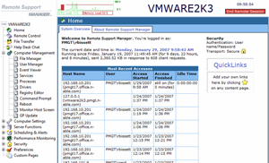
Managed Device Remote Control- By way of this feature, the need of a VPN connection is not needed to take control of managed systems anywhere and anytime you wish.
Attended Remote Control- To attain control of any Windows device to which the user has the necessary permissions.
Patch Management- Automate the task of protecting your customer networks against numerous risks.
Security- Assists in keeping customer IT infrastructures secure and operating faultless.
Asset and License Management- Effectively manage customer networks using critical information such as application compliance, license compliance and system changes.
Automatic Script Execution / Scripting- Use N-central to remotely install scripts as well as software to renew and preserve customer devices.
Intel vPro-Based PC Management- Due to the meteoric global rise in the need for MSP providers, Intel and N-able are providing complimentary technologies that will allow for capitalization on this high-growth prospect. Intel vPro processor technology broadens the functionality of N-central's premier class management platform to give users complete network visibility and manageability regardless of OS or power state. The following can be attained:
- Remotely discover devices that are powered off
- Remotely detect device network presence regardless of power or OS state
- Remotely power on devices that are powered off, regardless of OS state [5]
The benefits of the Intel vPro processor technology, is that it provides secure, remote access to the PC virtually any time for maintenance, updates, and upgrades, and for diagnostics, repair, and remediation. This functionally exists even if the PC is powered off, the OS is unresponsive, management agents are absent or hardware (such as a hard drive) has failed.
Microsoft System Center Essentials- The combination of Microsoft’s Systems Center and N-able creates a supreme remote monitoring and management environment that can be extended from the small business to mid-level enterprise. All of a customer's Windows and non-Windows network and system devices including desktops, laptops, servers, printers, routers, and firewalls can be monitored and managed on a single dashboard to drastically reduce costs and earn additional service revenues.
Tactical Operational Reporting- Business Performance Reporting- Troubleshooting and value delivery can both be simplified by utilizing reports to grow insight into your customers' infrastructures and continuing events.
Business Performance Reporting- Demonstrate the performance of a customer's IT under your management and the value you deliver. The following is a screenshot of the N-compass (an offline business reporting solution that is flawlessly included and harmonized with N-central) Architecture.
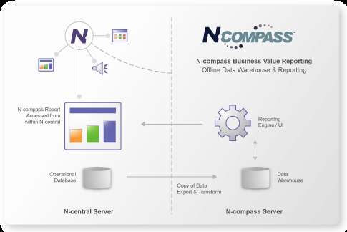
Interoperability- N-able allows for using the technology and tools of a third party in order to increase productivity as well as profit margins.
2.2.1 Functional Coverage
- Show which operating systems are supported- The operating systems that are supported are: Windows 95- Vista, Mac OS X, Novell, SUSE and Redhat Linux.
- Explain what can and cannot be managed and monitored by given solution- N-central supports monitoring the availability and performance of nearly any network device.
- Explain what underlying technology (agent, probe, etc.) is used to manage and monitor network with given solution- N-central provides the ability to monitor your customers' networks with both agents and probes or rather separately. Agents are significant for monitoring mobile devices that may not be connected to a network. If you are looking for an inexpensive method of monitoring large number of devices within a network, probes are the preferred option.

2.2.1.1 Remote Control
  - Discuss if researched solution has built in remote control ability- N-able comes equipped with remote control functionality. As a matter of fact, N-able has two versions of remote controlling. Managed Device Remote Control provided by N-able, in which N-central controls a Windows based platform that is supervised by N-central, regardless of whether the platform is attended or unattended. This feature allows for better efficiency and less expense seeing as onsite management is reduced, providing technicians with more time to focus on the clients’ business functionality, and integrated remote control solution isn’t reliable on a VPNs.
For devices that are not managed by N-central, Attended Remote Control is utilized. Remote Control can be attained over any Windows device simply by having a user connect to a Web page and complete a form.
  - Discuss what can be done with remote control (file transfer, etc) - An essential matter in any industry, is the need for efficiency and productivity. Downtime in the work force is something that is to be avoided at all costs. With remote control, it is possible to undertake control of a company’s devices, in the most time efficient manner. With remote controlling, various functions can be performed such as: easy deployment, secure chat and file transfer, with remote desktop management you can acquire remote access to your entire computing infrastructure, increasing your productivity.
2.2.1.2 Auditing & Asset management
  - Discuss if researched solution has built in auditing & asset management ability- N-able doesn’t have this feature incorporated in its package.
2.2.1.3 Monitoring
  - Discuss if researched solution has built in monitoring ability- N-able does indeed have remote monitoring ability.
  - Discuss how monitoring is accomplished- Monitoring is accomplished by simply selecting the desired information that you wish to take a closer at. By doing this, the user can simply perform a number of functions such as making modifications to the information presented before him.
  - Discuss what can and cannot be monitored- Nearly any IP-enabled device can be monitored with N-central. Through device monitoring, devices such as laptops, desktops, printers, copiers, routers, firewalls, etc.
Through monitoring support for industry-standard protocols: Log file analysis, SNMP, Syslog/SNMP Traps, TCP/IP etc.
Through IP Network monitoring: traffic, bandwidth, frame relay, TCP, Ethernet Errors etc.
Through Windows Network Monitoring: Application compliance, Connectivity, Disk, Memory, Patch Level, Process etc.
Through OS Monitoring: Suse and Redhat Linux, Windows based platforms, Mac OS X, Novell [6].
Through Email Monitoring: IMAP, POP, SMTP Queues, SMTP, Exchange Server.
Through Printer Monitoring: Printer Page Count and Printer Toner Level.
And with additional monitoring: Backup, Citrix and Firewall are some examples of what can be monitored [6].
  - Discuss what monitoring information can and cannot be attained- The easy access of observing the state of a device. This allows you to assess and correct network problems rapidly, and can be attained through the use of monitoring.
2.2.1.4 Patch Management
  - Discuss if researched solution has built in patch management ability- N-able does indeed house patch management functionality.
  - Discuss how patch management is accomplished- Is accomplished by assessing security risks automatically, accurately and comprehensively. It maintains and monitors patch compliance throughout an entire enterprise to accurately detect security vulnerabilities. Administrators can easily observe which devices are in security compliance and rapidly assess vulnerability.
  - Discuss what can and cannot be patched- Operating Systems, Applications, software and not just Windows based Operating Systems patches can be patched.
  - Discuss what patch management information can and cannot be attained- With patch management, you can meet even large-scale, complex network security requirements with full support for high availability, clustering, and load-balancing technologies. N-central and Microsoft Windows Software Update Services (WSUS) interoperates with one another to supply scalable, quality patch management.
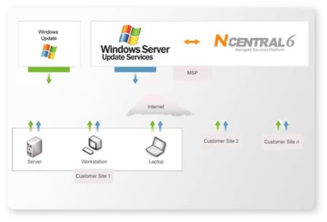N-central automatically creates a WSUS computer group for each customer you monitor by connecting directly to the WSUS server; this in turn reduces the amount of time of setting up and configuring WSUS.
2.2.1.5 Backup & Disaster Recovery
  - Discuss if researched solution has built in backup & disaster recovery ability- N-able doesn’t have this feature incorporated in its package.
2.2.1.6 Endpoint Security
  - Discuss if researched solution has built in endpoint security ability- N-able doesn’t have this feature incorporated in its package.
2.2.1.7 User State Management
  - Discuss if researched solution has built in user state management ability- N-able doesn’t have this feature incorporated in its package.
2.2.1.8 Help Desk
  - Discuss if researched solution has built in help desk ability-Yes N-able does in fact have a help desk feature.
  - Discuss how help desk is accomplished- Help desk is accomplished by way of N-ables N-supportPro which gives your team the highest level of security available and the smallest download footprint in the industry, to start client sessions faster.
  - The following screenshot is of the N-able NSupport Pro.
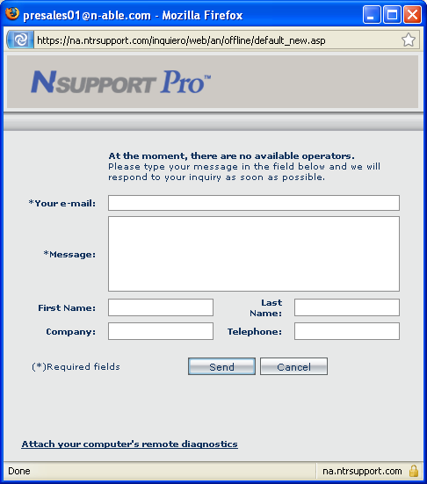
  - Discuss what help desk information can and cannot be attained- Information such as sales inquiries, how to purchase, benefits, as well as features of N-ables packaged product or options that can be included as well as how to use various features can be attained. Whereas addresses of staff members cannot be obtained for safety purposes.

2.2.1.9 Usability
- N-able offers a great user friendly environment to novices as well as experts that can both operate various functions with minimal difficulty. N-able offers easy navigational tools to operate its function abilities in the utmost timely manner. Features to provide for easy understanding of N-able are: Powerful and easy-to-use chat, Drawing tools, Sound alerts, Voice and video communications, Pre-session surveys to route requests, Post-session and surveys to gauge satisfaction.

2.2.1.10 Reliability
- The N-able solution, houses reliable service, that provides full maintenance levels of functionality. N-able provides for user defined alerts that inform the user as to when a breach in a selected state has occurred. With automation, solutions will be solved before noticed.
2.2.1.11 Performance
- As mentioned earlier N-able solutions has been honored with numerous awards. These credentials include being named as one of North America's top IT vendors by Everything Channel for four consecutive years (2005-2008).
- N-ables use of the N-compass Report Library, houses more than 20 pre-built reports that allow the user to make adjustments to system performance. Some of these performance tools include: Firewall Incident Trend Report, CCM Server Performance Report, Downtime Cost Report, Network Health Overview Report, Utilization Comparison Report etc.

2.2.1.12 Supportability
With N-able solution, the user is provided with an array of support for various functionalities. Here are just a few instances provided:
- Establish Remote Control in Seconds
Connection is made easy through Firewall, NAT and proxy-friendly, N-supportPro. One-click access through an active chat session or assign the customer a session code for immediate connection through your Web site or their desktop.
- Five Available Connection Modes
From passive collaboration to complete control, you choose the mode that best meets your need.
- Extensive System Snapshot with Remote Diagnostics
Through one click access you get a complete diagnostics report on the remote machine in seconds.
- Support Pocket PC Users
Investigate and solve technical problems on your customer's pocket PCs using remote control.
Note: It should be documented, that the N-supportPro is an optional feature and doesn’t come along readily available with the N-able package.

Additional Features
N-able offers an optional feature known as Remote Domain Policy Management in which a customary environment is created for all PCs at a customer’s site as a means to be cost efficient and supervise customer domain. Remote Environment Manager is a potent desktop management tool that allows you to simply control the customer domain. The centralized and standardized desktop management process with this feature provides for reduced cost and more productive management of applications.
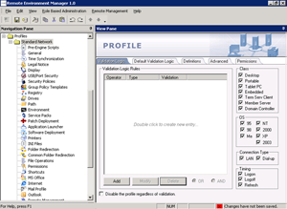

With Remote Domain Policy Management you can configure each aspect of the desktop at built in intervals such as logon, logout or at frequent periods throughout the day.
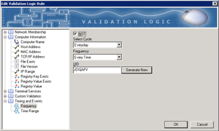
With Remote Domain Policy you can control or manage Remote Support Management, USB and Port Security and a nifty function known as Granular Management Selection, which allows the capability of creating numerous profiles that allows you to establish which users and computers obtain their respective configuration settings.
N-able also comes equipped with an N-compass reporting library. With this feature, you have access to more than 20 pre-built reports that allows for a swift assembly and communication of essential business information from an assortment of areas, which incorporates features such as network availability, reliability, utilization, regulatory compliance and asset reporting.

