2.2 N-able
Overview: N-able is an IT service organization that gives services related to network and systems management software and business support. This organization provides services with software to supply a wide range of utilities like remote monitoring apply patches to the computer systems and execute scripts.
Background: Founded in March 2000, N-able Technologies started as a IT managed service provider with several products to improve the small and medium business. From the start, N-able provided and still provides services as monitoring; optimize information technology and security to the organization and companies which they provide service. Over the years, N-able Technologies, has received several awards and recognition as trusted and efficient software. To mention a few, in June 5, 2007 is named to PROFIT Magazine's Top 100 List; and in March 26, 2008 receives a 5-Star Gold one of North America's top IT vendors.
Functional Coverage: N-able software is compatible with several Operative System (OS). Those are Win 98 SE/ ME/ XP/ Vista, WinServer NT 4.0 / 2000 sp3 / 2003 / 2008, Novell 6.5 SP 1a / SP 2 / SP 3 / SP 4, Mac OS X 10.3.9, Linux Kernel 2.4, 2.6 (like Ubuntu, Debian, Red Hat, Mandriva or SuSE Linux distributions). All these system and above are compatible, but is always recommended to read the instructions if is for customer or administrator services.
Grouping Managed Devices: The N-able software consists of a probe software (administrator) and agent software (designated for the clients). All these systems is managed by websites, from the website is possible to select the device, like another server, client pc or laptop, even a printer and many services can be applied, for example make a fix or just check status of the system.

2.2.1 Remote Control
Remote control in N-able Technologies allows a technician to troubleshoot and fix issues at the moment. The software provide tools that gives flexibility to address specific support needs, such as whether or not the device is working or situations that requires attended or unattended remote control.
Some of the features available to use are chat and file transfer, remote reboot and remote control with chat mode (Fig 1). These optimize the use of the system and give the clients more options at the moment of a remote help with their system.
With the Kaseya Automating system, the process of remote support is by opening a browser window and by an ActiveX download or a no ActiveX file, the remote control is then connected to the client. Keseya give a lot more options like ability to modify the computer management or verify the performance of the system real time, all these options are viewable oon the same window. N-able is preferred.
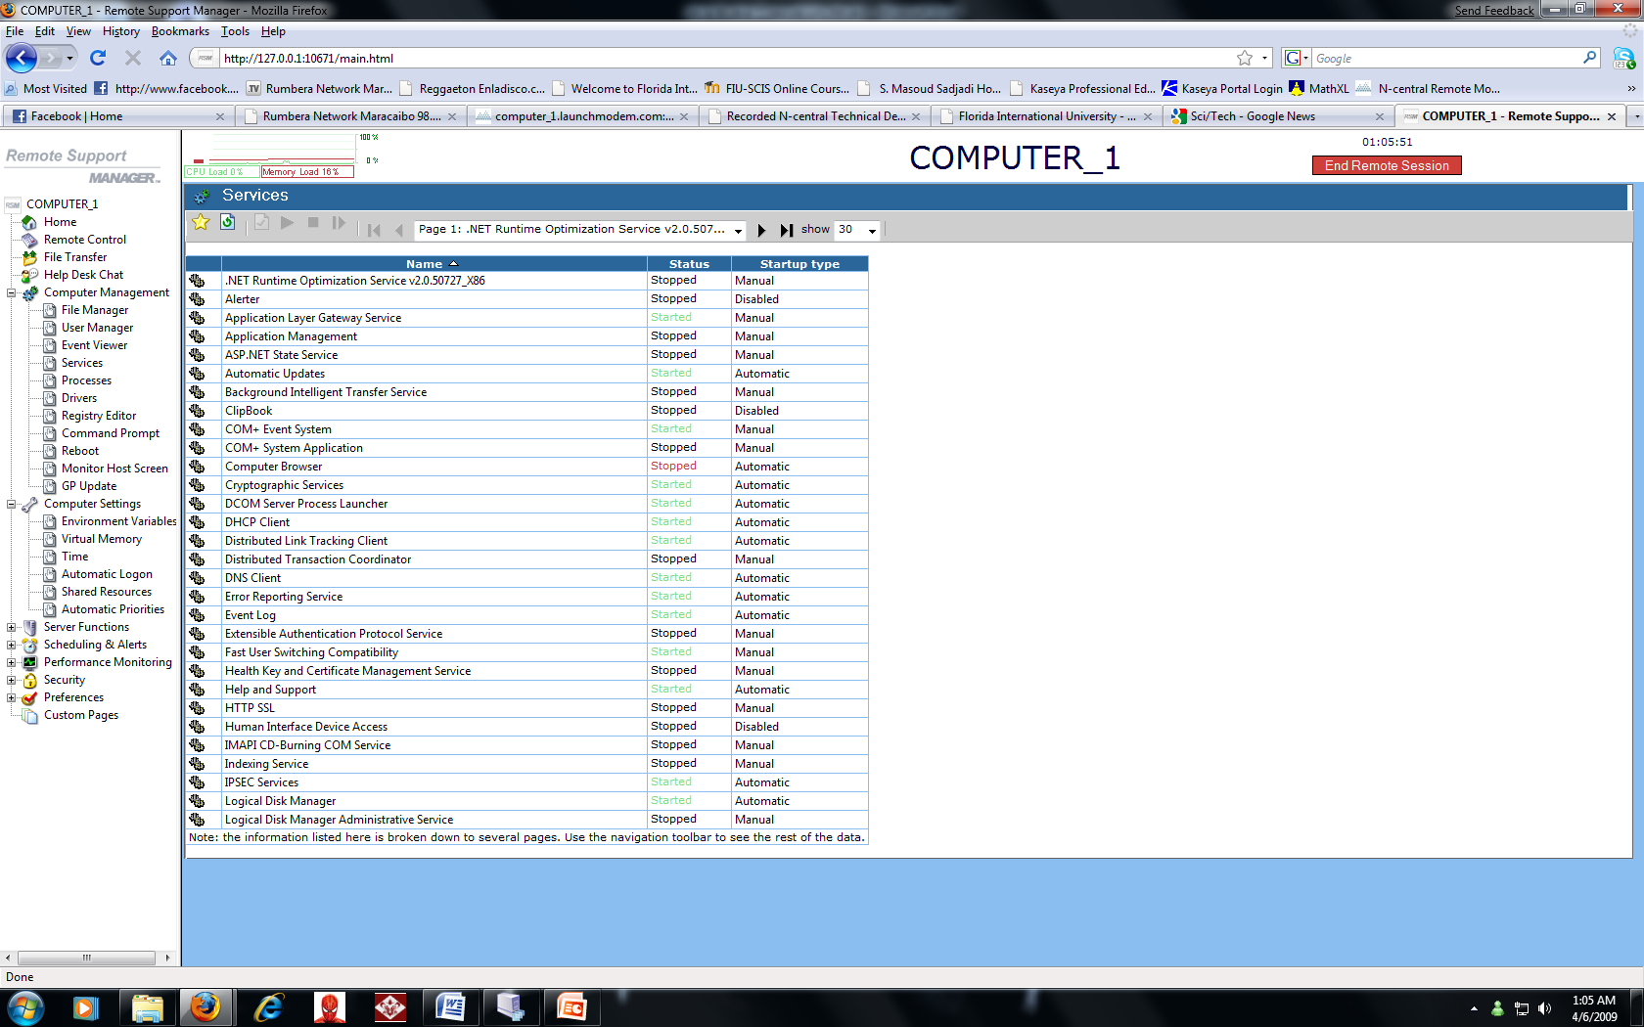
2.2. Auditing & Asset management
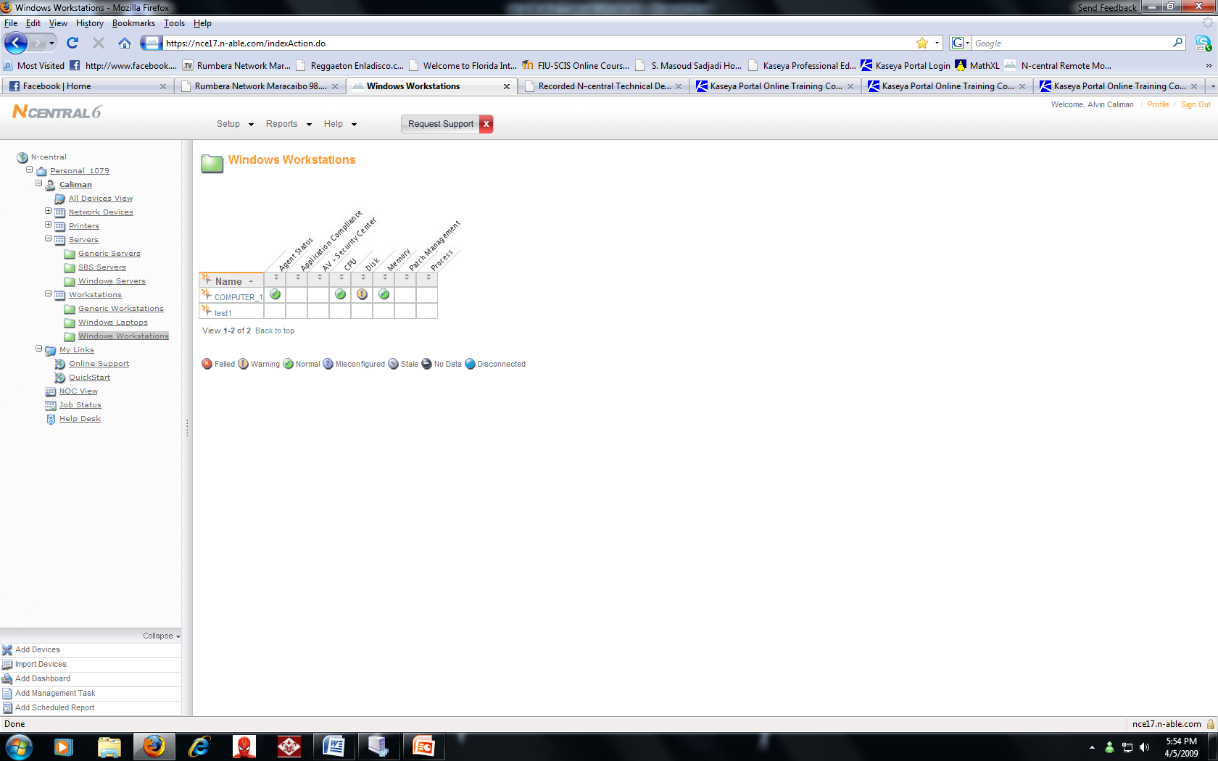
N-able technologies have a utility or software by their website that allows the discovery, tracking and management of devices on customer networks. N-able includes a discovery engine and license management feature set to monitor application compliance, license compliance and system changes on the systems. Adding scripts make audit options an easy task on N-able dashboard. Simple and fast to add them to the devices required like servers, clients or even printers.

2.2.3 Monitoring
The N-able website comes with a dashboard. With it, it can monitor the systems and devices, also alerts and monitor the protocols available for use. N-able automatically discovers devices on a customer network within a specified IP range, allowing you to quickly build an inventory of devices to monitor. Monitor routers, switches, firewalls and servers. Also allows quickly building of an inventory and monitoring Windows workstations and servers for: Application compliance, Connectivity, CPU, Disk Queue Length, Event Log, File Size, Local IP, License compliance, Memory and few more.

2.2.4 Patch Management
Patch management is one of the few reasons for using system automation like N-able, it deploys each patch on PCs at a central location which can secure and keep the customer’s network updated. N-central incorporates with Microsoft Windows Software Update Services (WSUS) to provide scalable, cost-effective patch management. With this system, it allows the server to patch all the computers needed so the internet bandwidth with not be used several times for the same process of patching.

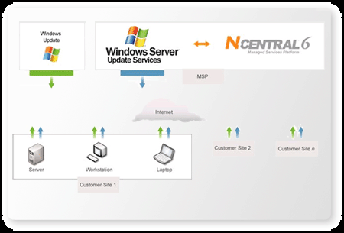
    - Backup & Disaster Recovery
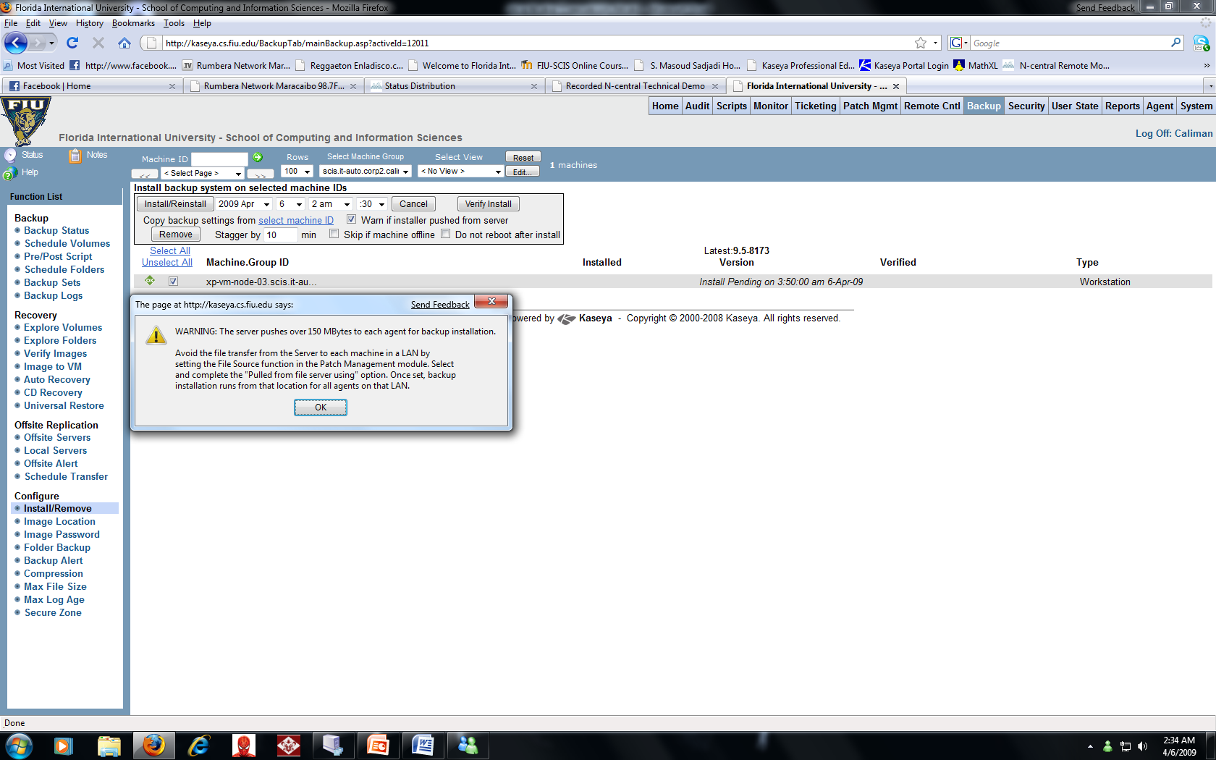
N-central 6.5 managed services platform and Iron Mountain Digital's LiveVault server backup service are together to provided the backup service. Backup is an extra service that by calling sales department can make the upgrade and have physical records on management, storage, data protection, availability, data destruction and secure shredding services.

2.2.6 End – Point Security
On the N-able dashboard, it can manage all security services from one convenient location. Packaged with monitor anti-spam, spyware and virus services, application compliance by remotely detecting non-approved applications; checks warranty, lease and support expiry services. All allow you to track expiry and replacement dates for security software and hardware.
N-central integrates with American Power Conversion (APC) equipment to allow the users to take advantage of this feature and monitor and manage APC universal power supplies (UPS) and security and environmental devices. In a state like Florida most of the computer hardware and mainly server are requires to have one UPS. By N-central provides a single solution for monitoring the entire customer’s uptime (runtime) and send alerts at the moments of emergency power off or constant blackouts.

2.2.7 User State Management
The N-able automating system allows remote control, distribution of patches, create or use predesigned scripts, distribute software, monitors for security events (viruses, system offline), and performance monitoring. (Fig 8) uses an agent to extract the information of the system and others connected to it for example printers and offers backup & disaster recovery.

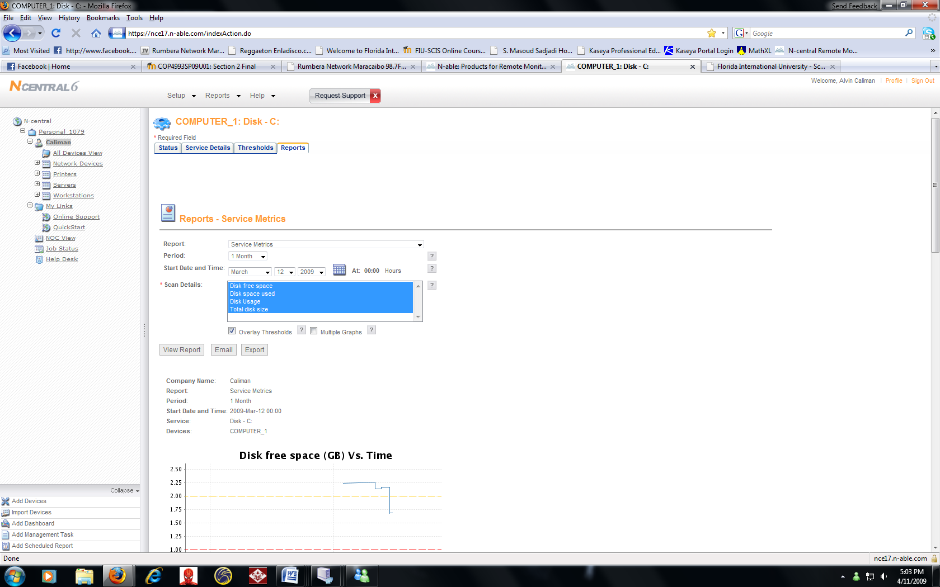

2.2.8 Helpdesk

N-able system offers diagnostic dashboard, that show and email Error messages, to increased support capacity with remote desktop and preventing future errors with logs and reports check.
Help Desk is not a main function of N-able system.

2.2.9 Usability

N-able website allows a fast access to the most common task to use, like overview of the systems, which system is online or offline or with problems. The web site is compatible with the most used Internet browsers like Firefox, Internet Explorer and Chrome. The N-able automation system can be remotely accessible by the administrators in office or even when they are at home. After login access gained to the administrators, they can control and do the entire tasks that the system can offer from anywhere and only requiring be connected to the internet.
In the other hand, Kaseya is also accessed with many browsers but with random issues like in Firefox, the access to remote desktop is sometimes denied or doesn’t open the file downloaded for this feature to be accessed. At work with Windows Internet Explorer, the Kaseya browser works flawlessly.

2.2.10 Reliability

The constant updates that can be preconfigured on the system, computers and servers will provide enough information of the usability and prevent any failure or a freeze due to memory issues or hard drives being full.
Users are always requesting that with all the changes, they want their computers to be more reliable to do their work. With this in mind, N-able the system can be accessed at anytime during the week and fix any user issue that could involve from the system is down or where other office administrators are unable to access their computer.

2.2.11 Performance

The biggest issue on the students and teachers are more in-depth into performing the work that needs to be done and access to it as fast as possible. Users will see the difference after the smart patch management and IT administrator prevention system; and at the same time, the use of prevention software to handle viruses, spyware, and other software that prevent the good performance of their desktops. Both Kaseya and N-able system operate at the same average quality to issue system slowdowns on performance.

2.2.12 Supportability

Like Kaseya system, N-able the support available when administrators access the IT automation system remotely, it’s able to use a standard web browser for example Windows Internet Explorer or Firefox. The system should support all Windows (even Windows 7) and Mac based platforms.

