  - N-able Technologies.
08
Fall
N-able, is an IT Automation & Managed Services Solution. According to their records and many other sources all over the web, N-able is one of the most popular and well-respected global suppliers for remote monitoring and management, providing state of the art technology for business, support services for managed service providers in all over the world. With their respected awards such as:

N-able is a market leader and award-winning provider of managed services technology and business transformation services, with more than 1,300 global technology partners servicing 36,000 customers who combined generate over $360 million in managed services revenue and significant revenue increases year after year.

N-able Technologies, provides to small and medium-size companies with a great managed service with automation software and business transformation services for resellers, such companies as IT Leaders, Wave Technologies, Precision IT Group, IT Authorities, masterIT, JPMerc & Co., Pardee Network Solutions, Control Circle, CHIPS Computer Services, Solsoft, just to name a few. Their product include various aspect such as Velocity System that comprises remote monitoring and management platform, and performance reporting; and Momentum System, an on-demand Web-based remote monitoring and management service that monitors and manages multiple customer information technology systems with devices at multiple client sites over the Internet with an very reliable and fast pace. “The company delivers technology and training that transforms service organizations into managed service providers by combining products, people, and processes to help service providers develop, sell, and deliver managed services” [11]. N-able Technologies, Inc. was founded in 2000 and its headquarter is located in Ottawa, Canada.

The following data gathered from N-able’s website will provide us with the different products offered by N-able: [1]
- N-central — the leading remote monitoring and management platform deployed globally by MSPs servicing the SMB market.
- Remote Support Manager — an included component that is integrated with N-central to give MSPs real-time remote PC and server management capabilities.
- Remote Environment Manager — a desktop management tool that enables MSPs to create, manage and enforce standardized environments for all PCs at a customer site.
- N-central OnDemand — the leading remote network, desktop and security monitoring and management service designed for MSPs delivering time-based managed services.
- N-compass — an MSP Performance Reporting solution that enables MSPs to demonstrate the performance of their customers' IT infrastructure from a business perspective.
Functional Coverage:

As a wide range of supportability and well-known company, N-able stands up with a variety of operating systems such as Windows 95/2000/XP/Vista, Mac OS X, Novel, SUSE, and Redhat Linux based.
Note: N-able works on Intel based chips only, not on AMDs.
Just like in any other software, some minimum system requirements are needed. According to N-able website, the minimum system requirements are as fallow:

For N-compass,
Hardware [2]:
- Processor: Minimum Pentium 4 (3 GHz) or equivalent.
- Memory: Minimum 1 GB (2+ GB recommended).
- Hard Drive Space: N-compass™ 3.0 requires a minimum of 60 GB for a dedicated data partition. This will allow N-compass to:
    - Import data from an N-central server that monitors up to 5,000 services.
    - Retain data for up to 1.5 years.
Software [2]:
- Operating System (one of the following required).
    - Microsoft Windows Server 2003 Standard Edition with Service Pack 2.
    - Microsoft Windows Server 2003 Enterprise Edition with Service Pack 2.
    - Microsoft Windows Server 2008 Standard Edition.
    - Microsoft Windows Server 2008 Enterprise Edition.
- Database System Supported (one of the following required).
- Microsoft SQL Server 2005 Standard Edition with Service Pack 2.
- Microsoft SQL Server 2005 Enterprise Edition with Service Pack 2.

Note: 32-bit and 64-bit platforms are supported.

Another great and cost effective-handy feature from N-able is that it’s capable of supporting virtual machines environment from VMware. “N-able Technologies has added VMware ESX Server 3.x to its list of N-central Certified Server Hardware” [2]. Not only that, N-able also provide customer support to VMware environments, handling these virtual machine in the same manner as any other physical machine’s customer support with N-central certified hardware.
Because virtual machine restrict us in some ways that differ from actual physical machines such as abstraction layer between the hardware and the operating system, we need to take into consideration two aspects when using this method:
- System Performance:
Because of this nature, N-able is not capable of guaranteeing the performance of the system due to these factors, which are stated in their website: [2]
  - Variability in field environments resulting from VMware server configurations.
  - The number of parallels virtual machines.
  - The performance of the underlying system.

Even though this is a problem cause by the infrastructure of virtual machines, N-able tries its best maintaining guidelines on configuring the VMware instances that N-central should run in. This method is applied in order to maximize the performance of the virtual machine and also its reliability as much as possible.

- Supportability:
Just like I mentioned above, since the nature of how virtual machines works and the abstraction layer between the hardware and operating system, N-able is unable to provide us with customer support such as troubleshooting on VMware systems or any performance issues related to VMware environments factors.

Recommended Configuration for virtual machines, using VMware according to N-able’s data base:
VMware Server [2]

- VMware ESX Server Version 3.5.
- The system must have sufficient RAM and hard drive space to provide permanently allocated resources as outlined below.
- Current N-central recommended hardware configurations specify 1 Quad Core Xeon Processor (51xx or better). We recommend that the VMware server be able to provide this level of processor performance to the N-central Guest Virtual Machine.

N-central Guest Configuration
- Guest Type: Typical.
- Guest Operating System: Linux.
- Version: RedHat Enterprise Linux 5 (32 bit).
- Number of Virtual Processors: 2 minimum.
- Memory: 6,144MB (6 GB) minimum.
- Network: 1 network interface card required.
- Virtual Disk Capacity: 140 GB minimum.

It’s safe to say that even N-able is capable of handling Linux and RedHat Enterprise Linux 5, it was not tested by me since I could not have access to these software, neither the physical capabilities/requirements in my machines in order to accomplish these testing.
The fallowing are the features that N-able has by default; of course 3rd party application are welcome but are not listed here: [3]

- Remote Monitoring.
- IP Network Monitoring.
- Windows Network Monitoring.
- Fast, Easy Deployment.
- Flexible Web-Based Administration.
- Alerting.
- Remote Management.
- Remote Domain Policy Management.
- Remote Desktop and Server Support.
- Managed Device Remote Control.
- Attended Remote Control.
- Patch Management.
- Security.
- Asset and License Management.
- Automatic Script Execution / Scripting.
- Intel vPro -Based PC Management.
- Microsoft System Center Essentials.
- Tactical Operational Reporting.
- Business Performance Reporting.
- Interoperability.

The fallowing are features that N-able does not have by default:

- Back up and Disaster Recovery.
- Desk Help and Ticketing are not built-in as default, but can be implemented as an Add-On to N-central.

Note: Desk Help is provided by N-able as an additional-option feature.

In order to accomplish tasks on some of the features previous mentioned above, N-able uses software agents and probes to gather all critical data and built inventory on devices on customers’ networks.

Agents:

Agent is a piece of software that acts for user or other program in a relationship of agency. Such action implies the authority to decide which action is appropriate. In N-able’s case, agents are not invoked for a task, but they activate themselves. N-able uses agents for different tasks, such as remote connection, deployment of scripts and patch managements to allow connectivity to that specific machine were agent where previously installed on and perform the decided task.

N-central Probe:

N-able uses probe to monitor multiple private networks without compromising their security, including every scheme of IP used. This component stays installed in the customer’s network in order to become monitored. Probe comes in two deployment methods:
- “Windows probe software: Software-based probe that provides WMI and network-based monitoring of up to 25 KNEs” [12].
- “Probe software: Probe software ISO installed on certified probe hardware (network appliance) provides full monitoring functionality” [12].

Grouping Managed Devices:

Definitely N-able provides groping managed devices over the network. As previously mentioned, multiple computers can be monitored and remotely managed at the same time with bare minimum or no lag at all. Devices range from desktops, laptops, windows mobile phones, printers, routers, servers, firewalls and virtually any IP-enabled device connected to the network. With its category selection, we can create a filters, section or subcategory, where then they can assign different functions depending on their needs.

2.7.1 Remote Control

For today’s IT service providers, cutting cost and time is the key to success. Therefore, implementing the right tool at the right time is essential for every occasion. Remote Control is one of those tools. N-able offer us a friendly remote control yet powerful, fast and effective way to accomplish these tasks before small problems become bigger. N-able’s remote control tool will allow us to seamlessly access and take full control of customer devices regardless of their type or location.

This feature will enable us to troubleshoot and fix issues from a single dashboard. This will speed up the process by deserting weather a technician should be or not physically present on that particular machine in order to fix its issues. Also with N-able we are capable of remote control devices that are not under N-central, for example we can gain remote control over any Windows device by just asking the user to connect to a Web page and complete a form. This is very useful tool for new computers that doesn’t have the agent installed yet on their machines or for service providers who deliver help desk outside of a fixed managed service contract.

N-able Technology INC, as a well-respected IT Automation & Managed Services Solution company, in their product N-central they offer us features like: integrated remote control capability, that allows to our technical staff to control any Windows-based device (2000/2003/NT/XP) under management in a secure, flexible and powerful way. Since remote control is integrated in their product as a pre-packaged and seamlessly remote solution, it lowers our cost and time by not having us to rely on third parties applications in order to accomplish our needs in the remote control field. Also N-central’s remote control doesn’t rely on open external ports or VPN’s.

2.7.2 Auditing & Asset management

Auditing & Asset License Management are implemented to manage customer’s networks using critical information such as application compliance, system changes and license compliance.

This method is implemented to keep our customer’s network in a peak performance, in our particular case NMB Senior High. In order to manage effectively our network, proper asset management is a must. According to N-able’s website [4], we can implement Integrated Asset Management; which will allow us to monitor critical device information such as:

- System Changes: This will monitor the hardware components of an individual device to record and report on hardware changes.
- License Compliance: Monitor the number of licenses of purchased software being used to ensure compliance and plan future purchases, keeping everything legit and running smoothly.
- Application Compliance: Basically this will create "black" and "white" lists of applications to track application compliance and protect unauthorized software usage by our customers.

2.7.3 Monitoring

One of the most important tools in IT Automation is monitoring and N-able is well known for this. This is critical to the delivery of effective management services that keep our school’s infrastructure up and running.

As mentioned above, N-able as a respected company for IT automation, have reliable and well-rounded tolls like monitoring. “N-central features a built-in tool to monitor the availability and performance of IP-enabled devices, including desktops, laptops, servers, printers, copiers and routers” [13]. N-central uses software agents and probes to gather all critical data and build an inventory of devices on our network in a very efficient way, which will allow us to detect problems before they lead to costly downtime.

N-central supports monitoring on a wide range of services, virtually any on network device. It comes with a pre-defined setting with over a hundred services. The fallowing are the devices and services that N-central are capable of monitor:

Monitoring of a wide range of devices: [3]

- Desktops
- Laptops
- Servers and Web servers
- Printers and copiers
- Routers
- Exchange servers
- Firewalls
- And virtually every other IP-enabled device

Monitoring support for industry-standard protocols

- SNMP
- Log file analysis
- TCP/IP
- WMI
- Syslog/SNMP Traps
- ODBC
- EDF

IP Network Monitoring

- Ethernet Errors
- Traffic
- Bandwidth
- Frame Relay
- TCP
- SNMP

Windows Network Monitoring

- Application compliance
- Connectivity
- CPU
- Disk
- Disk Queue Length
- Event Log
- File Size
- Local IP
- License compliance
- Memory
- Patch Level
- Process

OS Monitoring

- Windows 95 to Vista
- Mac OS X
- Novell
- SUSE and Redhat Linux

Email Monitoring

- Exchange Server
- IMAP
- POP
- SMTP
- SMTP Queues

Printer Monitoring

- Printer Page Count
- Printer Toner Level

Additional Monitoring

- Backup
- Citrix
- Firewall
- RAID controllers
- Local services
- Custom services defined by you

N-central has the great capability of alerts, which can send alerts to us via either via emails, pager or SMS when warnings or failures occurs on our network, so we can address these issues in a fast en efficient manner before the become more complicated or to a point of losing critical data, which is always a high priority in any company, in our case NMB school.

2.7.4 Patch Management

N-central uses Windows Software Update Services (WSUS) to provide a cost effective and scalable patch management. N-central provides us with an easy WSUS configuration, as well as reporting of patch levels and monitoring across WSUS-enable devices.

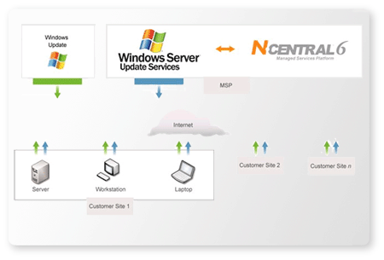
Figure 2.1.1.4a – Patch Management function. [5]

Patch management is the single most effective way to secure our network. This is done by having N-central directly connected to WSUS server, downloading updates and patches automatically, reducing the amount of time that this could take to do them individually on each machine. After updates or patches are obtained, we can monitor and report on patch levels for those devices and even set up alerts to those devices that are falling behind with the updates.

2.7.5 Backup & Disaster Recovery

Unfortunately, Backup and Disaster Recovery is not supported by N-able at this moment. But implementing a third-party application could accommodate this lack of service.

2.7.6 Endpoint Security

Security is always a must, nowadays even more. Having hackers, trojans, fisher, spam, virus, etc, we cannot take the change to overlook at this field, therefore N-central provides us with a reasonably security.

N-central offers monitoring atispam, spyware and virus services that ensure our IT infrastructure is always protected. It proactively monitors and manages multiple security appliances and applications to minimize our IT infrastructure downtime. Also, they ensure application compliances by remotely detecting non-approved applications. Tracking security performance over time to provide valuable reporting is a very nice service that N-central provides with its security service. And track and manage firewalls and intrusion detection system and proactive alerts are just some of the security features that N-central provides us wit.

2.7.7 User State Management

User State Management comes very handy when it comes to policies and inoperative machines, meaning computers that are not being used for x period of time. For example, employees or students usually leave their station after work hours and forget to turn off their computers, leaving them vulnerable for the online predators since the system is up and running and open to the network. Also the consumption of electricity will affect the company with higher and unnecessary electricity bills, just because their forgot to turn off their computers or just trying to be clever by leaving their workstations on and avoid the boot up time saving them time when they come back to work the next day, next shift or next class in case of a student. All these problems can be avoided by controlling the computers power management remotely or by creating policies. Thankfully, N-central provides us with a product called Remote Environment Manager. This product will allow the administrator of the company, in our case NMB Senior High School to control the power management for all the computers located in the network. This great service from N-central is controlled by the administrator, which could have the choice of setting up power-schedules individually or globally to the computers connected to the network. This would be a great compliment for any company since electricity bills will be cut off and also lowering the risk of online malicious treads or predators.

2.7.8 Help Desk

One of the most important features that any IT automation solution offers to speed up the process of troubleshooting is Help Desk. N-able currently doesn’t provide us with this feature as a built-in package with N-central, but it’s offered to us an additional Add-on to our N-central product by paying low monthly fees, or buying it on its own by purchasing a license with N-supportPro. This will allow us to attend our customers with fast, effective help, regardless of the operating system they're using. N-supportPro will allow us to remote support multiple computers our NMB Senior High School with a secure, stable, efficiently and economically way by implementing an small downloadable client in order to start their sessions faster.
Fallowing are some of the benefits that N-supportPro offers, according to N-able’s website [14]:

- Shorten case resolution times and reduce repeat calls for the same issue.
- Reduce costs by increasing service desk productivity.
- Increase the number of incidents resolved on first contact.
- Minimize the need for costly, time-consuming visits to customer sites.
- Improve customer satisfaction by providing fast, non-intrusive and effective technical assistance.

N-supportPro is amazingly well structure to accommodate Help Desk in many different features. Some of these great features that N-supportPro offers are:
- Using the Administrator mode, we can have the ability to reboot and reconnect remote machines without losing the control connection.
- With N-supportPro we can get a complete diagnostics report on the remote machine, with a simple click.
- Thanks to their proxy-friendly and NAT, N-supportPro make it easy to crate a chat conversation, assign a code to that person that needs assistance in their machine and even a voice and video conversation; all this can be done trough the web interface.
- N-able supports “Drag and Drop Two-Way” File Transfer.
- Record and Playback Remote Control Sessions
- With N-supportPro, we can establish Remote Control in Seconds thanks to the lightweight client that can be downloaded truth their web-interface into individual machines or deployed truth the network.
- Files can be sent and received between the technicians and the client.
- Extensive System Snapshot with Remote Diagnostics.
- Print documents remotely on the operator's printer - no file transfer or special configuration is required.
- Show or Hide Applications during Remote Control.
- Brandable Interface will enable us to use our own NMB logo.
- Customize chat windows, e-mails and surveys with the look and feel of your service organization.
- Sound alerts are also available.
- Multi-platform support includes Windows, Linux, Mac and mobile devices
- And last but not least, N-supportPro can support Pocket PC Users.

Note: All these option are sold as an Add-on by paying a low monthly fee or just by purchasing their long-term license on its won, provided by N-supportPro.

2.7.9 Usability

With the easy and friendly GUI, N-able is simple to operate. To accomplish a task we have different approaches that are done by having two columns; one on top we have the (Setup, Reports and Help) tabs; and on the left pane we have the Network Devices, Printers, Servers and Work Stations. Each individual tab has subcategory related to that specific tab. In Figure 2.1.1.8a and Figure 2.1.1.8b we can appreciate more of the interface that N-able works on.

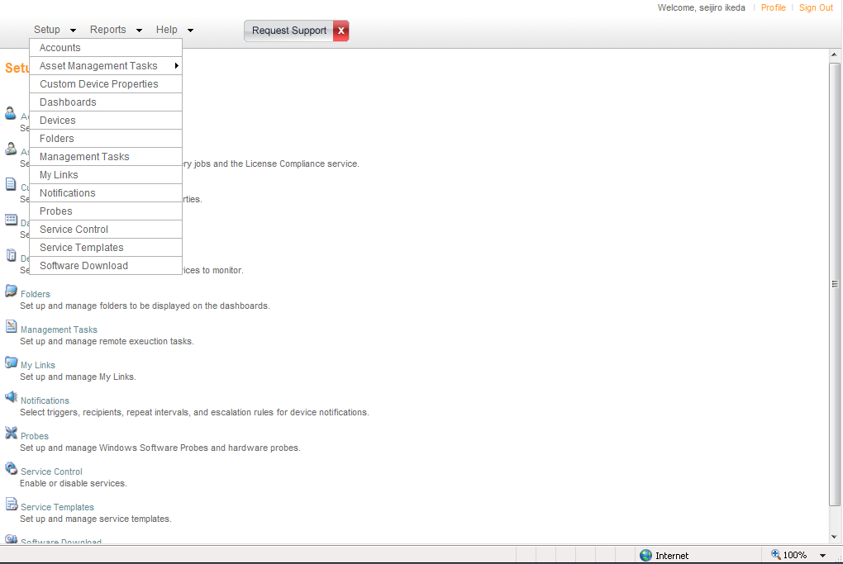
Figure 2.1.1.8a – Three tabs located on top-left (Setup, Report and Help).

Each tab has its own submenus that allow us to reach to the desire task in an organized and easy way. Inside “Setup” tab, we have:

- Accounts.
- Asset Management Task.
- Custom Device Properties.
- Dashboard.
- Devices.
- Folders.
- Managements Tasks.
- My Links.
- Notifications.
- Probes.
- Service control.
- Service Template.
- Software Download

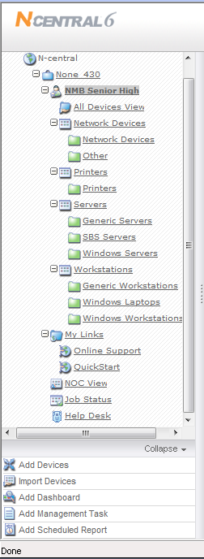
Figure 2.1.1.8b – Left pane, always visible from the main page.

In Figure 2.1.1.8b we find Network Devices, Printers, Servers and Work Station, each with their own respective subcategory. In this pane we can check the current status of the selected device. Different detail subcategories about the selected device are displayed, all nicely done with a clean GUI and friendly colored legend. In Figure 2.1.1.8c, we can see a little example of N-central’s legend and layout of their web interface management system.

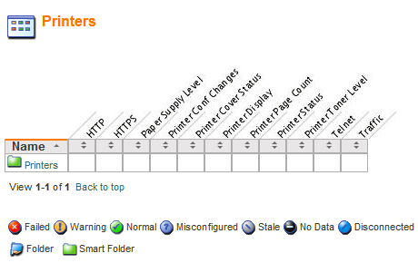
Figure 2.1.1.8c – Example of N-central’s Legend and Layout of the Printers
Section.

Overall N-central offers a very friendly and eye catchy Web Interface, where everything can be understood in an easy manner. But even though N-able offers a friendly interface, I found it tedious when finding a specific task. Everything is subcategorized into different folders and layers, where makes it hard to deal with.

2.7.10 Reliability

N-able is famous for the Monitoring. Their infrastructure is very well stable and reliable. With lightweight client and small footprints to be deployed or individually installed, their remote support is easily managed trough their web interface. And their 24/7 Support is provided with great feedback from previous customer. Regardless all these positive aspects from N-able, I found many incompatibilities installing their Probe and Agent; problems related with .DLL level. Extended personal research, I found many companies that were unsatisfied with their product. For example: David Wertz, president of PC Work Plus, stated: “We couldn’t even get six customers set up on N-able, despite spending hundreds of man-hours and thousands of dollars over a two month period.”[6]

This problem evolve from trying to implement N-able in PC Work Plus company, and he only tried with six of his customer having less than 100 workstations.

At the end of his journey with N-able, Mr. Wertz stated: “ The N-able software looks nice – it has all the bells and whistles – but it is about 25 percent as usable as Kaseya. And ultimately, that’s what really matters.” [6]

2.7.11 Performance

Performance wise, N-able stood up very well. By implementing a lightweight client, remote assistance can be done fast and simple, making any company or in our case NMB Senior High, resolving problems in a fast manner producing a higher productivity overall. Great monitoring system, prevented problem from expanding to a highly cost and timely consume error that could be resolved if proper tool were to have, in this case N-central Monitoring tool.

2.7.12 Supportability

N-able is not only well recognized by their great Monitoring tool, but also for the Support. Their support range from: 24/7 online product and business support, Telephone and Electronically support via phone calls, Self-service Portal, Product Documentation and online training and just few of the supports provided by N-able. It’s safe to say that in order to acquire their best customer support satisfaction, the “Maintenance and Support Program” should be purchased. N-able only provided their best support, which they call “Premium” only if the customer buys their Maintenance and Support Program, versus their “Standard” support, which only includes “24/7 Online and Business Training”.

