2.4 N-Central 6.5 (Sajjad Zaidi)
Overview:
IT industry is evolving at the speed of light and the complexity of the service demands more time and effort to solve modern day IT Issues. In today’s complex or simple business model, IT is the spinal cord and in order to grow and survive business’s wants fast on demand services. IT managers are looking for many solutions that are available in the market to do this said job. Among these many solutions three products have made their mark on MSP’S. N-able along with its competitors have achieved recognition and is competing with it competitors like Kaseya and Level Platforms.

N-Central current version 6.5 has probe-bases agent that can detect all IP based devices and can build inventory in seconds. THIS brings system management into a simplified solution. Any devices outside the network can be monitored with the help of physical agent installation (N-Central ™ 1).

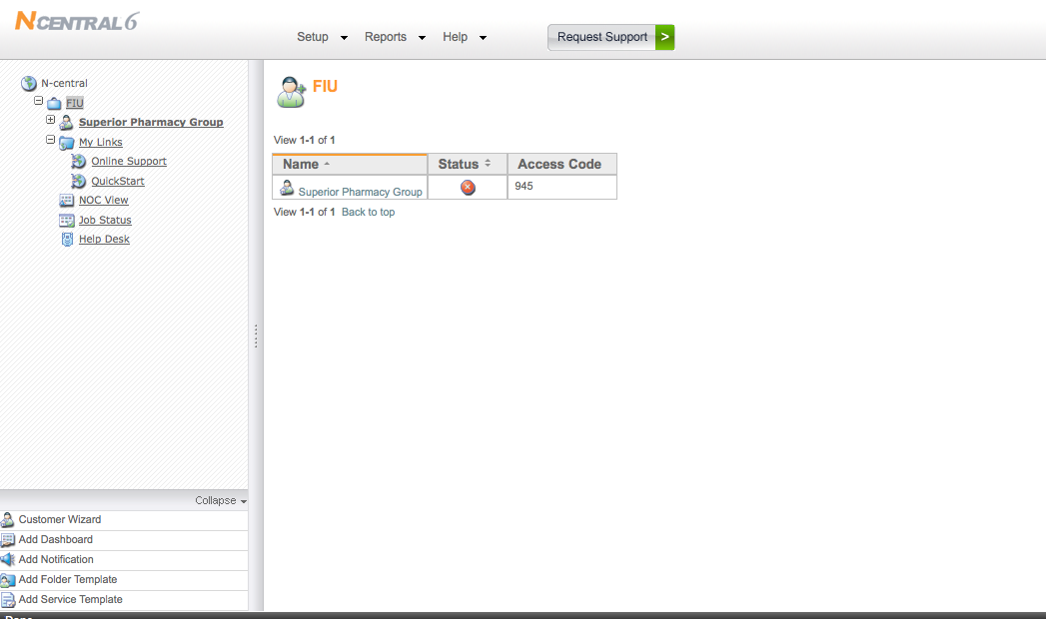
Screen-shot of the Trial Version

Functional Coverage:

System Requirement
A web enable monitoring interface makes N-Central easy to manage and its implementation even simpler. This MSP can take over the system with in minutes and helps to manage inventory (N-Central ™ 2).

Supported Client Platforms
- Windows 2000/2003/2008/XP/Vista, 2008 Small Business Server
- Novell 6.5 SP 1a / SP 2 / SP 3 / SP 4
- Red Hat Linux AS/ WS/ ES 3.0, 4.0, 5.0
- Mac OSX 10.4, 10.5

Features
The interface has a console where a comprehensive dashboard with useful features can monitor networks and devices from a single Web UI called a dashboard. The system sends alerts via SMS, email and pager. N-central can also send alerts, warnings or failures that may occur (N-Central ™ 3).

Operating Systems and Protocols

N-Central provides a platform where al IP activated devices can be monitored

Protocols that are supported:
- SNMP
- Log file analysis
- TCP/IP
- WMI
- Syslog/SNMP Trap
- HTTP/HTTP(s)
- ODBC
- EDF

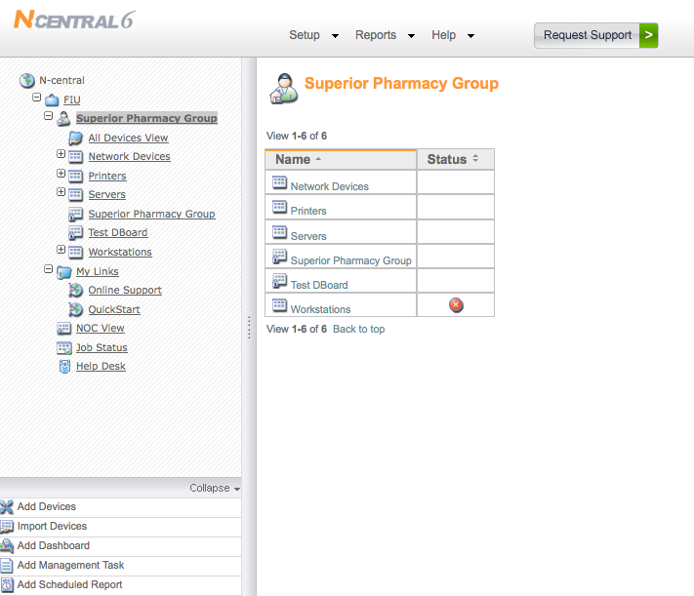
Screen-shot of the Trial Version

2.4.1 Remote Control
N-central has a remote control that can troubleshoot and resolves issues from a single WEB UI dashboard. The feature gives the flexibility and can also address specific support needs. The proprietary remote control agents has unique feature that can probe a system and is able to resolve issues. N-Central also has other easily available third party software that can also perform the task.
Using this functionality provides a remote control over any OS. N-central features an integrated remote control capability that allows control over any OS especially Windows-based device (2000/2003/NT/XP) under management by N-central. The unique feature does not relay on open ports or VNC (N-Central ™ 4).

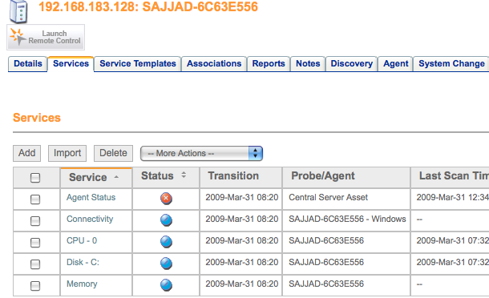
Screen-shot of the Trial Version Used

2.4.2 Asset, Audit, License Management:
Inventory management is not only easy to mange but it takes it to the next level. This feature allows the IT Admin jobs much easier and does not require manual labor. The built in tool that probes the specified IP range makes it inventory of all hardware and software with in seconds. In order to manage networks effectively, a proper asset management must be in place and N-Central can deliver. N-central's has an asset management features that builds proper inventory and makes a complete list that tracks applications and can safeguard computers from unauthorized installation and use of software. License Compliance is also a provided and useful feature that monitors compliance and future purchases if are planed. N-central can also monitor hardware components of each individual device to record and reports any hardware changes (N-Central ™ 5).

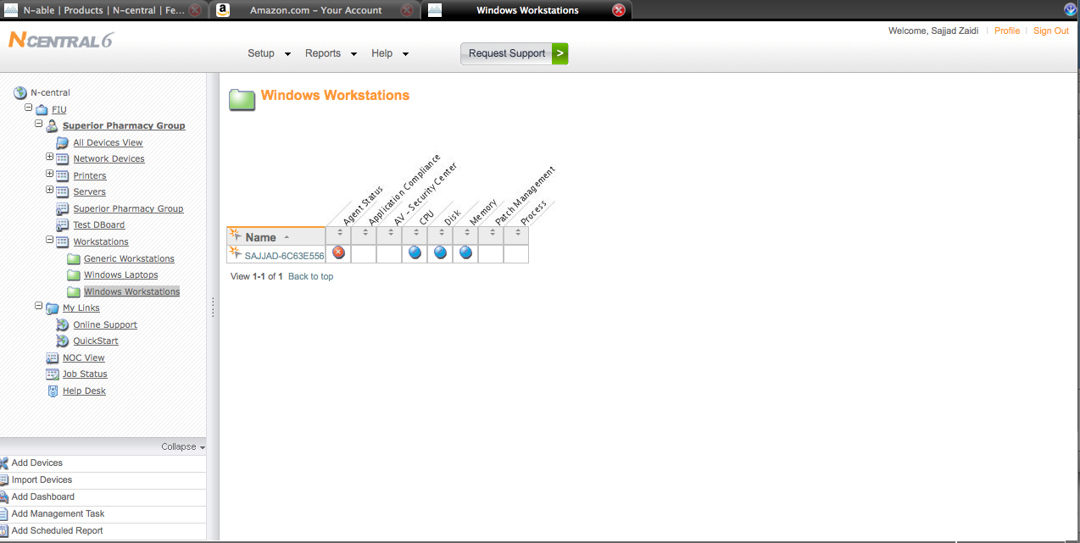
Screen-shot of the Trial Version Used

2.4.3 Monitoring (N-Central ™ 6):

IP Network Monitoring
N-Central automates and monitors a specific IP enabled device or a range of IP can be input to get the desired results. It can Monitor routers, switches, firewalls and servers for:
- Ethernet Errors
- Traffic
- Bandwidth
- Frame Relay
- TCP
- SNMP

Network Monitoring
Automatically discover devices on a network, which allows the monitoring of devices. The Servers and Workstations can be monitored for the following:
- Application compliance
- Connectivity
- CPU
- Disk
- Disk Queue Length
- Event Log
- File Size
- Local IP
- License compliance
- Memory
- Patch level
- Process

Agent Deployment
N-central probe and agents can be deployed via login scripts, Group Policy Objects or other agent called N-able's Remote Environment Manager or Microsoft Systems Management Server. When an agent is installed, they discover themselves, contact N-central and create a new device to begin monitoring themselves. This can also be automated agent deployment using retry logic and PSEXEC as a helper application. This increases reliability and ensures that agents will be installed, even if the target device is powered off at the time the deployment is initiated. Unlike other solutions, N-central shows whether a device is normal, failed, nearing failure, misconfigured, disconnected, reporting stale data or not reporting data. Also helps in building the probe can detect asset changes and updates monitoring appropriately, including reconfiguration due to agent or probe additions (N-Central ™ 7).

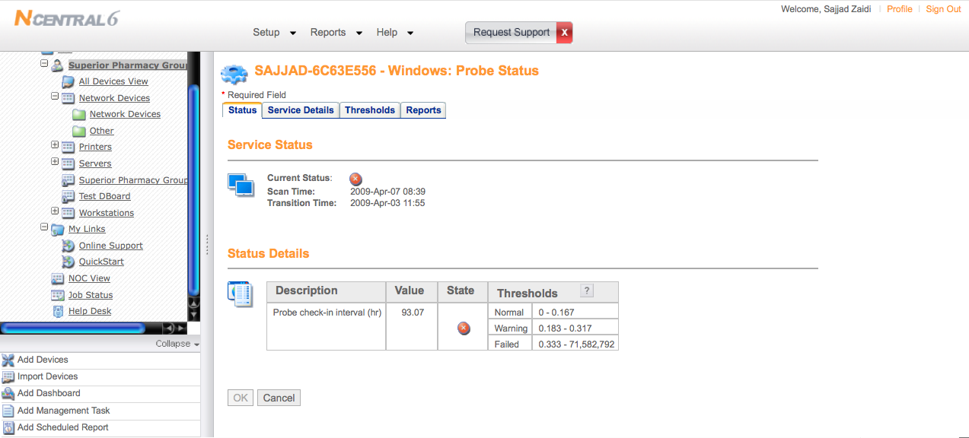
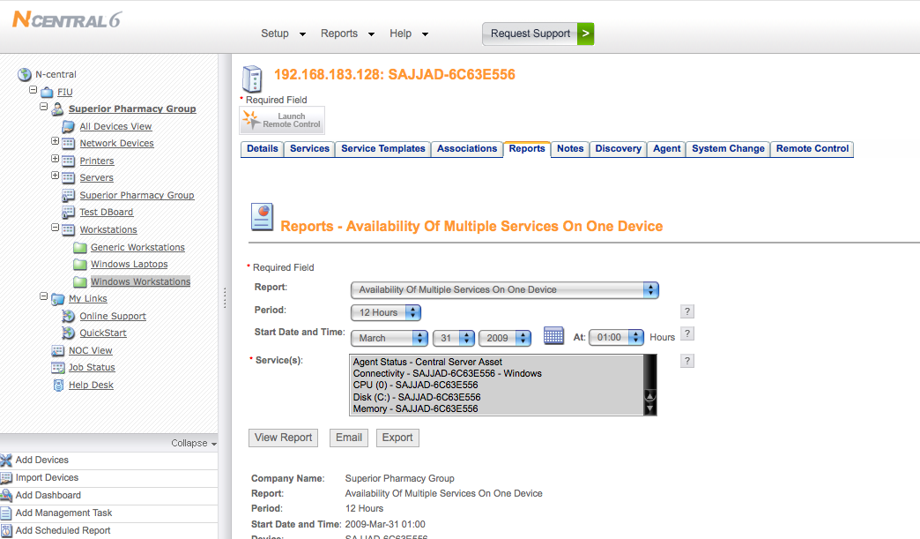
Screen-shot of the Trial Version Used

2.4.4 Patch Management
For a secure network patch Management s. N-central can interoperate with Microsoft Windows Software Update Services (WSUS) to provide patch management. With N-central easy WSUS configuration is possible, as well as monitoring and reporting of patch levels across WSUS-enabled devices. N-central can be connected directly to the WSUS server and automatically creates a WSUS computer group. It also monitors and reports on patch levels for devices, and set up alerts for machines that are not updated (N-Central ™ 8).
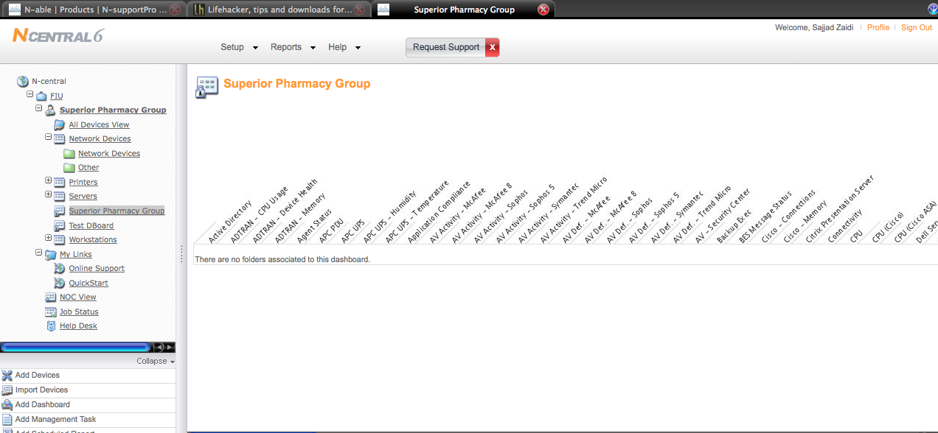
Screen-shot of the Trial Version Used

2.4.5 Backup And Disaster Recovery:
For backup N-Central relies on a product call Backup Exec. This tool comes with the entire data tools available to perform this task. What N-Central is lacking is the built in too that can select the individual volumes. Data recovery and Back has to go through this program, which is a comprehensive solution to perform this task. Backup Exec provides three different layers and can be customized:
- Data Protection
- System Recovery
- Extended Backup Capabilities

The Backup Exec tool is highly customizable software, which gives the user the power of managing data recovery with minutes. System experiences no downtime and can be up and running with in minutes (N-Central ™ 9).

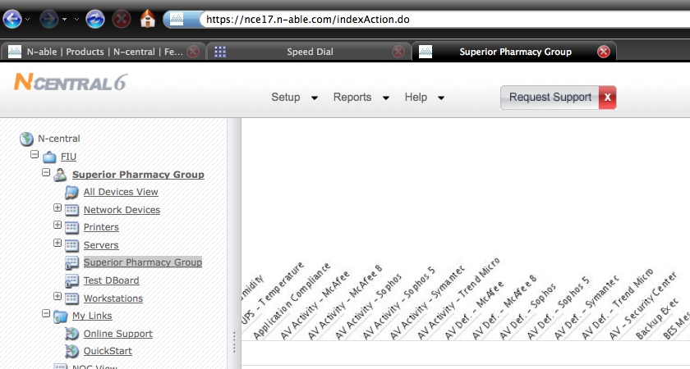
Screen-shot of the Trial Version Used

2.4.6 End Point Security
N-Central Proactively monitors and manage multiple security appliances and applications to minimize IT infrastructure downtime. It manages different security services from one location. It can monitor anti spam, spyware and virus services to ensure that IT infrastructure is protected. It monitors that application compliance can also detect by remotely detecting non-approved applications. It also Monitors and manages firewalls and intrusion detection systems and can receive alerts upon their attack. It also tracks security devices to ensure adherence to software licensing and IT governance (N-Central ™ 10).

Numerous tools are provide to perform this task and are not limited to the MSP’s capabilities. Few of them are:
- McAfee
- Trend Micro
- Symantec

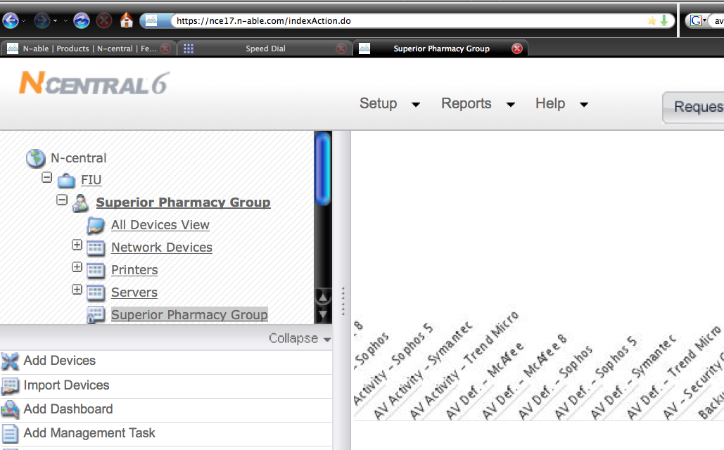
Screen-shot of the Trial Version Used

2.4.7 User State Management:
The cost benefits of User state management cannot be ignored and in today’s IT infrastructure. Focused today on energy efficiencies and cost, the power management feature can remotely shut down idle machines. Remote Environment Manager also allows controlling and preventing access to USB and peripheral storage devices that can bring viruses also. The USB and Port Security option can control read and write access to USB ports, storage and communication devices on the desktop. This is an important feature for differentiation and especially for customers with critical information on their database (N-Central ™ 11).

Remote Support Manager works with any Java-enabled browser and can manage:
- Point-to-point file transfers
- Services, processes and drivers
- File System and the Registry
- Installed applications
- Open files, DLLs and registry keys
- Tasks and alerts

N-Central can create multiple profiles that can be applied based on patented validation logic that allows determining which users and computers receive which configuration settings. There are built in validation tools and can also be customized. Remote Environment Manager is fully integrated with Active Directory and administrators can also use this feature to configure individual user profile (N-Central ™ 12).
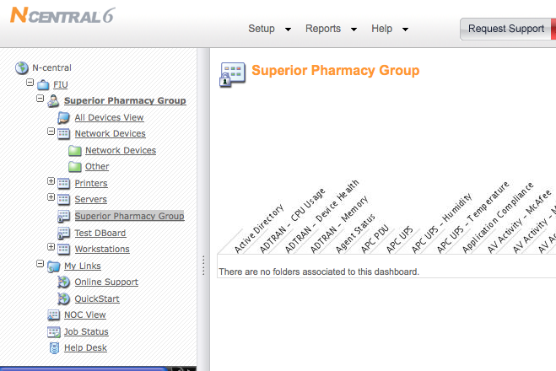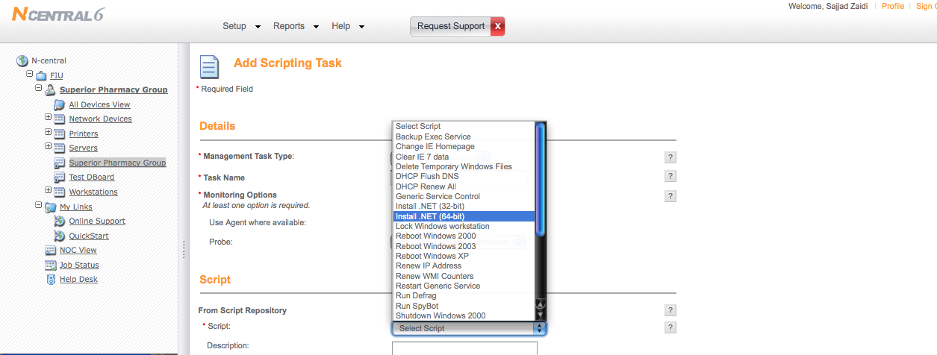
Screen-shot of the Trial Version Used

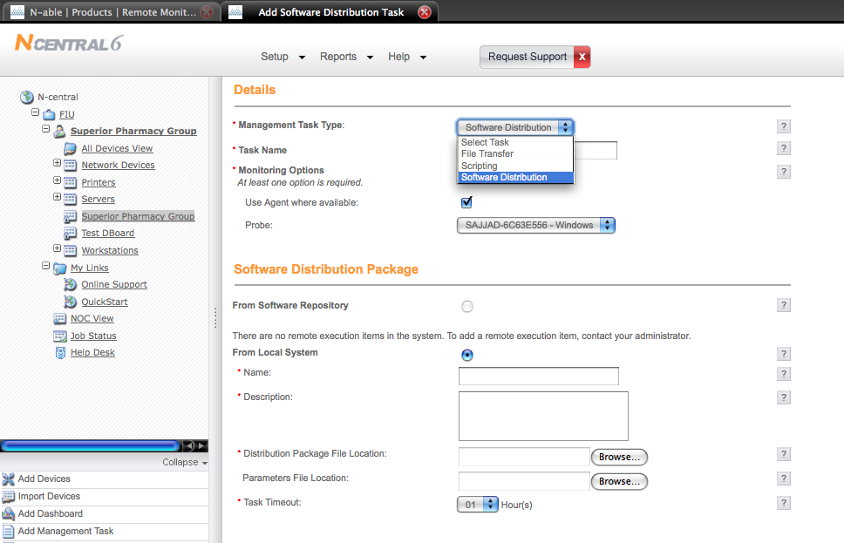
Screen-shot of the Trial Version Used

2.4.8 HELP DESK:
Help Desk can be provided either by N-Central or it can be used by sys admin. Help-desk is NAT and proxy-friendly and makes connecting easy. Users can get help via one-click or an active chat session can be used for this task. The feature available through helpdesk is automated ticket and email dispatch. Remote file transfer or remote monitoring is also available (N-Central ™ 13).

Other Features Include
- Powerful and easy-to-use chat
- Drawing tools
- Sound alerts
- Voice and video communications
- Pre-session surveys to route requests
- Post-session surveys to gauge satisfaction

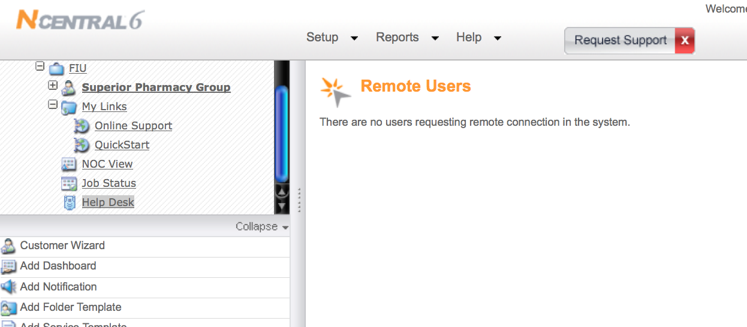
Screen-shot of the Trial Version Used

2.4.9 Usability
A user-friendly web access provides a powerful interface to manage and handle form a complex to a simple task in a very easy manner. The system can be access from a web browser, which does not require any complicated installation.

2.4.10 Reliability
Since the service is accessed through web it is extremely reliable and can be accessed from anywhere, which makes it easier for a Sys administrator’s job extremely easy. All web based MSP’s have the edge over all other solutions that require actual physical installation and are hardware dependent.

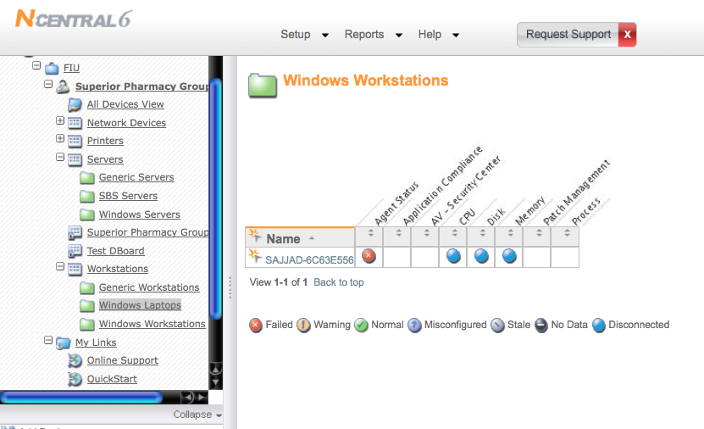
Screen-shot of the Trial Version Used

2.4.11 Performance
Since it is a web based tool all the requirements can be fulfilled without extensive hardware requirement.

2.4.12 Supportability
N-Central Supports all OS platforms, which makes the job easier for as compared to non web-based MSP’s. In short all MSP’s will be providing web-enabled console to better service.

Acknowledgement
I would like to thank NCentral6 for the trial version available free of their website.

Disclaimer
All the information and material obtained for this document is through the software manufacturers website. The trial version used is available free off N-Able’s website. All screenshots posted in this document are obtained after the testing phase. Due to limited recourses at my disposal all the aspects as mentioned in this document have not been tested. The trail version was tested on Mac OSX™ and Windows XP ™.

