  - N-able
Overview: N-able Technologies has 5 major products:
N-central – web-based platform for IT Services Automation & Service Automation
Remote Support Manager – real-time remote PC and server management capabilities (which is included with N-central)
Remote Environment Manager – desktop management tool
N-central OnDemand – hosted, subscription based solution
N-compass – an MSP Performance Reporting solution that enables MSP’s to analyze the performance of their customers’ IT infrastructure from a business perspective. [1]
Background:
N-able Technologies started in 2000 in Ontario, Canada. Now, they have expanded to two additional locations, one in the Untied Kingdom and the other in Sydney, Australia. Currently, N-able technologies is the preferred global supplier of remote monitoring and management technology as well as business support services for managed service providers (MSP’s). [2]
Company Highlights:
- Award-winning provider and market leader of managed services technology
- More then 1,300 global technology partners servicing 36,000 customers who combined generate over $360 million in managed services revenue.
- VARBusiness Partner Program Winner 2008
- VARBusiness Tech Innovator Winner 2007
- Microsoft Gold Certified Partner
- Profit 100 – Canada’s Fastest Growing Companies 2007
- Deloitte – Technology Fast 50 2007 [1]

Functional Coverage:
Supported Operating Systems:
All windows based
Mac OS X
Red Hat 3, 4 and 5 families
SUSE
There are two data collectors that are installed at the client’s site to help collect data. These pieces of software are called agents and probes. Agents are installed on individual devices and they monitor that particular device. Probes are installed on devices on the network and monitor the devices on that network. Probes monitor printers, routers, firewalls, as well as servers.
Grouping Managed Devices: N-central allows administrators to easily group any or all the devices on the network that has been imported into N-central. Administrators can use the default device group names or create their own based on the operating system, department or location.

2.1.1 Remote Control (Rating: 5)
N-central has a proprietary component called Remote Support Manager which allows you connect and manage a remote computer. Other remote control technologies that can be used are VNC, Terminal Services, SSH, RAdmin, and Telnet. Using the Remote Support Manager allows you to log into a remote machine without having to interrupt the user at the other end. Once logged into the remote support manager, there is a column with a list of different management choices on the left with some of the following options:
- File Transfer – able to transfer files from the local machine to remote machine via the File Transfer Protocol (FTP).
- Help Desk Chat – able to chat with the user if they are logged into the machine
- Computer Management – registry modifications, drivers, reboot
- Computer Settings – virtual memory, time, automatic login
- Server Functions – FTP configuration, status, stats, port forwarding, active directory.
- Scheduling & Alerts – system monitoring, email alerts, task scheduler, scripting
- Performance Monitoring – CPU and memory load, disk space, installed applications.
- Security – access control, IP address lockout and filtering.
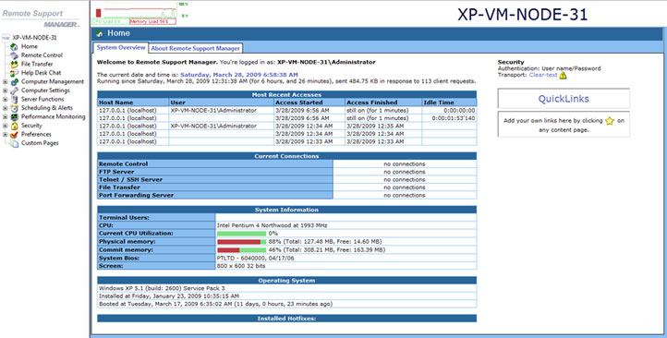
Figure 2.1.1a – Screenshot of the homepage for Remote Support Manager.

2.1.2 Auditing & Asset management (Rating: 3)
When you add a new device within N-central you can use what is called a discovery job to locate any devices on a network. You can also split up or combine the discovery jobs across multiple networks. This is especially helpful if the network has a large number of devices on the network. By initiating a discovery job all of the detected devices are then queued waiting for the administrator to import them into the N-central system and then agents will automatically be distributed to Windows devices. Administrators also have the option to deploy agent manually or via group policy.
Keeping track of all the machines and devices on the network is very simple with the “Windows Explorer” navigation feel on the left hand side of N-central. Below is an image of what the default break down of the different devices would look like:

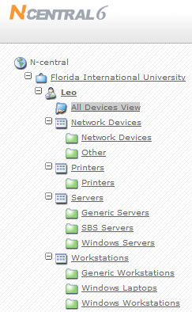
Figure 2.1.2a – Snap shot of the left navigation of N-central and how it demonstrates a “Windows Explorer” feel.
If administrators need to look up certain specs on given devices without having to remote desktop or use the remote support manager which would give them certain specs like CPU speed, CPU type, hard drive capacity, operating system, they could simply use the menu above and click through to the machine that they are interested in and click on the Details tab to see this information. Here is snapshot of a machine running VMware:

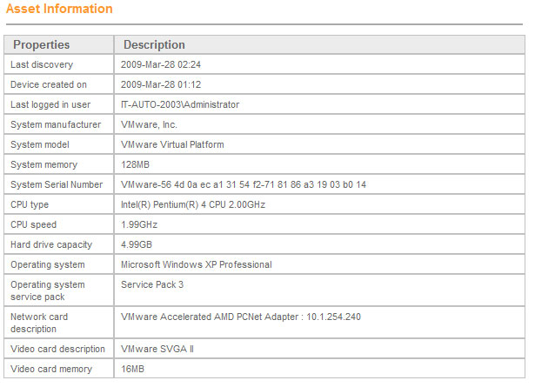
Figure 2.1.2b – Snapshot of some detail information about a machine on the network.
For asset management involving power options and similar features, N-able Technologies has a product called Remote Environment Manager which allows administrators to control some of the power features/settings of the remote machines. For example, the ability to shut down machine after they are idle for a certain amount of time.
There are 3 main asset management features within N-central, Application Compliance, License Compliance, and System Changes. The first feature, Application Compliance, allows administrators to create “black” and “white” lists of applications to track application compliance and protect customers from unauthorized software usage. Here is a snap shot of Application Compliance:

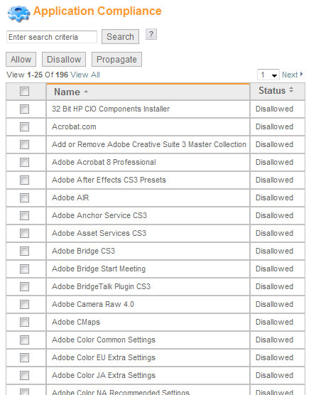
Figure 2.1.2c – Snapshot of some of the applications that can be allowed or denied under the Application Compliance section.
The next major asset management feature is License Compliance. This allows the administrators to monitor the number of licenses of purchased software being used to ensure compliance and plan future purchases.
The last major asset management feature of N-central is System Changes. This feature enables the administrators to monitor the hardware components of an individual device to record and report on hardware changes. Here is a snap shot of this feature and notice how it has section for “Baseline” and then “Current”. Baseline is what the specs was when the machine was first imported into N-central and current would be the real-time state of that particular component.
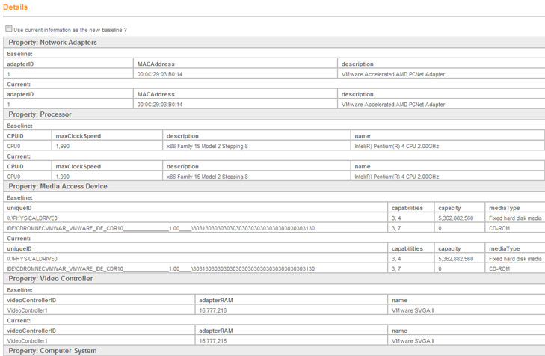
Figure 2.1.2d – Snapshot the System Changes section in N-central.

2.1.3 Monitoring (Rating: 5)
Monitoring has to be one of N-central’s strongest features. As an administrator, when you first login you can setup your N-central profile to show the “NOC View” page which is the page that shows the administrator all of the issues on the network. Some issues could be a Windows XP laptop running out of disk space or a router on the edge of the network having connectivity issues. When looking at the NOC View, there are simple yet effective indicator that explain what each status means. Here is a snapshot of the NOC View:
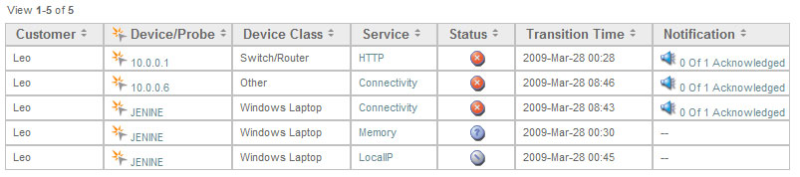
Figure 2.1.3a – Snapshot of NOC View
Here is a legend of the different status icons that could come up to show you what the issue is about:

Figure 2.1.3b – NOC View Legend of icon status icons.
Once you see an issue that can be fixed or if you would like to know more specific information about the issue, the administrator can simply click on the device name and it will provide information about the current status.
N-central also allows the administrators to see a matrix breakdown of a particular computer group or all of the devices on the network to see if there are any issues. For example, from Figure 2.2.1.2a let’s say you would like to see the status of all the Windows Workstations. All you would have to do is click on the “Windows Workstations” link and here is the matrix you will see:

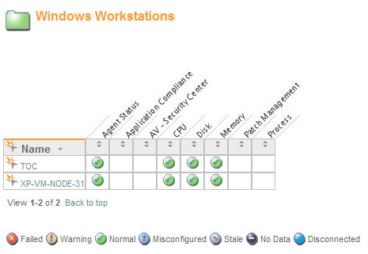
Figure 2.1.3c - Matrix of the Windows Workstations
As you can see of the two Windows workstations on the network they are all running “normal”. N-central allows you to monitor different features like Agent Status, Application Compliance, Anti-Virus, CPU, Disk, Memory, Patch Management, and Processes.
Administrators can be notified through SMS, email and a pager of any issues on the network. Automatic escalation, repeats, delays and acknowledgements ensure that notifications are not missed.
As mentioned in section 2.2.1, N-central uses data collectors called agents and probes. These collectors use Simple Network Management Protocol (SNMP) and Windows Management Instrumentation (WMI) to collect the data on the network devices.
N-central can monitor the following devices & services:
Monitoring of a wide range of devices  - Desktops  - Laptops  - Servers and Web servers  - Printers and copiers  - Routers  - Exchange servers  - Firewalls  - …and virtually every other IP-enabled device | Monitoring support for industry-standard protocols  - SNMP  - Log file analysis  - TCP/IP  - WMI  - Syslog/SNMP Traps  - ODBC  - EDF
IP Network Monitoring  - Ethernet Errors  - Traffic  - Bandwidth  - Frame Relay  - TCP  - SNMP | Windows Network Monitoring  - Application compliance  - Connectivity  - CPU  - Disk  - Disk Queue Length  - Event Log  - File Size  - Local IP  - License compliance  - Memory  - Patch Level  - Process
OS Monitoring  - Windows 2000/2003/2008/XP/Vista, 2008 Small Business Server  - Novell 6.5 SP 1a / SP 2 / SP 3 / SP 4  - Red Hat Linux AS/ WS/ ES 3.0, 4.0, 5.0  - Mac OSX 10.4, 10.5 | Email Monitoring  - Exchange Server  - IMAP  - POP  - SMTP  - SMTP Queues
Printer Monitoring  - Printer Page Count  - Printer Toner Level | Additional Monitoring  - Backup  - Citrix  - Firewall  - RAID controllers  - Local services  - Custom services defined by administrator

2.1.4 Patch Management (Rating: 3)
N-central interoperates with Microsoft Windows Software Update Services (WSUS) to provide cost-effective, efficient patch management. N-central provides simple WSUS configuration and monitoring and reporting of patch levels across WSUS-enabled devices.
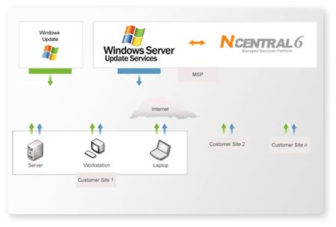
Figure 2.1.4a – How N-central works with WSUS.

N-central connections to the WSUS server and will automatically create a WSUS computer group. This greatly reduces the amount of time it takes to set up and configure WSUS. You can them monitor and report patch levels for those devices, and set up alerts for machines that are falling behind.
2.1.5 Backup & Disaster Recovery (Rating: 3)
Like most IT automation solutions, N-able does not currently have a backup or disaster recovery component installed but N-central can be setup to work directly with Backup Exec. Backup Exec is from the Symantec family and is the Gold Standard in Windows protection and system recovery. Backup Exec can be installed separately from N-central but N-central can monitor Backup-Exec main services to make sure that backup services are running and to ensure backups are initiated.
Administrators can install any backup solution on the network but N-central can only currently monitor Backup Exec services.
2.1.6 Endpoint Security (Rating: 3)
N-central has several security features that will help keep you network safe and secure. Here are several features:
- Proactively monitor and manage multiple security appliances and applications to minimize your customers' IT infrastructure downtime.
- Managed Security Dashboard lets you manage all your security services from one convenient location.
- Proactively monitor ant-spam, spy ware and virus services to ensure your customers' IT infrastructure is always protected.
- Ensure application compliance by remotely detecting non-approved applications.
- Monitor and manage customer firewalls and intrusion detection systems and receive proactive alerts upon their attack.
- Track and manage your customers' security devices to ensure adherence to software licensing and IT governance.
- Warranty, lease and support expiry services allow you to track expiry and replacement dates for security software and hardware.
- Track security performance over time to provide valuable reporting and insight for growth planning and budgeting.
- IT governance compliance is facilitated through 24×7 monitoring and reporting of security issues as defined by industry-specific legislation.
N-central allows the administrator to setup different dashboards for different needs. For example, if all the windows workstations have McAfee Anti-virus installed the administrators can setup a dashboard to monitor the different McAfee services like virus definitions and updates as well as the overall activity. If any issues come up, the administrators can be notified via email, SMS or pager and a status icon will appear in the NOC View indicating an issue.
2.1.7 Reporting (Rating: Not included in rating system)
Performance and Tactical reporting has to be another one of N-able’s strengths. Administrators would use the N-compass product which is built into N-central to generate detail reports. N-compass ships with more then 20 pre-built reports that administrators can use as is or create unique custom reports. You can use N-compass to report on key service performance metrics such as uptime, capacity, and security. Below is a list of some of the types of high-level reporting available within N-compass:

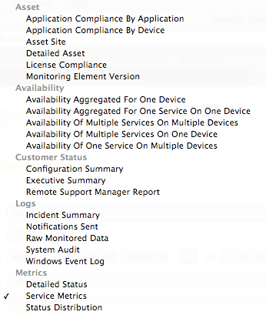
Figure 2.2.1.7a – List of optional reporting tasks within N-compass
Below is a list of some of the detailed low-level reports available:
Application Availability Report | Hardware Inventory Report
Availability Comparison Report | Hardware Upgrade Planning Report
Availability Comparison Report | Managed Devices SLA Report
CCM Call Activity Report | Network Health Overview Report
CCM Server Performance Report | Notification Summary Report
Cisco Call Manager Summary Report | Patch Level Summary Report
Data Availability Report | Remote Control Usage Report
Downtime Cost Report | Software Inventory Report
Event Log Reports | Technical Summary Report
Executive Summary Report | Traffic Usage Report
Firewall Incident Trend Report | Utilization Comparison Report

One of the reporting tools in N-compass allows administrators to see the percentage of time a machine was available in a certain period of time. Below is an example report:

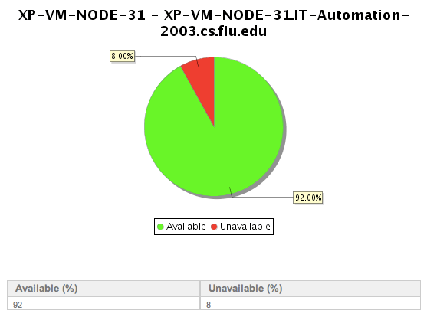
Figure 2.2.1.7b – Availability report for a particular machine in a 24-hour period.
2.1.8 Help Desk (Rating: 4)
N-central does not have a built in ticketing system currently but does integrate with other helpdesk/ticketing systems. Some of those ticketing systems are Tigerpaw, ConnectWise and Autotask. For example, N-central works very well with ConnectWise. When email alerts are generated in N-central they are converted into service tickets using an add-on called Email Connector.
2.1.8 Usability (Rating: 4)
N-central has to be one of the easiest IT automation products out there today. With N-central’s simple “Windows Explorer” navigation administrators have a clear break down of devices/machines. Administrators can also access the N-central anywhere in the world via the web-based interface. Administrators can manage machines easily through the custom dashboard that can be setup.
N-central is also fully brand able by administrators so incase the company has administrators working in different departments or tiers of the company the look and feel of N-central can be changed.
2.1.9 Reliability (Rating: 3)
N-central can be easily configured to work with Microsoft SQL Server’s for backup or data corruption issues. The brain of N-central is located on a central server and this server is in charge of all the key functions of N-central. Functions like the web-user interface, data manipulation, data processing, notifications, and reporting. There is no need for additional servers to worry about or rely on since all of the N-centrals actions are being performed from this central server.
2.1.10 Performance (Rating: 4)
The web-based interface of N-central is quick, sleek and easy on the eyes. Since there are very little images loading on each page the load time in minimal.
With the help of the agents and probes mentioned earlier it makes the data collecting aspect of the system run quickly and efficiently.
2.1.11 Supportability (Rating: 4)
Not only does N-able have a nice range of operating systems it supports but N-able has fantastic technical support and will work closely with administrators incase of an N-able software issue.

