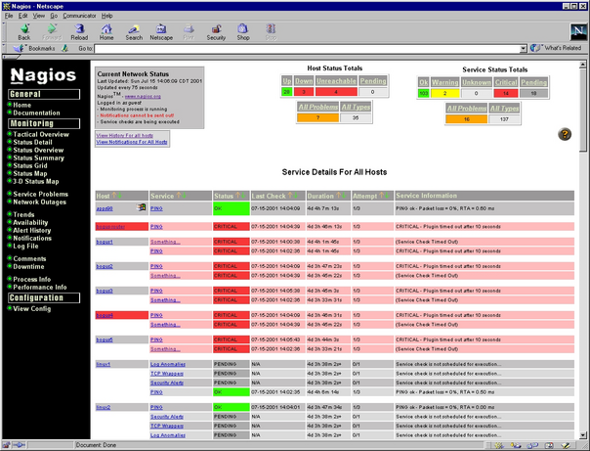
2.4 Nagios
Screenshot of Nagios interface

Overview:

Nagios was written 1999 by Ethan Galstad. It is an open source program and networking monitoring software application. It was originally called NetSaint, but the name had to be changed to Nagios due to legal issues with owners of similar trademark. Nagios stands for “Nagios Aint Gonna Insist On Sainthood”, which is in relation to their original name. Its initial release was on March 14, 1999. Nagios was created to work under Linux and other Unix-like operating systems that have a C compiler and TCP/IP configured. Nagios is licensed under the terms of the GNU General Public License Version 2 under the Free Software Foundation. In 2008, Nagios won the LinuxQuestions.org 2008 “Monitoring Application of the Year” and was honored as being one of Infoworld's “Best of Open Source Software”, also called the BOSSIE Award. Nagios can monitor Windows, Linux/Unix, routers, switches, firewalls, printers, services, and applications.
Functional Coverage:
Only Linux and UNIX-like operating systems support Nagios, but it is able to monitor Windows systems, Linux/Unix systems and Netware Server.
Nagios can monitor network services such as SMTP, POP3, HTTP, NNTP, and Ping among others. All monitoring services can be modified to the user's needs through the availability of plug-ins and add-ons provided by and to Nagios. Due to the array of plug-ins and add-ons available it is difficult to say what cannot be monitored because you can modify the software to monitor what you wish.
The agents used depend on what operating system is being used.

Grouping Managed Devices: Nagios has the capacity of separating devices into separate groups to be monitored. To do so, you just need to configure the main configuration file.

2.4.1 Remote Control
Nagios does not offer any remote control ability; however, if accompanied with Opengear's SDT connector, Nagios is able to remotely access sites [Linux Devices 2008]
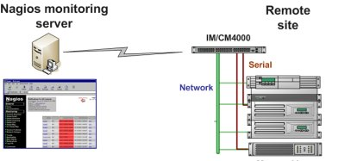
SDT for Nagios in Action

2.4.2 Auditing & Asset management

Nagios does not have any auditing built in. Through a program called Remedy to accompany Nagios, administrators can audit passwords, unauthorized users, system logs, and the patch management among other things.

2.4.3 Monitoring

Remote monitoring is available and supported through SSH or SSH encrypted tunnels. By the software providing us with immediate notification of any problems via cell phone, pager, and email, it allows for technicians to take immediate action to tackle the problem. It also provides comprehensive network monitoring through Windows, Linux/UNIX, routers, switches and firewalls, printers, services and applications. Advertised as allowing you to gain insight into your network and fix problems before your customers even know they exist. Nagios monitors CPU, memory, file system size, processes. If you know how to create scripts, there is basically nothing you cannot monitor.
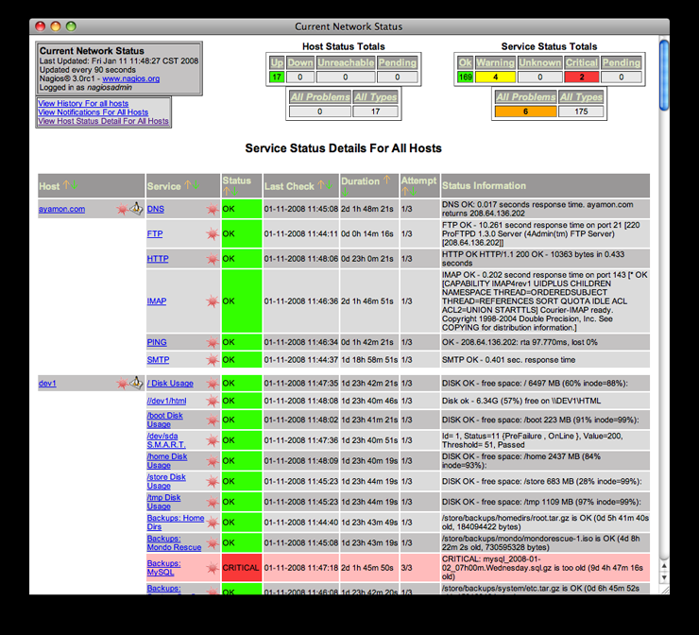

Alert History

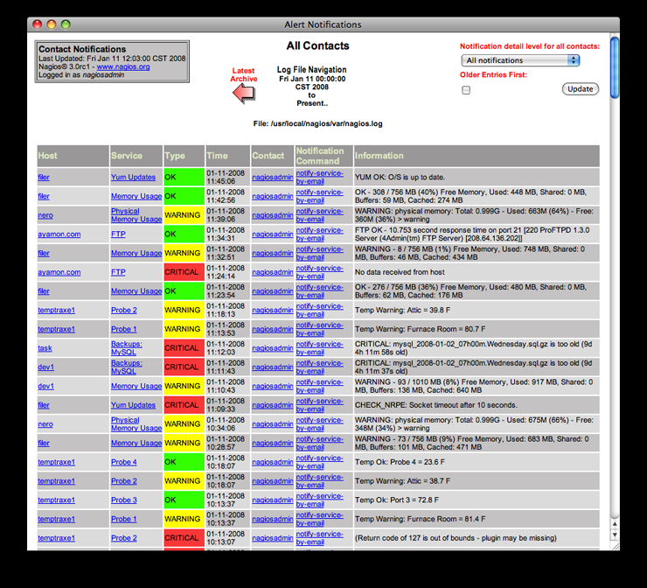
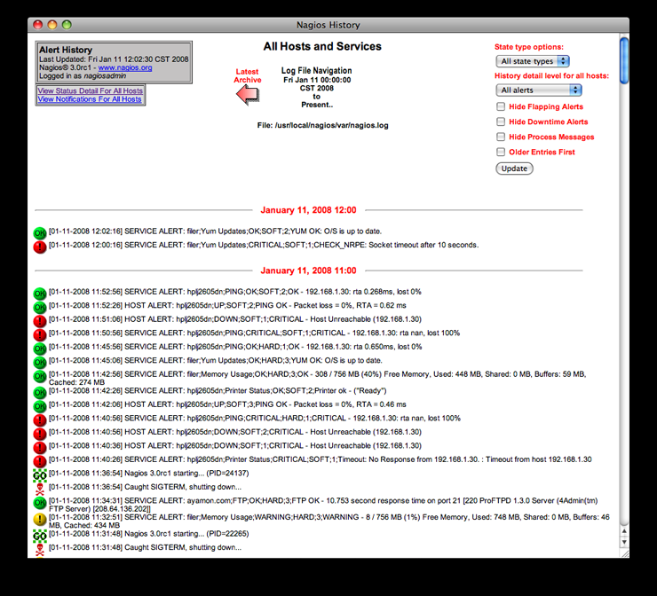
2.4.4 Patch Management

The interface is always checking for issues and attempts to repair them. It does not repair them by itself, but scripts can be created to control certain features and software can be added. The software also provides some literature on what scripts would be useful and some best practices. The scheduled downtime is used for network upgrades and it provides capacity planning capabilities through usage monitoring. What can and cannot be patched is based on what scripting you provide the interface. It can be modified to patch anything your program it to patch. Same goes for what patching information can be attained or not. Nagios offers a lot of flexibility with its plug-in and add-ons, but it may be an inconvenience that this feature is not built in.

2.4.5 Backup & Disaster Recovery

Nagios does not offer any backup or disaster recovery; however, it acknowledges problems through web interface and automatically restarts failed applications, servers and hosts with web handlers so technicians don't have to. The software provides literature on ideas on how to secure the system so as to protect it from the outside. These ideas include some scripts and some common best practices that help when installing the software and using the interface. A program that can be used to offer backup and disaster recovery is Amanda. It allows the administrator to do a single backup server for multiple systems.
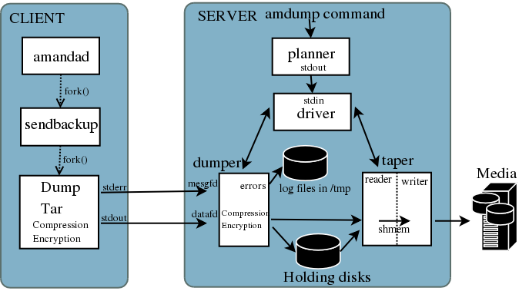
Amanda Software Architecture

2.4.6 Endpoint Security

Nagios does not offer any endpoint security. A program that can be used in collaboration with Nagios to provide endpoint security is Blue Coat. What can be secured by it is web access, blocks malware,...etcs and reports any attempts to access such things.

2.4.7 User State Management

Multiple users can access the interface and each user has their own restricted , unique view. It also has an extensive community website network and over 250,000+ users worldwide and it is completely customizable because users have full access to the open source software's code.

2.4.8 Help Desk

It offers integration with existing applications through trouble ticket systems and wikis. The software also offers basic support services, Nagios Solution Providers, which offer enhanced support, integration, and monitoring services for organizations.
2.4.8 Usability

The interface is very easy to use and every user's interface is customizable allowing the users and administrators easy navigation.

2.4.9 Reliability

The software is labeled as a “stable, reliable and respected platform.” It has been in development for 10 years and still offers room for customization on the code. It has won multiple awards for reliability.

2.4.10 Performance

It is known for stability and claims that users and administrators do not have to worry about any lockups or computer crashing.

2.4.11 Supportability

If any issues were to arise, organizations are offered basic support services, which offer enhanced support and monitoring services.

