2.5 TrackIt
Overview:
Numara Software is a worldwide provider of many different types of service desk management tools for the IT or administrator specialist. Numara was founded in 1991 under the company Blue Ocean Software which is known globally as the makers of Track-It, the most widely installed help desk and asset management solution for the IT profession. Once the company launched independently, Numara bought out UniPress Software which is known for FootPrints service. Numara has been highly active in the market for more than a decade, with FootPrints being the number one seller.
Background:
Numara has five main IT automation products with Numara Track-It being the most popular and widely implemented product. Numara Track-It was developed in 1991, mainly for tracking assets over the entire network. The latest version is 8.5 and it used for help desk and asset management solution. Numara Asset Manager is another product that is used in companies to provide visibility and knowledge of all its IT assets on the network. This product also provides effective asset discovery joined together with Numara FootPrints. Numara Deploy gives the administrator the ability to not have to be there locally; the administrator can do many tasks at a central computer. It also allows you to create and distribute packages and install and update software applications. This can be done on local, mobile, and remote Windows laptops, PCs and servers throughout your entire business. Numara also offers the Patch Manager. Patch manager is easy to use; it can scan, download and deploy security patches to multiple workstations. It can also download all Microsoft windows updates and keep them locally on your targets compute. The last tool that Numara offers is the network monitor; this product can monitor any network continuously and maintain a report on the health and performance of all vital network components.
Functional Coverage: Track it supports a wide variety of Operating System including:
- Windows Vista
- Windows Server 2003 Standard, Enterprise, and Web Edition
- Windows XP Professional, Home Edition
- Windows 2000 Server, Advanced Server
- Windows 2000 Professional
- Windows NT 4.0 Terminal Server (SP4), Server/Workstation 4.0 (SP4)
- Windows ME, 98SE
- Red Hat Linux 7.0, 8.0 and 9.0 on Intel
- Red Hat ES 2.1 and ES 3
- SUSE Linux 9.3 and 10.0 on Intel
- Solaris 8 (SunOS 5.8) and Solaris 9 (SunOS 5.9)
- Solaris 10 (SunOS 5.10) on SPARC
- Mac OS X 10.3.9 on Power PC, 10.4.5 & 10.4.5 Serve
2.5.1 Remote Control
- With Remote Management Track It can manage OS remotely and access services, such as registry, event logs, shared folders, and system states. File Transfers are done easily and effectively by the drag-and-drop interface, which can also give you the ability to copy, move, and recover lost files. With the ability of Scripting, you can trigger file transfers and other actions on schedule times. Also with the ability of communication you can communicate with the users via audio, and video which saves time by allowing the administrator to communicate with the users without being there locally. Remote Management supports a wide range of Protocols form TCP IPv4 and IPv6 and UDP and Terminal Server.
2.5.2 Auditing & Asset management
- Track IT can provide control of the network infrastructure by identifying all of the assets on the network. Track It can provide a detailed data on all installed software and also the configuration of PCs on the network. Track It supports Windows Mac and Linux Operating Systems. Track It can be used in a small companies that have as a small number of PCs or in large cooperation’s that have numerous amount of PCs.

- Once the agent is deployed the Asset Manager auditing capabilities can provide an outlook of what is on your network. This includes PCs, servers, network printers that are SNMP compatible, and switches. Track It also has the ability to audit PDAs and USB stick drives. Track it uses a tool to locate these devices called LANProbe which has the ability to automatically detect network attached devices the only thing required is that the device has an IP address on the network.

- LANProbe's makes it easy for the asset manager to find changes made to the network devices being added or removed or a device being moved from one location to another location. Asset Manager Web Edition allows users to access all assets information which can be viewed from a web browser. It supports internet explore or Firefox..

2.5.3 Monitoring
- Track it monitoring tool has the ability to constantly monitor the health and keep track of the performance of the network. Critical components apart of the network are kept up and running keeping you aware of any problems before it happen. It can detect conditions that seem to be out of place with the network which tend lead to lead to much bigger problems. Network monitor can isolate the problem of the component that requires urgent attention. Network Monitor can alert you in many different ways such as e-mail notifications. These alerts can have detailed information that is placed in a log for screening.
- Track It can discover when a service has failed or attempt to re-start a failed service. Also Track It is capable of informing the admin the current health of the system and if anything has the ability to go wrong and immediately notify you of this problem.
2.5.4 Patch Management
- Patch Management can simply and quickly manage all Microsoft windows updates and patch updates and can also deploy these updates. Initially, it performs a scan to bring the Admin up to date with the current patched and update that are installed or missing. Once this is done you can then deploy security patches to multiple workstations from a central console on a schedule bases. This can be done by automated scripts that can be applied by the administrator. It also has the ability for you to create your own scripts as well.
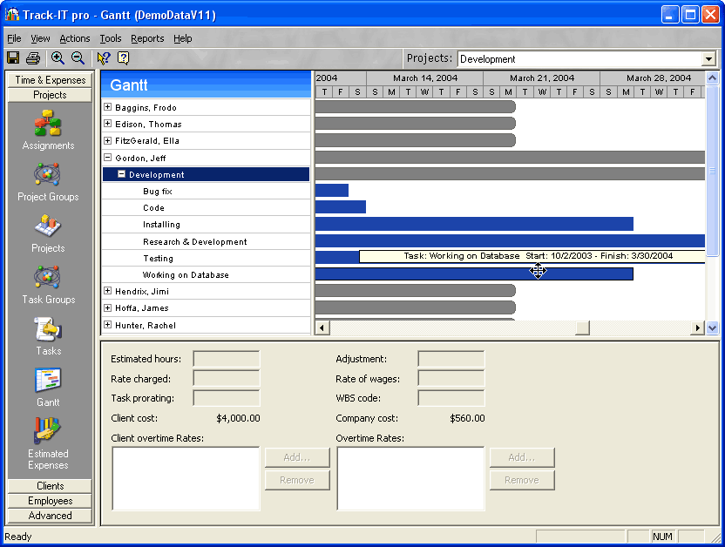
- Track It has also allows you to control which group of workstations will be scanned, and when and which patches are to be deployed to which workstation. You can also set up a schedule for when you want a patch or update to be deployed or you can deploy it right away. Track IT can send patches and updated to Workstations and Servers.
2.5.5 Backup & Disaster Recovery
- Track IT Does not offer backup & Disaster Recovery
2.5.6 Endpoint Security
- With Track It security provides the remote computer with the latest protected against any unauthorized access across the network. Track it provides end point protection by Integration with Directory Services. Track it has the ability to implement Smart Card Authentication, which can prevent unauthorized changes of remote controlled application with their preferences and configurations.
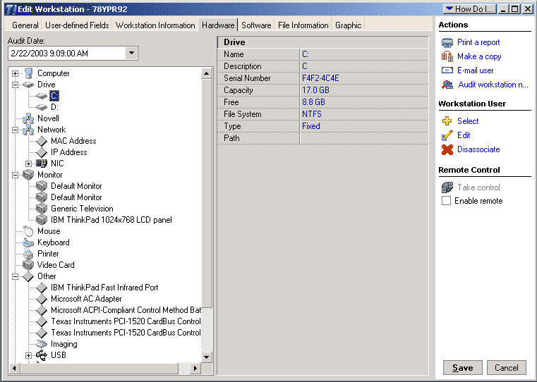
2.5.7 User State Management
- Track It Does not offer backup & Disaster Recovery
2.5.8 Help Desk
- Help Desk makes using Track It trouble-free. Their Technical Support people all have knowledgebase solutions for all of their business applications. The information on all of their products is updated on a daily real-time base located on there website. Also Track It has a Search Engine that can search across a broad range of topics thereby making things quick and easy to find.
- Diagnostic trees
- Error messages
- Problem/solution pairs
- Fast, expert service
- Increased support capacity

