2.3 Numara Track It!
Overview:

Numara Software is known primarily for two IT management solutions, Track-It! and Footprints. Track-It! is Numara’s help desk and asset management solution, and Footprints is their service management solution. Track-It! is a GUI based and provides a familiar workspace for IT management professionals. It has many unique features and is most notable for its exceptional help desk solution. Footprints is a web-based service management solution that is highly customizable due to its ability to be integrated with other solutions that are Windows service-based or SQL based. Also of note is Numara’s Patch Manager, which is a Windows patch management solution.

Background:

Numara Software was first founded in 1991(as Blue Ocean Software). They were acquired by Intuit in 2002, but were bought out by TA Associates (an private equity firm) in 2005. According to Numara, the Track-It! software that they have developed has become the most widely used help desk and asset management solution in the world. With 50,000 customers and 200 employees, Numara is not just a trailblazer in IT management, but a market force as well.

Functional Coverage:

Numara Track-It! is Windows based and therefore must be run on a Windows based server or virtual server. Numara can manage and audit Windows based workstations and also has limited support for Mac OS X based systems. Hardware and software monitoring, including software licenses, can be managed by Track-It!, but integrated patch management is unavailable, though a patch management solution with a similar interface is sold by Numara. Additionally, Numara does not provide an integrated back-up solution in Track-It!, nor do they provide a backup solution.

Grouping Managed Devices:

Numara provides customizability of device profiles which allow types and subtypes to be defined for devices, as well as grouping by network. This allows for managing device groups, instead of limiting management to one large group of individual devices, or categories that aren’t customizable. This is a key feature in managing this type of network due to the number of roles and locations there are to deal with in the high school.

2.3.1 Remote Control
The Track-It! Remote system allows fast and easy access to systems available for remote control. The technician merely has to click one button from the appropriate view to take control of the machine.
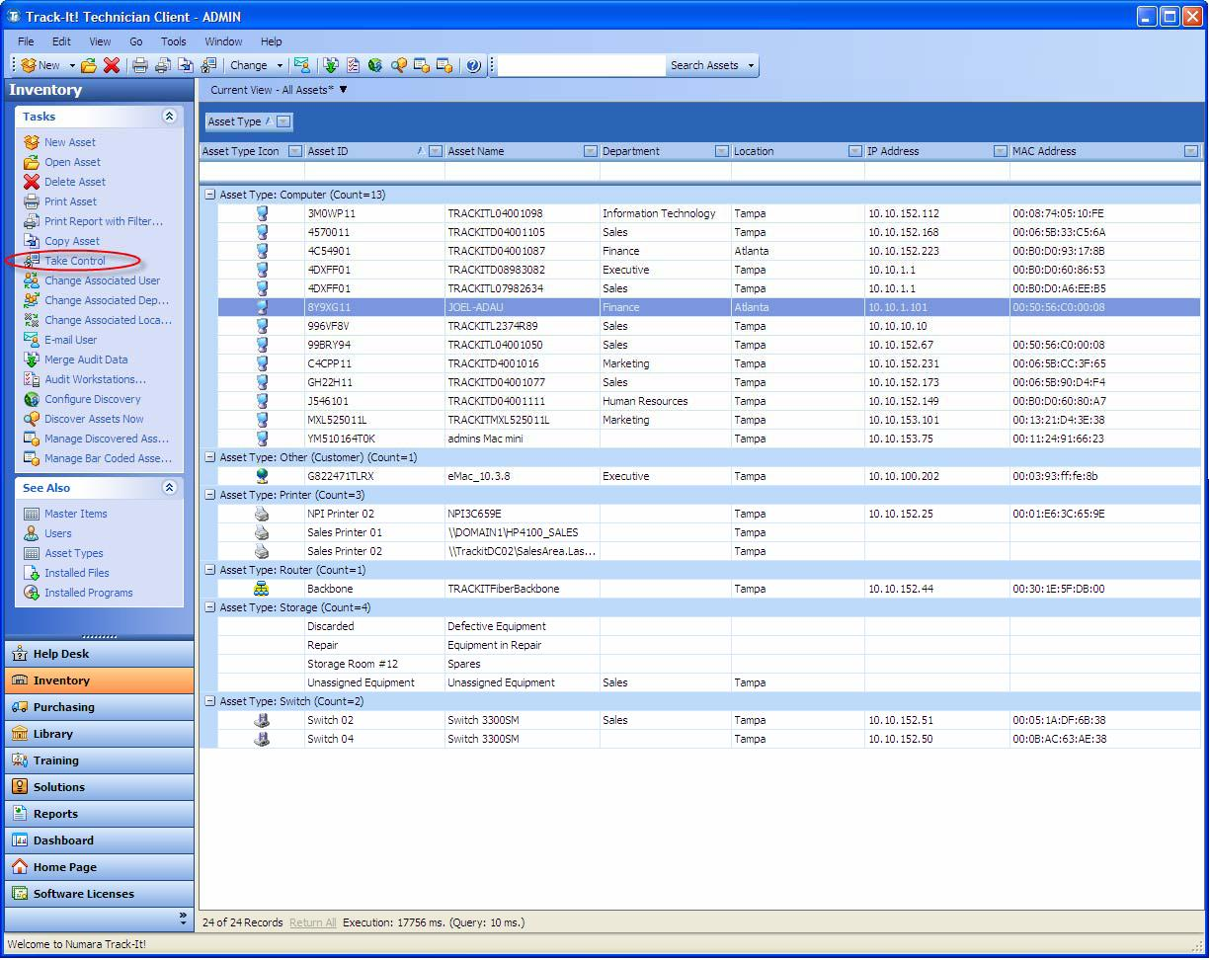

2.3.2 Auditing & Asset management

Track-It! features agent-based auditing which allows for on demand tracking of assets that are registered. In addition, the auto-discover feature allows for assets to be added automatically, without having to manually configure each one, a key to speeding up the set up of larger and more fluid systems.

2.3.3 Monitoring

Network monitoring is an add-on feature available for Track-It!, meaning that it can be part of an integrated solution.

2.3.4 Patch Management

This is an add-on feature to Track-It!, which allows for easy tracking and patching of managed systems.

2.3.5 Backup & Disaster Recovery

Numara Track-It does not feature an integrated backup solution, thus a third party solution such as Paragon would be required.
2.3.6 Endpoint Security

As with backup, a third party solution must be used for anti-virus, anti-malware, anti-spyware, anti-rootkit and firewall management.

2.3.7 User State Management

User state management is not a feature of Track-It!, meaning Active Directory or third party software will have to be used.

2.3.8 Help Desk

The help desk system in Track-It! is quite robust, it can turn e-mails into work orders, features a tiered work order system, built-in knowledge management and automated notifications and elevations

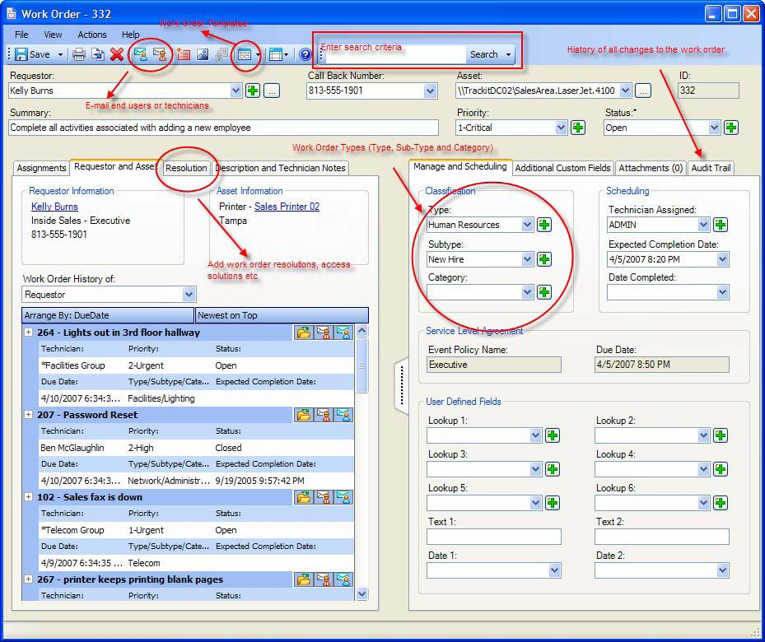

2.3.8 Usability

One of the main draws of Track-It!, it features a GUI modeled after Microsoft Outlook, which leads to easier use and less training time than other systems available.

2.3.9 Reliability

There is no reason to think that through the functional coverage, great reliability cannot be achieved.

2.3.10 Performance

The asset management and monitoring should allow a consistent level of performance to be achieved across the board.

2.3.11 Supportability

The powerful help desk feature of Track-It! should allow for a superb level of support that if implemented properly, could fully rectify, to the degree that is possible, and track all issues with ease.

