2.1 Numara (Jonathan Sanchez)
Overview:
Numara Software has a wide collection of IT Automated Solutions, the software company is known for its Help Desk software, Numara Track-It! In addition, the software company also has add-ons for Numara Track-It!
Numara Patch Manager, which scans for missing / updated patches; Numara Network Monitor, monitoring workstations health and performance; Numara Remote, connecting to a host workstations remotely; and Numara Deploy, creating and install packages to any workstation connected to your network.

Background:
Before the company changed its name to Numara Software, the company went by the name Blue Ocean Software when it was founded in 1991. Since then, Numara Software grew in popularity, due to the success of Numara Track-It! It was widely used in all small and medium businesses worldwide. Numara Software tried to distance itself from the pack when the company announced the acquisition of Umpires Software, who created FootPrints, a web-based help desk solution, which was properly named, Numara FootPrints. With the success of Numara Track-It! And the acquisition of FootPrints, Numara Software established itself as a dominant leader in the competitive help desk market.

Functional Coverage:
Numara Track-It! Is an IT Help Desk and Asset & Audit Management software tool whose GUI is very similar to Microsoft Outlook (see Figure 1). Additional add-ons are available for Numara Track-It! Numara Patch Manager, Numara Deploy, Numara Network Monitor and Numara Remote. These add-ons are purchased and installed separately. One of the functionalities that Numara lacks is the omission of Backup & Disaster Recovery; that will have to be acquired from a different vendor.

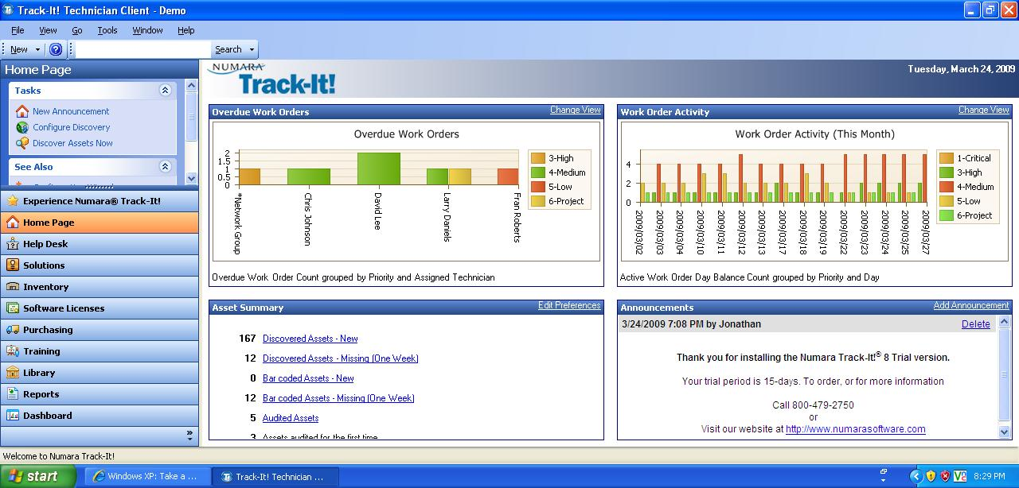
Figure 1 – Numara Track-It! User Interface

With the lack of backup and disaster recovery in Numara Software, an alternative solution is provided for Superior Pharmacy. Since the pharmacy runs on Windows XP, you can use the Windows XP Back up function. For disaster recovery, you can go with a web-based solution, Norton Online Backup.

The system requirements to install the Numara Track-It! is:

Windows Server
- Windows Server 2000 w/ SP4
- Windows Server 2003 w/ SP1 (Standard, Web, Enterprise, and Small Business)

Database Server
- Microsoft SQL Server 2000 w/ SP4
- Microsoft SQL Server 2005 (Standard, Express, Enterprise and Workgroup)

The system requirements to install Numara Deploy are:

Deploy Console – Supported Platforms
- Windows 2000
- Windows XP
- Windows Server 2003

Deploy Client & Package Builder– Supported Platforms
- Windows 2000
- Windows XP
- Windows Server 2003
- Windows Vista

The system requirements to install Numara Remote are:

Supported Platforms
- Windows Vista
- Windows Server 2003 (Standard, Web, and Enterprise)
- Windows XP
- Windows Server 2000
- Windows 2000 Professional
- Windows NT 4.0 Terminal Server w/ SP4
- Windows ME
- Windows 98SE

The system requirement for Norton Online Backup is:

Web Browser
- Internet Explorer 6 or 7

Supported Platforms
- Windows Vista
- Windows XP
- Windows Server 2000 Family
- Windows Server 2003 Family

Grouping Managed Devices:
Numara Software has the capabilities to group every workstation at Superior Pharmacy. This is mostly done thru Numara Patch Manager, you can group the workstation located at each of the five locations. If you plan to scan the workstations, you don’t have to scan each one individually; instead, you can scan a location that has ten workstations for each location. You can also group all the workstation for the entire company that is under the same network. For Numara Network Monitor, you can group all the workstations under the same network, as well as group all the routers and switches in the same network.

2.1.1 Remote Control
Numara Remote allows taking full control of a workstation from remote locations. In order for you to successfully log-in remotely to another workstation, you will need to install the Host Interface and Guest Interface. The Host Interface is installed on all workstations and servers that need to be controlled, while the Guest Interface is installed on the workstation (IT Administrator) that would want to access the Host workstations or server. Numara Remote allows you to collaborate with other IT professionals; it is capable of allowing multiple users in viewing the same remote workstation. If you need to communicate with the users, you can communicate using the audio/video chat capabilities. In regards to retrieving data, since Numara Remote have scripting capabilities, you can schedule a file transfer or you can choose the drag and drop function that allows you to copy, sync, and move and transfer data on a split screen.

2.1.2 Auditing & Asset management
You can capture the hardware information of any workstation, server, printer, router, switch, and laptop. You can do an audit check either on the spot or scheduling one to capture the asset information at a later date. Each asset is assigned an “Asset Type Icon” which has an icon of a computer, printer, router, etc. so each asset can be easy to identify and categorized. They also have an ID number attached to it as well as the name of the asset, the department and location of the asset. When you capture the asset information in regards to a workstation, it displays the OS version, the OS Service Pack, CPU, network, the software installed as well as the hardware (see Figure 3). You can assign a user that uses that specific workstation that was audited. After you completed the audit, you can print out a report of that asset as well (see Figure 2). You can have separate inventory for software only, you can keep the software’s serial number, activation key and when it expires.

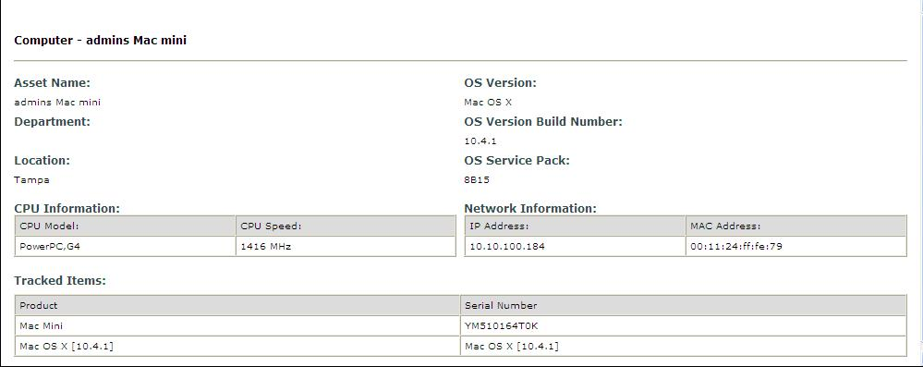
Figure 2 – Asset Information

2.1.3 Monitoring
Numara Network Monitor monitors the health and performance of the network that if unchecked, can be detrimental to a business. When there is an issue with the health and performance of the network, Numara will isolate the problem and assist you in trying to find a solution. Numara Network Monitor has a user-friendly GUI that is easy to follow, the network layout of a company can be mapped and displayed visually (see Figure 3). With the Auto Discovery Wizard, it will scan the specified IP range that you provided and gather information about the device found (routers, hub, servers, and workstations). After Auto Discovery Wizard completes the scanning, the map will populate automatically, another option is to create the map from scratch. In the device Properties table, you can create a device name; input the IP address, serial number and the location. When it comes to actually monitoring the workstations and seeing if there is a problem with the network, you can use ping command to see if a workstation is up and running. You can monitor the disk space of the workstation to see if its running low in the form of scripts, these scripts can be assigned in the properties table of that specific device. When there is a problem with the network, any of the devices that are mapped will turn to the color red (see Figure 5), notifying you that there is a problem with the network.

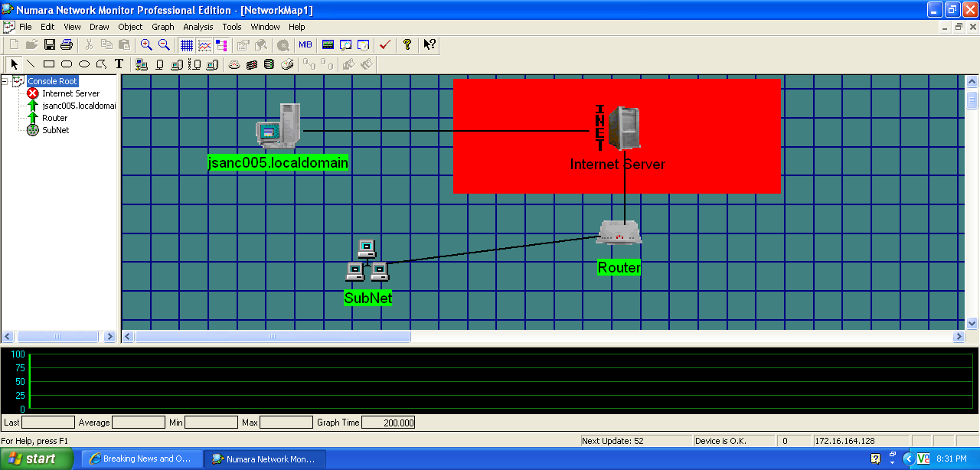
Figure 3 – Mapping of Network & Error on Internet Server

2.1.4 Patch Management
Numara Patch Manager allows you to scan patches for Microsoft Operating System and applications. You can scan for patches to any workstation from a central console, eliminating the process of physically being in front of a workstation. There are multiple ways to scan a workstation: scanning the workstation itself, by domain name, machine group, the IP address of that workstation, or selecting an IP address range. You will have the option to set a date and time when you want to schedule a scan, you can also set a recurring schedule (daily, weekly, monthly). A scanning template is also a viable option; with it you can apply restrictions, like deciding what you are planning to scan (i.e. missing security patches, installed security patches, non-security patches, WUScan). After scanning is complete, the next step is to install the patches, which you can design a deployment template. If you know a patch that requires a reboot after installation, than create a template that reboots after installing the patch. Once scanning is complete, you will receive a summery of the patch scan (see Figure 4), it will identify all the missing patches and service packs, it then groups the critical and important patches together. If you want to be notified that the deployment was successful, you can design a template that notifies you via email about the installation. You can keep a log of all the actions you took in regards to scanning and deploying the patches so you won’t repeat scanning the same workstation or server twice.

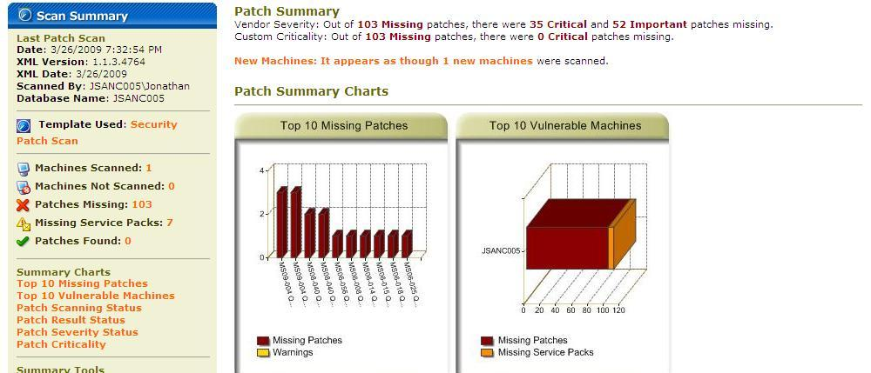
Figure 4 – Patch Summary

2.1.5 Backup & Disaster Recovery
Norton Online Backup (see Figure 5) is a web based backup solution that backs up all your files to a remote location. In case of a hard drive failure or natural disaster, since all files are stored online, retrieving the files will be quick and easy. The files are not just stored on one secure location, but multiple locations, so if a natural disaster where to occur in one location, you can be assured that the data is stored safely at another remote location.

Getting started, you first have to create an account, install the Symantec Protection Network agent to the workstation that needs the backup, and then start selecting the files that you need to backup. You can schedule a specific time when you want the backup to occur, and once that backup is complete an Alert is sent to you notifying you that the backup was complete or unsuccessful. You also have the option to generate reports of all Alerts and Backup history in PDF format.

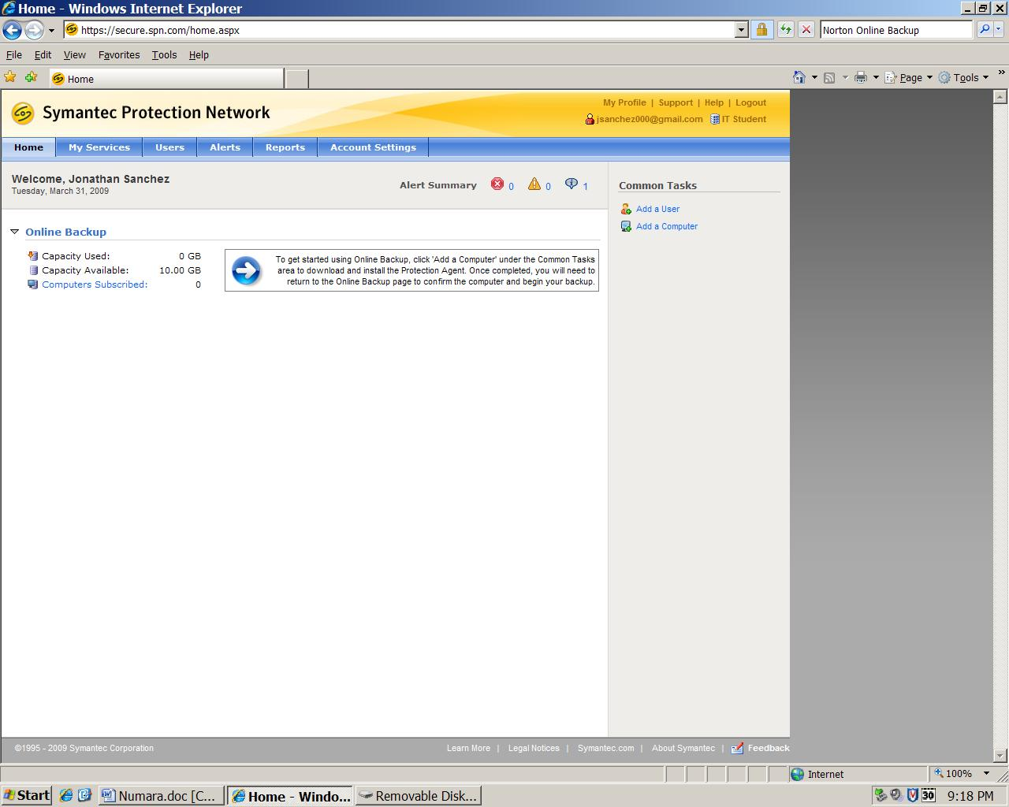
Figure 5 – Norton Backup

2.1.6 Endpoint Security
You can use both Numara Remote and Numara Patch Manager to secure all workstations, with Numara Remote
you can restrict any outside connection that is trying to access a user workstation (Host). One way is by checking a predefined MAC/IP Address list that checks the MAC/IP Address of all the workstations that are trying to connect to the user workstation. The user workstation also has the option to deny any access any workstation that is trying to connect from the outside, the user can run on stealth mode as well. With Centralized Authentication, every company that uses Active Directory, will be able to authenticate the Guest will be authenticated against the server. You can prevent unauthorized change of the users configuration; you can prevent the user from deleting the Host Interface and stopping communication to the Host workstation. With Numara Patch Manager, you can install the latest security updates and virus definitions to keep the workstations safe and secure from viruses and intruders.

2.1.7 User State Management
You can keeps logs of all Internet activities that are occurring in each workstation, whenever a user surfs the Net, the activity will be logged to a Windows Event Log. If you have Active Directory all ready in place, you can add permissions to a user, you can restrict downloads and websites that users visit while at the job. You can also create security policies for each workstation, restricting some of the workstations capabilities.

2.1.8 Help Desk
With Numara Track-It! you are able to stay in touch with the IT Administrator as long as a user has Numara Track-It! Installed on there workstation. When it comes to being notified in regards to potential problems or a reminder about a meeting, the IT Administrator is notified via a ticketing system known as “work order” (see Figure 6). A work order is a message that is viewed on the Help Desk menu; each work order is assigned its own ID number and a priority number (5-Low, 4-Medium, and 3-High) that identifies the level of importance. You are able to see the user who sent the work order, as well as the date it was sent, you also keep an audit trail in regards to all the modifications you did to the work order. You can create a policy that defines the due dates, notifications and escalations of a work order that matches specific criteria. There are other ways to communicate with users besides a work order, Numara Track-It! Gives you the option send emails.

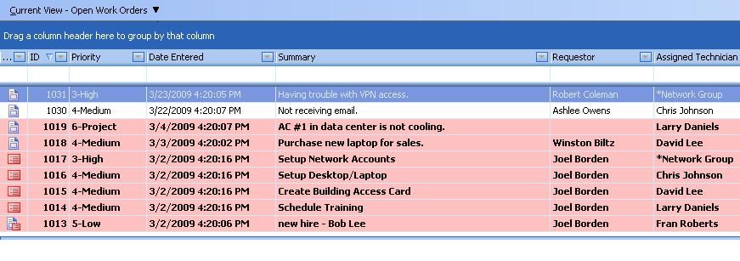
Figure 6 – Work Orders

2.1.9 Usability
You can have icons on your desktop for Numara Track-It! and its add-on’s, so you can have easy access to all Numara Software. You can run all the applications simultaneously, one on top of each other without any interference. Only Numara Track-It! requires a Log-in user name and a password, the other applications will start automatically.

2.1.10 Reliability
Numara is reliable in all of its functionalities, though, it is important that all of the workstations are functioning properly. Numara searches for all the missing patches thoroughly and monitors the entire network with out missing a beat. During our research, not once did any of the Numara software, crash.

2.1.11 Performance
Numara is a very powerful tool, to reap its full benefits, make sure before installing, that you meet all the minimum requirements for each individual software.

2.1.12 Supportability
Since the Numara Track-It! and the additional add-on’s are either installed via a CD or downloaded directly from the website, each software is has its own system requirements. The majority of the software is supported, Windows Operating System, Windows Server 2003 Family and Microsoft SQL Server. None of the Software is supported by MAC OS.

Acknowledgement
I would like to thank the Numara Regional Sales Team for supplying the trial version for Numara Track-It! , Numara Patch Manager and Numara Monitor, this is where most of my research came from, the screenshots came from the trial versions. I would also like to thank Tony Thomas, the Senior Network Engineer and Product Manager of Numara Software, he was able to provide me the information that I needed for remote control, end-point security and user state management, no trial version was available for Numara Remote, so I had to rely heavily on their information:
http://www.numarasoftware.com/pdf/whitepapers/Secure_Remote_Control_WhitePaper.pdf
http://numarasoftware.com/helpdesk/resources/Remote_Management.pdf
Since the trial version for Numara Monitor was very limited, I had to go with that I knew from trial version as well as the pdf file that was supplied to me by Numara Software:
http://numarasoftware.com/helpdesk/resources/Network_Monitor.pdf
I will also like to thank Symantic for providing me with a trial-version of Norton Online Backup, which is were I got the screenshots from.

