Created by: Jean Kesnel Chevery

2.3 Numara Track-it!
- The IT automation solution- The IT Automation solution chosen was Numara Track-it!
A brief background of the company’s history- Numara Software supplies over 5,000 patron places word wide, making it a principal in helping IT managers to solve a variety of software problems. The Numara Track-It! And Footprints programs make it simple for IT managers to carry out such tasks as tracking requests, automating workflows, and supporting internal and external customers.
Compared to other IT support software, Track-It! is easy to use, without causing any business interruption. The program can be tailored to individual IT environments, from human resources to training and support [1].

Company highlights- After becoming a part of Intuit in 2002, Numara continued to operate independently. Under the name Intuit IT Solutions, the company focused on perfecting and expanding its Track-It! product line. Numara has also won numerous awards such as:
The 2009 Stevie® Award for Sales and Customer Service [2].
Numara Track-It! won the CRM Excellence Award 2007 – 2008 [2].
First Class Customer Service for Multi-channel Solutions 2007 – 2008 [2].
On October 6th, Numara Software was a corporate sponsor of the “I Will Survive” fashion show [3].

- The main IT automation products/solutions the company offers (along with a summarized description of each individual offering).

2.3.1 Functional Coverage
- Agents using Numara Remote can deliver precision support, with a real-time snap-shot of user’s Windows, Mac, Linux, or UNIX platforms.
- Agents can automatically import assets, and other information from such sources as external databases or Numara Asset Manager
- Numara Patch Manager has the ability to scan and deploy Windows security patches to multiple workstations from a central console automatically.

2.3.1.1 Remote Control
- Discuss if researched solution has built in remote control ability- As a type of background tech support, Numara Remote supports low-bandwidth interaction between the user’s desktop and tech support.
Technicians are allowed to access such company files as services, event log, shared folders, and system states without disrupting service to users.
Numara Remote also allows technicians to control and transfer files to from Windows systems remotely from inside the Numara Track-It! Program [4].
  - Discuss what can be done with remote control (file transfer, etc) -

2.3.1.2 Auditing & Asset management
- Discuss how auditing is accomplished- When integrated with Numara FootPrints and Numara Asset Manager, Numara remote can automatically inventory a company’s computer and software assets
Agents using Numara Remote can deliver precision support, with a real-time snap-shot of user’s Windows, Mac, Linux, or UNIX platforms.
Agents can automatically import assets, and other information from such sources as external databases or Numara Asset Manager [5].

2.3.1.3 Monitoring
- Discuss if researched solution has built in monitoring ability- Network Monitor can track software developed in two version, which embedded auditing and management ability.

IT specialists can use Numara Network Monitor to continuously monitor the health and performance of vital network components, keeping the network up and running and solving network problems before they occur.
Maps can be customized to match the physical and logical topology of the company’s unique business network.
Multiple devices can be configured at once using Global Objects Setting
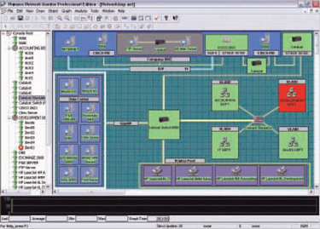
This layout shows the servers and clients machines that on Numara network monitoring [6].

2.3.1.4 Patch Management
- Discuss if researched solution has built in patch management ability- IT specialists can reduce time and administrative costs by using Numara Patch Manager to automate such functions as patch management, analysis, reporting, deployment and maintenance.
Numara Patch Manager gives IT specialist the ability to choose which servers or workstations to scan or not to scan, and to create machine groups and import the list of systems to be scanned. They can also specify systems or IP addresses/ranges that should not be scanned.
Numara Patch Manager has the ability to scan and deploy Windows security patches to multiple workstations from a central console automatically, and it provides an intuitive administrative console for deployment of critical patch management information.

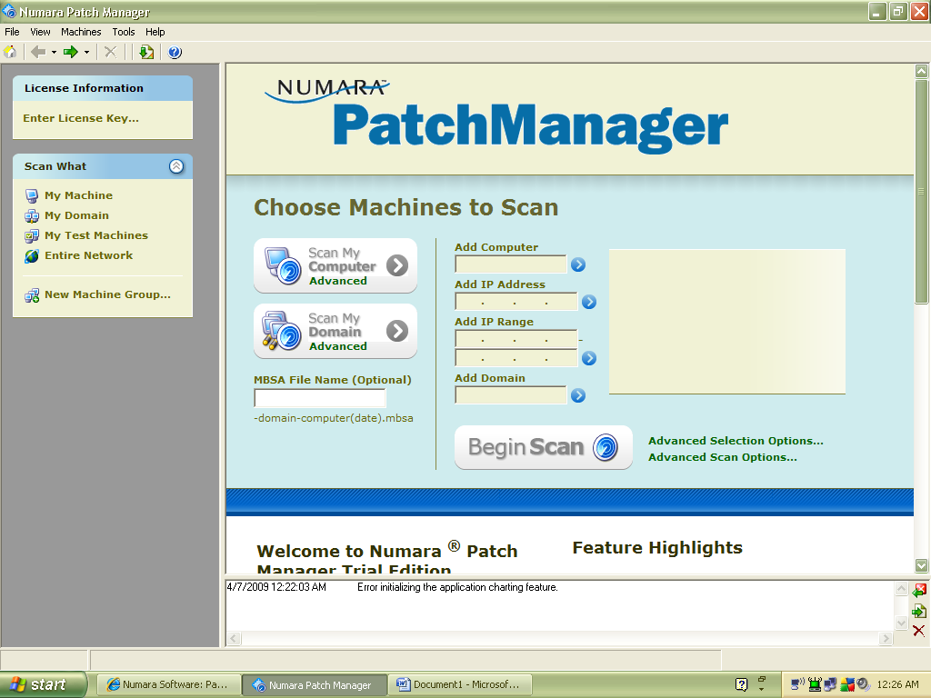
IT tasks can be simplified by controlling the items to be scanned, the criteria by which they will be scanned, and when and how patches are deployed [7].

2.3.1.5 Backup & Disaster Recovery
  - Discuss how backup & disaster recovery is accomplished- Numara keeps mission-critical data safe and simplifies disaster recovery. The fact that the Numara FootPrints application and database reside in a single directory makes it easy to backup.
Numara uses multiple security methods to protect data that is stored in Numara FootPrints, which is fully password protected. It also supports password authentication using Microsoft Windows, LDAP, web server, UNIX, or the built-in Numara FootPrints authentication.
Not fully supported with Numara Software [8].

2.3.1.6 Endpoint Security
- Discuss if researched solution has built in endpoint security ability- Numara track-it software does not support this feature.

2.3.1.7 User State Management
  - Discuss if researched solution has built in user state management ability- Numara track-it software does not support this feature.

2.3.1.8 Help Desk
  - Discuss if researched solution has built in help desk ability- Help desk software prominent include email request management, Field Tech Web interface update, augmented OS and hardware platform support, event and skills-based routing are some of the new help desk software features in the Track-It! program. Track-It! Provides for desk managers and technicians to personalize their dashboard views to identify and act on critical trends immediately. The program contains more than 100 reports for technicians and managers to convey valuable decision- making information to multiple stakeholders.

2.3.2 Usability
- Numara Track-it software provides flexible and manageable solutions in affordable packages and with diminished implementation costs.

2.3.3 Reliability
- Numara Software provides several online trainings for users about how beneficial to have Numara Software as the best solution for IT automation solution.

    - Performance
- Numara is easy and quick to distribute application software to Microsoft Windows Laptop and PCs across any connection, anywhere Numara Deploy makes it simple to install, remove update and repair software application.

2.3.5 Supportability
- Provides access to Numara Software solutions for users, and easy configuration.
- Software maintenance which may also from time to time that provides software maintenance releases.

