  - Windows 2003 Server

Overview/Background:

Windows 2003 Server is found in most companies and businesses today. Many companies or businesses are reluctant to update to Server 2008 as a result of compatibility. Microsoft released Windows 2003 Server in April 2003. Microsoft itself has been around since the mid 1980’s. Server 2003 currently has four flavors: Standard Edition, Enterprise Edition, Datacenter Edition and Web Edition. What makes these flavors different from one another is the hardware it can support. One might be able to support 64 bit processing vs. 32 bit processing, one might be able to support up to 4GB memory vs. 64GB of memory and different types of processing. Most companies and businesses already have a server 2003 in place but for those who don’t and have a server available can purchase 2003 server from $999 (Standard Edition) to $3,999 (Enterprise Edition). Though it is not web based, it can be remote into from any location via the remote desktop program. The reality is that technicians tend to overlook the power of the operating system and look for third party solutions. These solutions though user friendly are expensive and time consuming. Not everyone is Microsoft certified, but with a little knowledge you can save your company plenty of time and money and take advantage of what the server operating system has to offer. That is why I think this is a very good solution for most.

Functional Coverage:

Server 2003 supports all Microsoft Windows NT (2000/XP) workstations. It mildly supports Apple computers and does not at all support Linux machines. Microsoft Windows NT machines can be completely managed and monitored by Server 2003. Server 2003 does not use an agent or a probe to manage or monitor its workstations. The only underlying technology is that the computers are added to the domain on that server.

Grouping Managed Devices:

The only pre-requisite to manage the desktop computers, laptops, and servers as far as Windows Server 2003 is concerned is that the machines need to be added to the domain. This can be performed remotely via a script to all the machines in the network. Once on the domain, Active Directory can manage these computers and put them in specific containers to facilitate managing.

2.2.1 Remote Control:

Remote Control is not a problem because all NT machines (Windows XP/2000) have remote desktop capabilities. As long as the remote desktop option is checked, you can remote desktop to any machine in your network assuming you are the administrator to your machines. You can perform file transfers via the remote computers RUN command. You can also use MMC (Microsoft Management Console) on your server for instance and add the remote desktops snap in. This will allow you to add all the workstations in your network to the mmc console saving you the hassle of having to remember all the computer names in a very organized fashion.
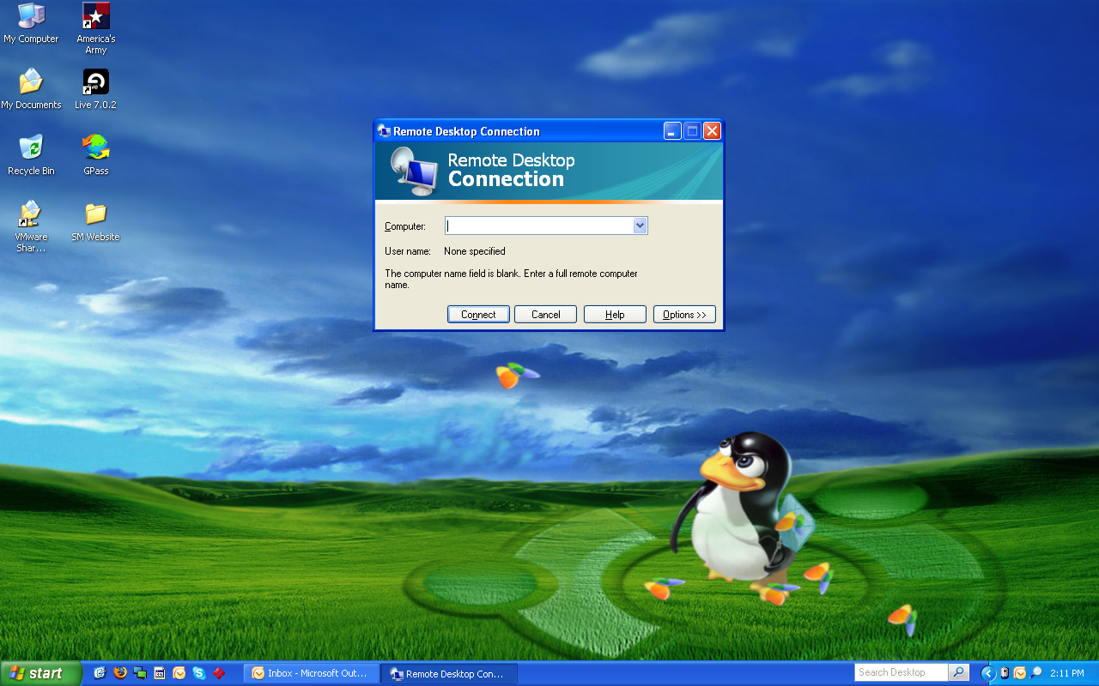
The following picture depicts the Remote Desktop application native to all NT workstations. This application allows the ability to remotely control any computer in your network.

2.2.2 Auditing & Asset Management:

With active directory, you have the ability to manage computers remotely. You can pull generic information such as the remote computers operating system, logs, alerts, devices and services to name a few. You can also perform remote tasks such as disk defragmentation and disk management. These tasks are the same as if you were managing the computer locally but are performed remotely on the server. For advanced auditing you can set up scripts to pull custom information from all the workstations in your network. Though auditing is not one it it’s powerful features, someone with script knowledge could get a decent amount of information about their machines.

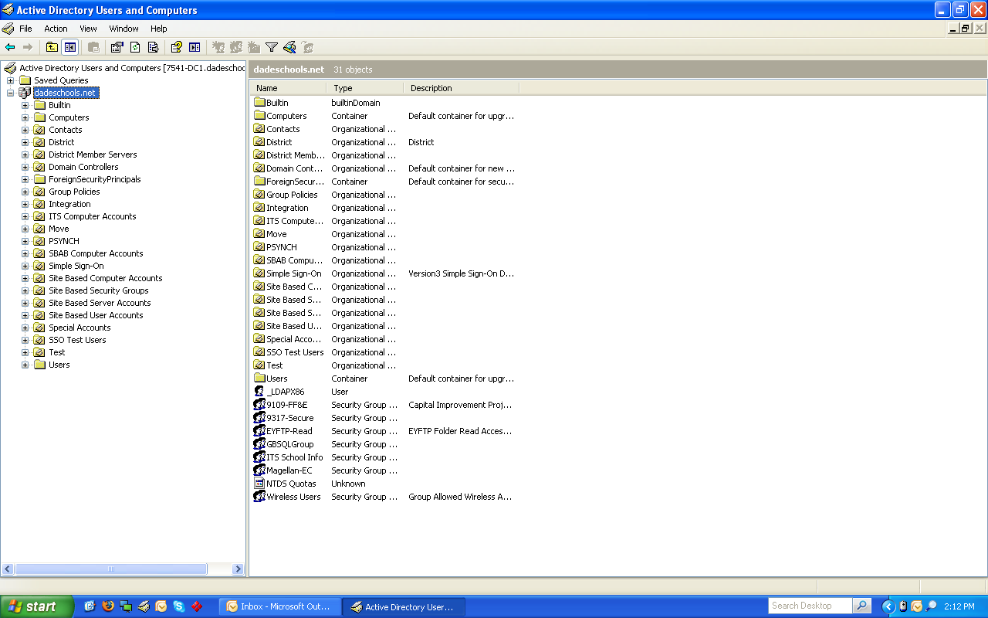
The following picture depicts the Active Directory application native to all servers. This application allows the ability to manage the users and groups in your network.

2.2.3 Monitoring:

Windows has built in logs and alerts located in the computer management section. With active directory you can access these logs and alerts remotely and monitor the machines from the server. In addition you can create specific scripts, deployed from group policies that can monitor these logs and alerts for you and use them to retrieve specific application, internet explorer, security and system information as well as warning and error logs. Though monitoring is not one it it’s powerful features, someone with script knowledge could get a decent amount of monitoring about their machines.

2.2.4 Patch Management:

WSUS (Windows Server Update Services) allows a technician to pull down Microsoft updates from the Microsoft server down to the local server. Once the windows updates are downloaded, they can be pushed to all the computers in the network. Though computers have the ability of performing windows updates automatically, using WSUS can conserve network traffic allowing the internet to be used more efficiently. By eliminating all the machines on the network from pulling updates from Microsoft, you are now dedicating only one machine for the task. Another great reason to use WSUS is that you can delegate which updates to push to your computers. Some updates may not be appropriate or even necessary for your network. MSI (Microsoft Installer) packages can be used to deploy software remotely. You can create MSI packages of any programs or set of programs and have them pushed via group policies to all the computers in your network from the server. Creating MSI packages is really easy and convenient enough to keep all the software in your network up to date. You can push as many software packages as you want to any number of computer in your network.

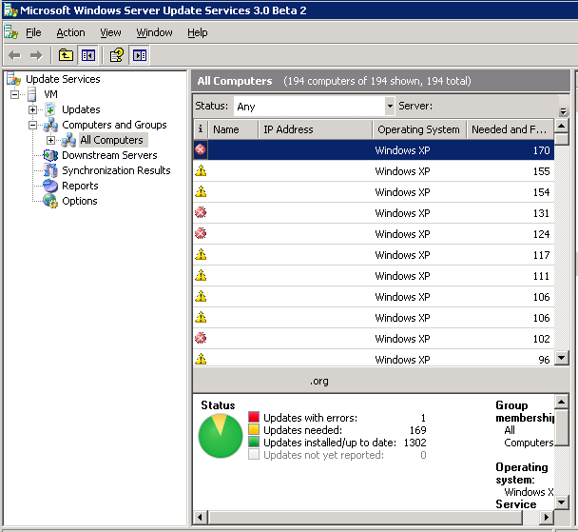
The following picture depicts the WSUS application. This application allows the ability to push patches to all the computers in your network.

2.2.5 Backup & Disaster Recovery:

As far as the hardware of that server is concerned, you can make sure to purchase a server with dual power supplies and a minimum of three hard drives for a RAID 5 configuration for redundancy. As far as the computers on the network, you can have all the profiles in the network roaming and located on the server so that if any of the computers were to fail, the user would not suffer the loss of his or her files. Windows 2003 server has an NT backup application that will back up the server. You can use this application to backup to DVD’s and image based files. With this program you have the ability to backup or restore, choose which files specifically you want backed up, choose the type of media to back up too, choose type of backup example incremental, differential, or daily and schedule your backup. Though this may not cover the computers in the network, at least it will cover the end user’s files.
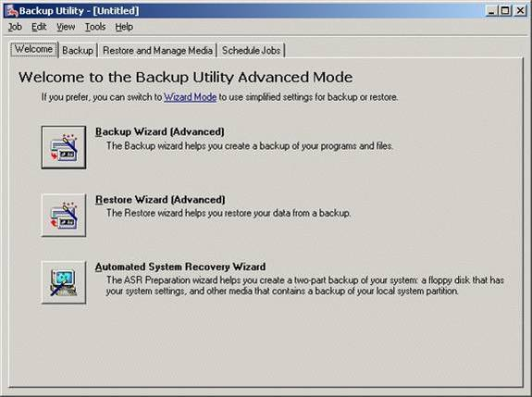
The following picture depicts the NT Backup application native to all servers. This application allows you to backup your server with great ease.

2.2.6 Endpoint Security:

One of the most exiting features of Windows 2003 server in my opinion is group policy in active directory. You can assign group policies to both users and computers in your network. Applying a policy to a computer forces that policy on that computer no matter what user is logged into that computer. Applying a policy to a user forces that policy on a user no matter what computer that user is logged into. With active directory, you can limit both what computer that user can log into, or what time that user can log in. In addition, with group policies, you can apply a policy from as simple as removing the ability to access the C drive, to as intense as locking the machine so tight that it can only be used to access the web and perform standard word processing. As far as antivirus, you will need to rely on a free anti-virus such as AVG. With MSI packaging, you can push this program to all the computers on the network. One thing to keep in mind, if policies are aggressively enforced and a powerful firewall is in place, it will be less likely that you will receive a virus on any of the computers in the network.
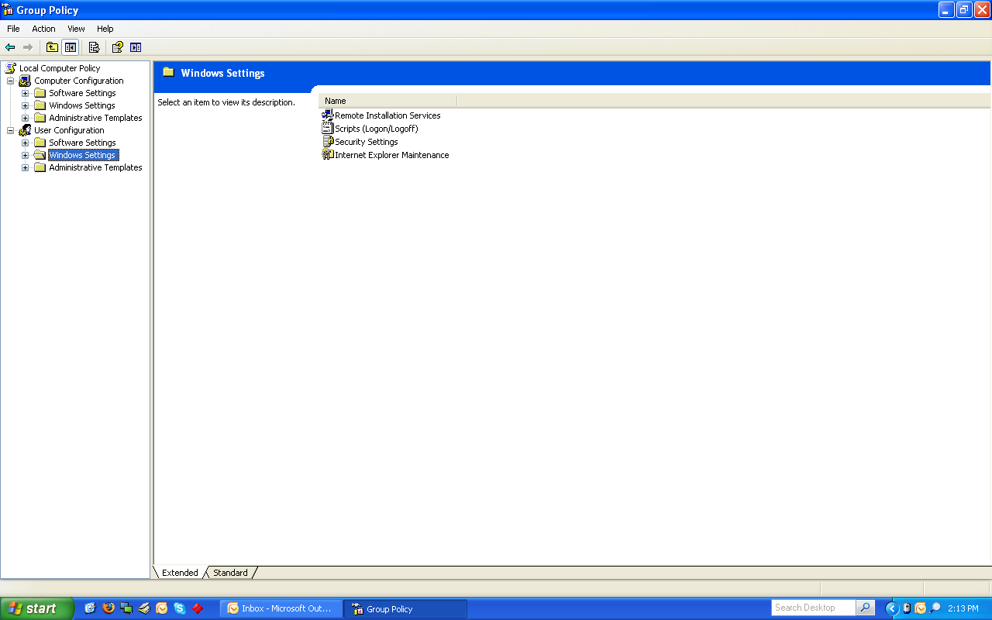
The following picture depicts the Group Policy application native to all servers. This application allows you to apply policies to all the computers in your network.

2.2.7 User State Management:

In addition to being able to apply group policy to users or computers on your network, you can also apply user state profiles. Two examples that can be used are roaming and mandatory profiles. A roaming profile is a profile located not on the local machine, but on the server itself. This profile will be pulled down to the user as he logs into any machine on the network. Thus having his profile and files following him no matter what computer he is logged into. A mandatory profile is also a profile not located on the local machine, but the server itself. This profile will also be pulled down to the user but on the other hand will be fixed and will never change. This profile is created by the technician in the case that the technician would like to keep the user from saving documents onto the computer. When the user logs off, anything saved on that profile will be removed and the next user will receive the same mandatory profile as the previous user. Scripting is a very custom option that you can use in Windows 2003 Server. You can create a specific batch file or visual basic script that can be pushed to one or many computers in your network. You can set it to either affect specific workstations or specific users in your network. Scripting is only limited by the knowledge of the technician implementing it. This could be the most powerful tool of all the tools available that you can use in Windows 2003 Server.

2.2.8 Help Desk:

With the implementation of Microsoft Exchange on your server, this works in conjunction with the users in active directory. You can create mail boxes for all he users in the network. You can also create a separate E-Mail for a specific technology account that can be used to receive work orders from your users. Adding web server services from IIS to your server with front page extensions allow you to create a web page that serves as an electronic work order form that can be used to E-Mail your technological work orders in a form of an E-Mail.

2.2.9 Usability:

If Server 2003 meets the needs of your company or business, usability would definitely be a perk. Most already have server 2003 in their network so no overhead is required. For those who do not have server 2003 implemented, adding computers to the domain can be done very easily through scripts binding the computers to your server. Microsoft has a lot of support on the internet for Server 2003. Like mentioned above, you do not need to be Microsoft certified to handle your way around the server. Google in some cases could answer about 75% of your questions with active directory.

2.2.10 Reliability:

As long as your server 2003 operating system is installed on a server chassis with dual power supplies and a minimum of three hard drives for a RAID 5 configuration for redundancy you should no issues with reliability. Even then you can have a backup domain controller that would serve as a backup to your primary domain controller if that one would fail.

2.2.11 Performance:

With good processors and a good amount of memory, Server 2003 should perform very well. I would recommend if using Standard Edition to have its capacity of 4GB of memory installed for the best performance. I would also recommend performing weekly defragmentation and disk clean ups. I would also make sure to have it up to date to the latest Microsoft patches.

    - Supportability:

Most to all companies and businesses today are mainly using Windows computers. Unfortunately Server 2003 is very limited to supporting Mac and can not at all support Linux. With Server 2003 you do not have monthly fees and it is very inexpensive compared to third party solutions.

